HOME AUTOMATION SYSTEM

PROJECT ID – 18-088

Design Document for the components ‘Remote Access Control of Home and Securing the Network’

A.R.J. Akwaththa (IT15093660)

BSc Special (Hons) - Information Technology (Specialization in Cyber Security)

Department of Information Technology

Sri Lanka Institute of Information Technology
Sri Lanka

March 2018

1

DECLARATION

I declare that this is my own work and this SRS does not incorporate without acknowledgement any material previously submitted for a degree or diploma in any other university or Institute of higher learning and to the best of my knowledge and belief it does not contain any material previously published or written by another person except where the acknowledgement is made in the text.

………………………….

Rajitha Akwaththa (IT15093660)

The above candidates are carrying out research for the undergraduate Dissertation under my supervision.

Name of the Supervisor: Signature of the supervisor: Date:

Mr. Yashas Mallawarachchi

2
Table of Contents

DECLARATION .......................................................................................................................................... |  |  | 2
Table of Contents .......................................................................................................................................... |  |  | 3
List of Figures ............................................................................................................................................... |  |  | 5
List of Tables ................................................................................................................................................ |  |  | 5
1. | Introduction ........................................................................................................................................... |  | 6
 | 1.1 | Purpose ......................................................................................................................................... | 6
 | 1.2 | Scope ............................................................................................................................................ | 6
 | 1.3 | Overview ...................................................................................................................................... | 6
2. | Overall Description ............................................................................................................................... |  | 6
 | 2.1 | Product Perspective. ..................................................................................................................... | 7
 | 2.1.1 | System Interfaces .................................................................................................................. | 7
 | 2.1.2 | User Interfaces ...................................................................................................................... | 8
 | 2.1.3 | Hardware Interfaces ............................................................................................................ | 10
 | 2.1.4 | Software Interfaces ............................................................................................................. | 10
 | 2.1.5 | Communication Interfaces .................................................................................................. | 10
 | 2.1.6 | Memory Constraints ............................................................................................................ | 10
 | 2.1.7 | Operations ........................................................................................................................... | 11
 | 2.1.8 | Site adaptation requirements ............................................................................................... | 11
 | 2.2 | Product Functions ...................................................................................................................... | 11
 | 2.2.1 | Use Case Diagram ............................................................................................................... | 13
 | 2.2.2 | Use Case Scenarios ............................................................................................................. | 14
 | 2.3 | User Characteristics .................................................................................................................... | 18
 | 2.4 | Constraints .................................................................................................................................. | 18
 | 2.5 | Assumptions and Dependencies .................................................................................................. | 19
3. | Specific Requirements ........................................................................................................................ |  | 19
 | 3.1 | External Interface Requirements ................................................................................................ | 19
 | 3.1.1 | User Interfaces .................................................................................................................... | 19
 | 3.1.2 | Hardware Interfaces ............................................................................................................ | 20
 | 3.3 | Performance Requirements ........................................................................................................ | 20
 |  |  | 3

3.4 Design Constraints 21

3.5 Software System Attributes 21

3.5.1 Reliability 21

3.5.2 Availability 21

3.5.3 Security 21

3.5.4 Maintainability 21

4. References 22

4

List of Figures

 |  | Page
Figure 2.1.1.1 | System Interface Diagram | 8
Figure 2.2 | Access Control System | 12
Figure 2.2.1 | Use case diagram | 13
Figure 3.1.1.1 | User Interface –Home Page | 17
Figure 3.1.1.2 | User Interface –1 | 8
Figure 3.1.1.3 | User Interface –2 | 9
Figure 3.1.1.4 | User Interface –3 | 9

List of Tables

 |  | Page
Table 2.2.2.1 | Use Case ID - 001 | 12
Table 2.2.2.2 | Use Case ID – 002 | 13
Table 2.2.2.3 | Use Case ID – 003 | 13
Table 2.2.2.4 | Use Case ID – 004 | 14
Table 2.2.2.5 | Use Case ID – 005 | 14
Table 2.2.2.6 | Use Case ID – 006 | 15
Table 2.2.2.7 | Use Case ID - 007 | 15
Table 2.2.2.8 | Use Case ID - 008 | 16

5

1. Introduction

1.1 Purpose

The purpose of this document is to indicate the design, structure and how internal components are collaborate with the access control section of the home automation system and securing the whole network in order to understand the system architecture by the designers/developers and build the proposed system in an efficient way.

1.2 Scope

This document will cover access control function and the network securing section of the proposed home automation system, structure of internal components, functional and non-functional requirements, ideal expected outcome comes from the expected behavior of the internal components and characteristics.

1.3 Overview

The proposed access control system will handle the doors and windows remotely according to the user commands given via user interfaces. Data that transmit through the internet will be secure through an encryption algorithm.

2. Overall Description

Access control of the home will be consisting of two main parts. Two parts can be categorized as

- Door access control

- Windows access control

Above section of the home automation system[1] going to be more important to the people who are always forgetting and feeling nervous after going away from home. This Design Document will cover the functions of the access control system.

6

Since the system is controlled by the user by a mobile application and a web interface, user has to access everything via cloud/Internet. Many of the home automation are willing to fail because of the data breach. Proposed home automation system will provide an assurance regarding the security breaches.

Security[2] will become the most critical part when it comes to connected devices. As a solution to the security of the data that transmit through the system an encryption method is using, so that unauthorizes personnel will not be able to access the critical information that passes through the internet.

2.1 Product Perspective.

Today most of the house owners are willing to make their ordinary home a smart home. A country like Sri Lanka specially having the need of having a smart home system to avoid the access of unauthorized party.

The function remote access control acts a major part in the proposed home automation system when it comes to security perspective. This remotely access will be done wirelessly. There will be many more home automation systems at the market place with Bluetooth or wired connectivity. But the home automation systems that runs depend on Bluetooth connectivity [3] and wired connectivity are getting failed because those kinds of systems limit their functional capabilities up to some extend and never can be improved.

Network securing feature is also lacking in the most of the systems that are in market place. Users are refusing to buy any home automation systems that have a greater chance of leaking the stored information. Network securing function evades the data security vulnerability of the proposed home automation system. And the user interfaces that interact with the user advocate user friendly environment and easy interfaces that can be understand by any non-technical user.

2.1.1 System Interfaces

- Interface to Encrypt data that transfer through the network

7
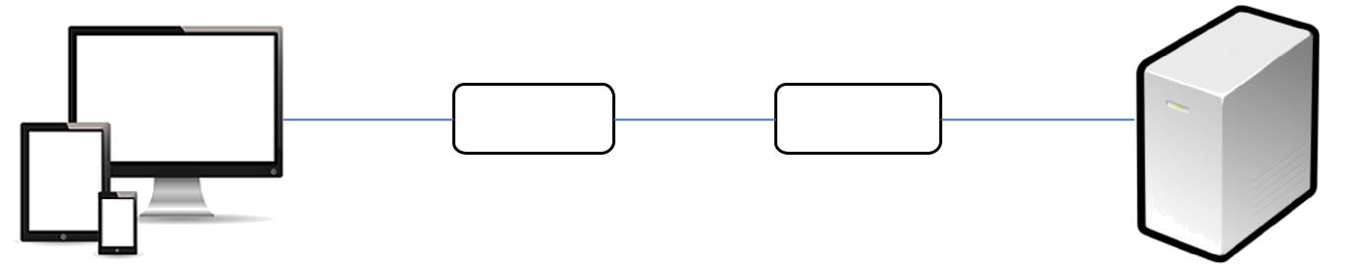
H247bsf0@

Lock the door

Encrypt

Decrypt
Lock the door

Figure 2.1.1.1

2.1.2 User Interfaces
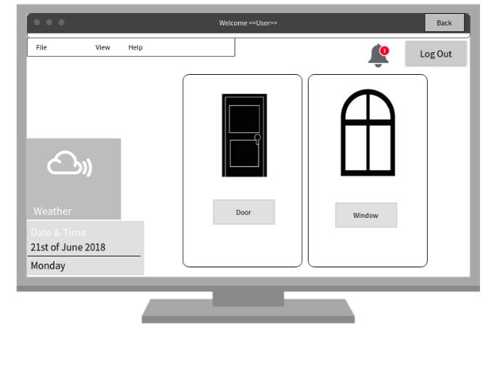

Figure 3.1.1.2: Door and Window Locking/Unlocking Interface

8

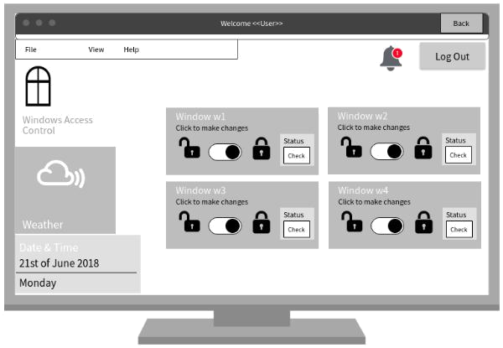

Figure 3.1.1.3: Window Locking Interface
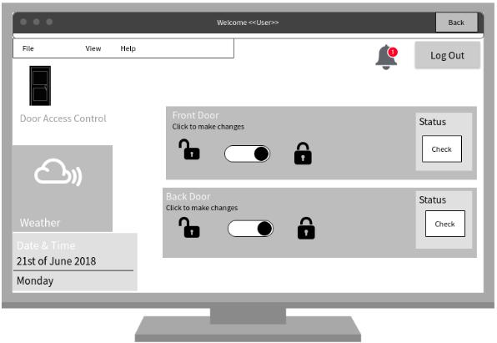

Figure 3.1.1.4: Door Locking Interface
9

2.1.3 Hardware Interfaces

- Raspberry Pi [4]

- Door locking and opening sensor

- Window locking and opening sensor

2.1.4 Software Interfaces

- Web application that have interfaces to control access will use Apache, My SQL and PHP as the backend [5] and Backend of the web application will run using Java and C++.

- VNC viewer [6]

Use to control raspberry pi from an interface in a computer.

Figure 3.1.1.3 : Windows Locking/Unlocking Interface

2.1.5 Communication Interfaces

Mobile and web application should have an unbroken communication with the cloud in order to send and receive data to control access of the home automation system. TCP/IP protocol [7] is using for the internal communication while HTTP [8] protocol is using for the communication via internet.

To maintain network connection WIFI module will be used and mobile data may use as per user’s wish to connect mobile application to the network.

2.1.6 Memory Constraints

Since all the data are sent to the cloud mobile device need space only to store the apk , server need space only to store the web application,

- 25 GB cloud storage

- 10 GB space on Hard Disk

- 4 GB RAM

10
2.1.7 Operations

Access Control operation –

Access control sub component helps user to remotely lock doors and windows whenever user needs. User will also be able to check the current status of the door/window(Lock/Unlock). If an intruder tries to unlock a door/window user will receive a notification on his/her mobile.

User ->

- Command to lock/unlock the door/window

- Request for the status of the door/window

Web/Mobile Application ->

- Notify Micro controller to lock/unlock the door/window

- Request for the status of the door/window from the sensor application.

Securing the Network Traffic -

Data travels through the unsafe network is encrypting using Tiny Encryption Algorithm.

2.1.8 Site adaptation requirements

Since the web application must develop in the server Apache httpd 2.2[8] need to be installed in the server. It should be up and running in the server to have the home automation access control service all time.

VNC viewer[6] should be installed in a computer to control the inputs and outputs to the raspberry pi micro controller.

2.2 Product Functions

Access Control System – Remote control doors and windows

11
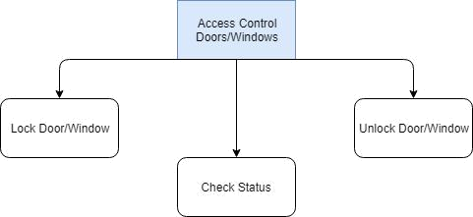

Figure 2.2

Above diagram shows the three main functions that cover from the access control system.

12
2.2.1 Use Case Diagram
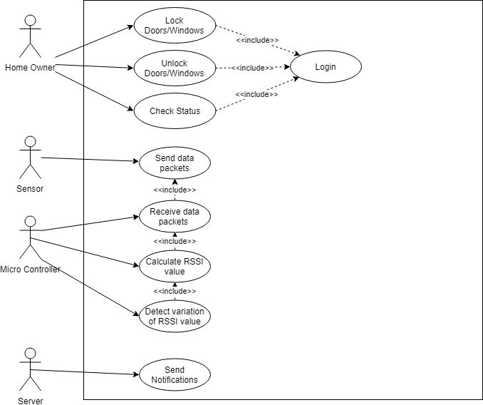

Figure 2.2.1

13

2.2.2 Use Case Scenarios
2.2.2.1 |  | Check Status
 | Use Case ID |  |  | 001
 | Use Case |  |  | Check Status
 | Pre-Conditions |  |  | User should log into the system
 | Primary User |  |  | Home Owner
 | Main Flow of the events |  |  | 1. Use case starts when user login into the
 |  |  |  | system
 |  |  |  | 2. Application will display the status of
 |  |  |  | the door or window
 |  |  |  | 3. Use case ends when the user closes the
 |  |  |  | application
 | • | Essential
 |  |  | Table 2.2.2.1
2.2.2.2 Lock Doors/Windows
 | Use Case ID |  |  | 002
 | Use Case |  |  | Lock Doors / Windows
 | Pre Conditions |  |  | User should log into the system
 | Primary User |  |  | Home Owner
 | Main Flow of the events |  |  | 1. Use case starts when user login into
 |  |  |  | the system
 |  |  |  | 2. Application send a command to the
 |  |  |  | microcontrller to lock the
 |  |  | 14

 |  |  |  | door/window
 |  |  |  | 3. Use case ends when the user closes
 |  |  |  | the application
 | • | Essential
 |  |  | Table 2.2.2.2
2.2.2.3 Unlock Doors/Windows
 | Use Case ID |  |  | 003
 | Use Case |  |  | Unlock Doors / Windows
 | Pre-Conditions |  |  | User should log into the system
 | Primary User |  |  | Home Owner
 | Main Flow of the events |  |  | 1. Use case starts when user login into the
 |  |  |  | system
 |  |  |  | 2. Application send a command to the
 |  |  |  | microcontroller to unlock the
 |  |  |  | door/window
 |  |  |  | 3. Use case ends when the user closes the
 |  |  |  | application
 | • | Essential
 |  |  | Table 2.2.2.3
2.2.2.4 Send Data Packets
 | Use Case ID |  |  | 004
 | Use Case |  |  | Send Data Packets
 | Pre-Conditions |  |  | Sensor respond according to the request come
 |  |  |  | by the micro controller
 | Primary User |  |  | Sensor
 | Main Flow of the events |  |  | 1. Respond to the request comes from the
 |  |  |  | micro controller
 |  |  | 15

 |  |  |  |  | 2. Change the status according to the
 |  |  |  |  | request
 |  |  |  |  | 3. Use case ends when sensor notify the
 |  |  |  |  | change to the micro controller
 |  | • | Essential
 |  |  |  | Table 2.2.2.4
2.2.2.5 |  | Receive data packets
 |  | Use Case ID |  |  | 005
 |  | Use Case |  |  | Receive Data Packets
 |  | Pre-Conditions |  |  | Sensor should send data packets to micro
 |  |  |  |  | controller
 |  | Primary User |  |  | Micro controller
 |  | Main Flow of the events |  |  | 1. Use case starts when micro controller
 |  |  |  |  | receives data packets from the sensor
 |  |  |  |  | 2. Micro controller then checks the
 |  |  |  |  | command from the user is equal to the
 |  |  |  |  | status
 |  |  |  |  | 3. Use case ends when micro controller
 |  |  |  |  | accepts the data packets
 |  | • | Essential
 |  |  |  | Table 2.2.2.5
2.2.2.6 |  | Calculate RSSI value
 |  | Use Case ID |  |  | 006
 |  | Use Case |  |  | Calculate RSSI value
 |  | Pre-Conditions |  |  | Micro controller should receive data packets
 |  |  |  |  | from the sensor
 |  | Primary User |  |  | Micro controller

16
 | Main Flow of the events |  |  | 1. | Use case starts when the
 |  |  |  |  | microcontroller receives data packets
 |  |  |  |  | from the sensor.
 |  |  |  | 2. | Check the RSSI value
 |  |  |  | 3. | Use case ends when the RSSI value get
 |  |  |  |  | confirmed
 | • | Essential
 |  |  | Table 2.2.2.6
2.2.2.7 Detect variation of RSSI value
 | Use Case ID |  |  | 007
 | Use Case |  |  | Detect variation of RSSI value
 | Pre-Conditions |  |  | Micro controller should calculate the RSSI
 |  |  |  | value
 | Primary User |  |  | Micro controller
 | Main Flow of the events |  |  | 1. | Use case starts when the
 |  |  |  |  | microcontroller detects RSSI value
 |  |  |  | 2. | Examine the RSSI value variation and
 |  |  |  |  | notify the change
 |  |  |  | 3. | Use case ends when RSSI variation
 |  |  |  |  | consider as a major impact.
 | • | Essential
 |  |  | Table 2.2.2.7
2.2.2.8 Send Notification
 | Use Case ID |  |  | 008
 | Use Case |  |  | Send Notification
 | Pre-Conditions
 | Primary User |  |  | Server
 |  |  |  |  | 17

Main Flow of the events |  | 1. | Use case starts when server gets signals
 |  |  | from the micro controller
 |  | 2. | Server send notification to the
 |  |  | application
 |  | 3. | Use case ends when server confirmed
 |  |  | application receive the notification
• Essential
 | Table 2.2.2.8

2.3 User Characteristics

User should be having the basic knowledge of using web application and an android device application. User could be a initiate user or a expert one to use the application and installed the application in the mobile device and registered with it.

Home owner will generally become the administrator of the system who should have a average or good knowledge about the IOT devices and Information Technology

2.4 Constraints

- Remote Access Control

- Registered user can be remotely access the home only using the web application and mobile application.

- No other user should able to use the web application or mobile application without registered user permission

- Server should always up and running to provide the main functionalities of the system

- WIFI connection should not be down for any reason

- Backup power supply need to be there in case of a power failure

- No any other request could clash with the system requests

18

2.5 Assumptions and Dependencies

Mobile application of the proposed home automation system will roughly need 100MB storage form the mobile internal storage. If the device’s memory if at low level, functionality of the mobile application will not be performed well. Another assumption would be like, if the power is at a low level in the device application would not be able to work.

Internet should be available continuously to the user in order to fulfill the functionality of the remote access control component of the proposed home automation system.

Assume that all the resources are available to develop the environment of the remote access control component of the home automation system.

Mobile application only planned to work in android devices but with certain set of modifications it will work on IOS devises too.

- Specific Requirements

3.1External Interface Requirements

3.1.1 User Interfaces
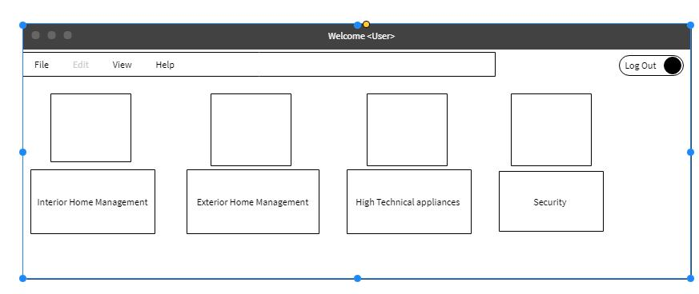

Figure 3.1.1.1

Figure 3.1.1.1 is showing the home page user interface.

19

- From Home Page Interface “Security” button will redirect the user to Figure 3.1.1.2 user interface.

- From Figure 3.1.1.2 UI, User can select which access method for home is going to be control. User can navigate to the Door or Window section in order to control the access remotely.

- If user selects Windows access control system from the Figure 3.1.1.2, It will be redirect to an interface shown in the Figure 3.1.1.3. In this interface user will be able to check the current status of any window in home and user can change the state as per his/her wish.

- In case user select Door access control section from the Figure 3.1.1.2 it will redirect into the Figure 3.1.1.4. There user can check the check the current status of the doors and change the state as per his/her wish.

3.1.2 Hardware Interfaces

- Door Locking/Unlocking sensor

This sensor is going to be connected with the Raspberry pi using a relay circuit in order to control the doors and windows remotely. Sensor will attach to the door lock and it will be connected with the Raspberry pi over the Internet using Wi-Fi. Sensor will react to the requests that are coming from the Raspberry pi and make changes in the door lock as per user wish.

- Raspberry Pi

Raspberry pi[6] is a small computer product that looks like a circuit which can be used to control doors and windows in the access control component of the proposed home automation system.

Sensors that are using to control the appliances need to be integrated with the Raspberry pi.

3.3 Performance Requirements

- Minimum 2GB RAM will be needing for the mobile application to run the mobile application

- Server will require a 4 GB RAM if several users are going to be registered with the application

20
3.4 Design Constraints

- Development team of the project going to be design the product in a suitable and attractive way.

3.5 Software System Attributes

3.5.1 Reliability

System will be tested in several ways to make sure the system is error free. Risk impact for a failure is low since the product will be tested under many conditions before launching.

Accuracy of the outputs will be high since they would be tested in a real-world scenario. Possible to repair the application at any time by any user.

3.5.2 Availability

Web application and the mobile application should up and running any time of the day. Registered users should be able to access the application whenever they need and access the home at anytime from anywhere.

3.5.3 Security

Security of the web application and mobile application will be wrap by providing username and password for authorized users. So that only authorized users will get access to home remotely. Data that travels through the network will be encrypted and intruder won’t be able to capture or monitor any data packets and exploit the vulnerabilities of the system.

3.5.4 Maintainability

Best code practices will be use when coding the system so that system can be maintain by any developer since coding methods are easy to understand.

Handling comments through out the coding will make coding to understand easily. IOT devices will be reboot time to time to refresh and clear the content after taking backups.

21

4. References

[1] Nevonprojects.com. (2018). IOT Home Automation Project | NevonProjects. [online] Available

at: http://nevonprojects.com/iot-home-automation-project/ [Accessed 15 May 2018].

- Jala, M. (2018). Is Your Smart Home Spying on You? Personal Data Issues with the Internet of Things. [online] Columbia Science and Technology Law Review. Available at: http://stlr.org/2017/11/22/is-your-smart-home-spying-on-you-personal-data-issues-with-the-internet-of-things/ [Accessed 15 May 2018].

- Ieeexplore.ieee.org. (2018). Smart home automation system using Bluetooth technology - IEEE Conference Publication. [online] Available at: https://ieeexplore.ieee.org/document/7916544/ [Accessed 15 May 2018].

- Mozilla Hacks – the Web developer blog. (2018). How to build your own private smart home with a Raspberry Pi and Mozilla’s Things Gateway – Mozilla Hacks - the Web developer blog. [online] Available at: https://hacks.mozilla.org/2018/02/how-to-build-your-own-private-smart-home-with-a-raspberry-pi-and-mozillas-things-gateway/ [Accessed 15 May 2018].

- Udacity. (2018). Front-End vs Back-End vs Full Stack Web Developers. [online] Available at: https://blog.udacity.com/2014/12/front-end-vs-back-end-vs-full-stack-web-developers.html [Accessed 15 May 2018].

- The MagPi Magazine. (2018). VNC: Beginner's guide to Raspberry Pi remote access. [online]

Available at: https://www.raspberrypi.org/magpi/vnc-raspberry-pi/ [Accessed 15 May 2018].

- echopedia.com. (2018). What is TCP/IP? - Definition from Techopedia. [online] Available at: https://www.techopedia.com/definition/2460/transmission-control-protocolinternet-protocol-tcpip [Accessed 15 May 2018].

- Httpd.apache.org. (2018). Apache HTTP Server Version 2.2Documentation - Apache HTTP Server Version 2.2. [online] Available at: https://httpd.apache.org/docs/2.2/ [Accessed 15 May 2018].

- Zone, A., Zone, A. and Guide, T. (2018). 2018 IoT Products | Overview of the Most Popular

Smart Home Devices. [online] Postscapes.com. Available at: https://www.postscapes.com/internet-of-things-award/winners/ [Accessed 15 May 2018].

22

