**Final-project Proposal**

Group 7

**1. Contact information**

2017312780 Yu Chanu, vldpfh321@naver.com

**2. Application type**

**3. Topic**

**4. Sketch**

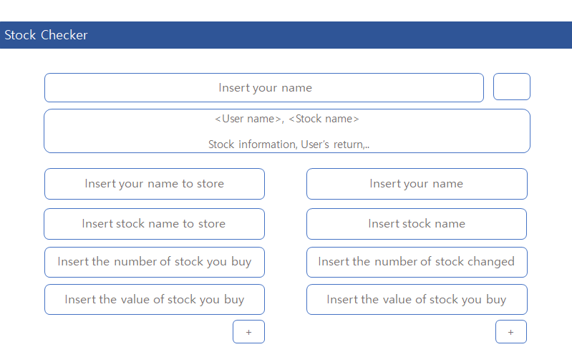

**5. Features**

**6. Usage scenario**

**7. Task assignment**

Yu Chanu:

Extracting data from Naver Stock homepage

Calculating return using local storage

Writing Proposal – Sketch, Task assignment

Choi Jeong Hoon:

Handling event handlers

Storing user information in local storage

Writing Proposal – Application type, Usage scenario

Jung Sung Joon:

Developing a web frontend

Presentation

Writing Proposal – Topic, Features