**1. FOLDER STRUCTURE**

1. api
   1. contains 36 php files
   2. communication between front-end (js) and back-end (database connection in php)
2. commons
   1. contains 4 folders
   2. 3rd party open source css, js, webfont files
3. conf
   1. contains 2 files
   2. database.php: set url, database, username, password, etc...
   3. url.php: set your physical path. default $base_URL .= "/";
4. js
   1. contains 19 js files
   2. front-end controller, these files are used to control the front page
5. lib
   1. contains 26 php files
   2. communication to database, these are the smallest model that gets values from the database.
6. views
   1. contains 8 folders
   2. The name of the folder matches the item in the menu
7. 4 files in root folder
   1. default page and menu related

**2. HOW TO INSTALL**

1. Download all files and copy them to the xampp\htdocs root.
2. Drop the existing database and execute database_tables_creation.sql, stored_procedures_creation.sql, insert_basic_data.sql in the workbench in order.
3. Modify the database.php file in the conf folder to match your database environment.
4. Open the web browser and put in localhost:[port]. Port is configured differently depending on your environment.
5. The default admin account ID/password is admin/1234.

**3. HOW TO USE**

1. 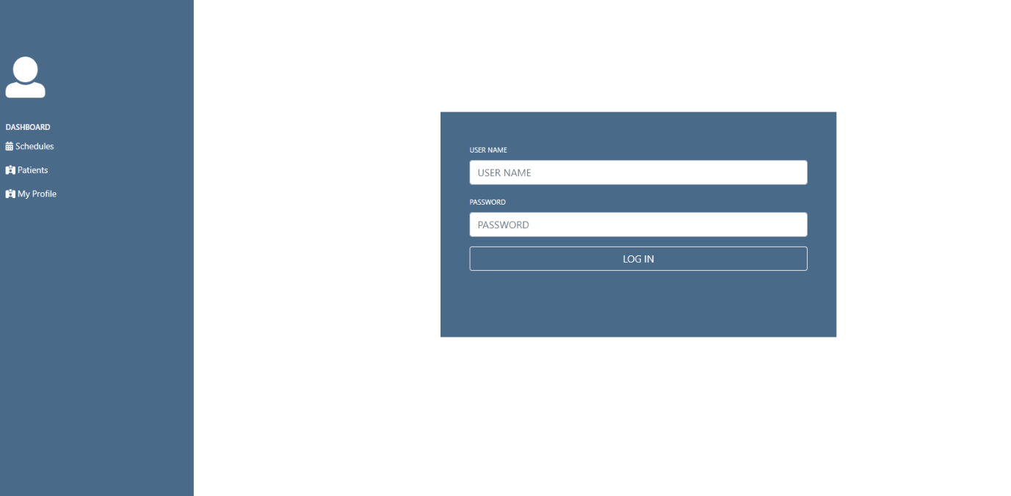Login

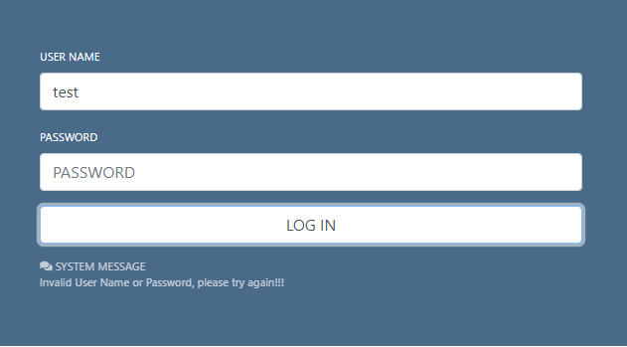

* 1. If the ID and password are missing or incorrect, the message is displayed at the bottom of the button. The message disappears automatically in five seconds.

1. 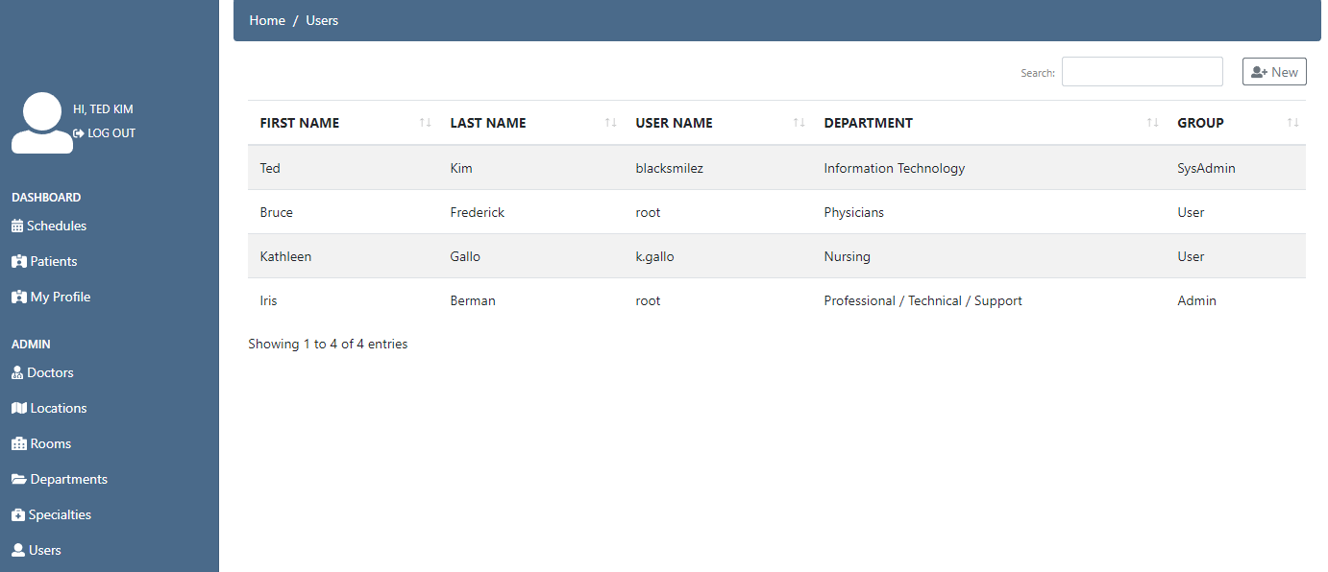 Users List
   1. This page is implemented using Datatables and ajax.
   2. If there are many users on the user list page, you can search for words only by typing them into the search box.
   3. Separate paging is set to not be performed, and if there are more than 10 rows, a vertical scroll bar is created.
2. Add/Modify User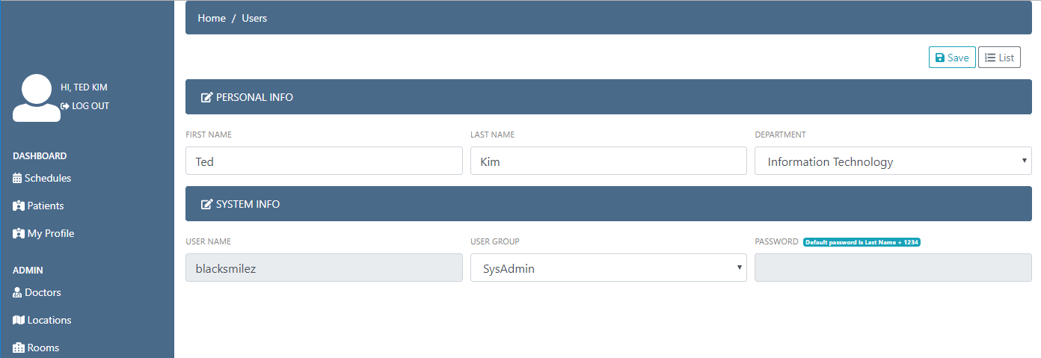
   1. User add/modify is enabled for SysAdmin only.
   2. There are three user groups: SysAdmin/Admin/User.
   3. All fields do not accept null values through validation checks.
   4. Passwords are not entered. The default password is last name + 1234.
3. Specialties List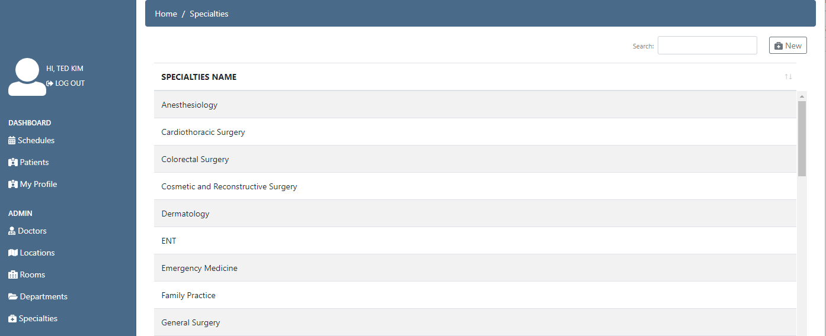
   1. It's a page for registering/managing doctors' specialty.
   2. Same as user list page.
4. 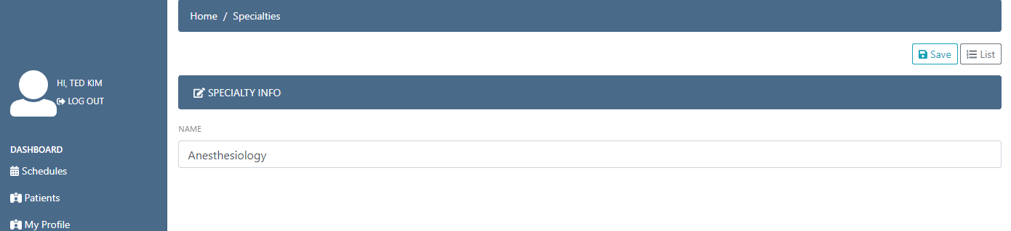Add/Modify Specialty
5. Departments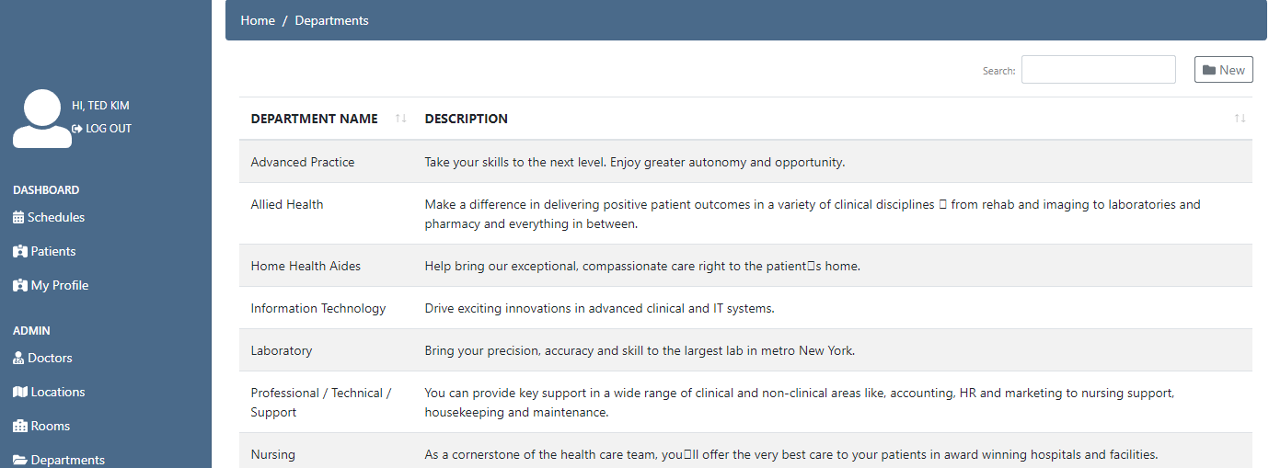
   1. It is an item that manages the department. Changes to this part are linked to the user registration page.
6. Add/Modify Department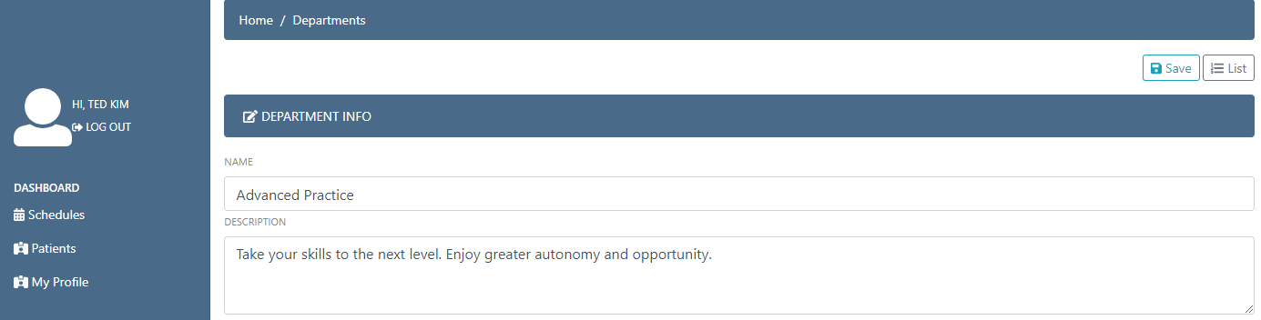
7. Rooms List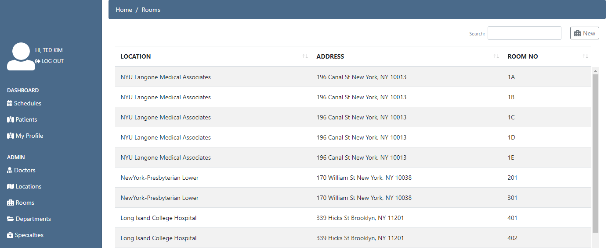
   1. The page to register/manage a doctor's office.
   2. There may be other rooms in the same building.
8. Add/Modify Room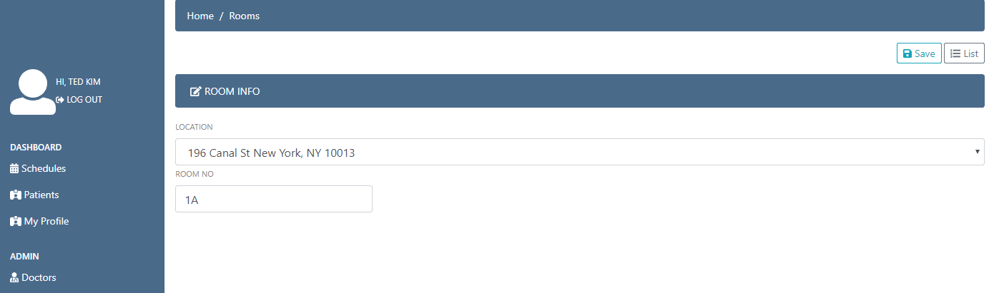
   1. A drop-down item that displays a location brings the data registered on the Location page.
9. Locations List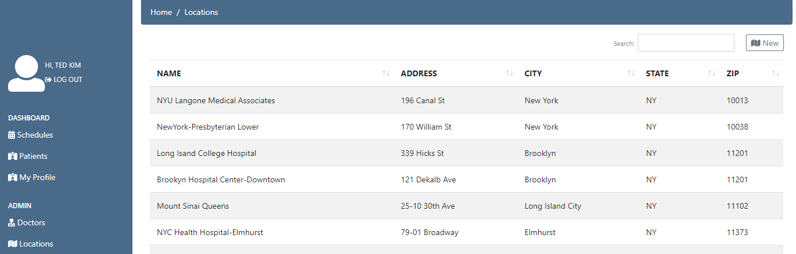
   1. This page registers and manages the location of the hospital/doctor’s office.
10. Add/Modify Location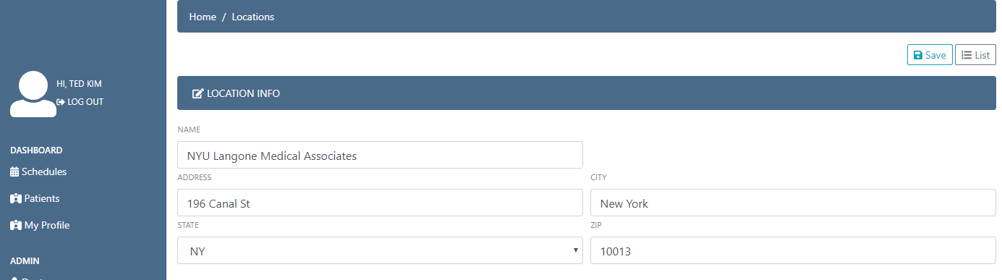
    1. State's drop-down items are taken from the database.
11. 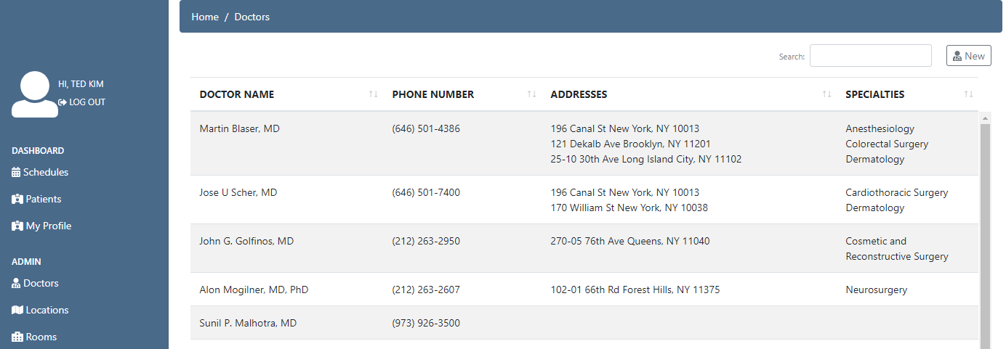Doctors List
    1. This page registers/manages a doctor.
12. 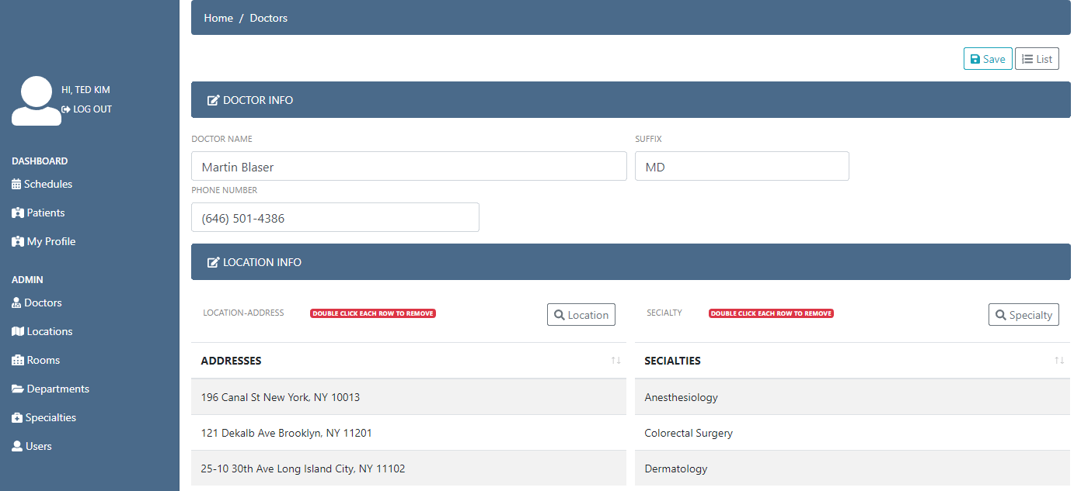Add/Modify Doctor
    1. Allow one doctor to have multiple locations and specialties.
    2. 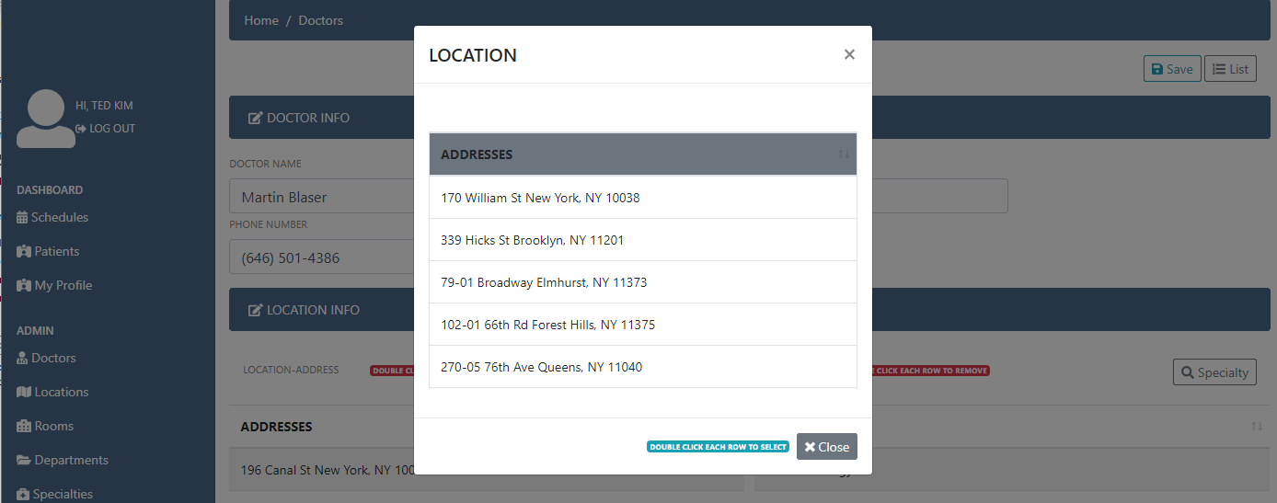Can add/remove by double clicking on the list. To add, press the button with the magnifying glass icon.
13. Patients List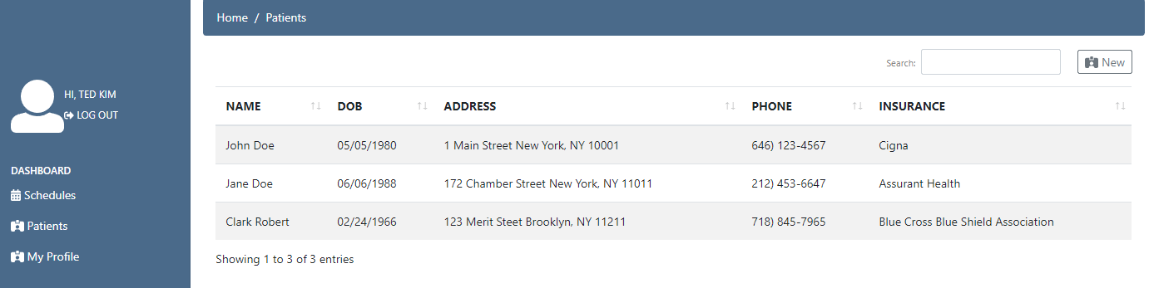
    1. The page for registering patients.
14. Add/Modify Patient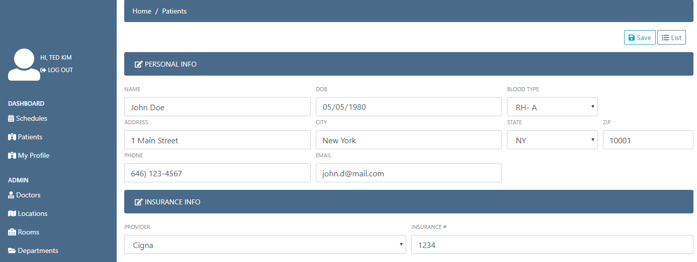
    1. Blood types, states, and providers are taken from each database table.
15. Schedules List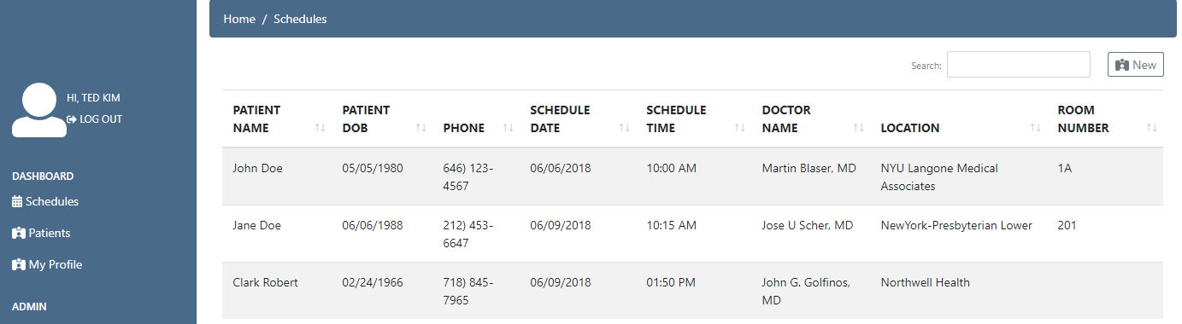
    1. It's a page that manages the schedule.
16. Add/Modify Schedule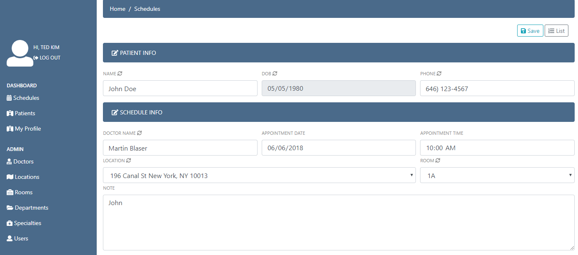
    1. 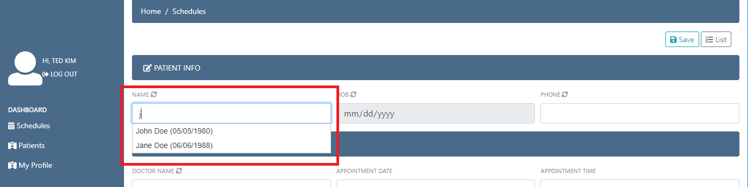If a patient's name or phone number is entered, the patient containing the input value is found and displayed below the field. implemented using jQuery UI and ajax.
    2. The select of a doctor works the same way above. When a doctor is selected, the doctor's location is taken from the database.
    3. When location is selected, the corresponding room is taken from the database.
17. My Profile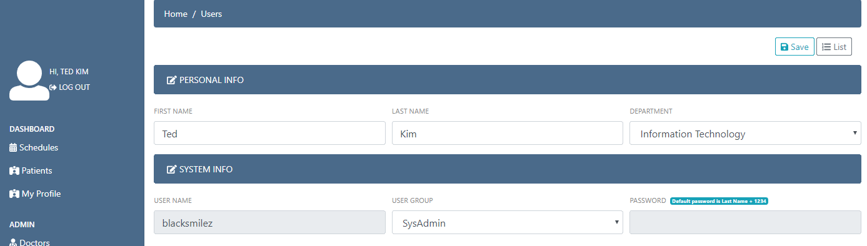
    1. For admins and users, only their own information can be viewed/modified.

**4. TECHNICAL PARTS**

1. JQUERY
   1. jQuery is a fast, small, and feature-rich JavaScript library. It makes things like HTML document traversal and manipulation, event handling, animation, and Ajax much simpler with an easy-to-use API that works across a multitude of browsers.
2. AJAX
   1. Asynchronous JavaScript And XML
   2. AJAX is a misleading name. AJAX applications might use XML to transport data, but it is equally common to transport data as plain text or JSON text.
   3. AJAX allows web pages to be updated asynchronously by exchanging data with a web server behind the scenes. This means that it is possible to update parts of a web page, without reloading the whole page.
3. AUTOCOMPLETE
   1. Autocomplete, or word completion, is a feature in which an application predicts the rest of a word a user is typing.