**Contents**

* INTRODUCTION
* Motive/Impact
* FEATURES
* SYSTEM ARCHITECTURE
* WORKING PROCESS
* RESULT
* FUTURE SCOPE
* CONCLUSION

1. **INTRODUCTION**

The System we are proposing is “Child Adoption Portal”, Where users can find nearby registered adoption centers, can view orphan children's profile, can apply for adoption, can get legal help regarding child adoption and can view registered adoption history through this portal.

1. **Motive/Impact**

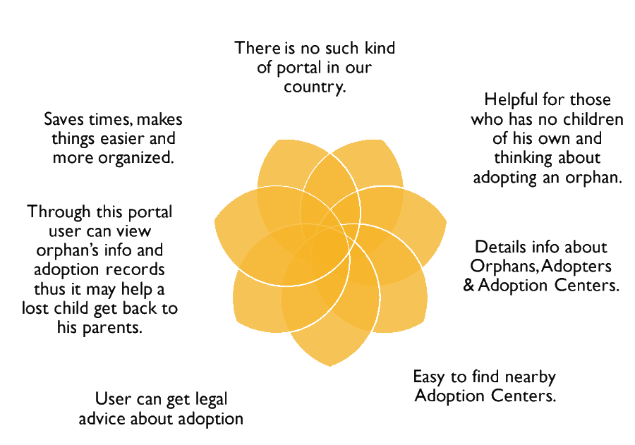

1. **FEATURES**

**User:**

* Easily Search Child
* Find Nearby Adoption Center
* Can Fixt Appointment With Adoption Center
* Can View Previous Record

**Adoption Center:**

* ADD Children
* Update or Remove Child
* Can View Previous Report
* Accept Reject Appoinment
* Can View All Appoinment List
* Can View Adopted history

**Authority:**

* Can Add Adoption Information
* Can View All Adopted Childrens List
* Can View All Users Information
* Can View All Centers Information
* Can View All Childs Information

**CONCLUSION:**

We hope this portal will be helpful for it’s users as well as the orphan children and make child adoption process more easier than before.