***Age****[Age Range: 1 to 150]*

Corresponding Schema Element:   
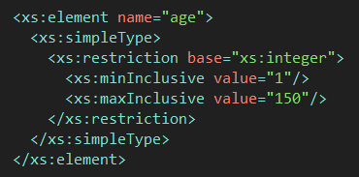

**Enter your age:** 35

***Browser****[Valid Values: Internet Explorer, Firefox, and Safari]*

Corresponding Schema Element:  
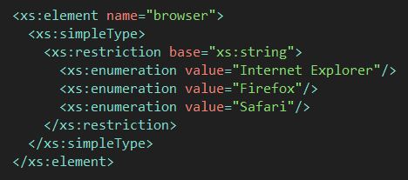

**Select your web browser:** Internet Explorer

***Initials****[Valid Values: 3 Uppercase Letters A-Z]*

Corresponding Schema Element: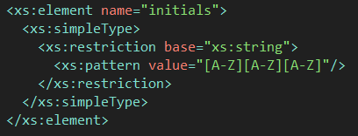

**Enter Initials:** MRS