PUBLIC HEALTH WHOLE GENOME SEQUENCING ANALYSIS REPORT

Antimicrobial Resistance Outbreak Report

| REPORT DATE | PROJECT NAME | PREPARED BY |
| --- | --- | --- |
| 2021-11-08 | AR Report Example | Abigail Shockey |

# SUMMARY

This report outlines the relationship between a set of samples collected at a facility described by the outbreak ID: 1337. A set of external OXA-24 samples were also included to provide context to the outbreak.

# SAMPLES

|  |  |  |  |  |  |  |  |  |
| --- | --- | --- | --- | --- | --- | --- | --- | --- |
| **Lab ID** | **Isolate Collection Date** | **Local ID** | **Species ID** | **Specimen Source** | **MLST** | **Resistance Genes** | **Comments** | **TreeGroup** |
| S1 | 6/2/2049 | WGS3213 | Acinetobacter baumannii | Skin | PubMLST ST406 (Pasteur) | blaOXA-24 |  | OXA-24 |
| S2 | 6/18/2049 | WGS3214 | Acinetobacter baumannii | Skin | PubMLST ST2 (Pasteur) | blaOXA-72 | Outbreak ID: 1337 | OXA-72 |
| S3 | 5/38/2049 | WGS3215 | Acinetobacter baumannii | Skin | PubMLST ST2 (Pasteur) | blaOXA-72 | Outbreak ID: 1337 | OXA-72 |
| S4 | 5/36/2049 | WGS3216 | Acinetobacter baumannii | Blood | PubMLST ST406 (Pasteur) | blaOXA-24 |  | OXA-24 |
| S5 | 6/13/2049 | WGS3217 | Acinetobacter baumannii | Skin | PubMLST ST406 (Pasteur) | blaOXA-24 |  | OXA-24 |
| S6 | 6/15/2049 | WGS3218 | Acinetobacter baumannii | Skin | PubMLST ST2 (Pasteur) | blaOXA-72 | Outbreak ID: 1337 | OXA-72 |
| S7 | 5/25/2049 | WGS3219 | Acinetobacter baumannii | Floor Drain | PubMLST ST2 (Pasteur) | blaOXA-72 | Environmental Sample obtained from outbreak site. | OXA-72 |

# RELATEDNESS

## HEATMAP

The number of Single Nucleotide Polymorphisms (SNPs) between each sample is shown on the heatmap below. There is no established rule for determining how many SNPs are needed to classify an outbreak.Generally it is best to look for patterns in the data between the SNP data and the core-genome tree. The samples are ordered based on the euclidean distance between each sample.

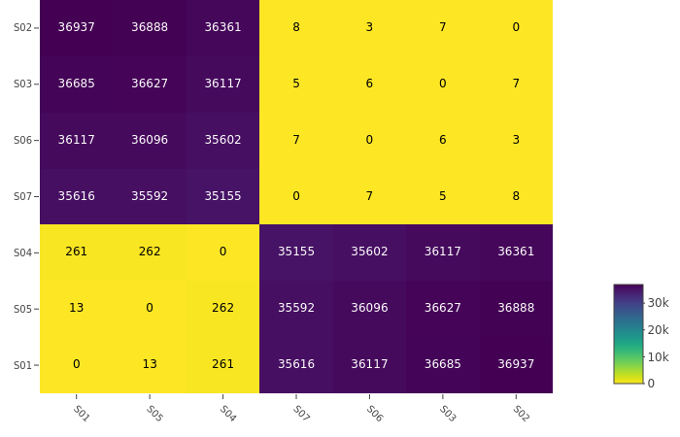

## PHYLOGENETIC TREE

The core-genome phylogenetic tree examines the genetic diversity across the core set of genes shared across all samples in the in the analysis. Related samples will generally share a recent common ancestor and a small amount of horizontal distance on the tree. The number of core-genes provides an indication of how diverse the sample is. A low number of core genes suggests the dataset is genetically diverse, or an outlier is present in the dataset.

Core Genes Identified: 2994

Total Genes Identified: 4574

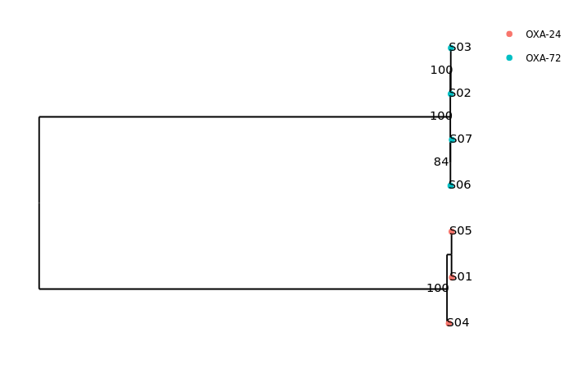

# AR GENE SUMMARY

This table shows a summary of all genes detected using the NCBI AMR Finder Plus detection tool.

|  |  |  |  |
| --- | --- | --- | --- |
| **Sample** | **Gene** | **Coverage** | **Identity** |
| S1 | blaADC | 100 | 98 |
| S1 | ant(3'')-IIa | 100 | 100 |
| S1 | ant(2'')-Ia | 100 | 100 |
| S1 | aadA2 | 100 | 100 |
| S1 | qacEdelta1 | 100 | 100 |
| S1 | sul1 | 100 | 100 |
| S1 | blaOXA | 100 | 99 |
| S1 | blaOXA-24 | 100 | 100 |
| S2 | blaOXA-66 | 100 | 100 |
| S2 | tet(B) | 100 | 100 |
| S2 | aph(6)-Id | 100 | 100 |
| S2 | aph(3'')-Ib | 100 | 100 |
| S2 | blaADC-30 | 100 | 100 |
| S2 | ant(3'')-IIa | 100 | 99 |
| S2 | qacEdelta1 | 100 | 100 |
| S2 | aadA5 | 100 | 100 |
| S2 | dfrA17 | 100 | 100 |
| S2 | msr(E) | 100 | 100 |
| S2 | armA | 100 | 100 |
| S2 | mph(E) | 100 | 100 |
| S2 | sul1 | 100 | 100 |
| S2 | aac(3)-I | 100 | 100 |
| S2 | aacA16 | 100 | 100 |
| S2 | blaOXA-72 | 100 | 100 |
| S3 | blaOXA-66 | 100 | 100 |
| S3 | blaADC-30 | 100 | 100 |
| S3 | ant(3'')-IIa | 100 | 99 |
| S3 | tet(B) | 100 | 100 |
| S3 | aph(6)-Id | 100 | 100 |
| S3 | aph(3'')-Ib | 100 | 100 |
| S3 | mph(E) | 100 | 100 |
| S3 | dfrA17 | 100 | 100 |
| S3 | qacEdelta1 | 100 | 100 |
| S3 | sul1 | 100 | 100 |
| S3 | armA | 100 | 100 |
| S3 | aadA5 | 100 | 100 |
| S3 | msr(E) | 100 | 100 |
| S3 | aac(3)-I | 100 | 100 |
| S3 | sul2 | 100 | 100 |
| S3 | aacA16 | 100 | 100 |
| S3 | blaOXA-72 | 100 | 100 |
| S4 | blaADC | 100 | 98 |
| S4 | ant(3'')-IIa | 100 | 100 |
| S4 | blaOXA-829 | 100 | 100 |
| S4 | ant(2'')-Ia | 100 | 100 |
| S4 | aadA2 | 100 | 100 |
| S4 | qacEdelta1 | 100 | 100 |
| S4 | sul1 | 100 | 100 |
| S4 | msr(E) | 100 | 100 |
| S4 | mph(E) | 100 | 100 |
| S4 | armA | 75 | 100 |
| S4 | aph(3')-Ia | 100 | 99 |
| S4 | aph(3')-VIa | 100 | 96 |
| S4 | blaOXA-24 | 100 | 100 |
| S5 | blaADC | 100 | 98 |
| S5 | ant(3'')-IIa | 100 | 100 |
| S5 | ant(2'')-Ia | 100 | 100 |
| S5 | aadA2 | 100 | 100 |
| S5 | qacEdelta1 | 100 | 100 |
| S5 | sul1 | 100 | 100 |
| S5 | blaOXA | 100 | 99 |
| S5 | blaOXA-24 | 100 | 100 |
| S6 | blaOXA-66 | 100 | 100 |
| S6 | blaADC-30 | 100 | 100 |
| S6 | tet(B) | 100 | 100 |
| S6 | aph(6)-Id | 100 | 100 |
| S6 | aph(3'')-Ib | 100 | 100 |
| S6 | ant(3'')-IIa | 100 | 99 |
| S6 | mph(E) | 100 | 100 |
| S6 | dfrA17 | 100 | 100 |
| S6 | qacEdelta1 | 100 | 100 |
| S6 | sul1 | 100 | 100 |
| S6 | armA | 100 | 100 |
| S6 | aadA5 | 100 | 100 |
| S6 | msr(E) | 100 | 100 |
| S6 | aac(3)-I | 100 | 100 |
| S6 | sul2 | 100 | 100 |
| S6 | aacA16 | 100 | 100 |
| S6 | blaOXA-72 | 100 | 100 |
| S7 | blaOXA-66 | 100 | 100 |
| S7 | ant(3'')-IIa | 100 | 99 |
| S7 | blaADC-30 | 100 | 100 |
| S7 | aph(3'')-Ib | 100 | 100 |
| S7 | aph(6)-Id | 100 | 100 |
| S7 | tet(B) | 100 | 100 |
| S7 | qacEdelta1 | 100 | 100 |
| S7 | aadA5 | 100 | 100 |
| S7 | dfrA17 | 100 | 100 |
| S7 | msr(E) | 100 | 100 |
| S7 | armA | 100 | 100 |
| S7 | mph(E) | 100 | 100 |
| S7 | sul1 | 100 | 100 |
| S7 | aacA16 | 100 | 100 |
| S7 | aac(3)-I | 100 | 100 |
| S7 | sul2 | 100 | 100 |
| S7 | blaOXA-72 | 100 | 100 |

# ADDITIONAL ANALYSES

This table shows the MLST scheme(s) idenitfied for each sample using mlst (https://github.com/tseemann/mlst):

|  |  |
| --- | --- |
| **Sample** | **MLST Scheme** |
| S1 | PubMLST ST406 (Pasteur) |
| S2 | PubMLST ST2 (Pasteur) |
| S3 | PubMLST ST2 (Pasteur) |
| S4 | PubMLST ST406 (Pasteur) |
| S5 | PubMLST ST406 (Pasteur) |
| S6 | PubMLST ST2 (Pasteur) |
| S7 | PubMLST ST2 (Pasteur) |

# METHODS

The figures shown here were generated using sequence data processed with the Dryad v3.0.0 (https://github.com/wslh-bio/dryad) and Spriggan v1.0.0 (https://github.com/wslh-bio/spriggan) analysis pipelines. If you have questions about this report please contact abigail.shockey@slh.wisc.edu.

# DISCLAIMER

The information included in this report should only be used to support infection prevention measures. This report should not be used to guide treatment decisions, nor should it be included in the patient record. Whole-genome sequencing analysis is a rapidly evolving technology. Whole-genome sequencing and SNP analysis will continue to be adjusted and refined over time due to the varied nature of bacterial genomes, limitations on available reference genomes and continual assessment of the inclusion of mobile genetic elements in this analysis. These results represent the most advanced method currently available for genome comparisons.