# 1 P2S协议

Peer to Stun的缩写，是打洞及NAT探测协议协议，STUN，英文全称为" Simple Traversal of User Datagram Protocol (UDP) Through Network Address Translators (NATs) "，几种常见的nat类型这里不多解析，参见文档“p2p业务说明_补充.docx”的”3.2 NAT知识“，本P2P系统中nat类型的定义如表所示。

NAT类型

|  |  |
| --- | --- |
| NAT类型 | 类型解释 |
| nat1 | 完全透明NAT(Full |
| nat2 | 受限NAT(Restricted |
| nat3 | 端口受限NAT(Port |
| nat4 | 对称NAT(Symmetric |
| nat5 | 无法接收外部包 |
| nat6 | 末知类型 |

## 1.1 NAT类型探测

### 1.1.1 探测条件

1）stun server由两个不同IP地址的服务器（公网ip）对组成，设A、B服务器。

2）A、B分别绑定两个端口：S1(IP1:Port1)，S2(IP1:Port2)，S3(IP2:Port1)，S4(IP2:Port2)

协议：

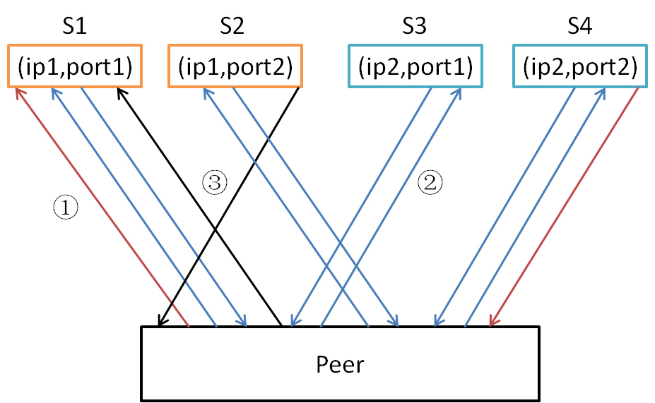

探测NAT类型

### 1.1.2探测流程

1）检测客户端是否有能力进行UDP通信及客户端是否位于NAT之后，与S1建立UDP通信，若有数据接收，说明防火墙可能过，确定返回的ip及port与本地的ip及port是否相等，若相等则客户端是公网ip，不在NAT之后，否则下一步；

2）检测是否是NAT1（Full Cone NAT），S1发，使用S4发，若收到数据则为NAT1，否则下一步；

3）检测是否是NAT4（Symmetric　NAT），S1，S2，S3，S4发若收到的ip及port有一对不同则为NAT4；

4）检测是否NAT2，S1发，S2回，若收到则为NAT2，否则为NAT3。

代码中探测及响应的过程如下：

1.req-binding-addr / rsp-binding-addr ：获取本地绑定的外网IP：PORT

2.req-stuns-addr / rsp-stuns-addr ：获取stun server :A、B的信息S1,S4

3.req-full-conn / rsp-full-conn ：探NAT1。 发S1，S4回，收到即是NAT1

4.req-symmetric / rsp-symmetric ：探NAT4。 发S1、S3，S1、S3回IP：PORT，不相同即是NA4

5.req-restricted-conn /rsp-restricted-conn ：探NAT2。发S1、S2回，收到即NA2，不然为NAT3

### 1.1.3 NAT的连通性

NAT类型可连接通性匹配

|  |  |  |  |  |
| --- | --- | --- | --- | --- |
|  | nat1 | nat2 | nat3 | nat4 |
| nat1 | 1 | 1 | 1 | 1 |
| nat2 | 1 | 1 | 1 | 1 |
| nat3 | 1 | 1 | 1 | 0 |
| nat4 | 1 | 1 | 0 | 0 |

表中列和行分别表示请求打洞和被连接者NAT类型，”1“表示可以打洞成功，”0“表示不能打洞成功

DownloadSource中"g_ConnectionType"定义的连接类型

其中1维为自己nat类型，2维为目标类型，标灰的是外网ip

|  |  |  |  |  |  |  |  |
| --- | --- | --- | --- | --- | --- | --- | --- |
|  |  | **Nat1** | **Nat2** | **Nat3** | **Nat4** | **Nat5** | **Nat6** |
|  | **TCP_CONN** | **TCP_TURN** | **TCP_TURN** | **TCP_TURN** | **TCP_TURN** | **TCP_TURN** | **UNUSABLE** |
| **Nat1** | **TCP_CONN** | **UDP_CONN** | **UDP_CONN** | **UDP_CONN** | **UDP_CONN** | **UNUSABLE** | **UNUSABLE** |
| **Nat2** | **TCP_CONN** | **UDP_CONN** | **UDP_CONN** | **UDP_CONN** | **UDP_CONN** | **UNUSABLE** | **UNUSABLE** |
| **Nat3** | **TCP_CONN** | **UDP_CONN** | **UDP_CONN** | **UDP_CONN** | **UNUSABLE** | **UNUSABLE** | **UNUSABLE** |
| **Nat4** | **TCP_CONN** | **UDP_CONN** | **UDP_CONN** | **UNUSABLE** | **UNUSABLE** | **UNUSABLE** | **UNUSABLE** |
| **Nat5** | **TCP_CONN** | **UNUSABLE** | **UNUSABLE** | **UNUSABLE** | **UNUSABLE** | **UNUSABLE** | **UNUSABLE** |
| **Nat6** | **TCP_CONN** | **UDP_CONN** | **UDP_CONN** | **UDP_CONN** | **UNUSABLE** | **UNUSABLE** | **UNUSABLE** |

|  |  |
| --- | --- |
| 连接类型 |  |
| TCP_CONN | TCP连接 |
| TCP_TURN | TCP反连接 |
| UDP_CONN | UDP连接 |
| UNUSABLE | 不可用 |
| UNKNOW | 未知类型 |

SourceService中

//一维下标:自身的nat类型，二维下标:对方nat类型

//7表未知类型,自己是6的,当自己是3类型，即只返回0，1，2，3

static char g_ConnectionType[7][7]，标灰的是外网ip

|  |  |  |  |  |  |  |  |
| --- | --- | --- | --- | --- | --- | --- | --- |
|  |  | Nat1 | Nat2 | Nat3 | Nat4 | Nat5 | Nat6 |
|  | 1 | 1 | 1 | 1 | 1 | 1 | 0 |
| Nat1 | 1 | 1 | 1 | 1 | 1 | 0 | 0 |
| Nat2 | 1 | 1 | 1 | 1 | 1 | 0 | 0 |
| Nat3 | 1 | 1 | 1 | 1 | 0 | 0 | 0 |
| Nat4 | 1 | 1 | 1 | 0 | 0 | 0 | 0 |
| Nat5 | 1 | 0 | 0 | 0 | 0 | 0 | 0 |
| Nat6 | 1 | 1 | 1 | 1 | 0 | 0 | 0 |

## 1.2 协议命令定义及数据结构

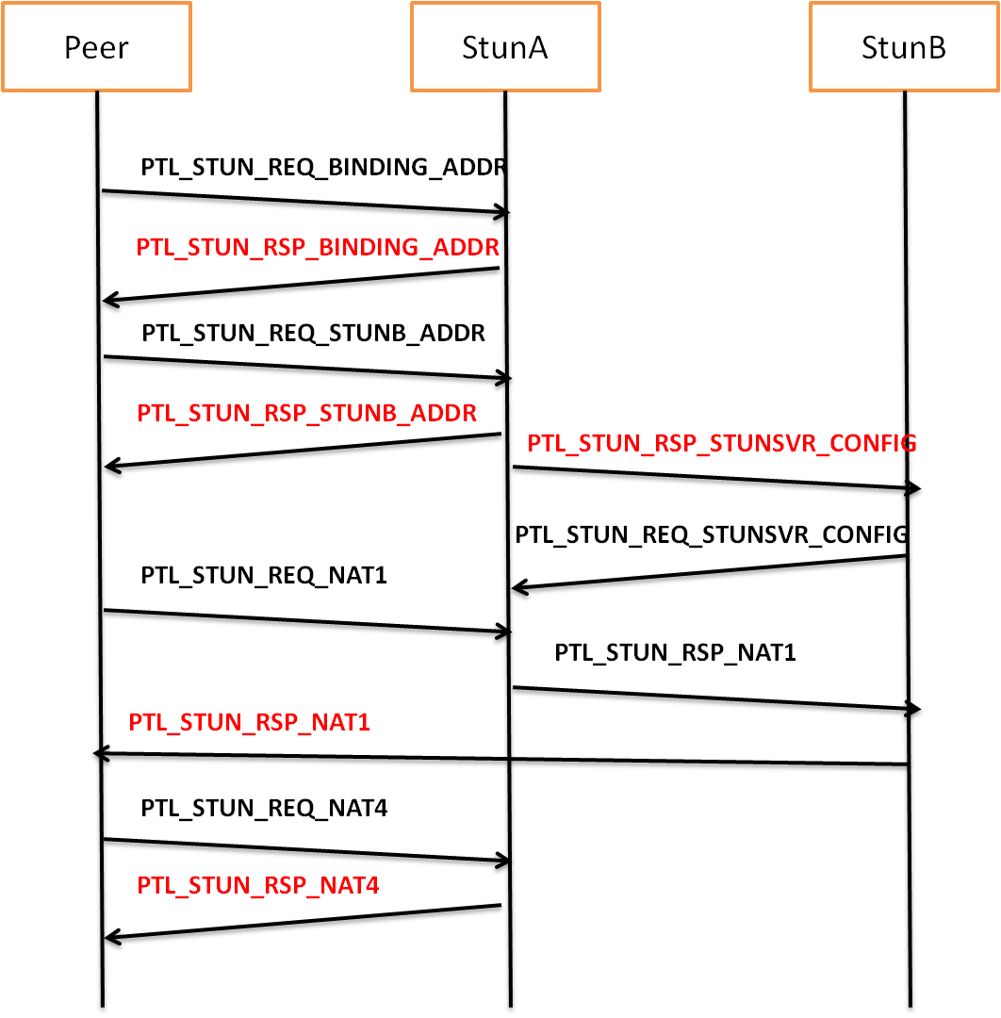

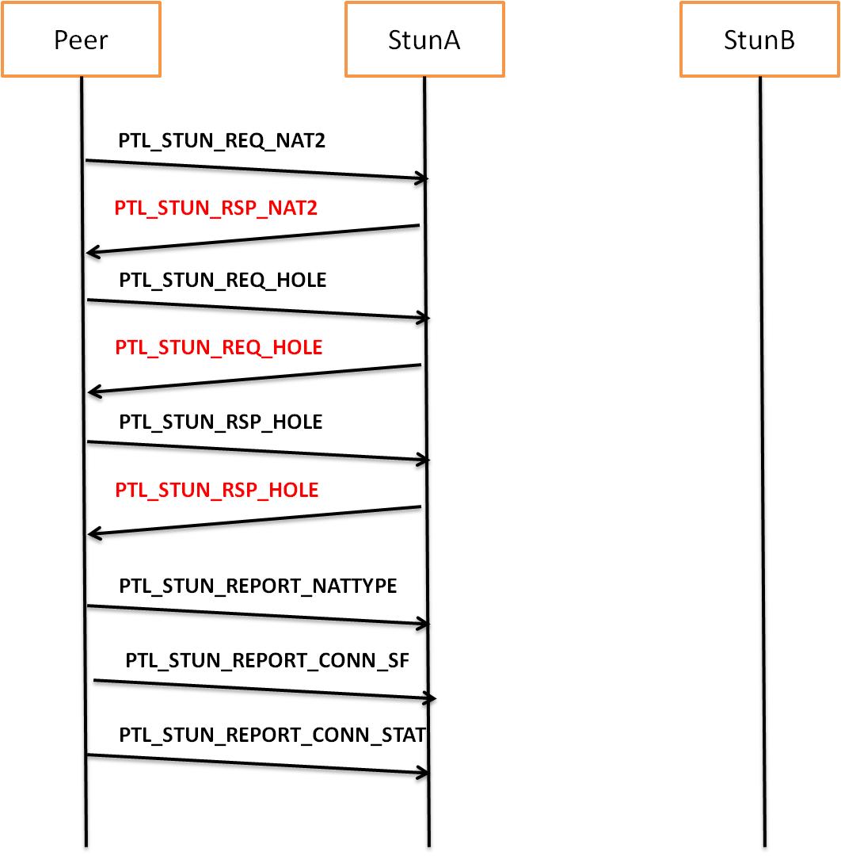

### 1.2.1 打洞命令定义

#define PTL_STUN_HEAD_STX 0x8f

Stun通信判定NAT类型命令：

PTL_STUN_REQ_UID //获取uid,用于后续命令的认证

PTL_STUN_RSP_UID //返回uid,用于后续命令的认证

PTL_STUN_REQ_BINDING_ADDR //获取绑定IP：PORT

PTL_STUN_RSP_BINDING_ADDR //

PTL_STUN_REQ_STUNB_ADDR, //获取S3(SBIP:P1)

PTL_STUN_RSP_STUNB_ADDR //

PTL_STUN_REQ_STUNSVR_CONFIG //获取SB的配置

PTL_STUN_RSP_STUNSVR_CONFIG //

PTL_STUN_REQ_NAT1, //测NAT1

PTL_STUN_RSP_NAT1, //

PTL_STUN_REQ_NAT4 //测NAT4

PTL_STUN_RSP_NAT4 //

PTL_STUN_REQ_NAT2 //测NAT2

PTL_STUN_RSP_NAT2 //

PTL_STUN_REQ_HOLE //请求目标发NAT_HOLE包,stun 转发给另一端

PTL_STUN_RSP_HOLE //请求目标发NAT_HOLE包,stun 转发给另一端

//统计命令

PTL_STUN_REPORT_NATTYPE //上报NAT类型

PTL_STUN_REPORT_CONN_SF //上报连接成功失败

PTL_STUN_REPORT_CONN_STAT //上报

Stun打洞命令包类型：

UDPS_CONN_CMD_NAT //打洞包

UDPS_CONN_CMD_CONN //请求新连接包

UDPS_CONN_CMD_OK //连接就绪包

UDPS_CONN_CMD_LIVE //通道保活包

UDPS_CONN_CMD_CLOSE //断开通道包

UDPS_CONN_CMD_DATA //通道数据包

UDPS_CONN_CMD_TESTSPEED_DATA //测速数据包

UDPS_CONN_CMD_TESTSPEED_ACK //测速回应包

### 1.2.2 打洞定义的数据结构

typedef struct tagPTL_STUN_Header

{

uchar stx; //

uchar cmd; //命令值

uint32 uid; //

uint32 uid_checksum;

tagPTL_STUN_Header(void):stx(PTL_STUN_HEAD_STX),cmd(0),uid(0),uid_checksum(0){}

}PTL_STUN_Header_t;

//BindingAddr

//typedef struct tagPTL_STUN_ReqBindingAddr

//{

//}PTL_STUN_ReqBindingAddr_t;

typedef struct tagPTL_STUN_RspBindingAddr

{

uint32 eyeIP;

uint16 eyePort;

}PTL_STUN_RspBindingAddr_t;

//StunsAddr

//typedef struct tagPTL_STUN_ReqStunBAddr

//{

//}PTL_STUN_ReqStunBAddr_t;

typedef struct tagPTL_STUN_RspStunBAddr

{

uint32 stunB_ip;

uint16 stunB_port1;

uint32 stunC_ip;

uint16 stunC_port1;

}PTL_STUN_RspStunBAddr_t;

//StunsConfig

//typedef struct tagPTL_STUN_ReqStunsvrConfig

//{

//}PTL_STUN_ReqStunsvrConfig_t;

typedef struct tagPTL_STUN_RspStunsvrConfig

{

uint32 eyeIP;

uint16 eyePort;

uint32 accept_ip;

uint16 accept_port1;

uint16 accept_port2;

uint32 stunB_ip;

uint16 stunB_port1;

uint16 stunB_port2;

uint32 stunC_ip;

uint16 stunC_port1;

}PTL_STUN_RspStunsvrConfig_t;

//Nat1

//typedef struct tagPTL_STUN_ReqNat1

//{

//}PTL_STUN_ReqNat1_t;

typedef struct tagPTL_STUN_RspNat1

{

uint32 des_nip; //stun server端用于转发，client端忽略

uint16 des_nport; //

}PTL_STUN_RspNat1_t;

////Nat4

//typedef struct tagPTL_STUN_ReqNat4

//{

//}PTL_STUN_ReqNat4_t;

typedef struct tagPTL_STUN_RspNat4

{

uint32 eyeIP;

uint32 eyePort;

}PTL_STUN_RspNat4_t;

//Nat2

//typedef struct tagPTL_STUN_ReqNat2

//{

//}PTL_STUN_ReqNat2_t;

typedef struct tagPTL_STUN_RspNat2

{

uint32 des_nip; //stun server端用于转发，client端忽略

uint16 des_nport; //

}PTL_STUN_RspNat2_t;

//Hole

typedef struct tagPTL_STUN_ReqHole

{

uint32 connid; //标识连接号，回复同样标识以确定是哪个连接发出的包

uint32 des_nip; //呼叫des_nip:des_nport 发NAT_TEST包给src_nip:src_nport

uint16 des_nport; //

uint32 src_nip; //代表发起连接方

uint16 src_nport;

}PTL_STUN_ReqHole_t;

typedef struct tagPTL_STUN_RspHole

{

uint32 connid; //标识连接号，回复同样标识以确定是哪个连接发出的包

uint32 des_nip; //回复，

uint16 des_nport; //

uint32 src_nip; //代表发起连接的另一方

uint16 src_nport;

}PTL_STUN_RspHole_t;

//report nattype

typedef struct tagPTL_STUN_ReportNattype

{

uchar nattype;

}PTL_STUN_ReportNattype_t;

//conn sf信息只有发起方上报

//report conn sf

typedef struct tagPTL_STUN_ReportConnSF

{

//ip:port由stunsvr自己获取

uchar bsucceed;

uchar src_nattype;

uint32 des_nip;

uint16 des_nport;

uchar des_nattype;

}PTL_STUN_ReportConnSF_t;

//conn 信息只有发送数据比接收数据多时写记录

//report conn stat

typedef struct tagPTL_STUN_ReportConnStat

{

//ip:port由stunsvr自己获取

uchar src_nattype;

uint32 des_nip; //

uint16 des_nport; //

uchar des_nattype;

uint32 sizeKB; //有效传输总数据量KB

uint32 sec; //传输总秒数

uint32 ttlMS; //只取最后的记录

uint32 send_num; //总共发出多少个有效包

uint32 resend_num; //总共重复发了多少个包

uint32 resend_timeo_num; //总共超时重发出多少个包

uint32 other_rerecv_num; //对方重复收了多少个包

}PTL_STUN_ReportConnStat_t;

# 2 P2P协议

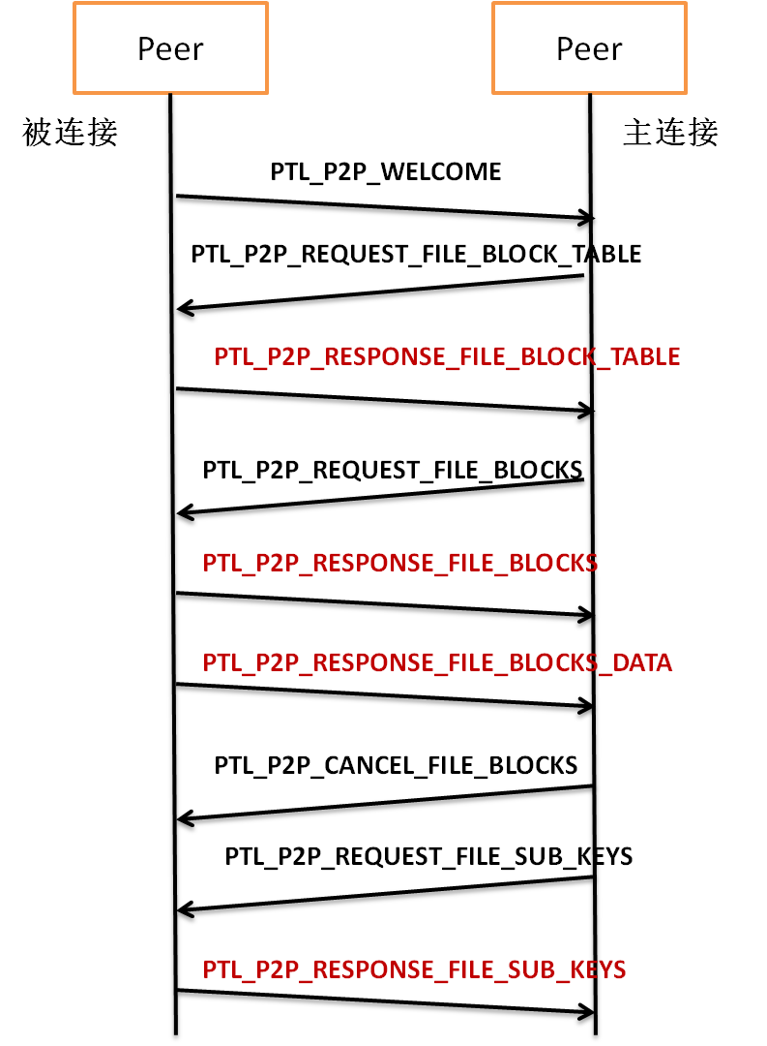

### 2.1协议命令定义

PTL_P2P_WELCOME

PTL_P2P_RELEASE

PTL_P2P_REQUEST_FILE_BLOCK_TABLE

PTL_P2P_RESPONSE_FILE_BLOCK_TABLE

PTL_P2P_REQUEST_FILE_BLOCKS

PTL_P2P_RESPONSE_FILE_BLOCKS

PTL_P2P_RESPONSE_FILE_BLOCKS_DATA

PTL_P2P_CANCEL_FILE_BLOCKS

PTL_P2P_REQUEST_FILE_SUB_KEYS

PTL_P2P_RESPONSE_FILE_SUB_KEYS

### 2.2协议命令定义的数据结构

**PTL_P2P_WELCOME**

typedef struct tagPTL_P2P_Welcome

{

uint32 ver; //版本

uint32 sessionID; //反连接时确定对方，uid也可以

char utype; //user type,用户类型,TCP,UDP,HTTP

char ntype; //统计时使用

char turn; //识别是否为返连接，1为返连接

}PTL_P2P_Welcome

**PTL_P2P_REQUEST_FILE_BLOCK_TABLE**

typedef struct tagPTL_P2P_RequestFileBlockTable

{

fhash_t fhash; //请求url的hash值

uint32 blockSize; //允许请求不同块尺寸的共享

uint32 startBufI; //表示table表中的第几个字节起中的数据,即每8块1字节,startBufI*8表示实际的绝对索引号

uint32 maxnum; //字节数，不是块数，一次不能要超过1024块

}PTL_P2P_RequestFileBlockTable;

**PTL_P2P_RESPONSE_FILE_BLOCK_TABLE**

typedef struct tagPTL_P2P_ResponseFileBlockTable

{

uint32 result; //-1:没有文件，0：下载中，有块表，1：已经完成

fhash_t fhash;

uint64 fsize;

uint32 blockSize;

uint32 startBufI; //表示table表中的第几个字节起中的数据

uint32 num;

char tableBuf[1024]; //32000*100KB=3.200,000KB ; 即100K每块的话，可以表示3.2G大小文件了

}PTL_P2P_ResponseFileBlockTable;

**PTL_P2P_REQUEST_FILE_BLOCKS**

typedef struct tagPTL_P2P_RequestFileBlocks

{

fhash_t fhash;

uint32 blockSize;

uint32 num; //后面2个数组的有效大小

uint32 indexs[32]; //块号

uint32 offsets[32]; //块内偏移

}PTL_P2P_RequestFileBlocks;

**PTL_P2P_RESPONSE_FILE_BLOCKS**

typedef struct tagPTL_P2P_ResponseFileBlocks

{

fhash_t fhash;

uint32 blockSize;

uint32 num; //后面2个数组的有效大小

uint32 indexs[32]; //块号

uint32 blockState[32]; //0:缺少，1：存在

}PTL_P2P_ResponseFileBlocks;

**PTL_P2P_RESPONSE_FILE_BLOCKS_DATA**

typedef struct tagPTL_P2P_ResponseFileBlocksData

{

fhash_t fhash;

uint32 blockSize;

uint32 blockIndex;

uint32 offset;

uint32 size;

char* data;

}PTL_P2P_ResponseFileBlocksData;

**PTL_P2P_CANCEL_FILE_BLOCKS**

typedef struct tagPTL_P2P_CancelFileBlocks

{

fhash_t fhash;

uint32 blockSize;

uint32 num; //后面2个数组的有效大小

uint32 indexs[32]; //块号

}PTL_P2P_CancelFileBlocks;

**PTL_P2P_REQUEST_FILE_SUB_KEYS**

typedef struct tagPTL_P2P_RequestFileSubKeys

{

fhash_t fhash;

uint32 blockSize; //这里的分块大小与下载block的大小不一定一样，但最好是下载block的整倍数

uint32 num;

uint32 indexs[1024];

}PTL_P2P_RequestFileSubKeys;

**PTL_P2P_RESPONSE_FILE_SUB_KEYS**

typedef struct tagPTL_P2P_ResponseFileSubKeys

{

uint32 result;

fhash_t fhash;

uint32 blockSize; //这里的分块大小与下载block的大小不一定一样，但最好是下载block的整倍数

uint32 num;

uint32 indexs[1024];

uint32 keys[1024]; //子块值为一个4位整数

}PTL_P2P_ResponseFileSubKeys;

# 3.P2T协议

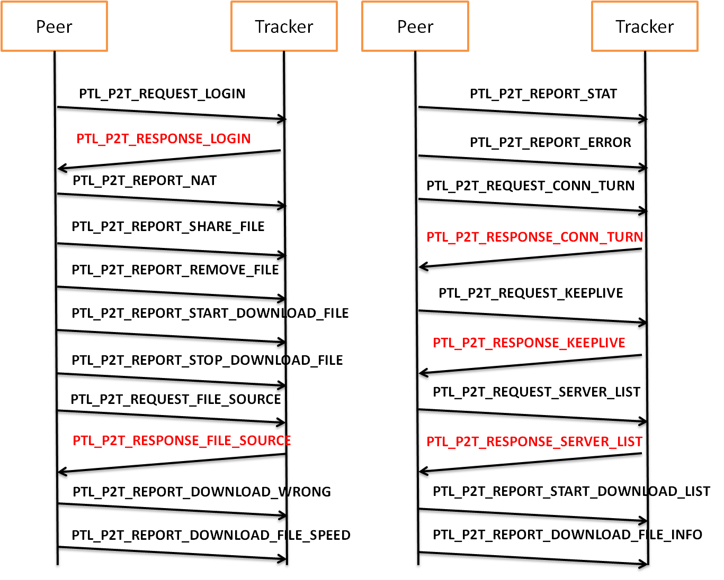

### 3.1协议命令定义

PTL_P2T_REQUEST_LOGIN

PTL_P2T_RESPONSE_LOGIN

PTL_P2T_REPORT_LOGOUT

PTL_P2T_REPORT_NAT

PTL_P2T_REPORT_SHARE_FILE

PTL_P2T_REPORT_REMOVE_FILE

PTL_P2T_REPORT_START_DOWNLOAD_FILE

PTL_P2T_REPORT_STOP_DOWNLOAD_FILE

PTL_P2T_REQUEST_FILE_SOURCE

PTL_P2T_RESPONSE_FILE_SOURCE

PTL_P2T_REPORT_DOWNLOAD_WRONG

PTL_P2T_REPORT_DOWNLOAD_FILE_SPEED

PTL_P2T_REPORT_STAT

PTL_P2T_REPORT_ERROR

PTL_P2T_REQUEST_CONN_TURN

PTL_P2T_RESPONSE_CONN_TURN

PTL_P2T_REQUEST_KEEPLIVE

PTL_P2T_RESPONSE_KEEPLIVE

PTL_P2T_REQUEST_SERVER_LIST

PTL_P2T_RESPONSE_SERVER_LIST

PTL_P2T_REPORT_DOWNLOAD_FILE_INFO

PTL_P2T_REPORT_START_DOWNLOAD_LIST

PTL_P2T_REQUEST_START_DOWNLOAD_LIST

PTL_P2T_REQUEST_STOP_DOWNLOAD_LIST

PTL_P2T_REPORT_DOWNLOADLIST_MAXNUM

### 3.2协议命令定义的数据结构

//size=56B

typedef struct tagPTL_P2T_FileInfo

{

fhash_t fhash;

uint64 fsize; //无穷大为-1，用于直播

}PTL_P2T_FileInfo;

//size=38B

typedef struct tagPTL_P2T_PeerInfo

{

uint32 trackID; //指定属于哪个tracker,用于支持多tracker级连保留

uint32 sessionID; //tracker使用的sessionID,直接指tracker上面的索引

char utype; //USER 类型 UT_CLIENT...

char ntype; //nat类型0~6,6为未知

uint32 menu; //菜单功能位:低0位共享支持,低1位TCP支持,低2位UDP支持

uint32 tcpLocalIP;

uint32 tcpRealIP;

uint16 tcpLocalPort;

uint16 tcpRealPort;

uint32 udpLocalIP;

uint32 udpRealIP;

uint16 udpLocalPort;

uint16 udpRealPort;

}PTL_P2T_PeerInfo;

//size=38B+PUIDLEN = 70B

typedef struct tagPTL_P2T_ServerInfo

{

puid_t uid;

uint32 ver;

char ntype;

char utype; // user type

uint32 menu;

uint32 sessionID;

uint32 beginTime;

uint32 sourceNum;

uint32 tcpRealIP;

uint32 udpRealIP;

uint16 tcpRealPort;

uint16 udpRealPort;

char reserve[4];

}PTL_P2T_ServerInfo;

////peer to tracker

#define MENU_VIP 0x8

typedef struct tagPTL_P2T_RequestLogin

{

puid_t uid; //用户ID

char utype; //用户类型

uint32 menu; //菜单功能位:低0位共享支持,低1位TCP支持,低2位UDP支持,低3位表示是否为VIP

uint32 ver;

uint32 sysver;

uchar mac[6];

}PTL_P2T_RequestLogin;

typedef struct tagPTL_P2T_ResponseLogin

{

sint32 result;

puid_t uid; //用户ID

uint32 trackID;

uint32 trackVer;

uint32 sessionID;

uint32 eyeIP;

char reserve[16];

}PTL_P2T_ResponseLogin;

//空包

//typedef struct tagPTL_P2T_ReportLogout

//{

//}PTL_P2T_ReportLogout;

typedef struct tagPTL_P2T_ReportNat

{

char ntype; //nat类型

uint32 tcpLocalIP;

uint32 tcpRealIP; //网络IP

uint16 tcpLocalPort;

uint16 tcpRealPort;

uint32 udpLocalIP;

uint32 udpRealIP; //网络IP

uint16 udpLocalPort;

uint16 udpRealPort;

}PTL_P2T_ReportNat;

typedef struct tagPTL_P2T_ReportShareFile

{

uint32 num;

PTL_P2T_FileInfo files[20];

}PTL_P2T_ReportShareFile;

typedef struct tagPTL_P2T_ReportRemoveFile

{

uint32 num;

PTL_P2T_FileInfo files[20];

}PTL_P2T_ReportRemoveFile;

typedef struct tagPTL_P2T_ReportStartDownloadFile

{

fhash_t fhash;

}PTL_P2T_ReportStartDownloadFile;

typedef struct tagPTL_P2T_ReportStopDownloadFile

{

fhash_t fhash;

}PTL_P2T_ReportStopDownloadFile;

typedef struct tagPTL_P2T_RequestFileSource

{

fhash_t fhash;

uint32 maxnum;

}PTL_P2T_RequestFileSource;

typedef struct tagPTL_P2T_ResponseFileSource

{

uint32 result;

fhash_t fhash;

uint64 fsize;

uint32 urlflag; //使用http url标志

uint32 num;

PTL_P2T_PeerInfo peers[20];

}PTL_P2T_ResponseFileSource;

typedef struct tagPTL_P2T_ReportDownloadWrong

{

fhash_t fhash;

fhash_t fhashnew;

}PTL_P2T_ReportDownloadWrong;

typedef struct tagPTL_P2T_ReportDownloadFileSpeed

{

fhash_t fhash;

uint64 size;

uint32 speed; // KB/s

uint16 cacheTimes; //缓冲数

uint16 dragTimes; //拖动次数

uint32 downSeconds; //下载时长(秒)

uint32 cacheSenconds; //缓冲总时长

char reserve[16];

}PTL_P2T_ReportDownloadFileSpeed;

typedef struct tagPTL_P2T_ReportStat

{

uint32 connSucceedPerNetT[5]; //nat0~nat4各数据

uint32 connFailedPerNetT[5];

uint32 downBytesPerIPT_KB[3]; //iptype_tcp/iptype_udp

uint32 shareBytesPerIPT_KB[3]; //iptype_tcp/iptype_udp

uint32 downBytesPerUserT_KB[6]; //预留可能增加多的类型

uint16 shareSeconds; //统计总共享时间

uint16 downSeconds;

char reserve[16];

}PTL_P2T_ReportStat;

typedef struct tagPTL_P2T_ReportError

{

uint16 dumpTimes;

uint16 downWrongBlocks; //下载错误block数

char reserve[32];

}PTL_P2T_ReportError;

typedef struct tagPTL_P2T_RequestConnTurn

{

uint32 desTrackID;

uint32 desSessionID;

}PTL_P2T_RequestConnTurn;

typedef struct tagPTL_P2T_ResponseConnTurn

{

PTL_P2T_PeerInfo desPeerInfo;

char reserve[4];

}PTL_P2T_ResponseConnTurn;

////keeplive 没有实体数据

//typedef struct tagPTL_P2T_RequestKeeplive

//{

//}PTL_P2T_RequestKeeplive;

////keeplive 没有实体数据

//typedef struct tagPTL_P2T_ResponseKeeplive

//{

//}PTL_P2T_ResponseKeeplive;

typedef struct tagPTL_P2T_RequestServerList

{

int maxnum;

}PTL_P2T_RequestServerList;

typedef struct tagPTL_P2T_ResponseServerList

{

uint32 trackID;

uint32 trackVer;

uint32 userNum;

uint32 beginTime;

uint32 allNum; //可能数量太多，分多包传送

uint32 startNum; //如果不为0，则为子包

uint32 num; //

PTL_P2T_ServerInfo servers[14]; //一次传14个左右,1K以内

}PTL_P2T_ResponseServerList;

typedef struct tagPTL_P2T_ReportDownloadFileInfo

{

char flag; //0表示下载过程中的，1表示下载停止时的记录

fhash_t fhash;

uint64 size;

uint32 speed_KB; // KB/s

uint32 downSeconds; //下载时长(秒)

uint16 cacheTimes; //缓冲数

uint16 dragTimes; //拖动次数

uint32 cacheSenconds; //缓冲总时长

uint16 connSucceedPerNetT[5]; //nat0~nat4各数据

uint16 connFailedPerNetT[5];

uint32 shareBytesPerIPT_KB[2]; //分享了多少数据

uint32 downBytesPerIPT_KB[3]; //iptype_tcp/iptype_udp/iptype_http

uint32 downBytesPerUserT_KB[6]; //client,server,http,center,super

}PTL_P2T_ReportDownloadFileInfo;

typedef struct tagPTL_P2T_ReportStartDownloadList

{

fhash_t fhash;

char url[1024]; //VIP启动时用于通知服务器加速

}PTL_P2T_ReportStartDownloadList;

typedef struct tagPTL_P2T_RequestStartDownloadList

{

fhash_t fhash;

char url[1024];

}PTL_P2T_RequestStartDownloadList;

typedef struct tagPTL_P2T_RequestStopDownloadList

{

fhash_t fhash;

}PTL_P2T_RequestStopDownloadList;

//用于super分配VIP加速节目

typedef struct tagPTL_P2T_ReportDownloadListMaxnum

{

uint32 downloadlist_maxnum;

}PTL_P2T_ReportDownloadListMaxnum;