- Create both tables and insert the required records.
Ans

CREATE TABLE departments (
departmentID INT PRIMARY KEY,
departmentname VARCHAR(50) NOT NULL,
location VARCHAR(50)
)

select * from departments;

CREATE TABLE employees (
employeeID INT PRIMARY KEY,
employeename VARCHAR(100) NOT NULL,
email VARCHAR(100),
salary DECIMAL(10,2),
departmentid INT,
FOREIGN KEY(departmentid)
REFERENCES departments(departmentid),
city VARCHAR(50),
joiningdate DATE
)

Employee table
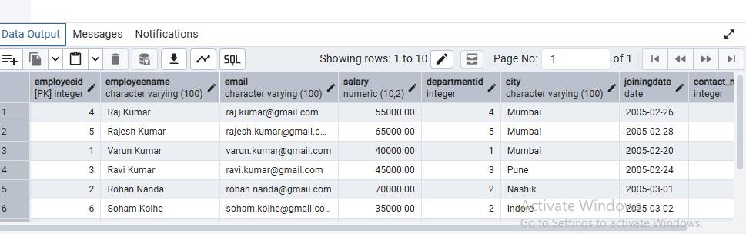

Department table

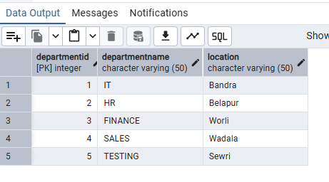

- Display all employees; then display only employee names and salaries.

Ans select employeename,salary from employees;

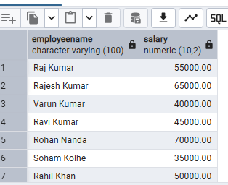

- Find salaries above 50,000; employees in Mumbai; salaries between 30,000 and 70,000; employees in Mumbai or Pune.
Ans

select *from employees where salary>50000 and city='Mumbai';

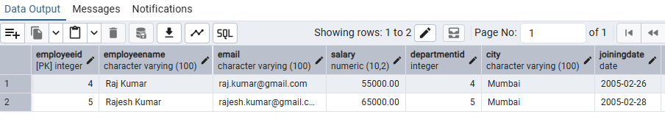
2.
select *from employees where city IN ('Mumbai','Pune') AND salary between 30000 AND 70000;

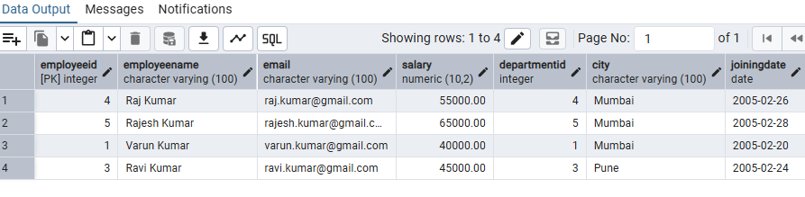

- Display distinct cities; update one salary; delete one employee; sort employees by salary from highest to lowest.

Ans
select DISTINCT city from employees;

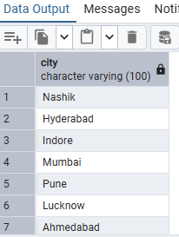

update employees set salary=45000 where employeeid='1';

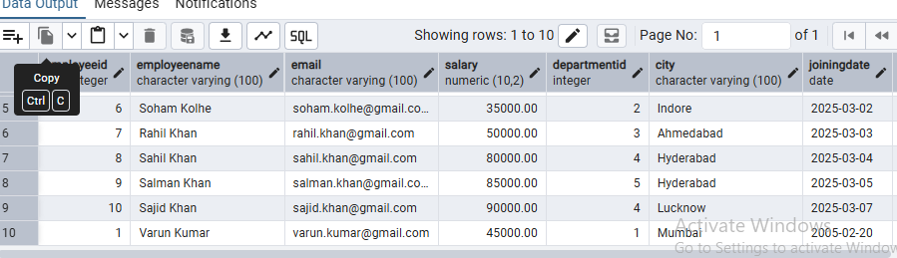

delete from employees where employeeid='6';

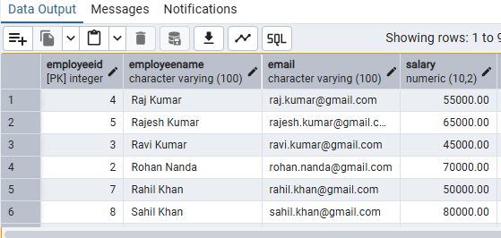

select *from employees ORDER by salary DESC;

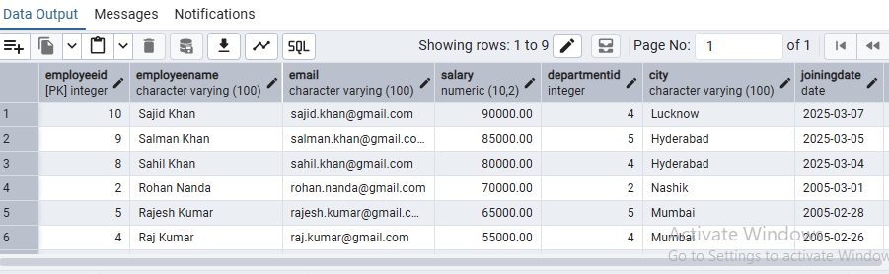

- Count employees by department; show departments having more than two employees.
Ans

select count(*)from departments;

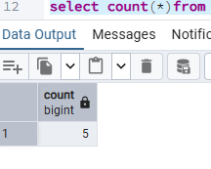

SELECT departmentid, COUNT(*) AS employee_count
FROM employees
GROUP BY departmentid
HAVING COUNT(*) > 2;

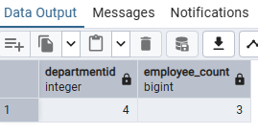

- Find the total, average, minimum and maximum salary.
Ans

select MIN (salary) from employees;

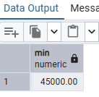

select MAX (salary) from employees;

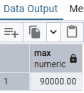

select sum (salary) from employees;

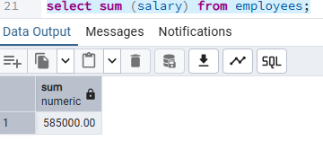

select avg (salary) from employees;

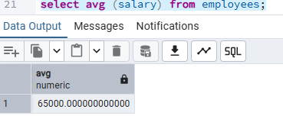

- Use INNER JOIN to show employee name, salary and department; use LEFT JOIN to show all departments and matching employees.

Ans

SELECT
e.employeeid,
e.employeename,
e.email,
e.salary,
e.departmentid,
e.city
FROM employees AS e
INNER JOIN departments AS d
ON e.departmentid = d.departmentid;

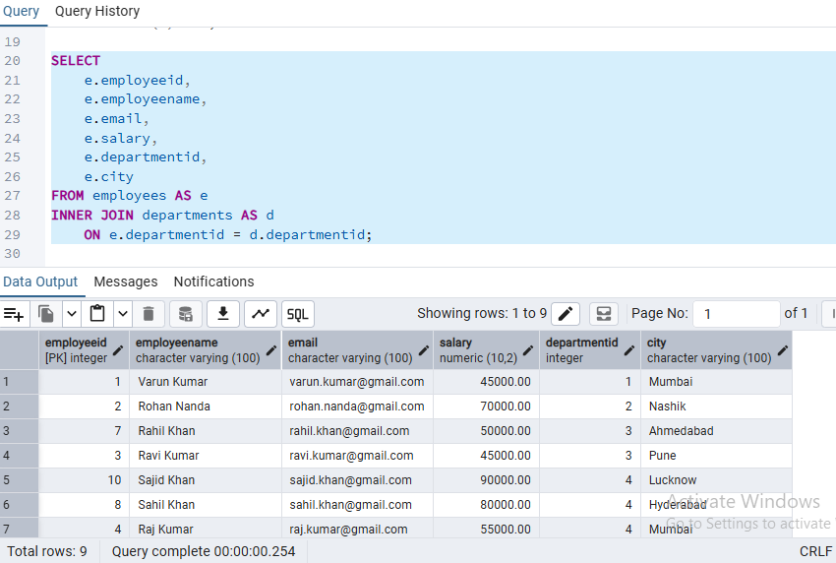

- Demonstrate COMMIT, ROLLBACK and SAVEPOINT using suitable statements.

Ans

BEGIN TRANSACTION;

insert into employees (employeeid,employeename,email,salary,departmentid,city,joiningdate)
values (6,'Soham Kolhe','soham.kolhe@gmail.com',35000,2,'Indore','2025-03-02');

SAVEPOINT employeesCreated;

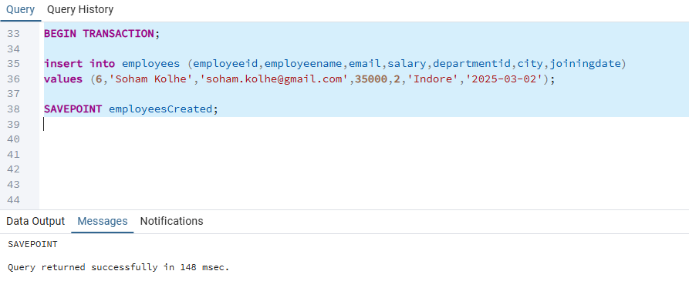

ROLLBACK;

BEGIN TRANSACTION;

insert into employees (employeeid,employeename,email,salary,departmentid,city,joiningdate)
values (6,'Soham Kolhe','soham.kolhe@gmail.com',35000,2,'Indore','2025-03-02');

COMMIT;

