Security Advisory Patches Portal
Visual operations guide (web app, Azure Files, AzCopy)
Generated: 2026-05-05
Replace gray placeholder images with real screenshots in Word (right-click picture → Change Picture).

1. Introduction
This guide complements the technical README in the repository. It walks through three workflows: end users signing into the web application and browsing advisories; administrators managing content in Azure File Share from the Azure portal; and bulk data movement using AzCopy for large migrations.

2. Web application

2.1 Sign in with Asgardeo
Open the portal URL provided by your organization. You are redirected to Asgardeo (or your hosted WSO2 Identity Server / Asgardeo tenant) to authenticate. After a successful login, you reach the file explorer.
- Suggested capture: Full browser window showing the Asgardeo (or IdP) login screen, without exposing test passwords in the shot.
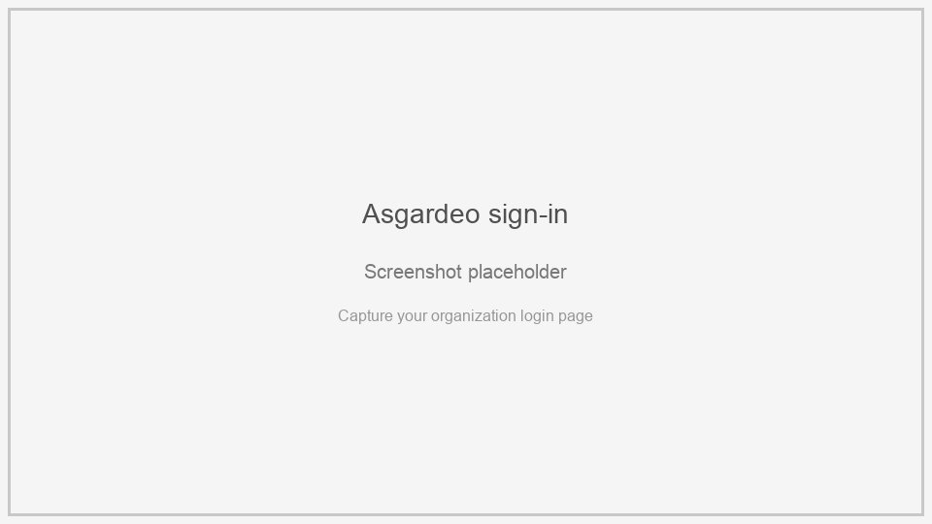
Figure 1 — Asgardeo (or identity provider) login screen.

2.2 Home page and directory structure
The main view lists folders and files from the Azure file share root (or the current folder). Users open folders to navigate; breadcrumbs show the path. Capture the listing that your customers will see day-to-day.
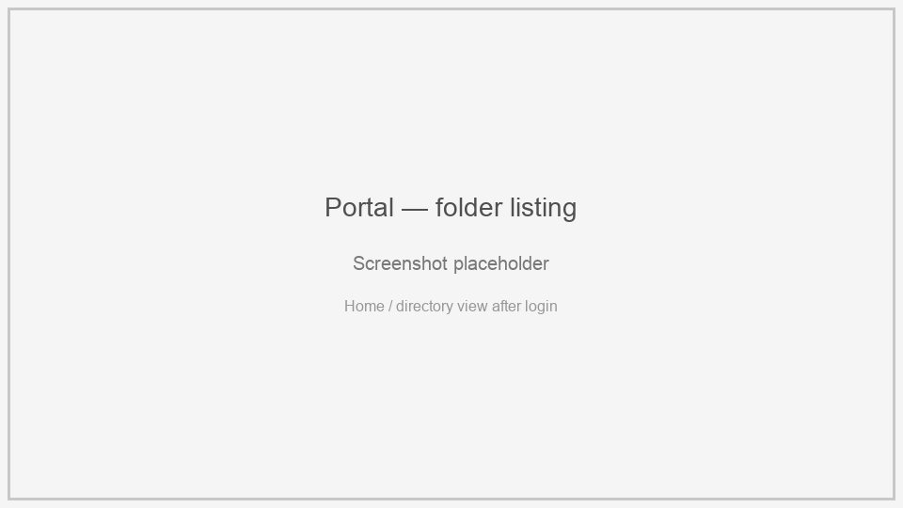
Figure 2 — Portal home or subfolder listing.

2.3 File preview and download
Selecting a file opens the preview panel (for PDFs and common image types). Use the Download control to save the file locally. Include both the file list and the preview pane if possible.
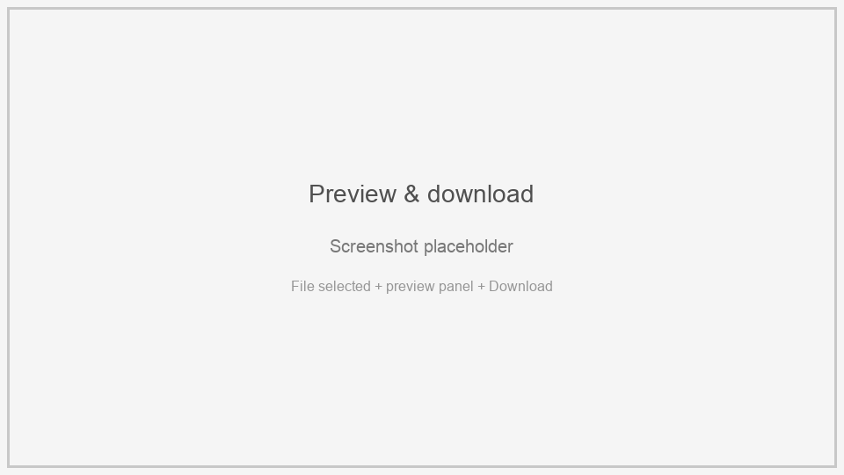
Figure 3 — Preview panel and download action.

3. Azure File Share (Azure portal)
Content is stored in a Microsoft Azure Storage account (Azure Files). Administrators upload or reorganize files here; the web portal reads the same share. Ensure folder names and permissions match your runbooks.

3.1 Navigate to the file share
In the Azure portal: Storage accounts → your account → Data storage → File shares → select the share used by the Security Advisory Patches backend (see backend configuration for the share name).

3.2 View folders and files
Open directories and confirm files appear as expected. This view should mirror what portal users see after authentication.
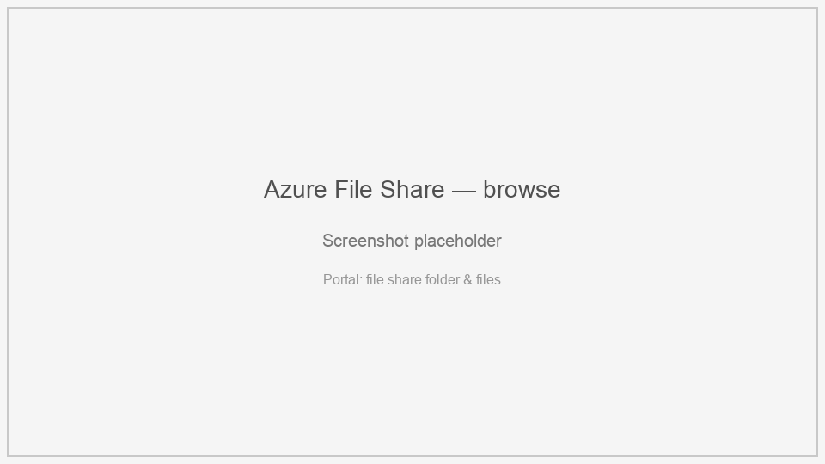
Figure 4 — Azure portal: file share directory listing.

3.3 Upload files or folders
Use Upload, drag-and-drop, or folder upload options in the portal (exact controls vary slightly by portal version). For many small files or deep trees, prefer AzCopy (section 4).
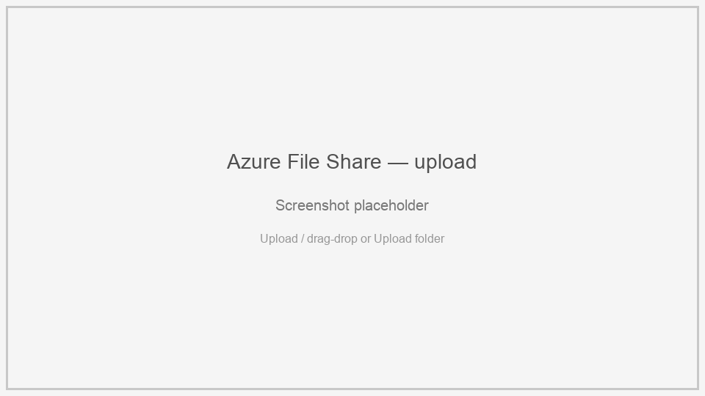
Figure 5 — Azure portal: uploading into the file share.

4. Bulk migration with AzCopy
AzCopy v10 is the recommended tool for large migrations: high throughput, resumable transfers, and scriptable runs when uploading thousands of files or very large payloads to Azure Files.

4.1 Install and documentation
Download and install AzCopy following Microsoft’s guide: https://learn.microsoft.com/en-us/azure/storage/common/storage-use-azcopy-v10
File-share–specific examples: https://learn.microsoft.com/en-us/azure/storage/common/storage-use-azcopy-files

4.2 Authorization
Typical approach: generate a SAS token on the storage account or file share with Read/Write/List (and Create) permissions as required, append it to the destination URL as ?sv=… . For directory-level operations, Microsoft also supports Microsoft Entra ID with AzCopy; see “Authorize AzCopy” in the get-started article.

4.3 Upload a directory recursively (common migration)
This pattern uploads a local folder and all subfolders into a path inside the file share. Use single quotes around paths on macOS/Linux; in Windows cmd.exe use double quotes.
azcopy copy '<LOCAL_DIRECTORY>' 'https://<STORAGE_ACCOUNT>.file.core.windows.net/<FILE_SHARE>/<OPTIONAL_TARGET_DIR>?<SAS_TOKEN>' --recursive
If <OPTIONAL_TARGET_DIR> does not exist, AzCopy can create it (see Microsoft Learn). Omit the directory segment to target the share root (still include the SAS on the URL).

4.4 Optional flags (SMB / metadata)
For Windows/SMB scenarios you may preserve ACLs and file properties (when supported):
azcopy copy '<LOCAL_DIRECTORY>' 'https://<STORAGE_ACCOUNT>.file.core.windows.net/<FILE_SHARE>/<PATH>?<SAS>' --recursive --preserve-permissions=true --preserve-info=true
For files larger than 256 MB where you want Content-MD5 set, add --put-md5 to the copy command (see Microsoft Learn).

4.5 Verify after migration
Compare file counts or spot-check in the Azure portal, then open the Security Advisory Patches web portal and confirm folders and previews behave as expected.
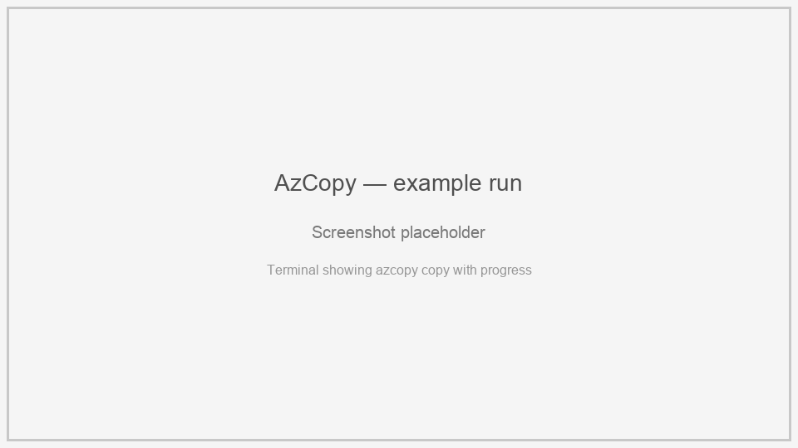
Figure 6 — AzCopy command line (progress / completion output).

5. Document maintenance
Regenerate this file by running: python3 build_visual_guide_docx.py (from the docs folder). Update screenshots when the UI, Asgardeo branding, or Azure portal layout changes.

