**Setting up IBM i Access Client Solutions (**Ver 1.2)

**Note:** Before installing IBM i Access Client Solution, you must install and connect to [Seneca Student VPN](https://employees.senecacollege.ca/spaces/77/it-services/wiki/view/3716/vpn) in your computer.

1. Download **"IBM i Access Client Solutions (5733XJ1) X86 X64**" ISO image file from ITS [Software Downloads](https://employees.senecacollege.ca/spaces/65/software/home) – under **iSeries.**
2. Mount or unzip the downloaded “IBM ACS.ISO” file. Note: You may use [7-zip](https://www.7-zip.org/download.html) to extract/unzip the ISO file on Windows 10.
3. In the “Root” folder of the image drive, you’ll find the installation folders for **Windows**, **Mac** and **Linux** operation systems, as well as the instruction file - **QuickStartGuide.html** file:

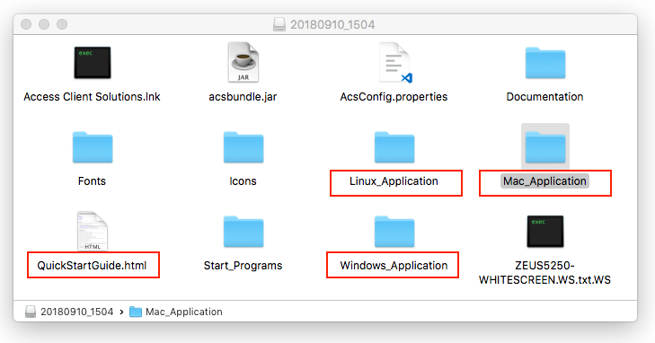

1. Before installation, make sure Java runtime or JDK is installed on your machine. For Mac OS, you may have to use this [link](https://support.apple.com/kb/DL1572?locale=en_CA). Then follow the Quick Start Guide to start installing ACS based your OS type.
   1. Start installation on Mac OS: click ***install_acs*** to start.If you cannot run ***install_acs*** directly, try to right-click ***install_acs*** and go into the package to find runnable file.

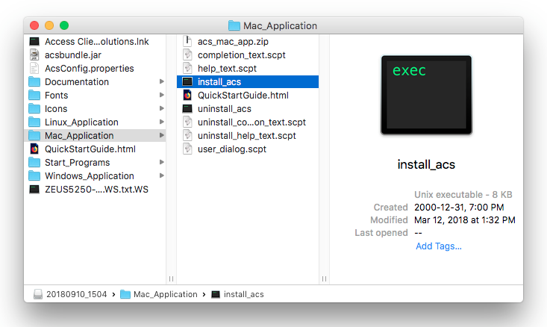

Note: For the newer Mac OS version, ACS may not be successfully installed due Java run time problems.

* 1. Start installation on Windows 10: find and right click **PowerShell** icon, then select ‘Run as Administrator’. Change the directory to “**Windows_Application**” and run a script that fits your PC using **WSCRIPT**, e.g.

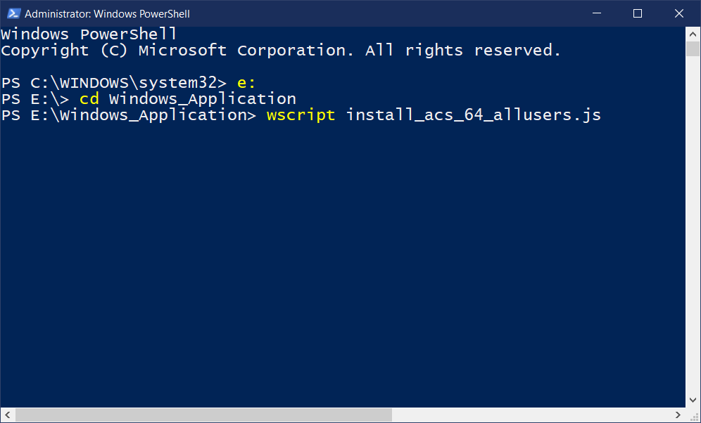

1. Launch Access Client Solutions in “Applications” on Mac or a shortcut on Desktop on Windows.

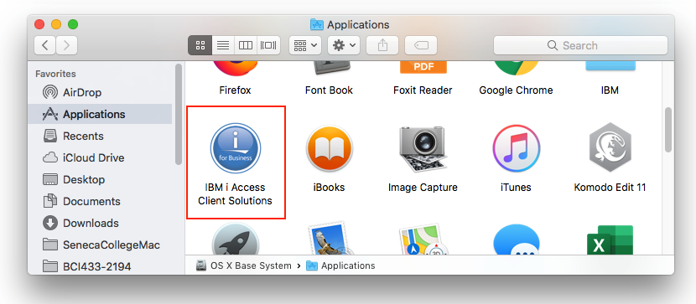

1. System configuration

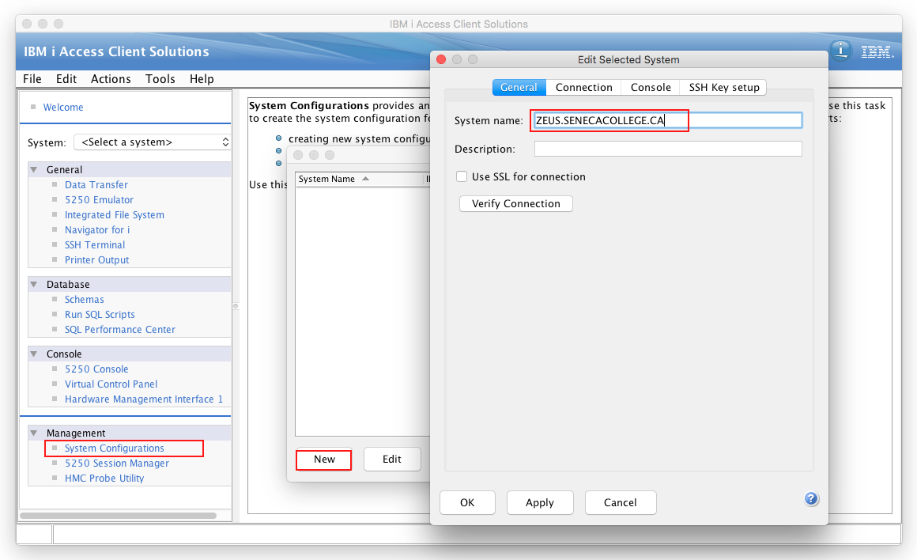

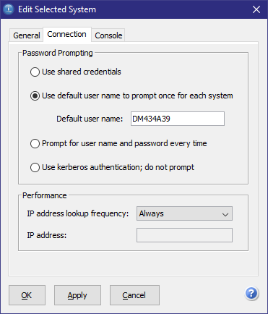

1. Start “0520 Emulator” from the Access Client Solutions window. Enter Zeus ID and password, then you’ll get:

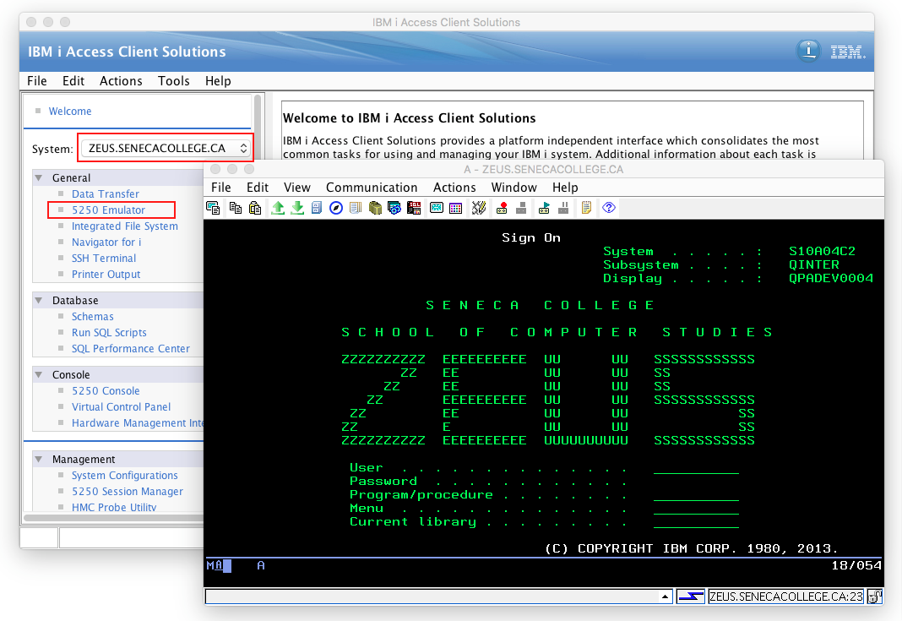

1. Add console configuration file: in Finder (for Mac) or File Exploer (for Windows), search “**HODData**” to locate the folder and then copy the **ZEUS5250-WHITESCREEN.WS.txt.WS** file from “**IBM ACS.ISO**” image drive and paste it into the “**HODData**” folder.

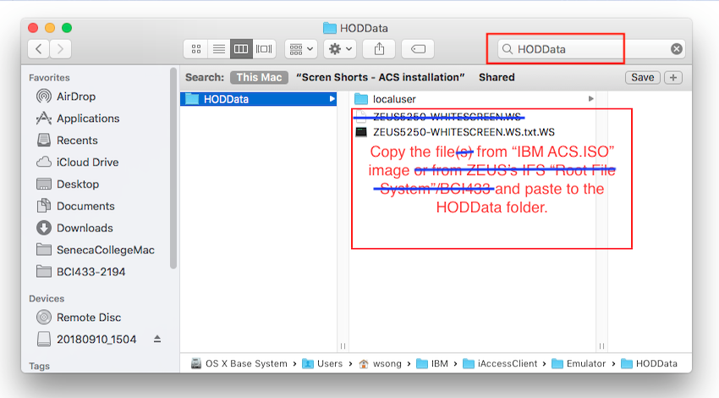

1. Use the configure file:

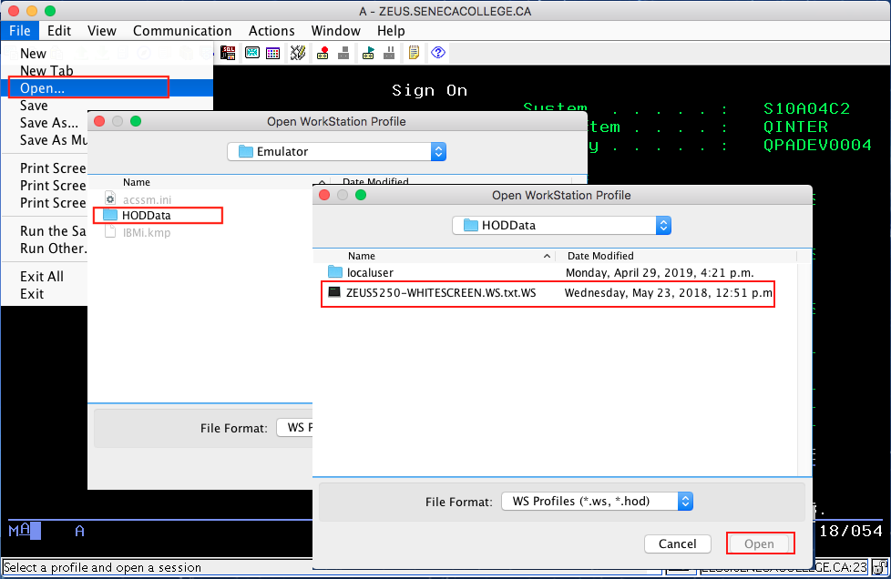

1. Click “No” then “Yes”

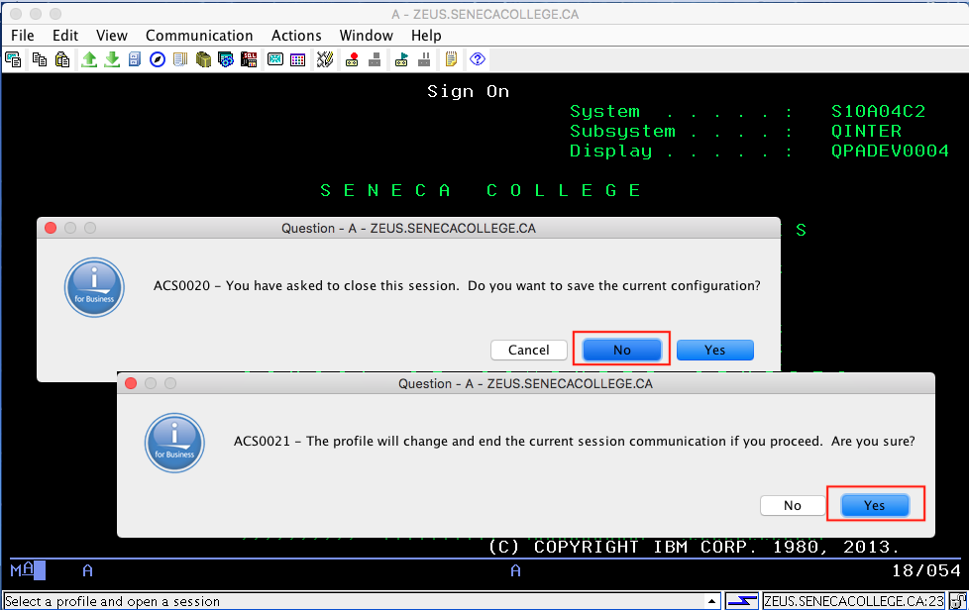

1. You’ll get the “WhiteScreen”. Then click the menu item **Communication**>**Configure**…, and make sure the “**Screen Size**” value is “**27x132**”.

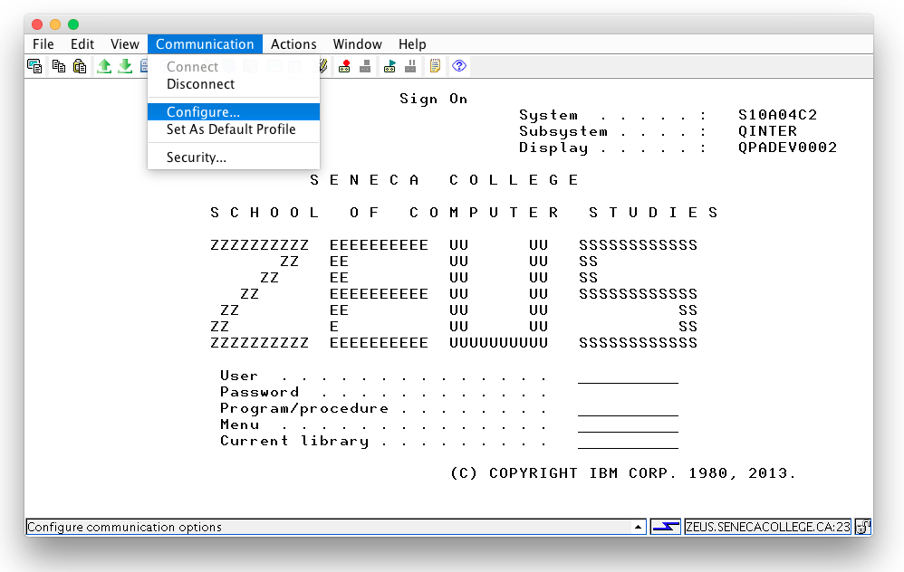

1. Set the **Keyboard** of **System Preferences**: check the “Use F1, F2, etc. keys as standard function keys” item

