**Installation Guide for IBM Rational Developer for i Ver9.6 (RDi9.6)**

**Note:** Before installing IBM RDi9.6, you must install and connect to [Seneca Student VPN](https://employees.senecacollege.ca/spaces/77/it-services/wiki/view/3716/vpn) in your computer.

* Download "**RDi V9.6 - Install 1**", "**RDi V9.6 - Install 2**" and "**RDi V9.6 - Activation**" files from ITS [Software Downloads](https://employees.senecacollege.ca/spaces/65/software/home) – under **iSeries.**
* Unzip "**RDi V9.6 - Install 1**", and "**RDi V9.6 - Install 2**" zip files then move the “**disk1**” and “**disk2**” folders into a single folder.
* Go to “**disk1**” folder drive and click on ***Launchpad.exe.*** Note:
  + For **Linux**, go to disk1/InstallerImage_linux_gtk_x86_64 folder, run **sudo** **./Install**
  + For **Mac OS**: From Finder, run **Launchpad.app** from disk1 or go to disk1/InstallerImage_macosx_cocoa_x86_64, and run **sudo ./install**
  + To use the launchpad to install, you must have Administrator or root privileges.

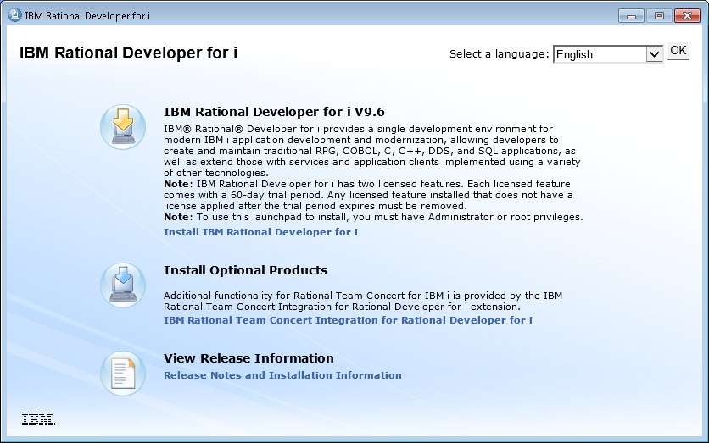

* Click on ***Install IBM Rational Developer for i***

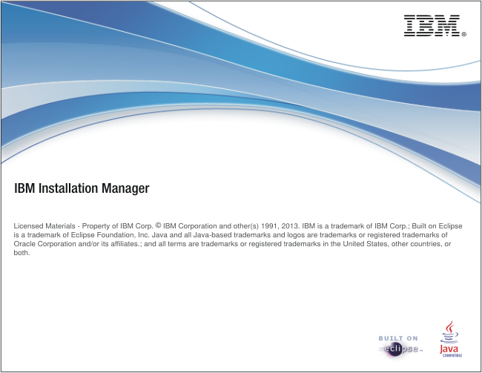

* Stayed at the above screen for a while

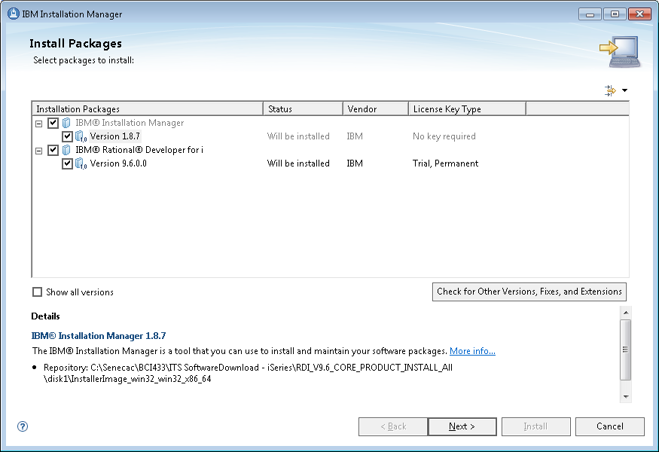

* Click on **Next**

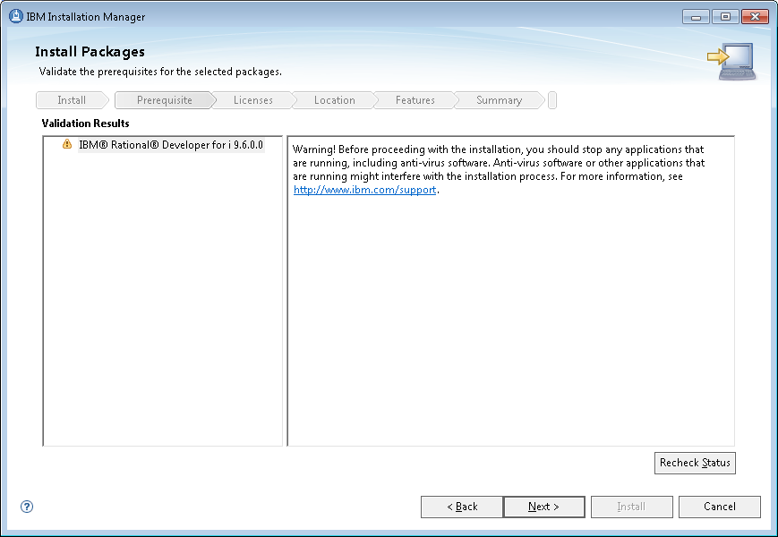

* Click on **Next**

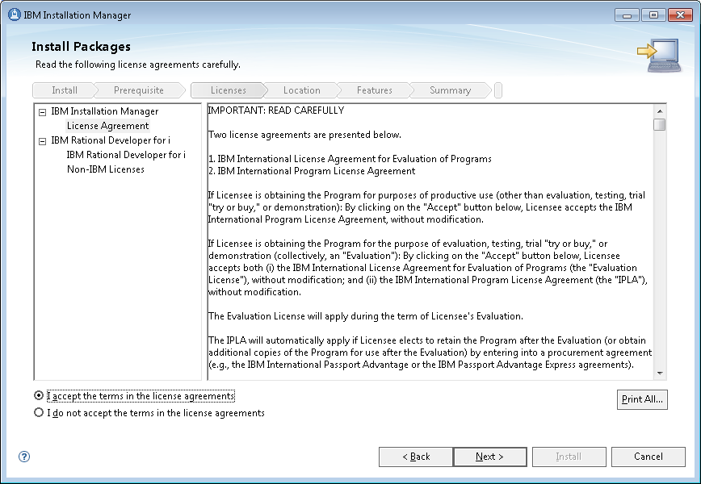

* Check ***I accept …*** and click on **Next**

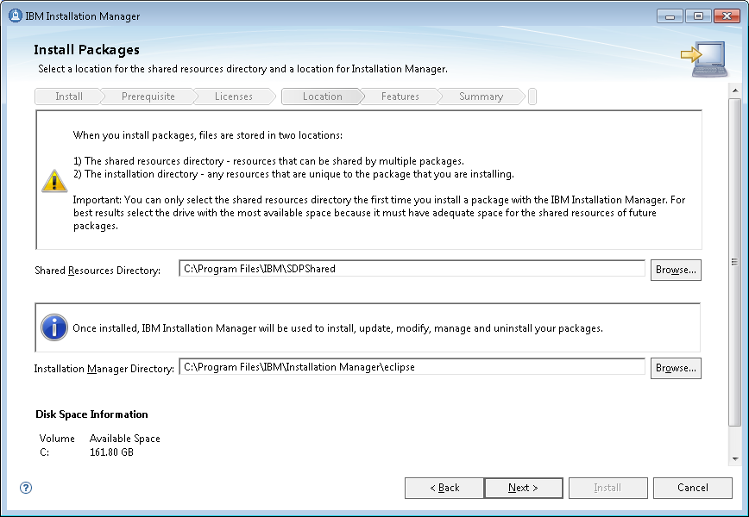

* Click on **Next**

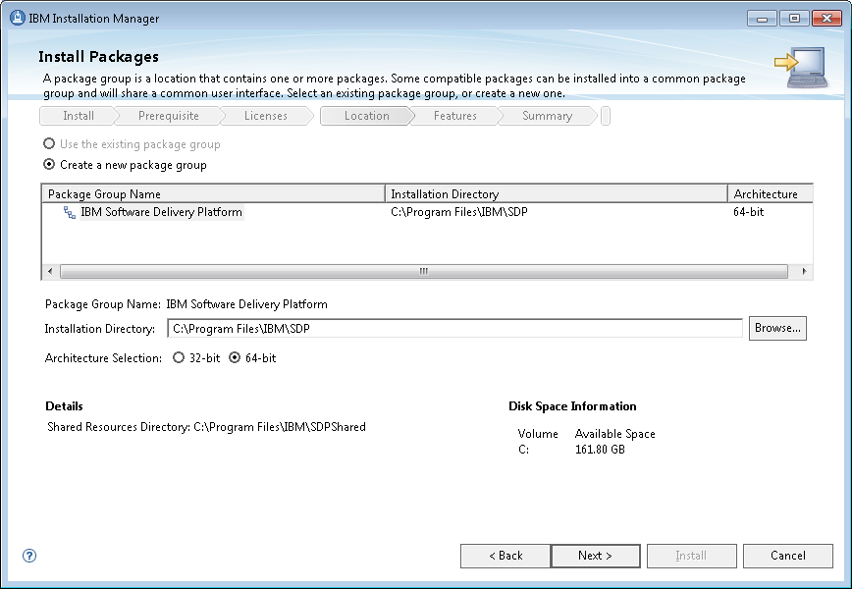

* Click on **Next**

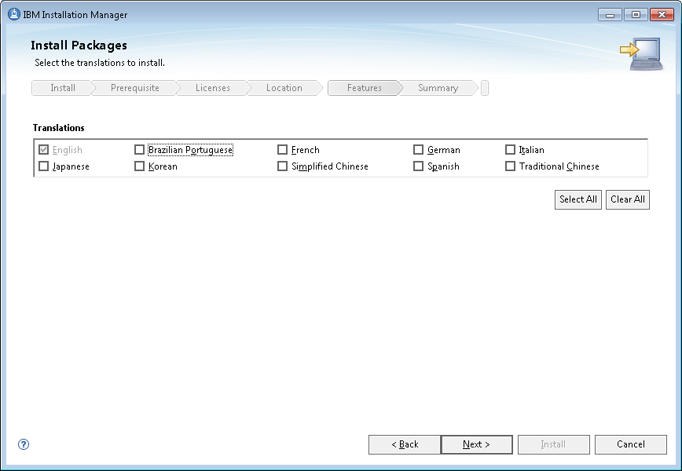

* Click on **Next**

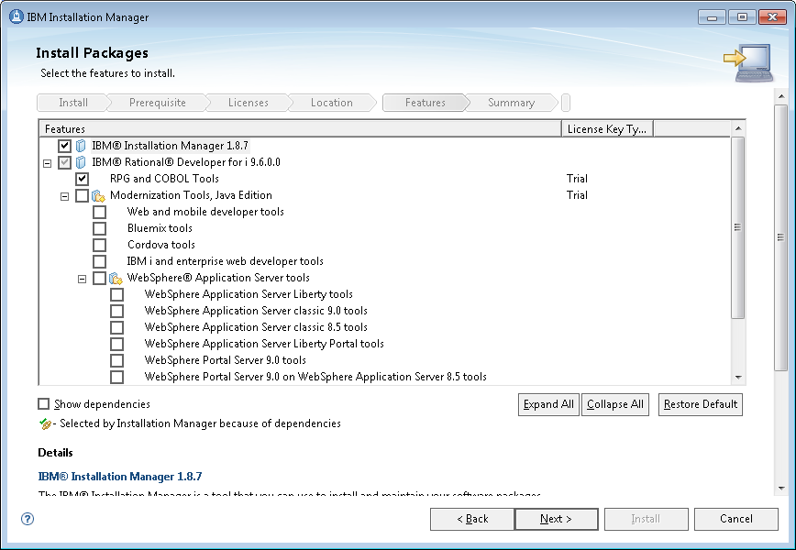

* Click on **Next**

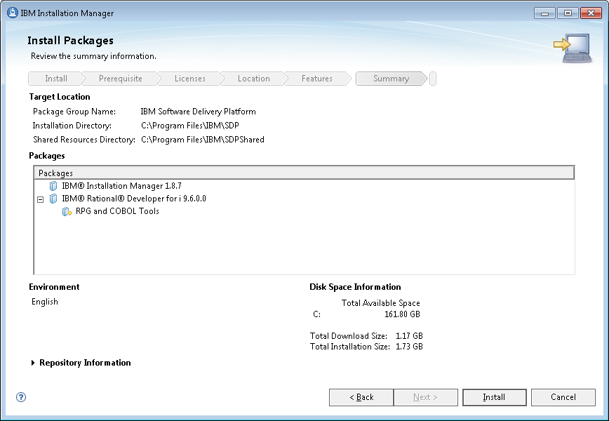

* Click on **Install**

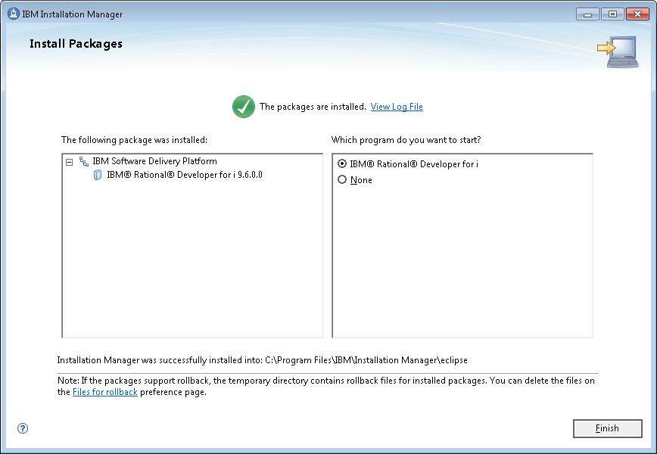

* Click on next, then RDi will start:

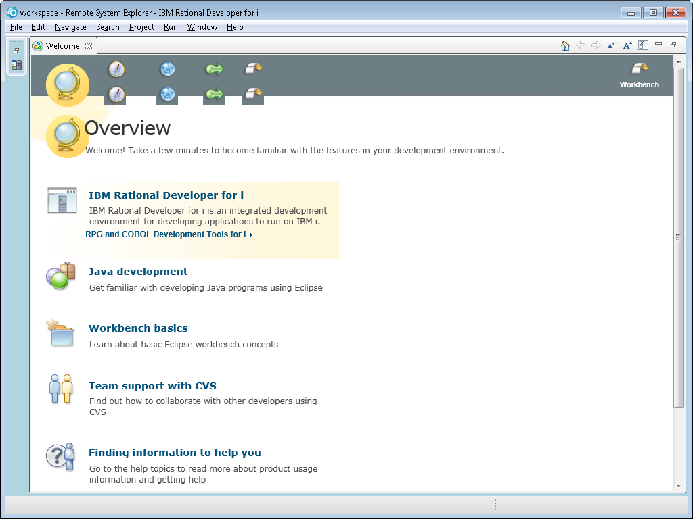

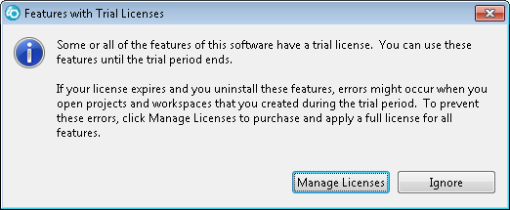

* Click on **Manage Licenses**
* (Or from Window Start button > All programs, launch the **IBM Installation Manager)**

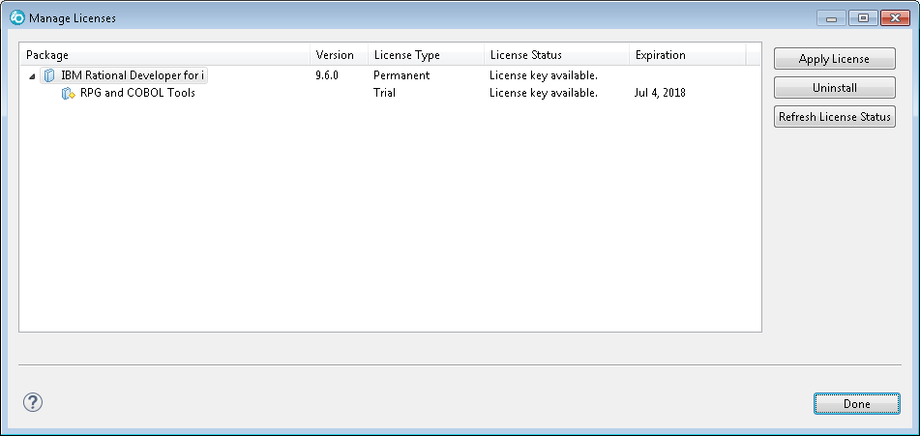

* Click on **Apply License**

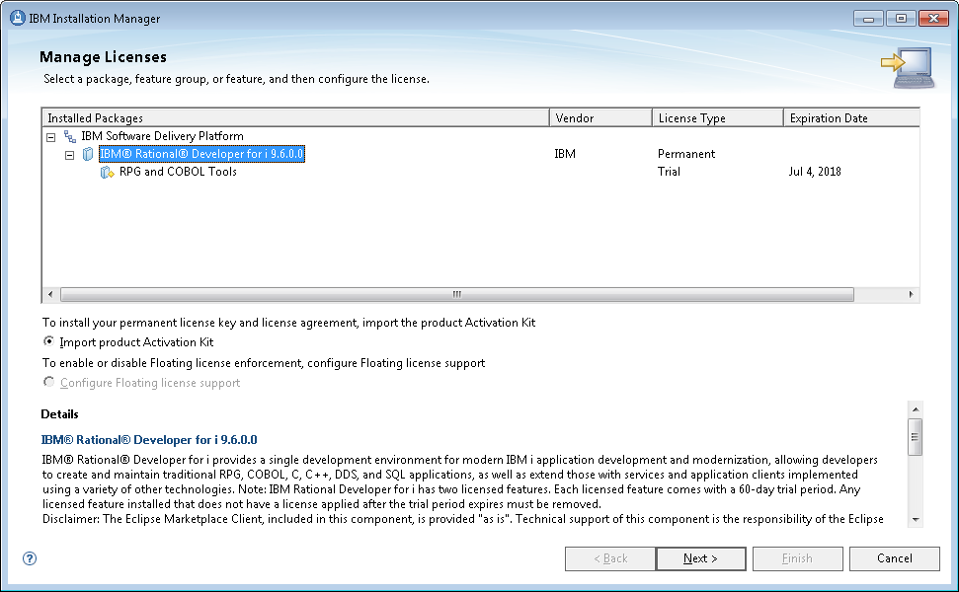

* Highlight **IBM® Rational® Developer for i 9.6.0.0** and check the radio button of ***Import Product Activation Kit***, then click on next

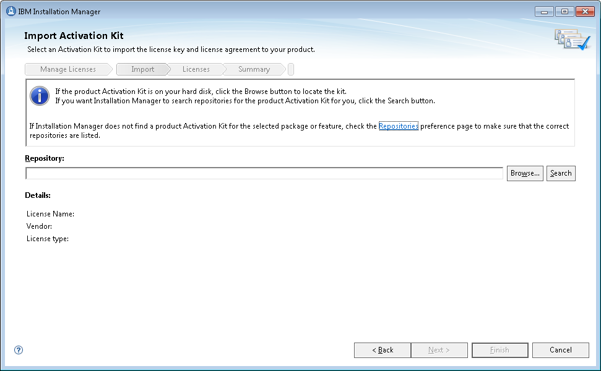

* Unzip the downloaded "**RDi V9.6 - Activation**" zip file, then click the **Browse…** button to select "**com.ibm.rational.developer.ibmi.rpgcobol.v96.pek.jar**" under the unzipped folder.
* Click on **Next**

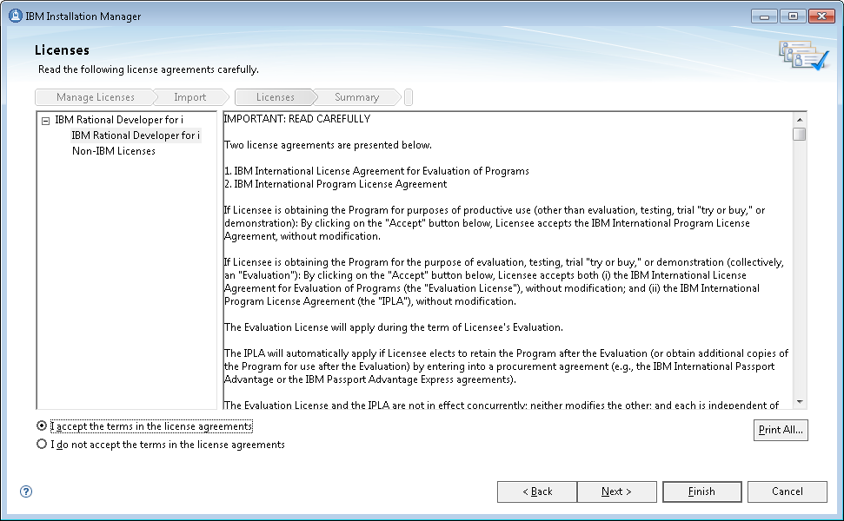

* Click on **Finish**

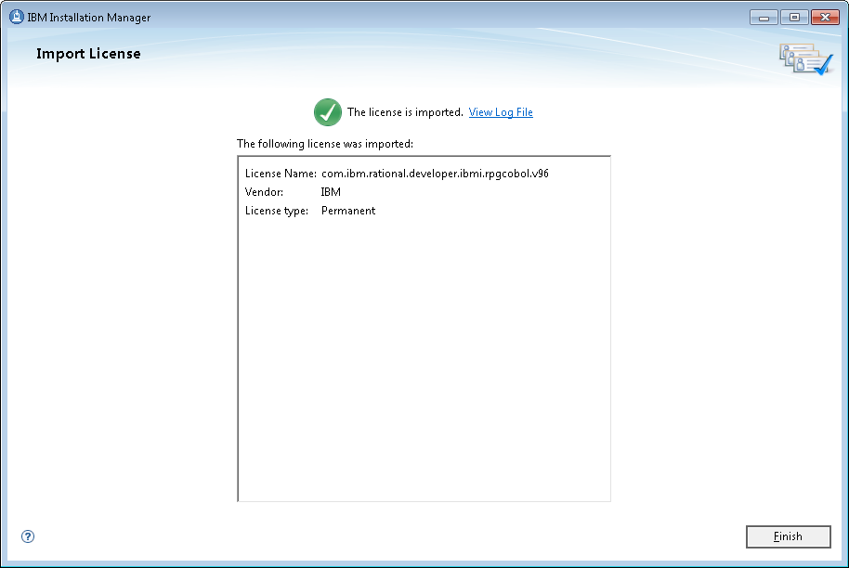

* Click on finish:

– You should see the start menu of ***IBM Installation Manager*** – DONE!

**Connect to Seneca IBM i (ZEUS) server using your user ID (profile) and password:**

* Start your RDi, and click OK to use the default Workspace.
* In the Remote Systems Explorer view, expand New Connection then double click "IBM i …":

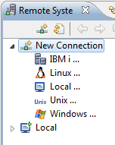

* Enter ZEUS.SENECACOLLEGG.CA for the Host Name, then click Finish:

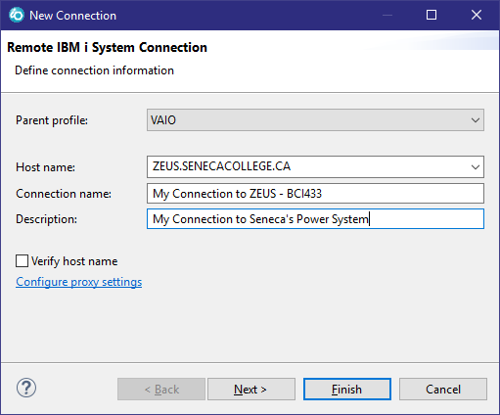

* Expand the created connection, then Objects, Library list, ….
* Enter your user ID and password when the "Enter Password" window pops up. Done!