# Test Data

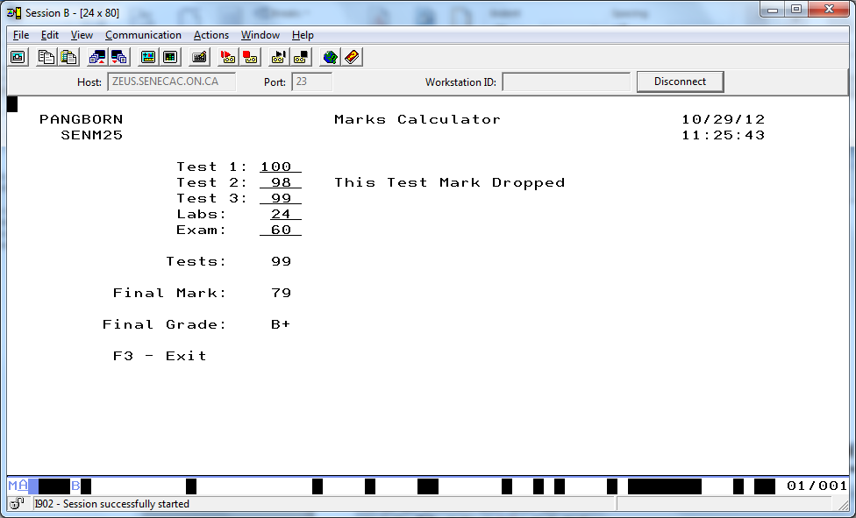

A final mark of 79 or 80 is acceptable

Half adjusting (rounding) the calculations for the Final Mark above:

EVAL(H) TESTOVRALL = (TEST1 + TEST2 + TEST3 -

Minimum) / 2;

EVAL(H) NUMGRADE = TESTOVRALL * .35 +

LABS +

EXAM * .35;

Final Mark of 79.82 had the decimal “.82” chopped off. It becomes 80 with half adjusting

If it was 79.35 it would be calculated as 79 with half adjusting.

