**Lab objectives: Menus, Security and Report Writer**

**Requirements to pass the lab:**

Menus – Demonstrate your menu to your instructor

Security – Your professor will either ask you to show authorities, or the professor will check the authority set up on the ‘LB’ library

Report Writer – Show your completed Payroll Report printer file in Report Writer

## Create a menu (MYWORK)

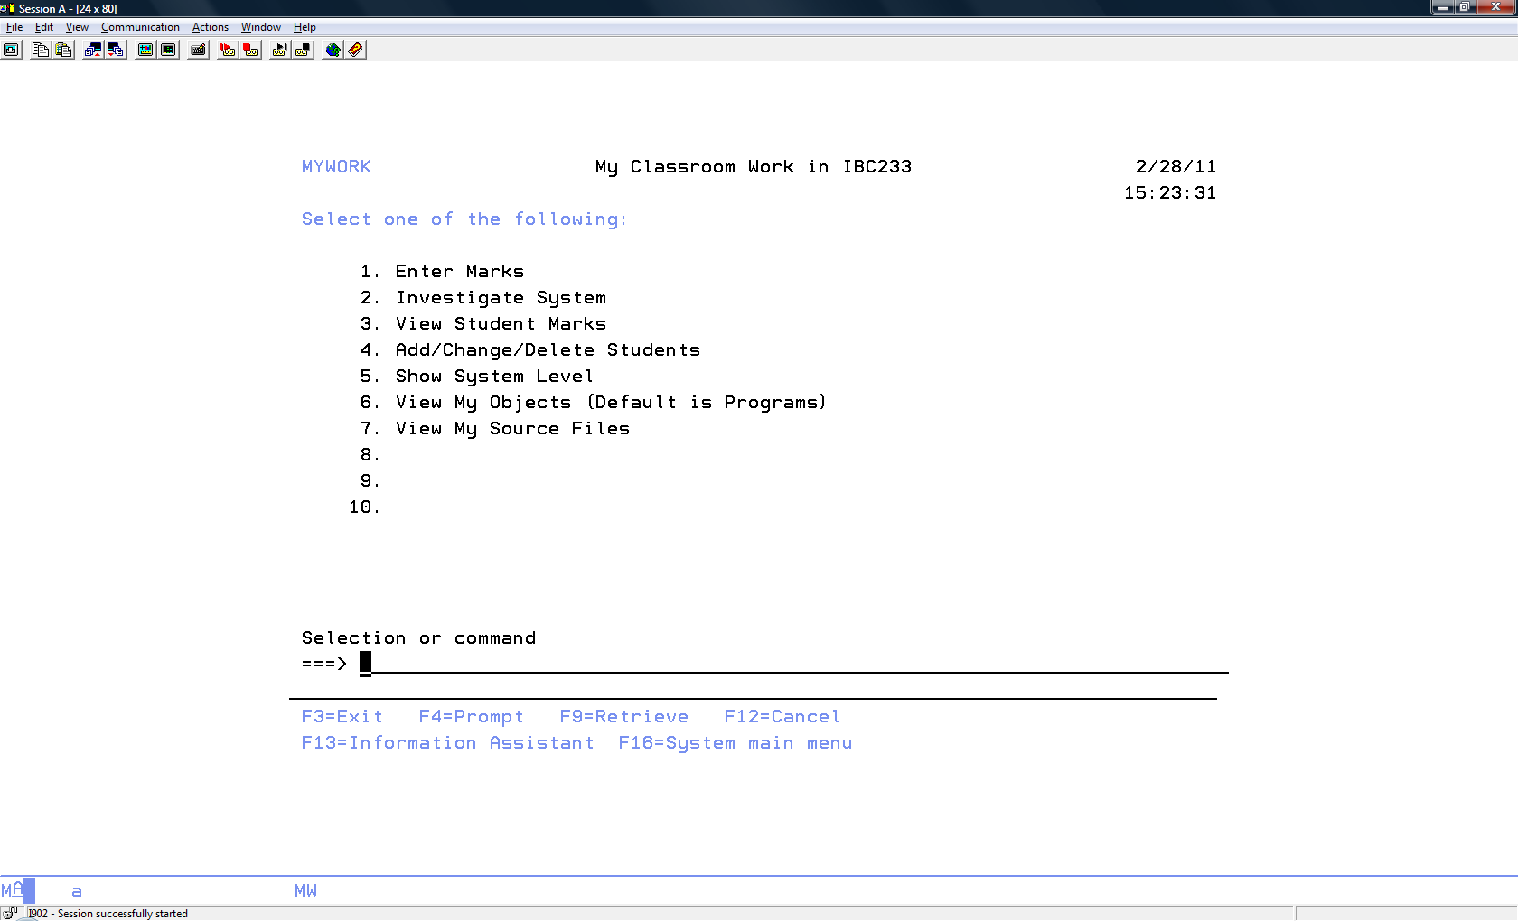

Options will provide the following:

Enter Marks – invoke your Lab3 or Lab7 RPGLE program that deals with entering marks.

Investigate System – invoke your Lab4 CLLE program.

View Student Marks – show your view of Students and Marks

Add/Change… – use the DFU command that allows this activity with STUDENTS

Show System Level – Run your lab8 command with the *MSGLINE value for the required parameter

View My Objects – Work with objects in your library, but allow people to change the *PGM object type with

this WRKOBJPDM command

View My Source Files – Work with objects in your library - Object type *FILE and attribute PF-SRC only.

##### Producing the Menu

In ‘Client Access

At the command line, type STRSDA. Screen Design Aid is the green screen version of Screen Designer.

Take the option to design menus. Name the menu MYWORK, with the source in QDDSSRC, in your library.

Work with menu image and commands.

IMPORTANT NOTE: Never press insert, delete or backspace!!!

Each element on the screen has an attribute byte to it. The attribute byte controls the display of the element. You accessed this byte in Screen Designer by clicking on an element and then selecting Properties. To Access the attribute byte in SDA, you type key strokes in the byte beside the element.

Delete the menu description ‘MYWORK Menu’ by typing a d beside the string and pressing enter. Add the new menu title by typing ‘My Classroom Work in IBC233’ where the original menu name was and pressing enter. Be sure to enclose the string in single quotes. The quotes will disappear when you press enter.

Centre the string by typing an A beside the string and a C on top of the S in ‘Students’. Press Enter.

Add the system date constant to the menu by typing *DATE in the top right hand side of the screen. Press enter.

The *DATE will convert to DD/DD/DD.

Please see below:

|  |
| --- |
| MYWORK My Classroom Work in IBC233 Menu DD/DD/DD    Select one of the following:    1.  2.  3.  4.  5.  6.  7.  8.  9.  10.      Selection or command  F3=Exit F10=Work with commands F12=Cancel  F13=Command area F20=Reverse F24=More keys |

Type *TIME under DD/DD/DD to display the system time constant on the screen. Press enter and TT:TT:TT will be displayed. Type text beside the menu choices as shown below. Make sure that you type the character strings in single quotes.

Use d to delete 6 through 10. Type ’90. Sign off’ for the last menu option.

When your work screen looks like the one on the first page, press the F10 function key to work with commands.

The first command could be something like CALL MARKSRPG or CALL MARKSRPG1 depending if you want to show your lab3 or lab 7 RPGLE program.

It is important that you enter the command for the option and you press the enter key to commit the command. If you just enter the command and press F3, it will not have been entered for the option.

The next page provides the first option. Your teacher will go over the other options in class. If you are not in class, you may be able to figure out most of these, but will need to get notes from one of your classmates on how to prompt a command.

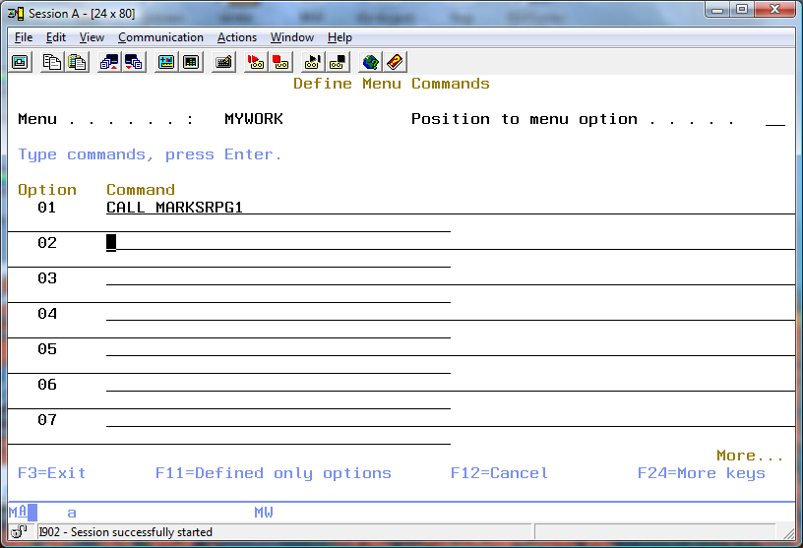

Exit the Define Menu Commands screen, the Menu Image work screen, and the Specify Menu Functions screen — you should be looking at the Exit SDA Menus screen. Make sure that the menu source will be saved and the menu objects created. Use "Menu of Student Applications" for the text. When you have completed the screen, press Enter to exit and save.

1. What message appears temporarily at the bottom of the Exit screen?
2. What message is displayed at the bottom of the Design Menus screen?

Exit to the AS/400 Screen Design Aid (SDA) screen, and on the command line enter the command to go to your menu. Test all menu options, and make sure they work. If one or more menu options fail, you must determine whether the command was incorrectly entered or the object referenced by the command is misspelled or not working. An error message from the menu should point you in the right direction. When you have tested all options, F3 or F12 will take you out of the menu.

To determine the objects that are needed to support your menu type the following:

=>WRKOBJPDM DY233??? MYWORK

What are the objects created to support your menu?

Object Type Attribute

_______________________ _____________ ________

_______________________ _____________ ________

_______________________ _____________ ________

## Security

You want to share one object with the public. This object is your file called STUDENTS. You can either put it in QGPL which is already on everyone’s library list and available to the public, or you can create a special library that will be made available to everyone. We will use this second approach keeping our personal libraries secure from prying eyes.

Create a new library called D?233???LB Use your ID to fill in for the ?

Use the CPYF command to place a copy of your STUDENTS file into the LB library. You probably can figure out what goes in the blanks below. If not, the blanks will be filled out in class.

Copy File (CPYF)

Type choices, press Enter.

From file . . . . . . . . . . . ____________ Name

Library . . . . . . . . . . . ____________ Name, *LIBL, *CURLIB

To file . . . . . . . . . . . . Name, *PRINT

Library . . . . . . . . . . . ___________ Name, *LIBL, *CURLIB

From member . . . . . . . . . . ___________ Name, generic*, *FIRST, *ALL

To member or label . . . . . . . *FIRST Name, *FIRST, *FROMMBR, *ALL

Replace or add records . . . . . __________ *NONE, *ADD, *REPLACE...

Create file . . . . . . . . . . __________ *NO, *YES

Print format . . . . . . . . . . *CHAR *CHAR, *HEX

Use WRKOBJPDM with the new ‘LB’ library.

On the STUDENTS file, either use PDM's EA user option on this *FILE object or, on the command line, prompt the EDTOBJAUT cmd. The edit object authority screen will show the file security levels for your User ID and for *PUBLIC (all other users) and perhaps others.

Who is the owner? ______________________

What authority do you have to the object? _____________

Who else has authority to the object? _________________

What is the Authorization List set to? _____________________

The F11 key is a toggle key which shows the detailed information.

Each object has Object authorities and Data Authorities. What selections show for the public and your user profile.

Object **----------Object---------------------**

User Group Authority Opr Mgt Exist Alter Ref

*PUBLIC *CHANGE __ __ __ __ __

DY233??? __________ __ __ __ __ __

Object **---------------Data---------------------**

User Group Authority Read Add Update Delete Execute

*PUBLIC *CHANGE __ __ __ __ __

DY233??? __________ __ __ __ __ __

. Try pressing F11 a few times. Position the cursor and use F1 for information about the various authorities.

Under Object authority *CHANGE can be set to *EXCLUDE, *USE or some non standard combination that shows up as USER DEF.

If you select *EXCLUDE, all the X’s dissappear under Object Opr, Object Mgt etc. If you toggle with the F11 key you will also see under Data Read, Data Add etc. the same thing occurs.

If you wanted to give everyone READ only access to STUDENTS *FILE, what object authority level do they need?

_________________

If you put an X under Mgt which is not selected with *USE authority, the USER DEF object authority appears.

The extras you are allowing here would be the ability for someone to build a logical file over your physical file and the option of setting the object authority – limited by what you have. With management authority another user can set the authority to your object. If they were not given *ALL authority, they would not be able to give that feature to another user.

They could give the same level of access they have or less.

If you wanted to give everyone all data authorities to STUDENTS *FILE, what object authority level do they need? _________________

If you wanted to prevent everyone from accessing STUDENTS *FILE, what object authority level is needed? ________ **Assign that authority to the file.**

**Let's add two new users with *USE authority. Press F6 and the userids DY233B39 and DY233D38.**

DY233B39 and DY233D38 now have read only access to the file.

Change this so DY233B39 can also build a logical file or view over the physical file and can dictate the access DY233D38 is allowed to the STUDENTS file.

Open another ‘Green Screen’ session and Signon with DY233B39 and password of “SECURITY”.

Can the new userid access this STUDENTS object in your LB library?

System messages will tell you why you cannot.

REMEMBER: We have only altered security on the file. We need to change the security on the library as well.

Return to the ‘Green Screen’ session with your own userid.

Sometimes students get confused as to which session they are working. Is it the security account or their account?

The DSPWSUSR command will tell them.

Enter the following command using positional notation:

EDTOBJAUT DY233???LB *LIB

Allow DY233B39 and DY233D38 minimal access to the library - *USE.

Test your security set up. With the new userid, check to see if you can copy STUDENTS in your ‘LB’ library using pdm option 15 and/or 3. Can you run UPDDTA (PDM option 18) against the STUDENTS? Can you add/change or delete a record in the file? What security level do they need to be able to do those things?

Now, signed on as DY233B39, exclude DY233D38 from the STUDENTS file.

Did this work? You can sign on as DY233D38 with a password of SECURITY2 and see if you can access the student file. DY233B39 does not own the file, but can exclude DY233D38 with object management authority. If you want to test this further go back to your DY233B39 signon and allow DY233D38 access to your STUDENTS file in the LB library and see if this works.

If you did not want anyone adding records to your file, and you gave DY233B39 management authority, but not Data Add, should they be able to give Data Add authority to DY233D38 – getting around your intentions?

________ The system does protect you here. If you want, try it to prove this.

With your own userid:

**Now, give authority to the LB library and its objects to all of the IBC233 professors.**

It would be very tedious to add each instructor's User ID to each object's security. Fortunately, your instructors are members of an Authorization List called IBCPRF. Using PDM's EA option or the EDTOBJAUT command, specify that the objects are secured by authorization list IBCPRF.

**DO NOT give another student authority to your assignment libraries. This will be viewed as very suspicious.**

### It is possible to become confused as to which sign in you are working in. Use the DSPWSUSR command to determine if you are signed in as DY233D38 or as yourself. (Display Workstation User)

### How would you set up the security for a new message queue called MYMESSAGES in your new library. What is the logical security set up if this message queue is used for communicating with other users on the system?

### Deliverables for this lab:

Menus – Demonstrate your menu to your instructor

Security – Your professor will either ask you to show authorities, or the professor will check the authority set up on the ‘LB’ library.

## Report Designer

The following report layout will be designed to be used in a later lab by an RPGLE program:

3/01/2011 14:24:55 Weekly Payroll Report Page:0001

Name: Student Name

Employee Work Pay Hourly Hours Regular Overtime Total

Number Shift Grade Rate Worked Pay Pay Pay

333-333-333 D 1 16.00 41 664.00 24.00 688.00

122-222-222 D 3 14.20 35 497.00 497.00

322-222-222 D 2 15.70 40 628.00 628.00

. . .

Totals: $28,685.69 $499.68 $29,185.37

This externally compiled printer file will be available to programs of all languages that print reports on the system.

The programmer will not have to provide the layout for the report. Instead they will just refer to the various types of output records available to them. They will write Title, ColHdg, EmpDetail and Totals.

Hopefully when you look at the report above, you can pick out those items.

The RDp GUI tool Report Designer will be used to develop your externally described printer file report.

Here is the code you will not be entering:

A R TITLE

A 1 45'Weekly Payroll Report'

A 1 89'Page:'

A 1 94PAGNBR

A 1 3DATE(*YY)

A EDTCDE(Y)

A 1 15TIME

A R COLHDG SPACEB(1)

A 6'Employee'

A SPACEB(1)

A 19'Work'

A 29'Pay'

A 37'Hourly'

A 47'Hours'

A 56'Regular'

A 71'Overtime'

A 89'Total'

A 7'Number'

A SPACEB(1)

A 19'Shift'

A 29'Grade'

A 38'Rate'

A 47'Worked'

A 58'Pay'

A 74'Pay'

A 90'Pay'

A R EMPDETAIL SPACEB(2)

A EMPNUM R 9S 0 5REFFLD(ALLSHIFT/EMPNUM SENECAPAY/A-

A LLSHIFT)

A EDTWRD('0 - - ')

A WORKSHIFT R 1A 20REFFLD(ALLSHIFT/WORKSHIFT +

A SENECAPAY/ALLSHIFT)

A PAYGRADE R 30REFFLD(ALLSHIFT/PAYGRADE +

A SENECAPAY/ALLSHIFT)

A HOURLYRATE 5 2 37EDTCDE(1)

A HRSWORKED R 48REFFLD(ALLSHIFT/HRSWORKED +

A SENECAPAY/ALLSHIFT)

A REGULARPAY 7 2 55EDTCDE(1)

A OVERPAY 7 2 70EDTCDE(1)

A TOTALPAY 7 2 86EDTCDE(1)

A R TOTALS SPACEB(2)

A 41'Totals:'

A TOTREGPAY 9 2 51

A EDTCDE(1 $)

A TOTOVTPAY 9 2 66EDTCDE(1 $)

A TOTEMPPAY 9 2 82EDTCDE(1 $)

Instead of entering code, open up RDp and create a source physical file called PayrollApp.

Create a new member in PayRollApp called PAYRPT and use the type PRTF (printer file)

Close this member and reopen it with Report Designer. Use the same technique that use used with Screen Designer to do this.

An absolute record is required first. You can create this by dragging Absolute Record from the left side Palette and releasing it in the work area. The default name for this is RECORD1. You can change this record name to TITLE in the Properties view on the lower right.

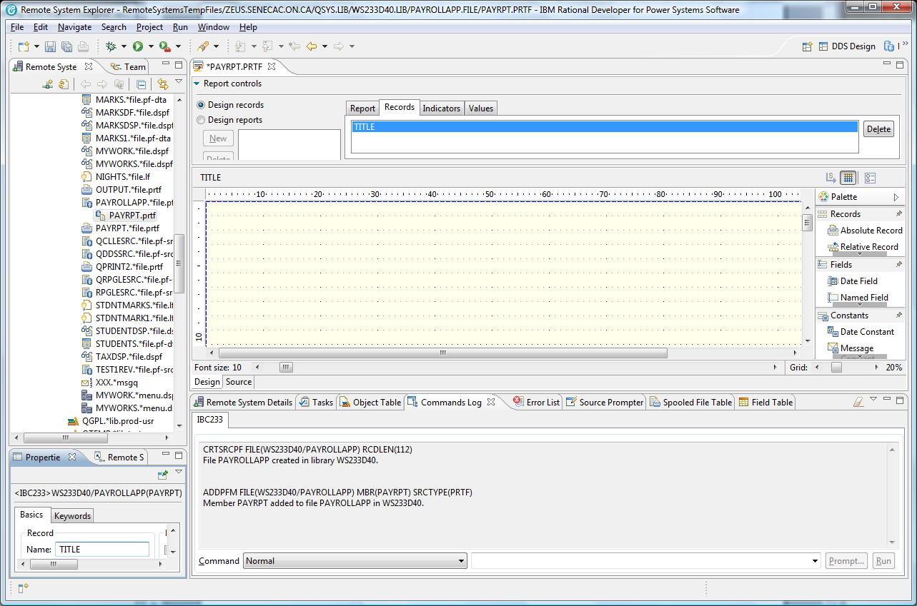

Double click on the PAYRPT.PRTF tab to get an expanded view of the palette. The content that needs to be added to the TITLE record includes a Date Constant, Time Constant, Text Constants and a Page Number Constant. All of this is found in the palette. You do not have to place everything in the exact column number that this report uses, but make it all visually fit between column 1 and column 100. Also include on the second line a Name label and your actual full name.

As you are working on this report, you can press CTRL+S occasionally to save your work.

There are Design and Source tabs available so you can look at the DDS code that is being generated.

The finished product shows on the next page for TITLE .

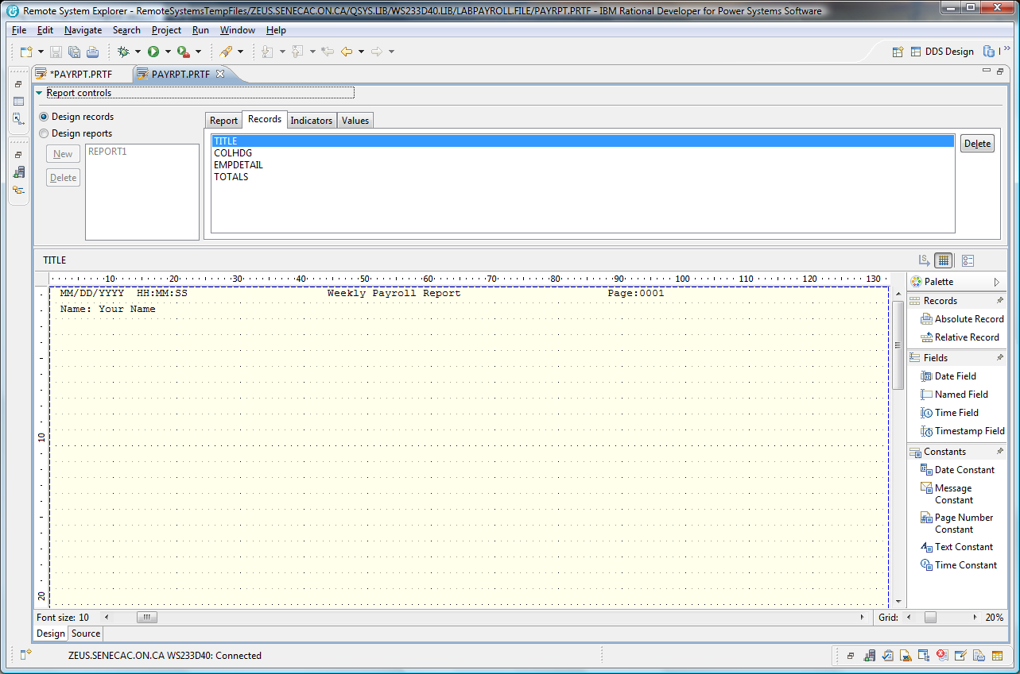

The next record you add from the palette should be a Relative Record called COLHDG. Drag this over and make sure you drop it on line 3 or 4. TITLE does not show, but you will be able to line everything up later when Designing Reports.

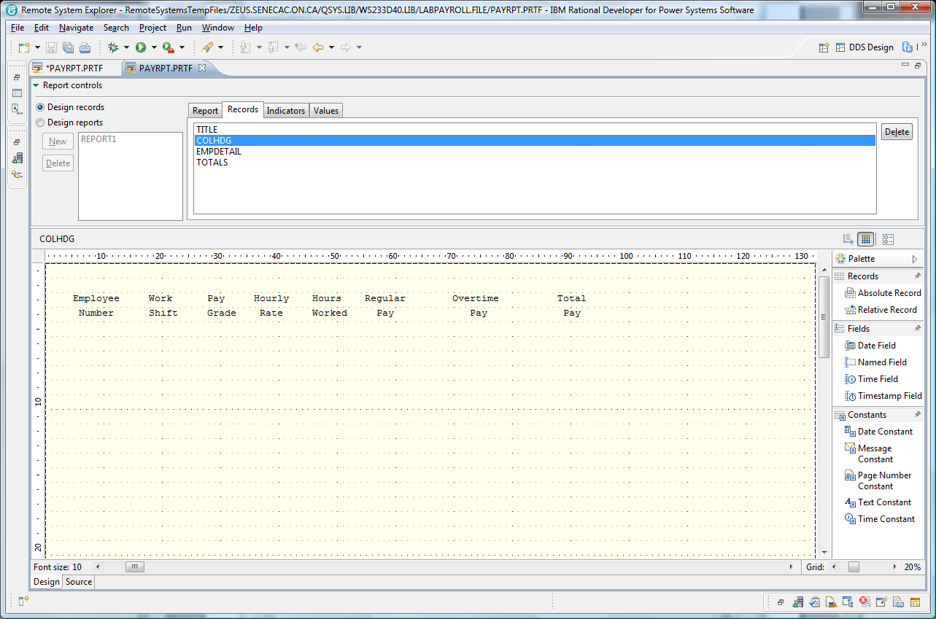

The EMPDETAIL relative record will have the fields from a file called ALLSHIFT in the SENECAPAY library dragged onto the screen on a line number lower than the column headings.

Notice in the screenshot below an object filter was created to the SENECAPAY library and the ALLSHIFT object. Then the ALLSHIFT.*file.pf-dta was right clicked on with a Show in Table – Fields selected for the field table.

Each field was dragged to an appropriate area on the screen and then the properties view was used to supply edit codes or edit words. An edit code of “2” was used on all the numeric fields except for the employee number.

An edit word was used for the employee number. **Create named fields for HOURLYRATE, REGULARPAY, OVERPAY, and TOTALPAY.**

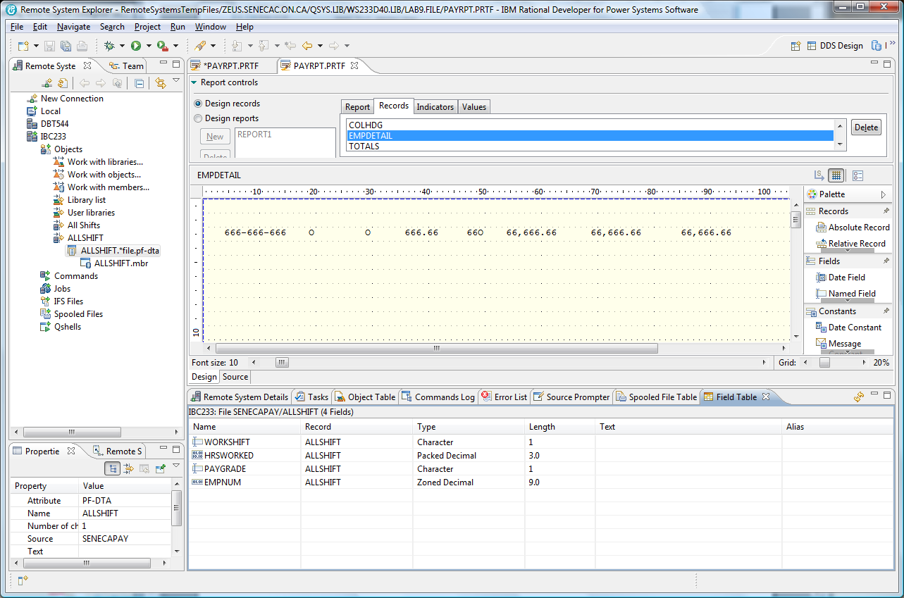

Provide a Totals record with **named fields** used for the last three column totals. TOTREGPAY, TOTOVTPAY and TOTEMPPAY. These fields are zoned numeric and 9 digits with 2 decimal places. These field also use an edit code of “1” and include the currency symbol.

You are now ready to put all this together. There is a report control area under the PAYRPT.PRTF tab at the upper right. It was set at Design records for this first stage.

Click on the Design reports radio button and click on the Report tab to change the name from untitled to Report1 and click on the Apply button.

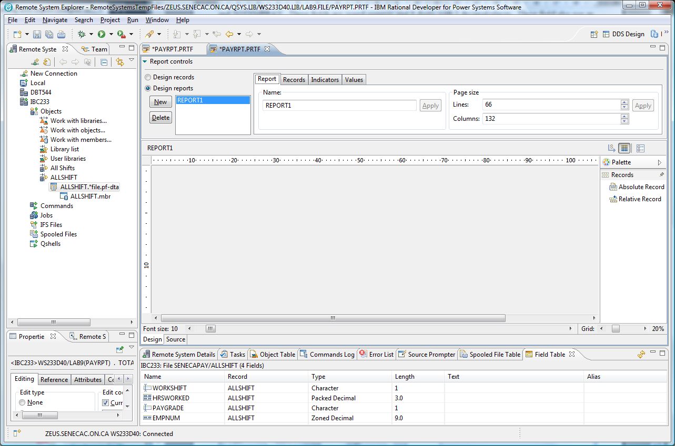

Click on the Records tab and use the Add button to add one record at a time in the proper order.

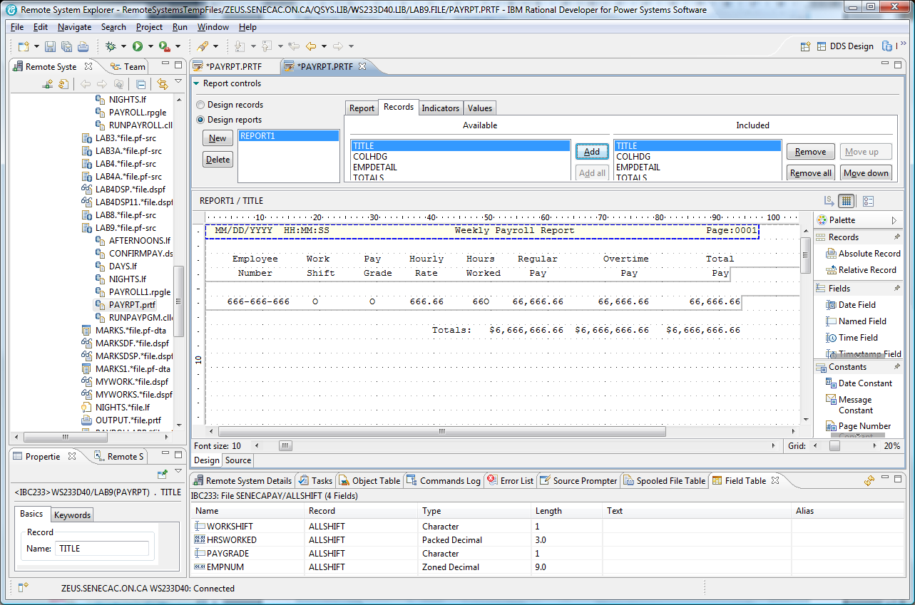

When you have added all the records, you can adjust where the fields line up or where the column headings line up by clicking on the record content.

After you have moved everything around so it appears similar to the last screenshot shown, save your work so it can be viewed by an instructor.

Your last step is to compile the DDS code that has been generated for you.

Click on the SOURCE tab in the DESIGN/SORUCE area and then using the top menu compile option with the CRTPTF command.

A successful compile produces an externally described file in your library that can be used by programs.

Object Type Attribute

PAYRPT *FILE PRTF

Any programmer can refer to this file in their program and they are relieved of entering the code that describes how the report will appear.