**Lab objectives:**

**- Use Screen Design Aid to produce a Menu**

**- Install LongRange on a mobile device and run RPGLE programs**

**Requirements to pass the lab:**

Demonstrate the completed menu in the screen shot below.

Demonstrate the Shipped demo on a mobile device (android, apple or windows)

Be able to navigate between Human Resource examples and Programming examples and be able to show source code on the device

This menu is called MYMENU and it is reached by typing Go MYMENU. Your menu will be your first name. For me I would type GO RUSS. Option 2 will be set up with prompting (simulate pressing F4)

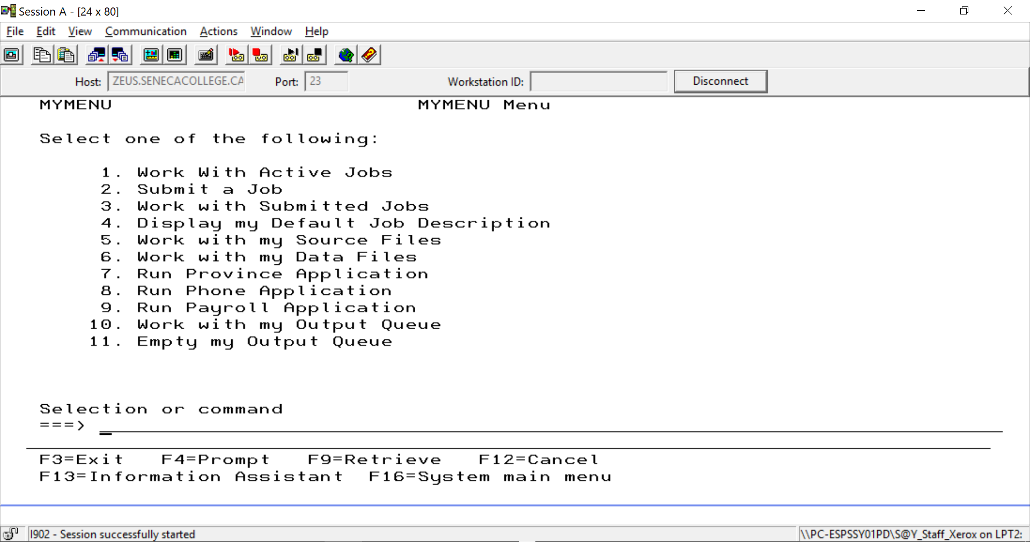

A demonstration was given in class on how to set up LongRange.

A demonstration was given in class on how to provide the menu.

This lab should be passed by everybody. It will involve a live demonstration of each task. Help will be provided for lab completion by the instructor when a student cannot solve the task.