**Lab objectives:**

**- Update a master file with adds/changes and deletes from a transaction file**

**- Use a CLLE driver program to automate testing of the update program**

**- View the journaled changes made to the master file**

**Requirements to pass the lab:**

All the parts for this application will be handed out. The RPGLE program, the CLLE driver program, and the master and transaction files. You need to adapt this application so you can update a master file in your own collection. **Successfully run the CLLE program updating data in a collection created by you and be able to show the add, update and delete journaled changes.**

Call RunLab7

SALESSTAF2 – data comes from SALESSTAFF in BCI433LIB

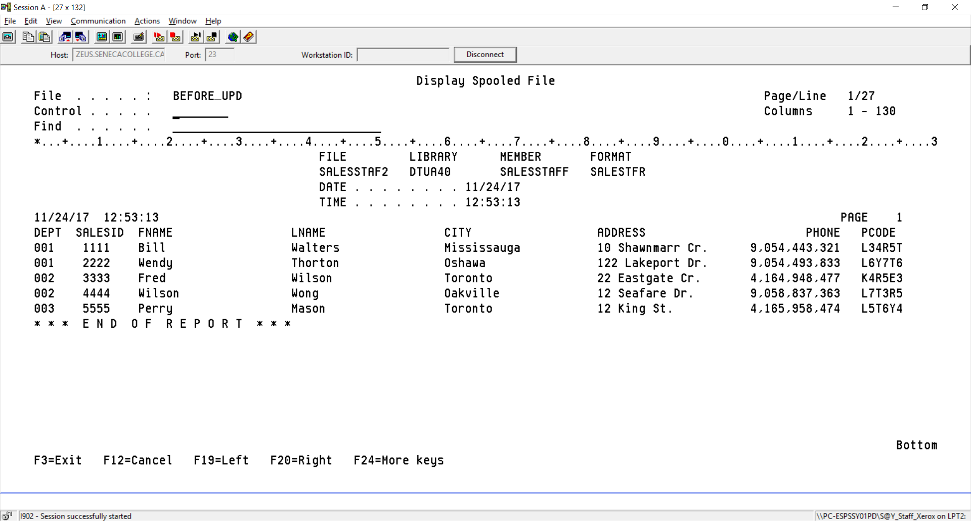

Transaction File SALESTRANS in BCI433LIB indicates adds, changes and deletes to your SALESTAFF table

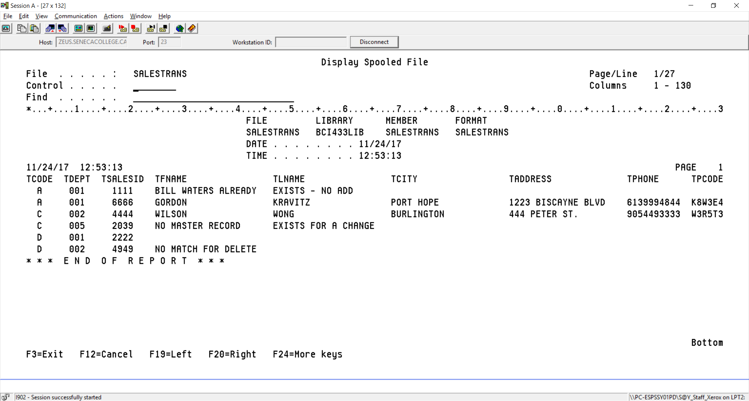

Report on what occurred when implementing the updates from the transaction file

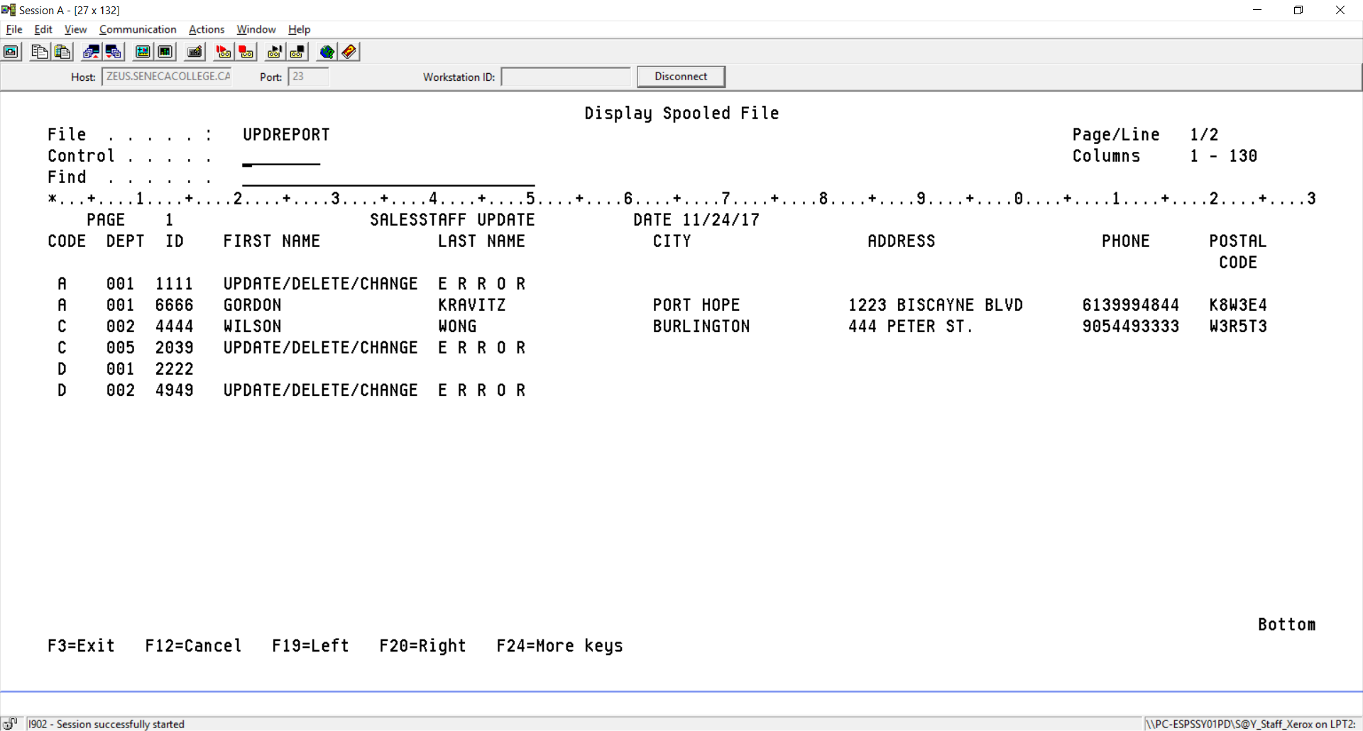

SALESTAFF after the updates were applied by your program

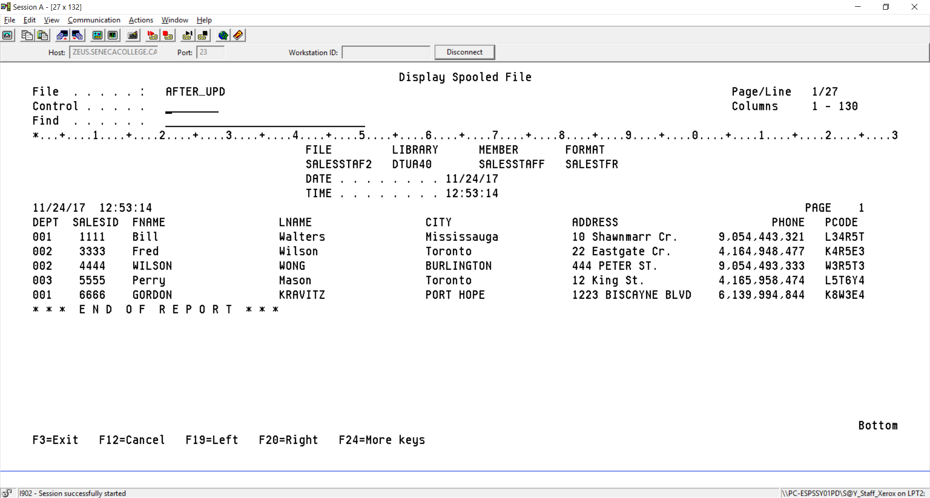

All the spooled files generated with meaningful names.

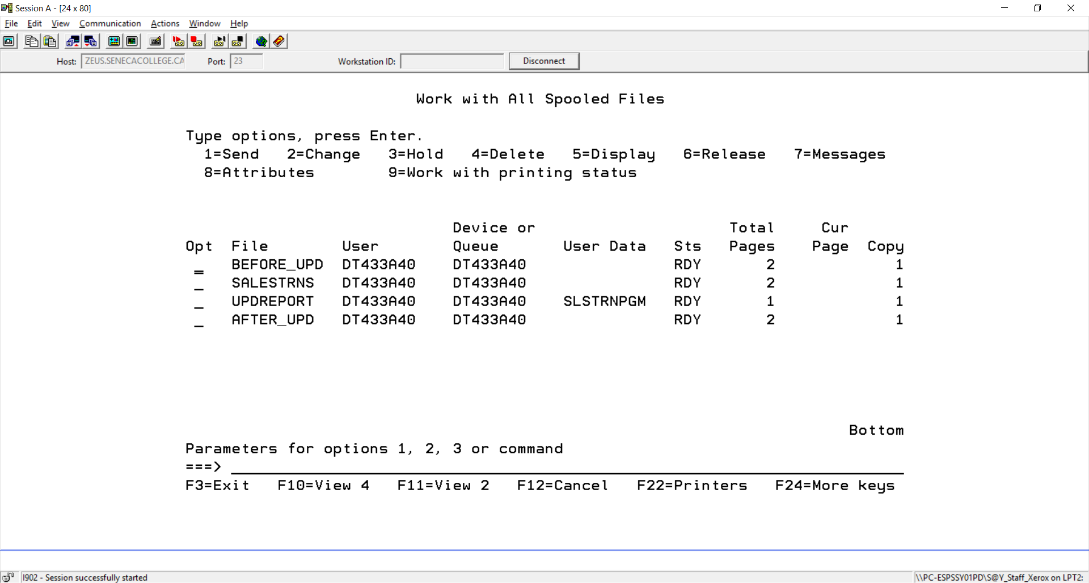

The transactions are journaled

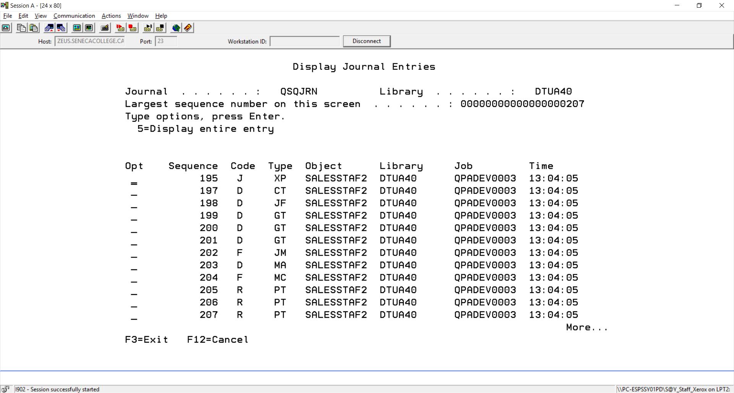

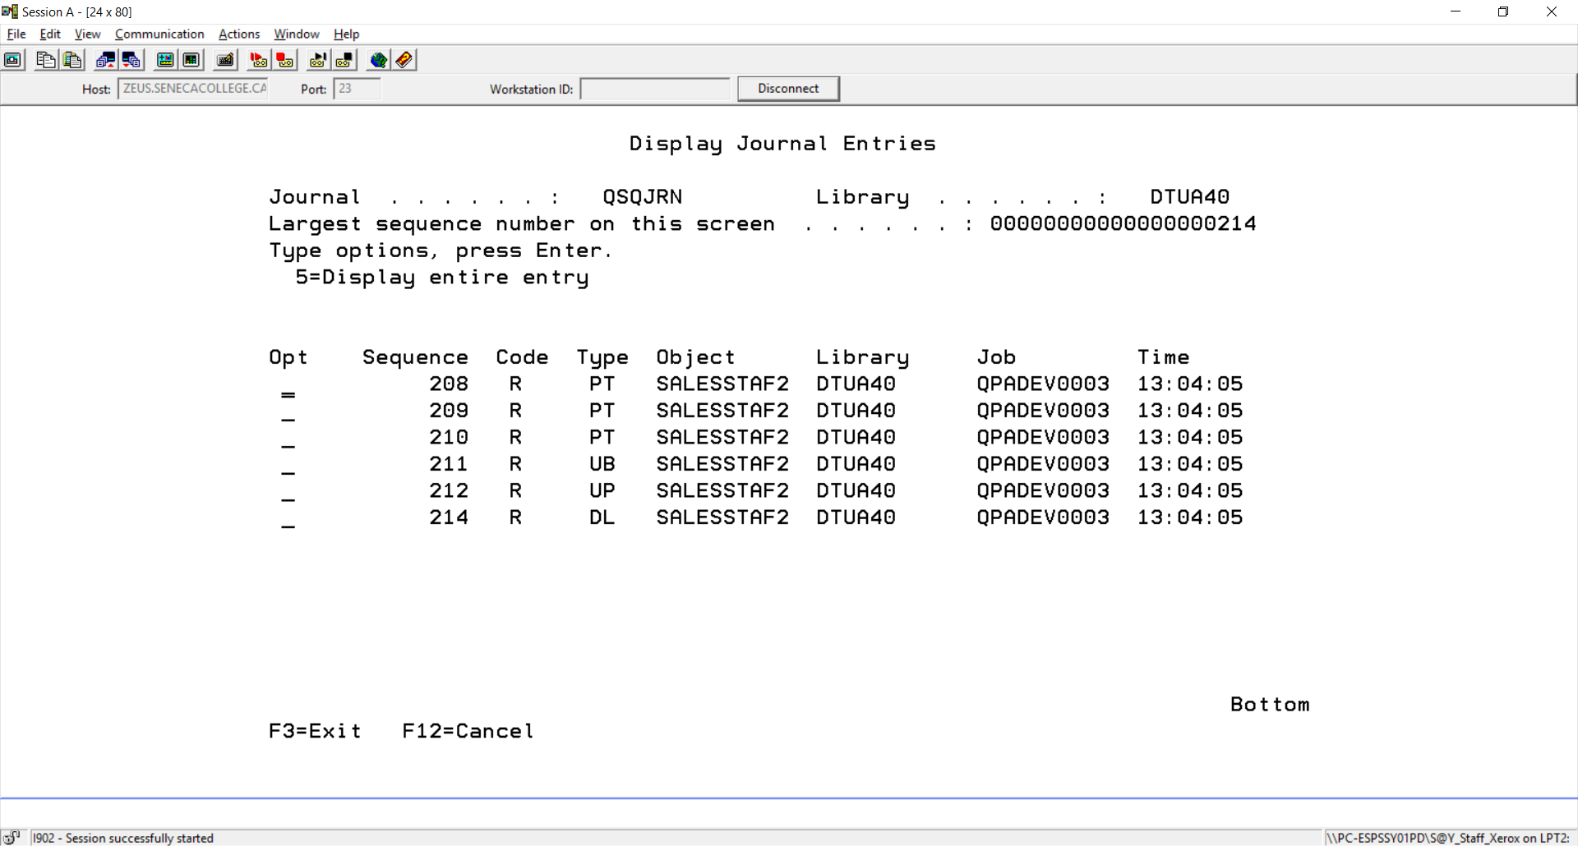

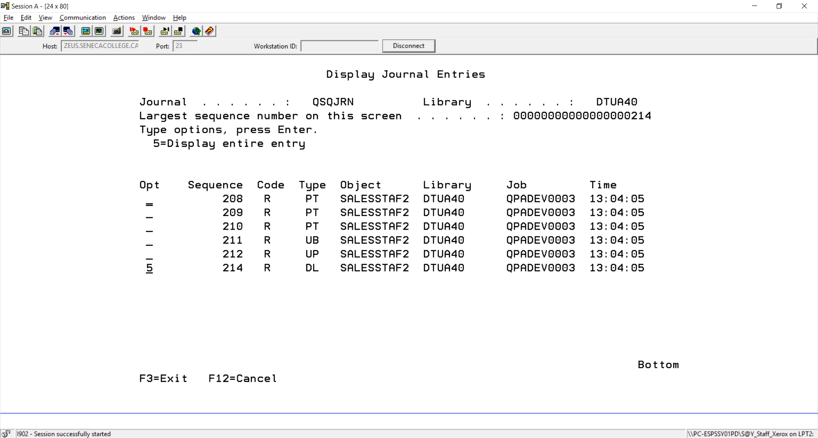

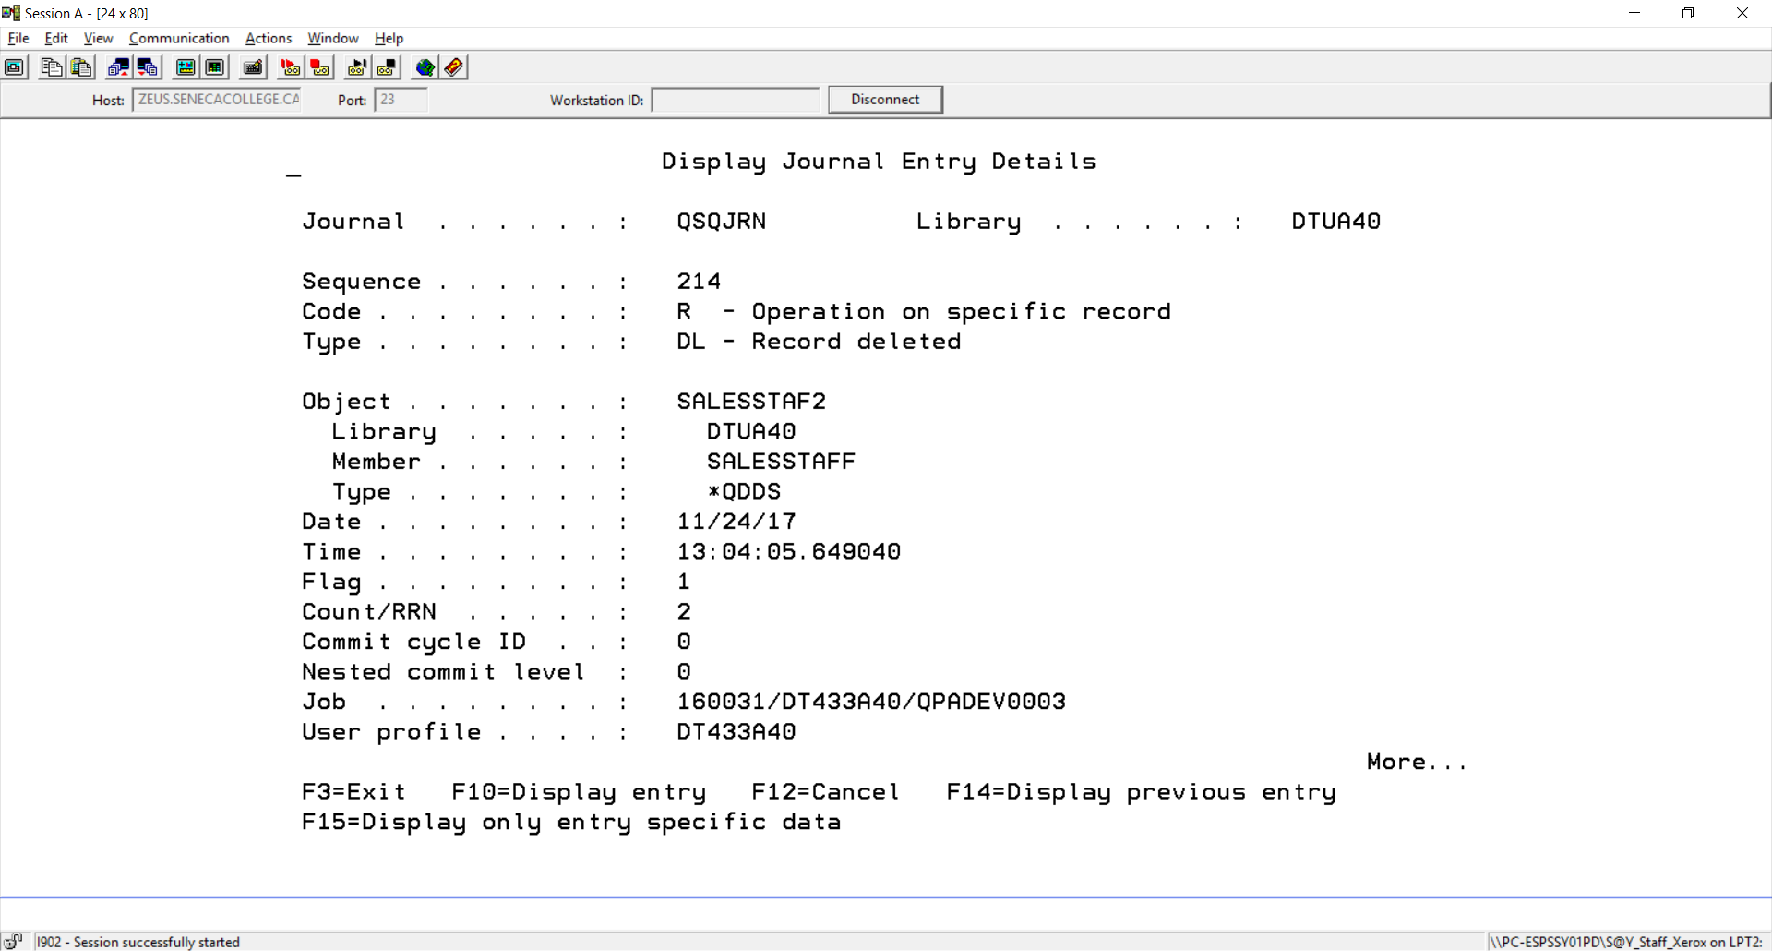

Steps to successfully run lab 7

1. Create a source physical file called LAB7
2. Create a collection using parts of your id (mine is DM433B40 so I will use DM and B40. The U stands for update and is common for all ids.

CREATE COLLECTION DMUB40

3. Copy the provided code in BCI433LIB/Lab7Code. The RPGLE program is called SLSTRNPGM and the CLLE program is called RUNLAB7. Study these programs. The code has been supplied for both on the next pages. You will need to write out four lines that will be provided in class for each program. These will be included in your copied members before compiling.

4. Also change the CLLE code so it refers to your data, journal and output queue.

RPGLE program to apply the updates

FSALESTRANSIF E DISK RENAME(SALESTRANS:SALESTRANR)

FSALESSTAF2UF A E K DISK

FQPRINT O F 132 PRINTER OFLIND(*INOF)

D SALESTRANSDS DS

D TDEPT

D TSALESID

D TFNAME

D TLNAME

D TCITY

D TADDRESS

D TPCODE

D SALESSTAF2DS DS

D DEPT

D SALESID

D FNAME

D LNAME

D CITY

D ADDRESS

D PCODE

D FullKey DS LikeRec(SALESTFR: *Key)

C/FREE

EXCEPT HEADINGS;

READ SALESTRANS;

DOW NOT %EOF;

_____________________________________________________________

_____________________________________________________________

SELECT;

WHEN %FOUND(SALESSTAF2);

SELECT;

WHEN TCODE = 'C';

EXSR CHGREC;

WHEN TCODE = 'D';

EXSR DELREC;

OTHER;

EXSR ERROR;

ENDSL;

WHEN NOT %FOUND(SALESSTAF2);

IF TCODE = 'A';

EXSR ADDREC;

ELSE;

EXSR ERROR;

ENDIF;

WHEN %ERROR;

EXSR ERROR;

ENDSL;

EXCEPT DETAIL;

READ SALESTRANS;

ENDDO;

*INLR = *ON;

RETURN;

BEGSR ADDREC;

______________________________________________

______________________________________________

WRITE SALESTFR;

ENDSR;

BEGSR CHGREC;

SALESSTAF2DS = SALESTRANSDS;

Phone = %Dec(TPhone:10:0);

UPDATE SALESTFR;

ENDSR;

BEGSR DELREC;

DELETE SALESTFR;

ENDSR;

BEGSR ERROR;

TFNAME = 'UPDATE/DELETE/CHANGE';

TLNAME = 'E R R O R';

ENDSR;

/END-FREE

OQPRINT E HEADINGS 2 02

O 8 'PAGE'

O PAGE 13

O

50 'SALESSTAFF UPDATE'

O 64 'DATE'

O UDATE Y 73

O E HEADINGS 1

O 4 'CODE'

O 10 'DEPT'

O 14 'ID'

O 28 'FIRST NAME'

O 49 'LAST NAME'

O 66 'CITY'

O 91 'ADDRESS'

O 113 'PHONE'

O 125 'POSTAL'

O E HEADINGS 2

O 124 'CODE'

O E DETAIL 1

O TCODE 2

O TDEPT 9

O TSALESID 15

O TFNAME 38

O TLNAME 60

O TCITY 82

O TADDRESS 102

O TPHONE 116

O TPCODE 125

CLLE driver program

/* This program will not work until have it refer to your own collection and userprofile */

PGM

DLTF **DMUB40**/SALESSTAF2

MONMSG MSGID(CPF2105)

______________________________________________________________________

______________________________________________________________________

______________________________________________________________________

______________________________________________________________________

CLROUTQ **DM433B40**

OVRPRTF FILE(QPQUPRFIL) SPLFNAME(BEFORE_UPD)

RUNQRY *NONE **DMUB40**/SALESSTAF2 *PRINTER

OVRPRTF FILE(QPQUPRFIL) SPLFNAME(SALESTRANS)

RUNQRY *NONE BCI433LIB/SALESTRANS *PRINTER

OVRPRTF FILE(QPRINT) SPLFNAME(UPDREPORT)

OVRDBF SALESSTAF2 **DMUB40**/SALESSTAF2

CALL SLSTRNPGM

OVRPRTF FILE(QPQUPRFIL) SPLFNAME(AFTER_UPD)

RUNQRY *NONE **DMUB40**/SALESSTAF2 *PRINTER

DSPSPLF BEFORE_UPD

DSPSPLF SALESTRANS

DSPSPLF UPDREPORT

DSPSPLF AFTER_UPD

WRKOUTQ **DM433A40**

DSPJRN JRN(**DMUB40**/QSQJRN) FILE((DTUB40/SALESSTAF2))

ENDPGM