**Lab objectives:**

**Create an RPGLE program that reads from a WORKWEEK table and updates the EMPLOYEE table.**

**Create a CLLE program to facilitate marking your update program that processes a WORKWEEK1 and WORKWEEK2 file with the same update program.**

**Requirements to pass the lab:**

Successfully run the CLLE Payroll update program.

INPUT from the SENECAPAY library:

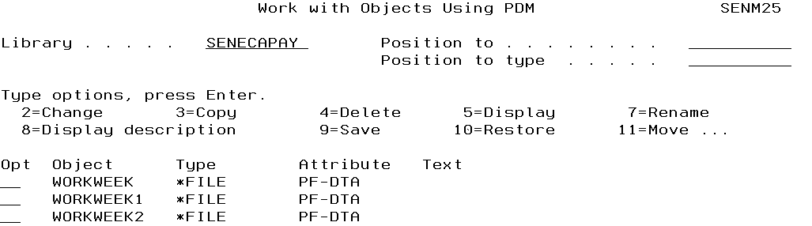

File to be updated is in your library. (copied from SENECAPAY library)

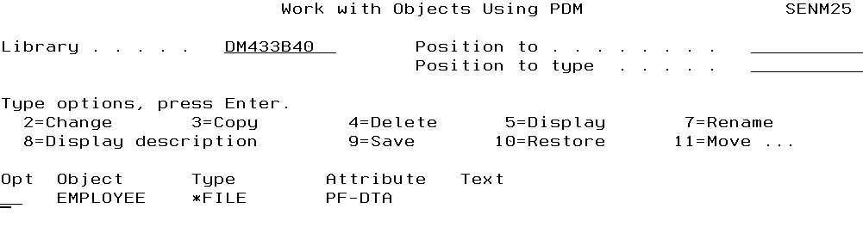

Copy your successfully completed Lab 5 RPGLE program, Printer DDS and Display file DDS code to a source physical file called LAB8. Rename the RPGLE program PAYROLLPGU, the Printer DDS code as PAYRPTU and the Display File DDS code as CONFIRMPYU.

Adapt the RPGLE program to update an EMPLOYEE file when doing the payroll report.

Code a CLLE driver program to do the following:

1. Show what is in your EMPLOYEE table (**copied from SENECAPAY to your library**) and always refreshed with the original data from SENECAPAY/EMPLOYEE. This is not all the columns in the EMPLOYEE table. You will have a view that provides information on the following columns.

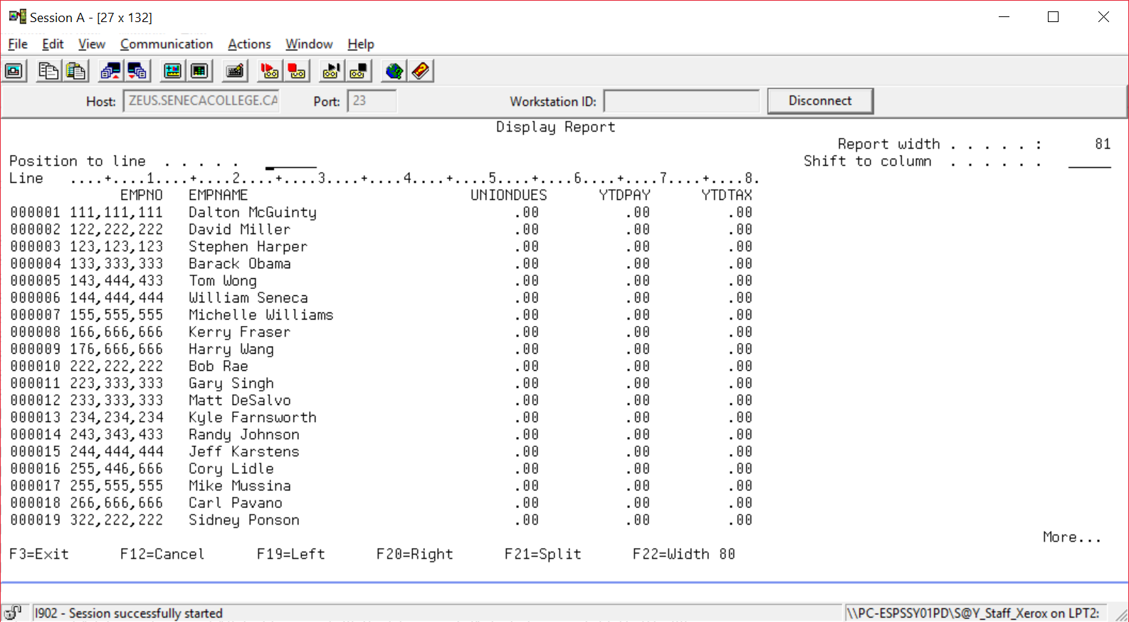

1. Set up and run your update program (adapted from your lab 5 payroll program) This RPGLE update program will process a WORKWEEK table stored in SENECAPAY. The WORKWEEK table is missing the PAYGRADE field that was stored in ALLFHIFT. You will have to look up the EMPLOYEE record using the employee number from WORKWEEK to find out the corresponding PAYGRADE stored in EMPLOYEE.

Three screens will show. First the CONFIRMPYU screen similar to the one used in the LAB5 PAYROLLPGM, then the report generated from doing the payroll and then the view that you have created that shows selected columns from your EMPLOYEE table to prove that table was updated with the payroll amounts.

CONFIRMPYU – is similar to the CONFIRMPAY display file. It has a 25 character field the indicates the work week number.

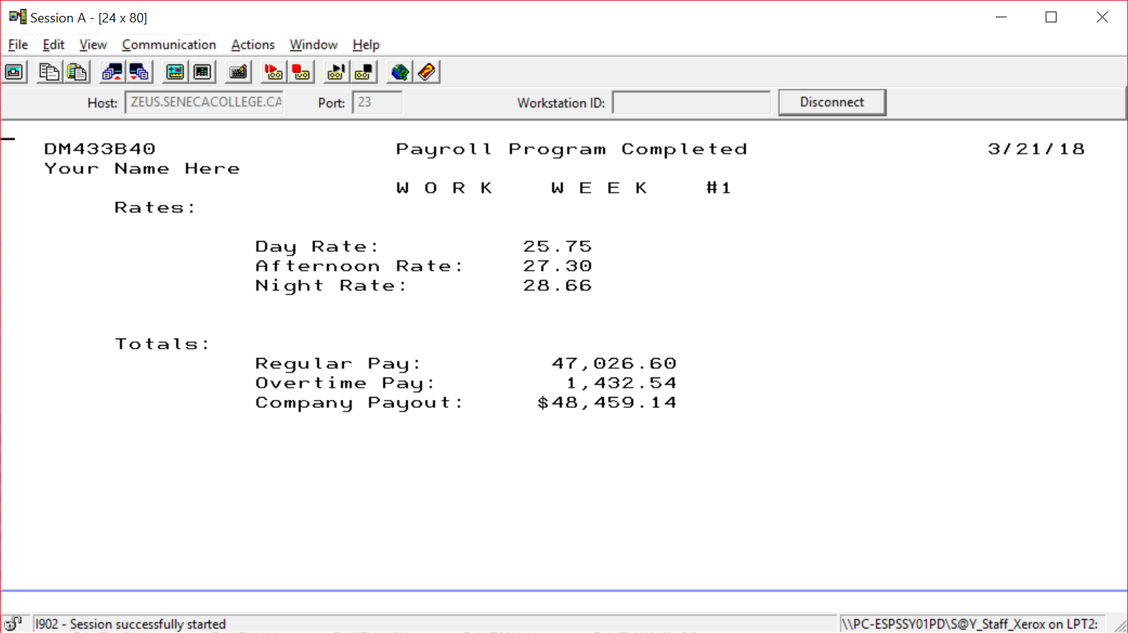

PAYRPTU is similar to PAYRPT. It also has a 25 character field that indicates the work week number. It also includes two new columns with column totals. The Tax deducted and the net pay.

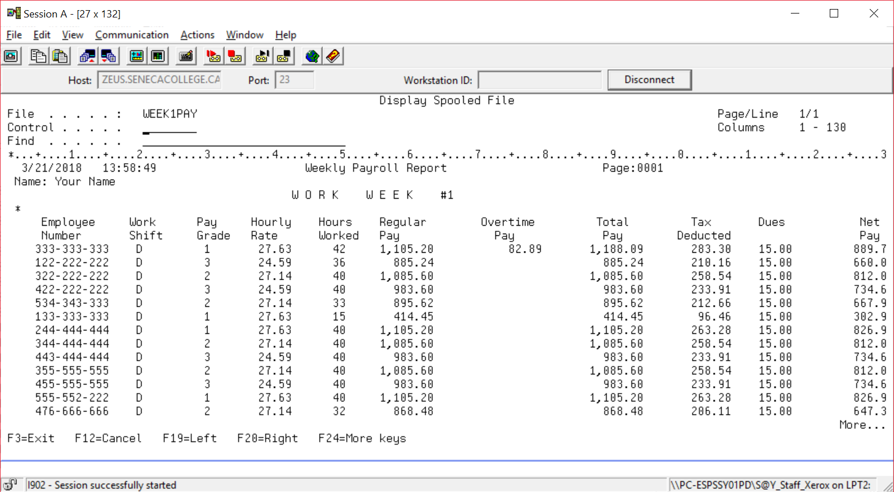

Code needs to be adapted in the copied Lab8 program to update each employee record with the pay earned by the employee for the week and along with a tax of 24.15% is applied to employees pay. Also union dues are collected each week. This amount is passed to the CLLE program that processes a WORKWEEK1 file and a WORKWEEK 2 file. In the screenshot below, $15.00 a week was passed as a paramter at run time for union dues.

==>CALL RUNUPDATE 15.00 (this was done at the start – we are in the middle of the driver program with the screenshot below

Net Pay amounts are not stored in the employee table.

Here is the EMPLOYEE table view that shows the updated fields for each employee.

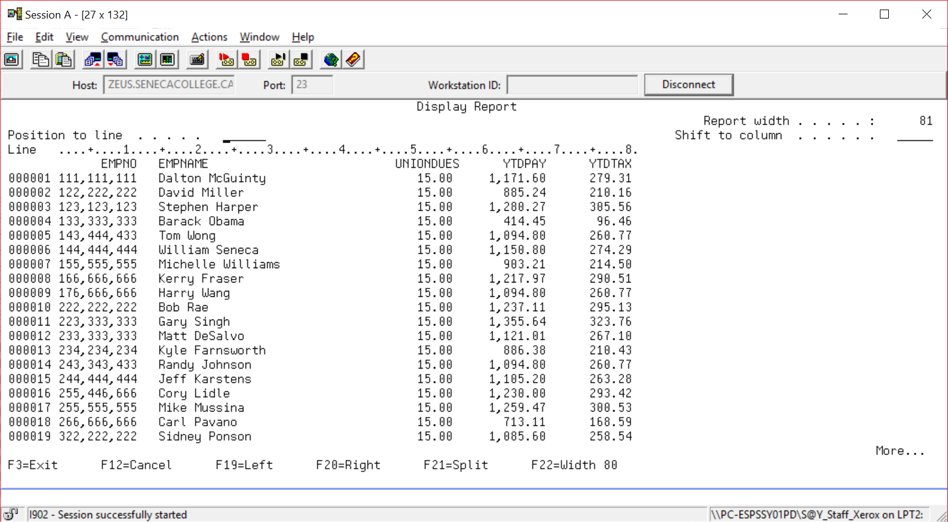

Your update program should then process a file called WORKWEEK2. Several screens will show for this step. First the CONFIRMPYU screen, then the report generated and the view you created to reflect the updates.

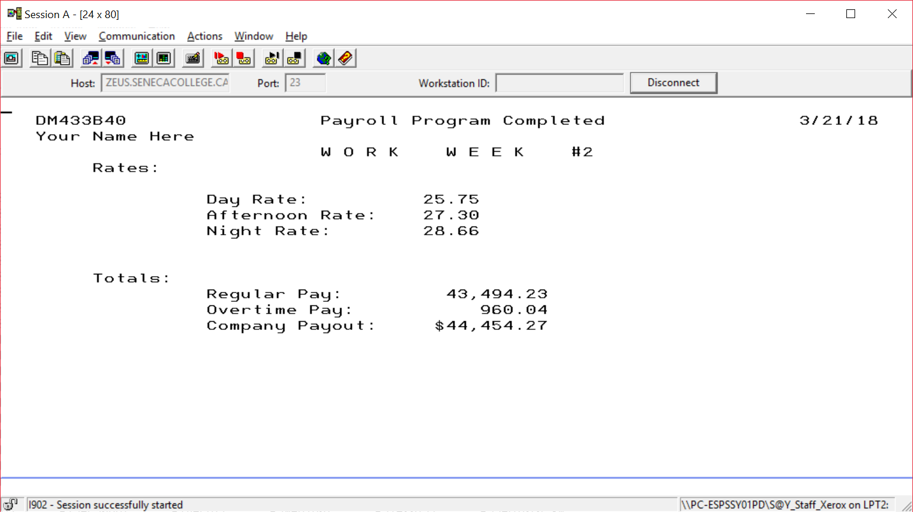

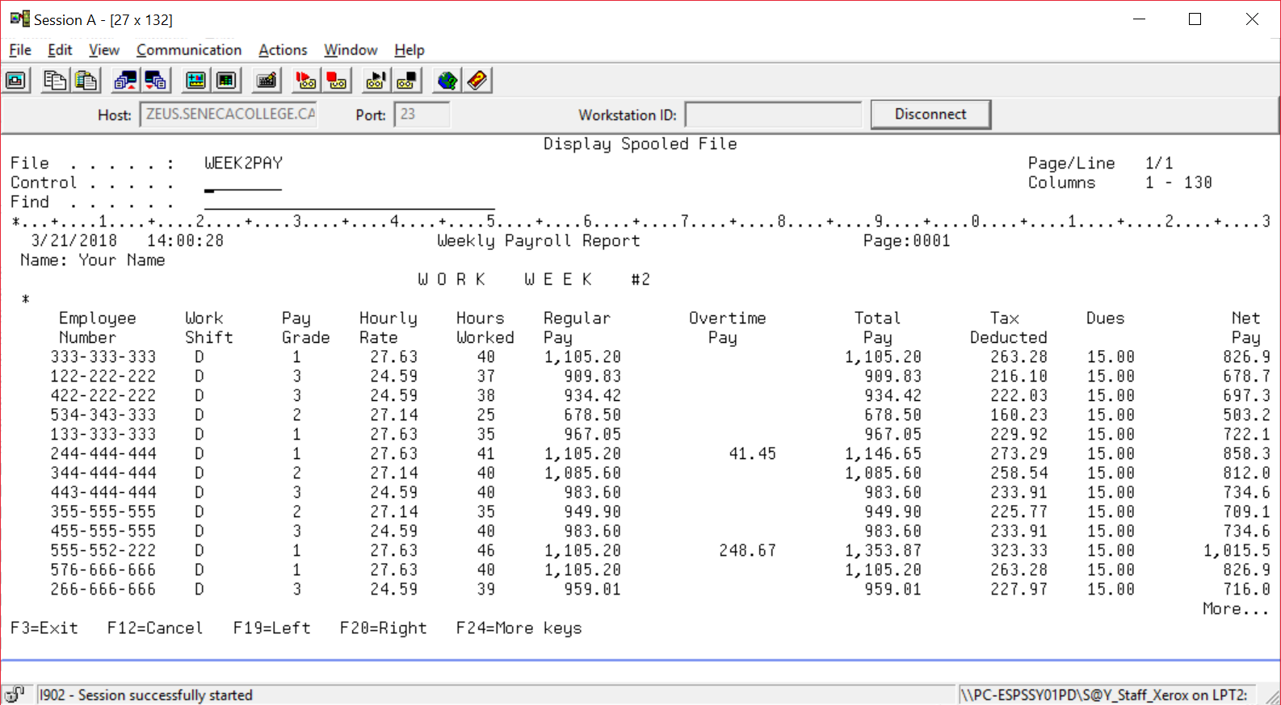

The EMPLOYEE file will now have had two updates applied.

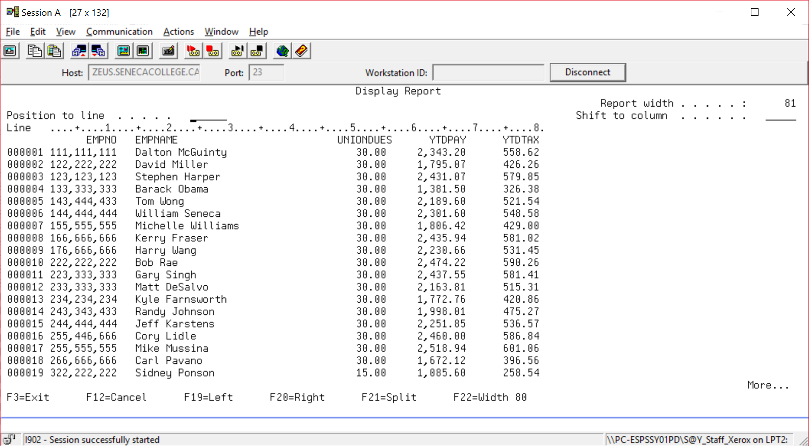

The names for the report should be adaptable depending on the workweek file being processed.

After displaying the spooled file contents, show the cleared output queue with the two reports.

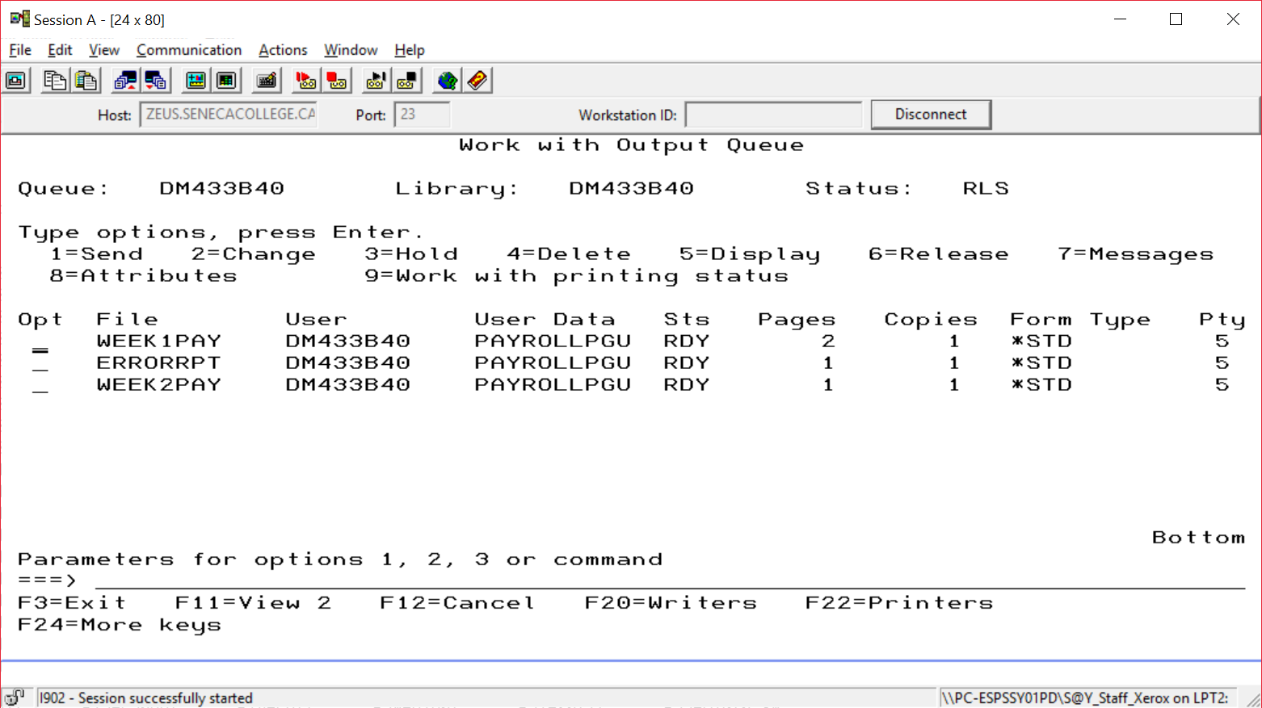

If a workweek record has no matching employee record, an error report is generated. This happened with some problem records in the WORKWEEK2 file.

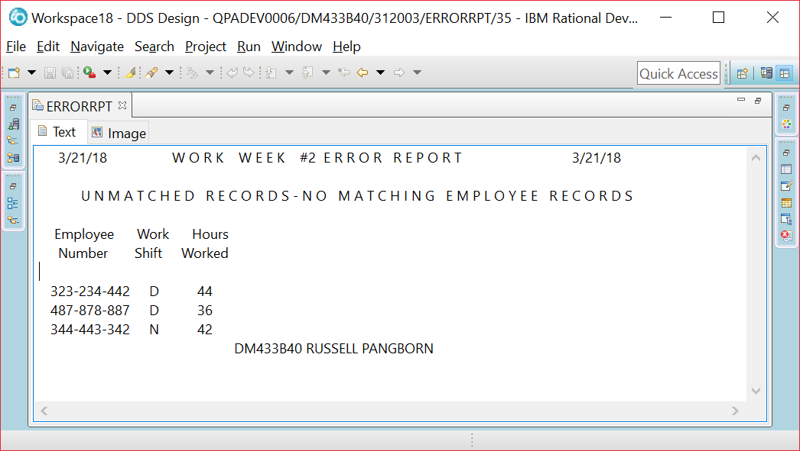

Here is how a report should look when displayed using Rdi.

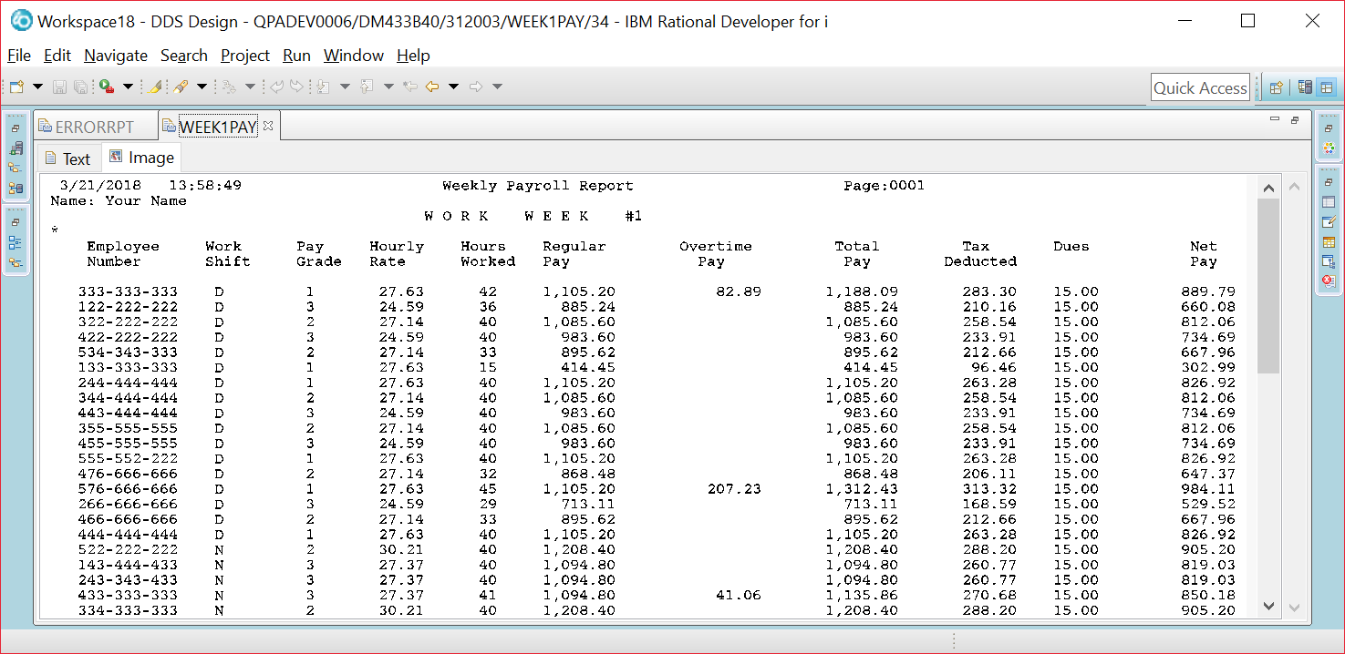

The EMPLOYEE table fields

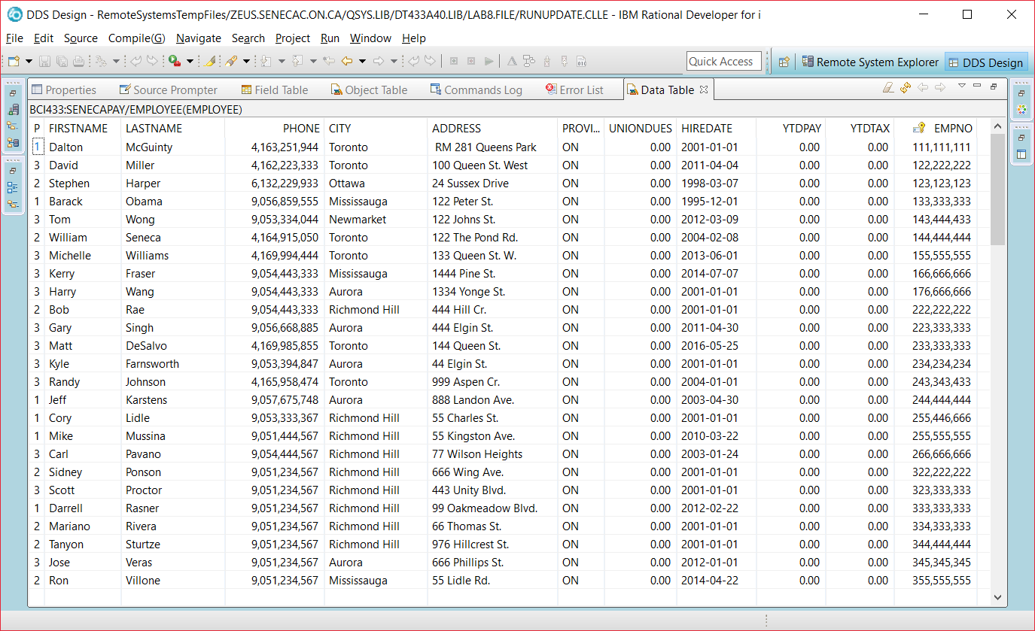

The WORKWEEK table fields

