**Lab objectives:**

**- Embed SQL statements in two RPGLE programs**

**- Provide related RPGLE code for the embedded SQL statements**

**Requirements to pass the lab:**

Successfully run the PhoneSQL program after copying supplied code and then adding the embedded SQL code and related RPGLE code that was given out in class.

Successfully run the ProvSQL SQL cursor program after copying supplied code and then adding the embedded SQL code and realated RPGLE code that was given out in class.

PhoneSQL

Input:

CONTACTW18 (accessed through embedded SQL statements)

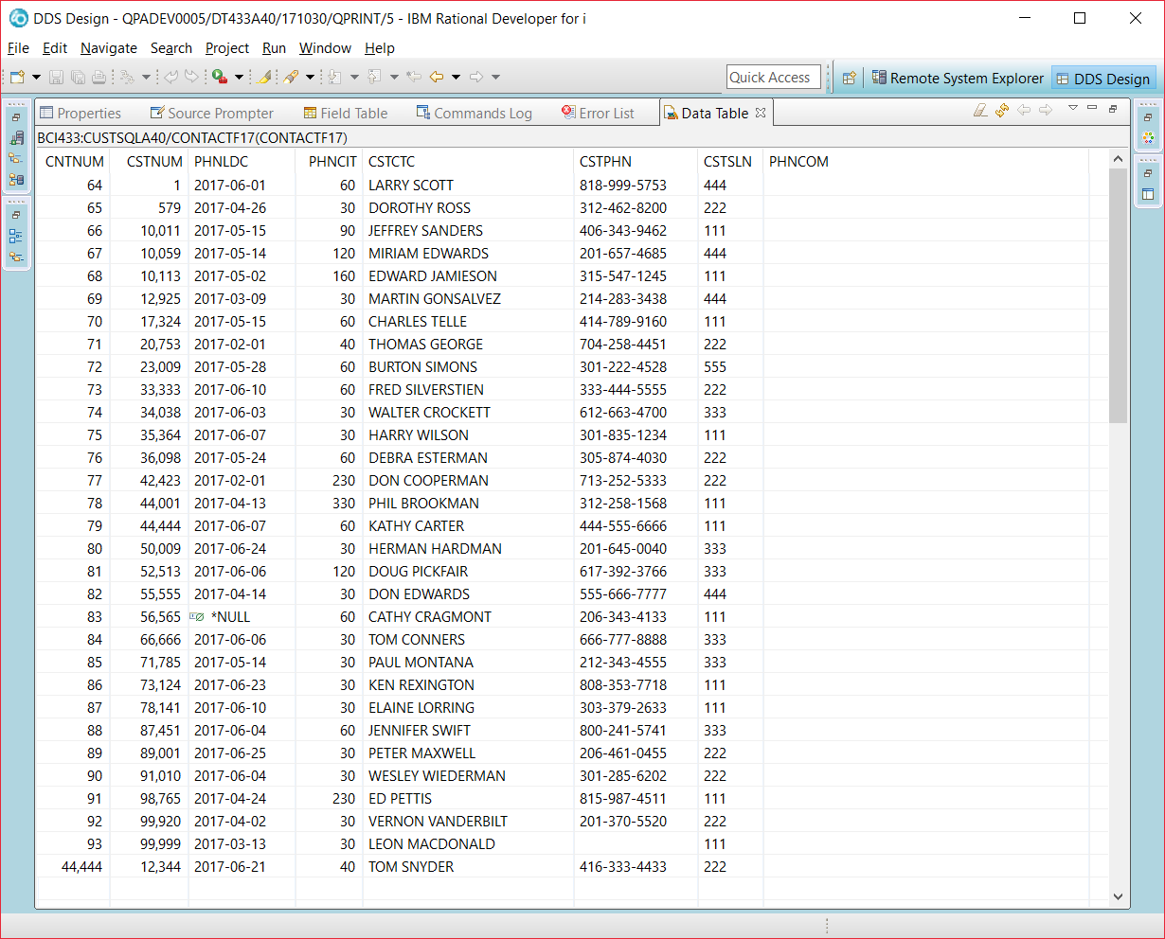

CUSTOMER18 (accessed by RPGLE read statement)

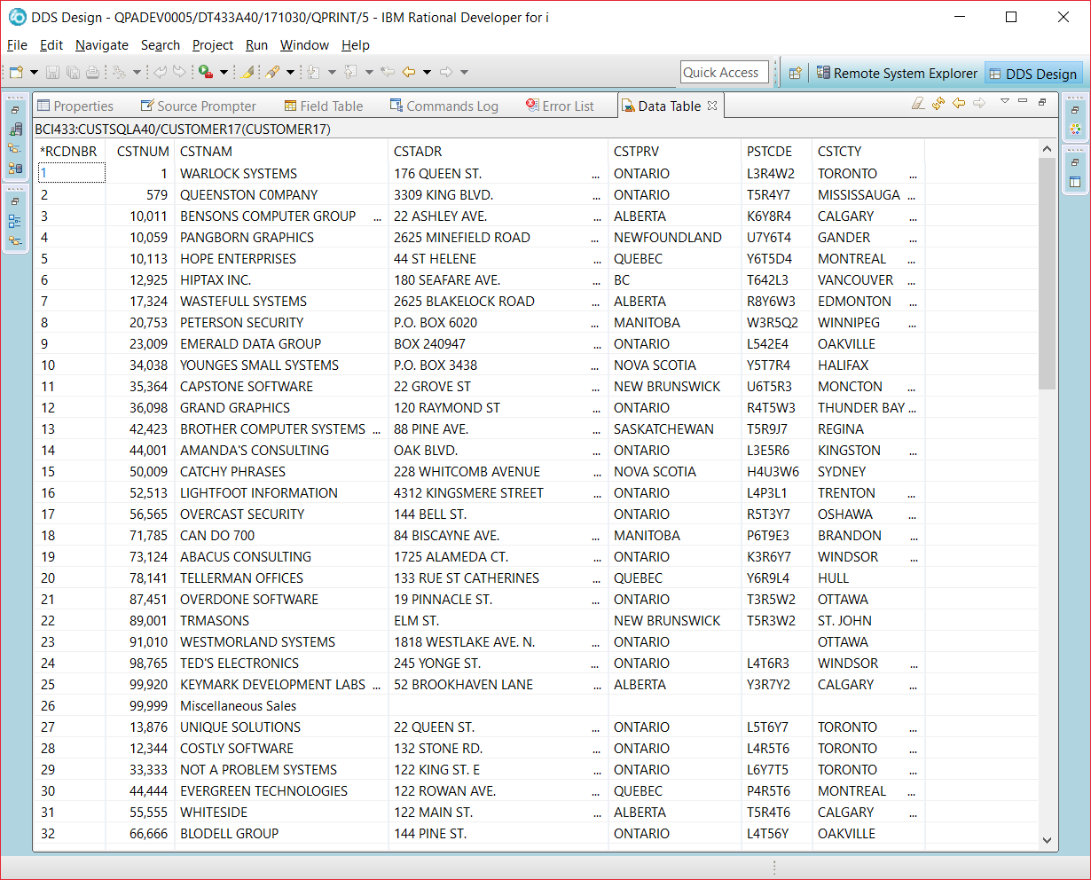

Output:

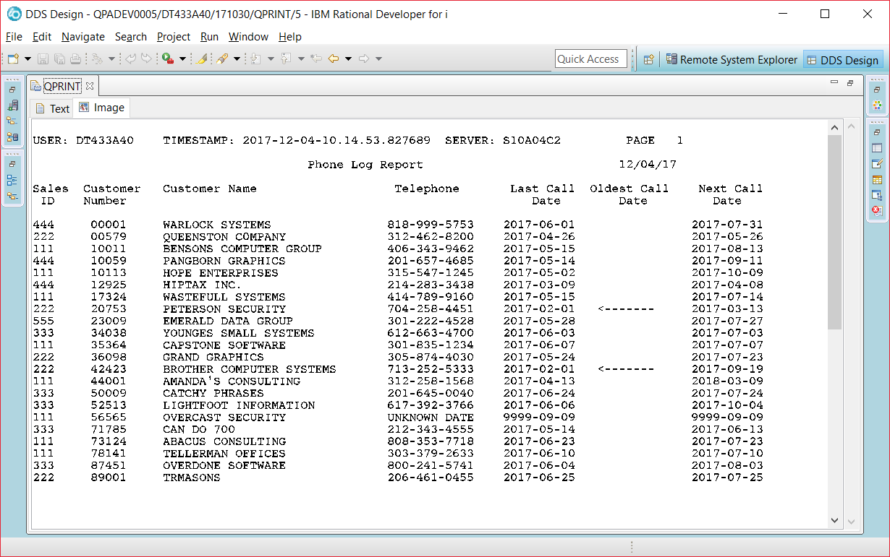

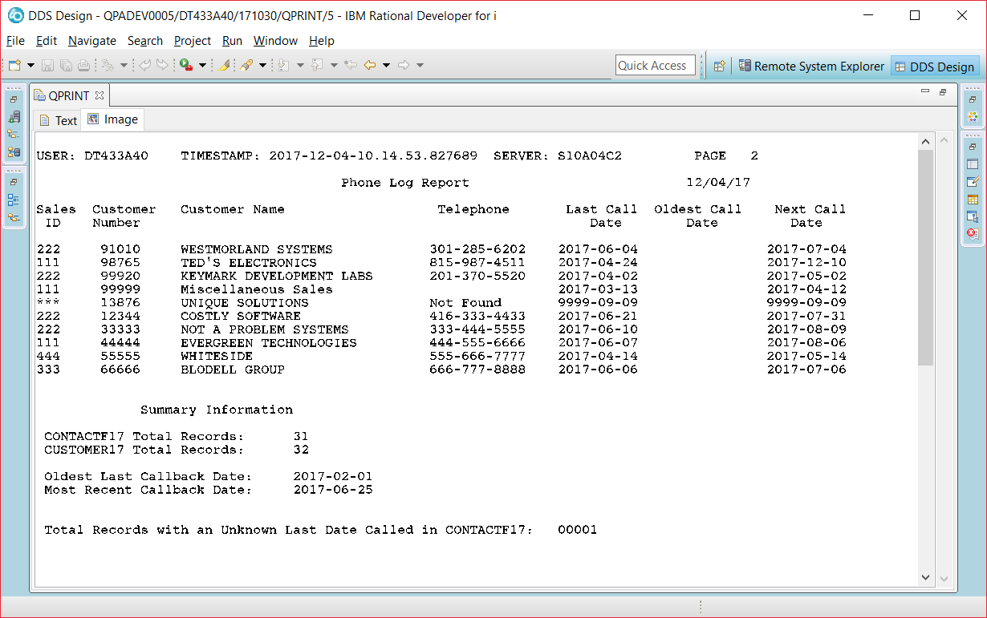

F**************************************************************************

F* CUSTOMER18 READ BY NATIVE LANGUAGE (ILE RPG)

F* CONTACTW18 ROW RETRIEVED WITH EMBEDDED SQL

F* DETAIL REPORT LINE INCLUDES INFORMATION FROM CUSTOMER18 AND CONTACTW18

F* SUMMARY REPORT INFORMATION RETRIEVED WITH EMBEDDED SQL STATEMENTS

F**************************************************************************

FCUSTOMER18IF E DISK RENAME(CUSTOMER18:CUSTOMERRF)

FQPRINT O F 132 PRINTER OFLIND(*INOF) FORMOFL(30) FORMLEN(66)

D* H O S T V A R I A B L E S

D* __________________________________??

D ContactTotal S 5 0

D CustomerTotal S 5 0

D UnknownTotal S 5 0

D OldestDate S D

D MostRecentDate S D

D User S 10

D Server S 10

D TimeStamp S Z

D DateIn S 5 0

D* I N D I C A T O R V A R I A B L E S

D* _____________________________________??

D* _____________________________________??

D Dummy S 1 0

D Flag S 7

D NextCallDate S D

C/EJECT

C**************************************************************************

C* *** M A I N R O U T I N E ***

C**************************************************************************

/FREE

EXSR SummaryInfo;

EXCEPT HEADINGS;

READ CUSTOMER18;

DOW NOT %EOF;

EXSR SQLSelect;

IF *INOF = *ON;

EXCEPT HEADINGS;

*INOF = *OFF;

ENDIF;

EXCEPT DETAIL;

READ CUSTOMER18;

ENDDO;

EXCEPT TOTALS;

*INLR = *ON;

RETURN;

//*************************************************************************

// S Q L S E L E C T S U B R O U T I N E

//********************************************************************

// A row from the contacts table has the same customer number found in the record

// read from the CUSTOMER18 file. That row is retrieved to find out the last date

// called, phone number, comments and the salesperson number.

// The call back interval is added to the last date called to determine the

// next date to call. Since null values may be stored in the last date called

// indicator variables are used.

ENDSR ;

//**********************************************************************

// S U M M A R Y I N F O S U B R O U T I N E

//**********************************************************************

BEGSR SummaryInfo;

// D E T E R M I N E T O T A L S F O R CONTACTW18 & CUSTOMER18

// D E T E R M I N E N U M B E R O F U N K N O W N L A S T D A T E

// C A L L E D R E C O R D S

// D E T E R M I N E O L D E S T & M O S T R E C E N T L A S T

// C A L L B A C K D A T E S

// D E T E R M I N E T H E U S E R, S E R V E R, & T I M E S T A M P

/END-FREE

OQPRINT E HEADINGS 2 02

O 5 'USER:'

O USER 16

O 28 'TIMESTAMP:'

O TIMESTAMP 55

O 64 'SERVER:'

O SERVER 75

O 87 'PAGE:'

O PAGE 90

O E HEADINGS 2

O 54 'Phone Log Report'

O UDATE Y 89

O E HEADINGS 1

O 5 'Sales'

O 15 'Customer'

O 31 'Customer Name'

O 59 'Telephone'

O 75 'Last Call'

O 88 'Oldest Call'

O 101 'Next Call'

O E HEADINGS 2

O 3 'ID'

O 13 'Number'

O 73 'Date'

O 85 'Date'

O 98 'Date'

O E DETAIL 1

O CSTSLN 3

O CSTNUM 13

O CSTNAM 48

O CSTPHN 64

O PHNLDC 75

O FLAG 86

O NextCallDate 101

O E TOTALS 2 2

O 32 'Summary Information'

O E TOTALS 1

O 26 'CONTACTW18 Total Records:'

O ContactTotal 1 34

O E TOTALS 1

O 26 'CUSTOMER18 Total Records:'

O CustomerTotal 1 34

O E TOTALS 1 1

O 27 'Oldest Last Callback Date:'

O OldestDate 42

O E TOTALS 1

O 27 'Most Recent Callback Date:'

O MostRecentDate 42

O E TOTALS 2 1

O 22 'Total Records with an'

O 47 'Unknown Last Date Called'

O 62 'in CONTACTW18:'

O UnknownTotal 70

ProvSQL

INPUT (from three tables)

Manitoba Customers

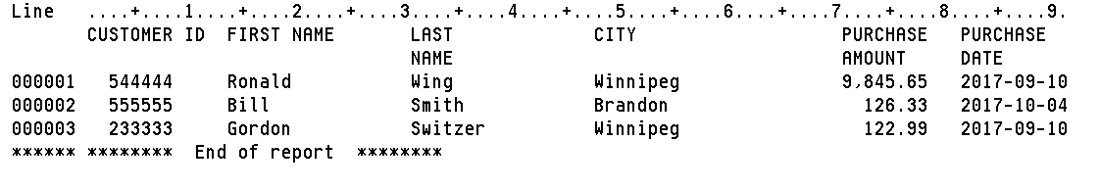

Ontario Customers

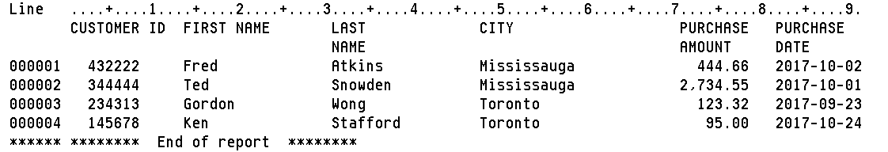

Quebec Customers

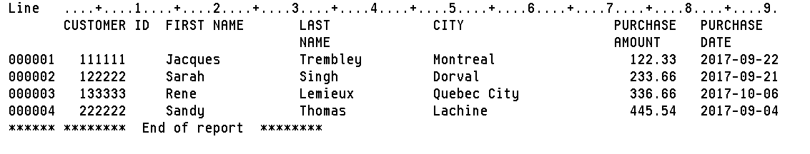

OUTPUT:

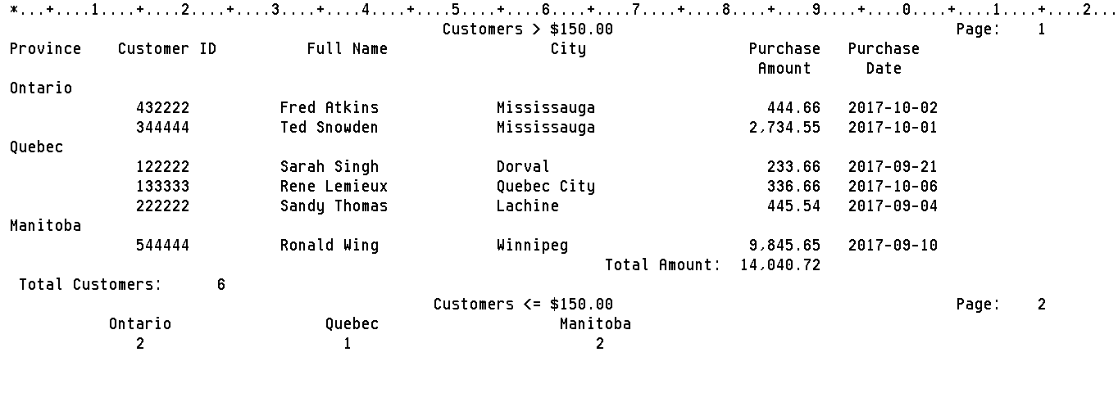

PROGRAM:

F************************************************************************************ F* THIS PROGRAM USES A CURSOR TO LOAD A TEMPORARY RESULT TABLE THAT JOINS THE ORDERS,

F* ORDERLINE, CUSTOMER, PART AND SALESREP TABLES. ORDER NUMBER IS USED AS A CONTROL*

F* BREAK FIELD WHERE CUSTOMER TOTALS ARE PRINTED ON NEW ORDER NUMBERS * F************************************************************************************

FQPRINT O F 132 PRINTER OFLIND(*INOF) FORMOFL(60) FORMLEN(66)

D CustomerRecord DS

D CustId 6

D FullName 31

D City 20

D Purchase 7 2

D PDate D

D Province 10

D ProvinceH S 10

D TotalCost S 8 2

D TotalRecords S 5 0

D TotalExtended S 9 2

D OntarioTot S 3 0

D QuebecTot S 3 0

D ManitobaTot S 3 0

D EndOfFile S N

C/EJECT

C************************************************************************************

C* *** M A I N R O U T I N E *** *

C************************************************************************************

/FREE

EXSR PrepareFiles;

EXCEPT HEADINGS;

EXSR GetRow;

Except NewProv;

ProvinceH = Province;

DOW NOT EndOfFile;

IF *INOF = *ON;

EXCEPT HEADINGS;

*INOF = *OFF;

ENDIF;

If ProvinceH = Province;

Except Detail;

Else;

ProvinceH = Province;

Except NewProv;

Except Detail;

EndIf;

TotalCost = TotalCost + Purchase;

TotalRecords= TotalRecords + 1;

EXSR GetRow;

ENDDO;

EXSR WRAPUP;

EXCEPT Totals;

*INLR = *ON;

RETURN;

// O P E N F I L E S S U B R O U T I N E

BEGSR PrepareFiles;

// S E T U P T H E T E M P O R A R Y R E S U L T S T R U C T U R E

// A T E M P O R A R Y R E S U L T T A B L E I S C R E A T E D

ENDSR;

// G E T R O W S U B R O U T I N E

BEGSR GETROW;

ENDSR;

// W R A P U P S U B R O U T I N E

BEGSR WRAPUP;

ENDSR;

/END-FREE

OQPRINT E HEADINGS 2 02

O 67 'Customers > $150.00'

O 110 'Page:'

O PAGE 115

O E HEADINGS 1

O 8 'Province'

O 23 'Customer ID'

O 42 'Full Name'

O 64 'City'

O 90 'Purchase'

O 101 'Purchase'

O E HEADINGS 2

O 89 'Amount'

O 99 'Date'

o E NewProv 1

O Province 10

o E DETAIL 1

O CustID 20

O FullName 61

O City 74

O Purchase 1 90

O PDate 103

O E Totals 2 1

O 79 'Total Amount:'

O TotalCost 1 90

O E Totals 1 1

O 17 'Total Customers:'

O TotalRecords 1 24

O E TOTALS 2 02

O 67 'Customers <= $150.00'

O 110 'Page:'

O PAGE 115

O E Totals 2

O 18 'Ontario'

O 41 'Quebec'

O 69 'Manitoba'

O E Totals 1

O OntarioTot 1 15

O QuebecTot 1 38

O ManitobaTot 1 66