**Installation Guide for IBM Rational Developer for i Ver9.6 (RDi9.6)**

* Download "**RDi V9.6 - Activation**", "**RDi V9.6 - Install 1**", and "**RDi V9.6 - Install 2**" files from ITS [Software Downloads](https://inside.senecacollege.ca/its/software/) – **iSeries**,
* Unzip "**RDi V9.6 - Install 1**", and "**RDi V9.6 - Install 2**" zip files then move the “**disk1**” and “**disk2**” folders into a single folder.
* Go to “**disk1**” folder drive and click on ***Launchpad.exe***

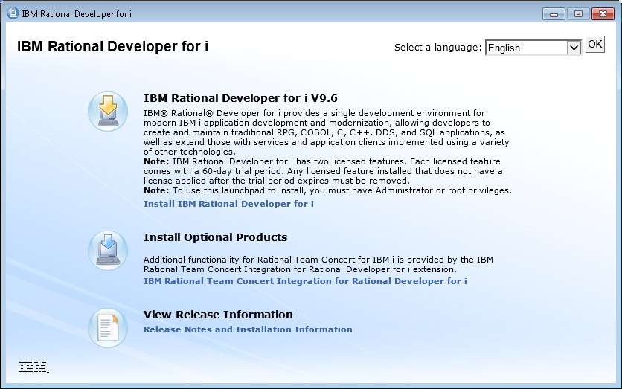

* Click on ***Install IBM Rational Developer for i***

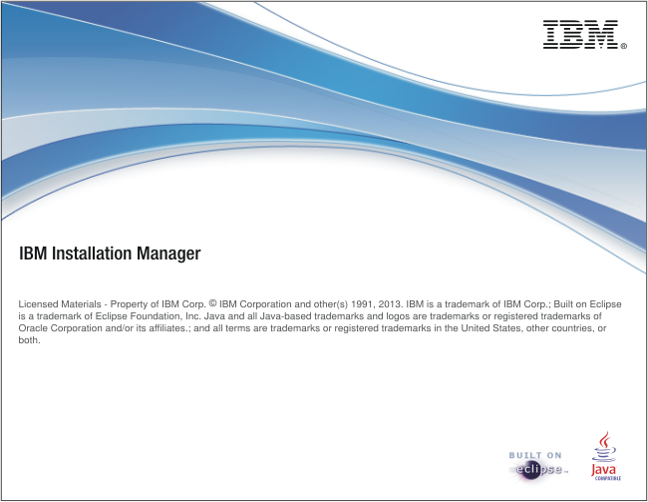

* Stayed at the above screen for a while

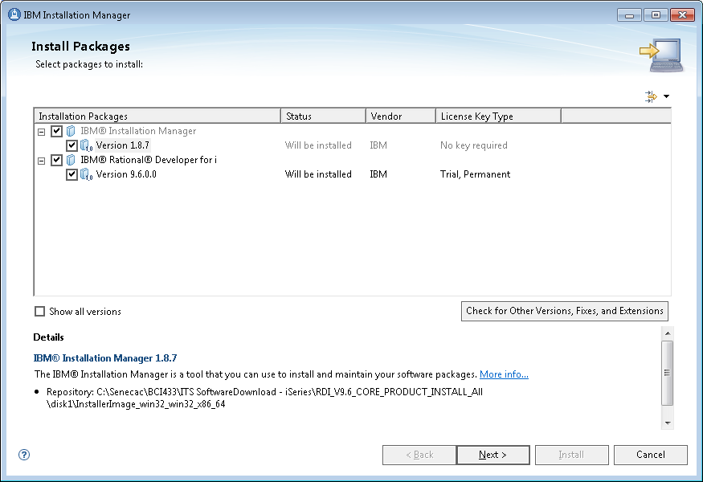

* Click on **Next**

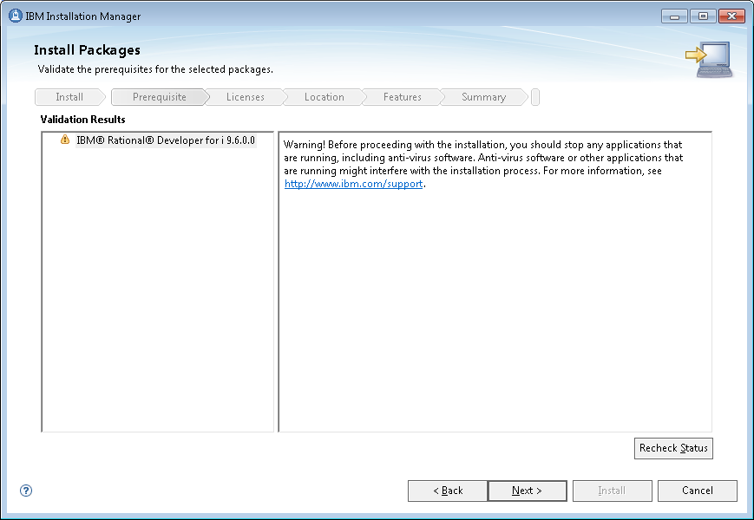

* Click on **Next**

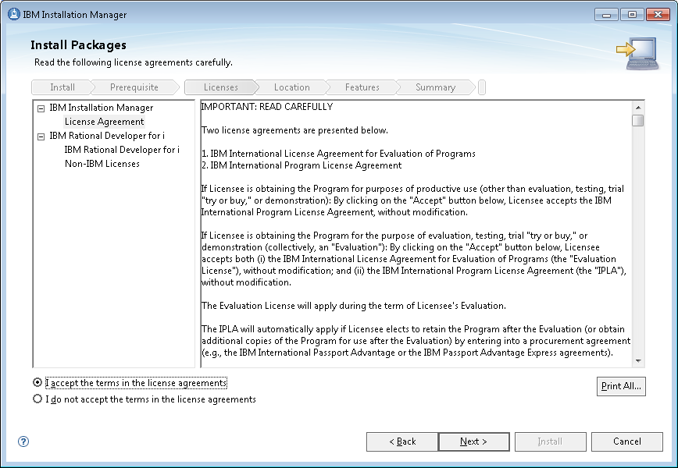

* Check ***I accept …*** and click on **Next**

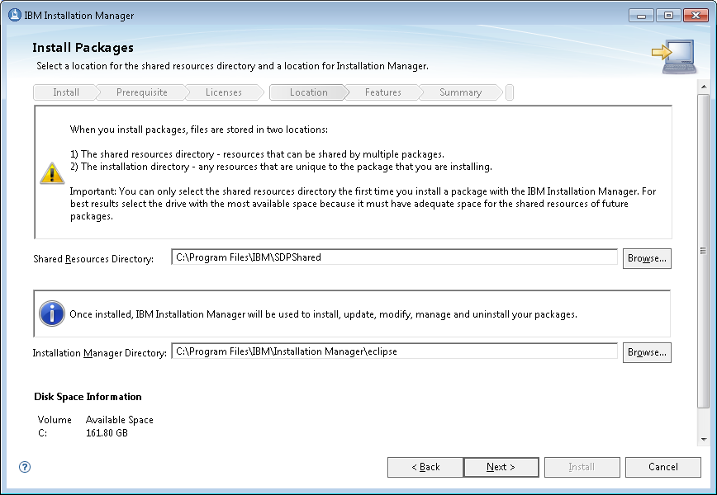

* Click on **Next**

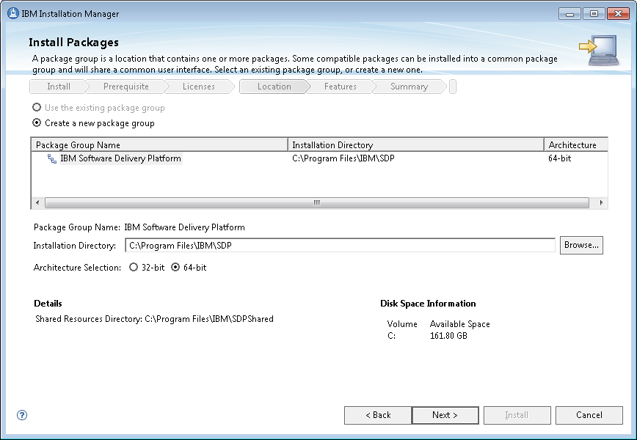

* Click on **Next**

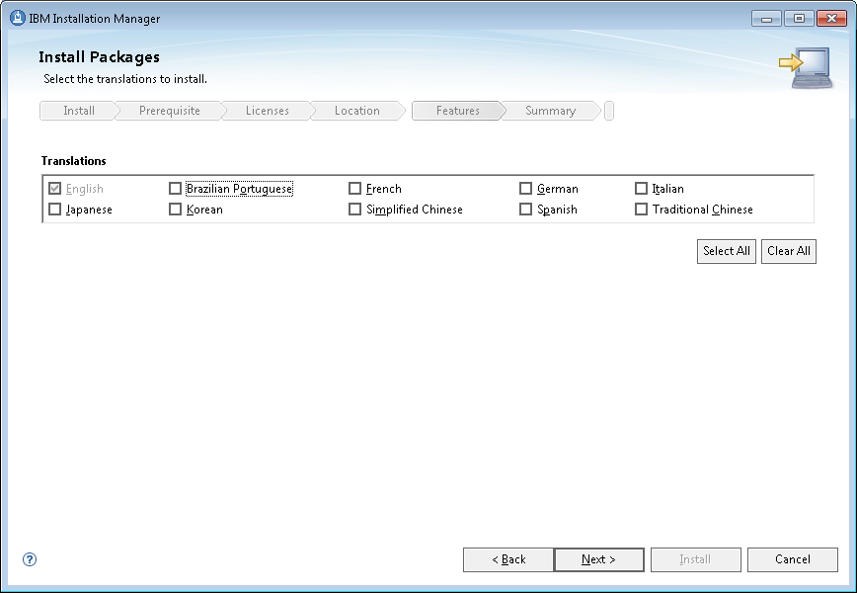

* Click on **Next**

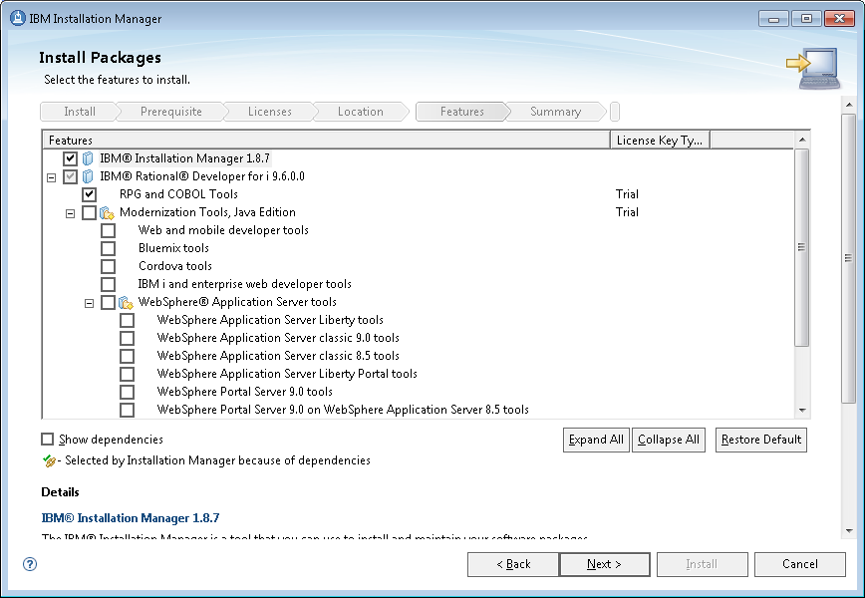

* Click on **Next**

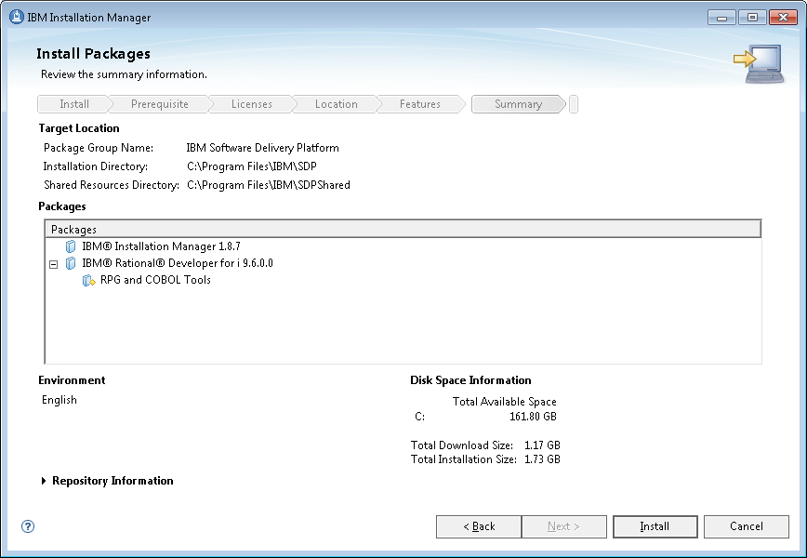

* Click on **Install**

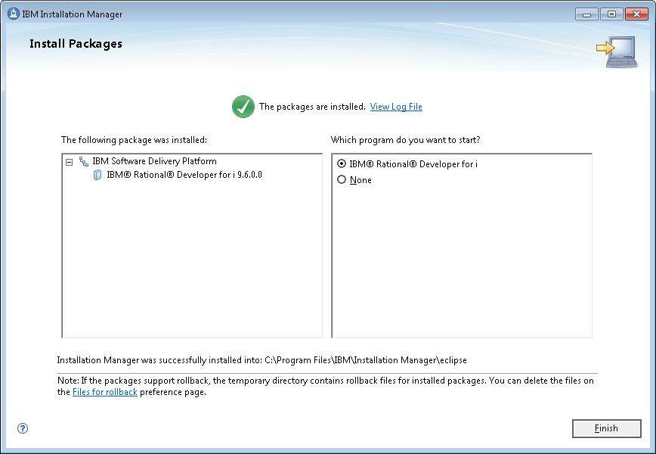

* Click on next, then RDi will start:

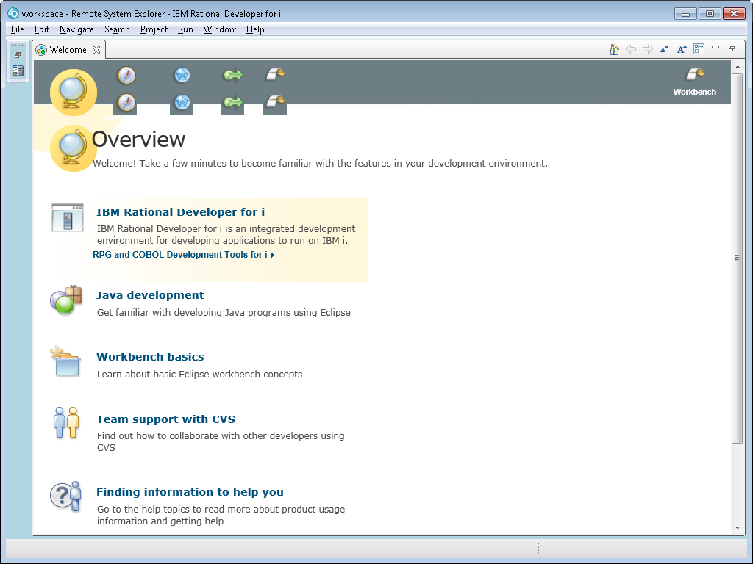

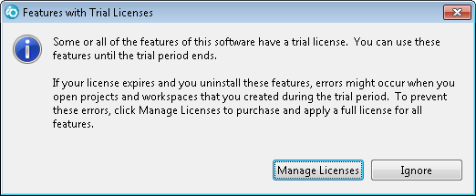

* Click on **Manage Licenses**
* (Or from Window Start button > All programs, launch the **IBM Installation Manager)**

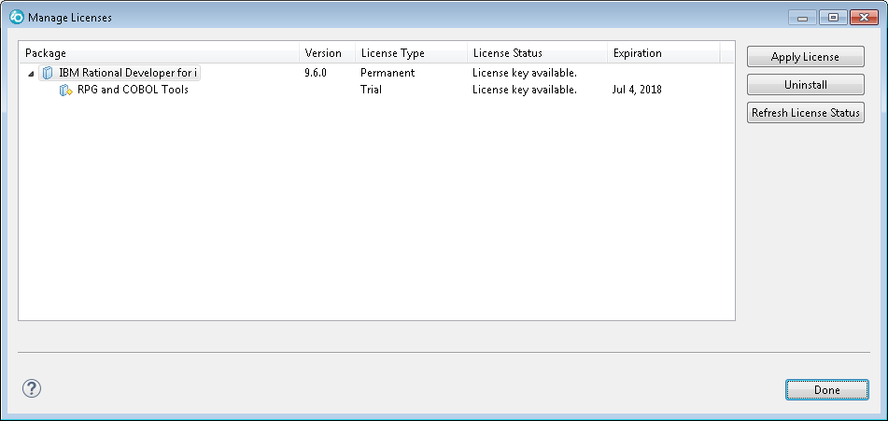

* Click on **Apply License**

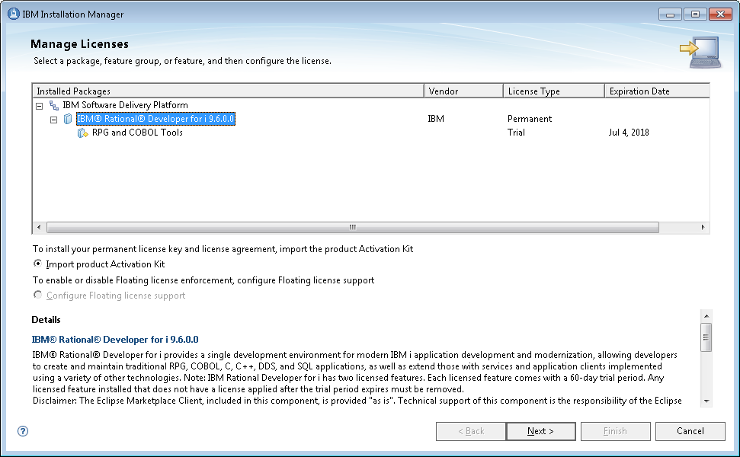

* Highlight **IBM® Rational® Developer for i 9.6.0.0** and check the radio button of ***Import Product Activation Kit***, then click on next

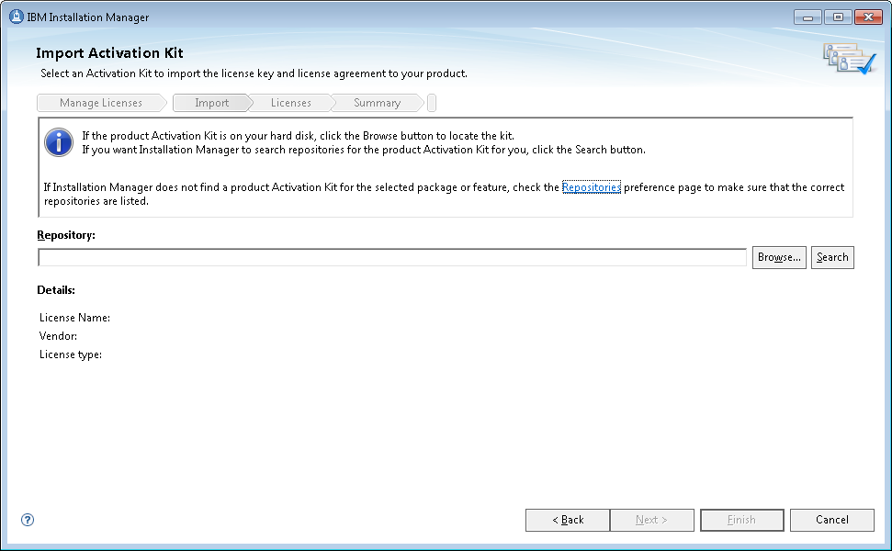

* Unzip the downloaded "**RDi V9.6 - Activation**" zip file, then click the **Browse…** button to select "**com.ibm.rational.developer.ibmi.rpgcobol.v96.pek.jar**" under the unzipped folder.
* Click on **Next**

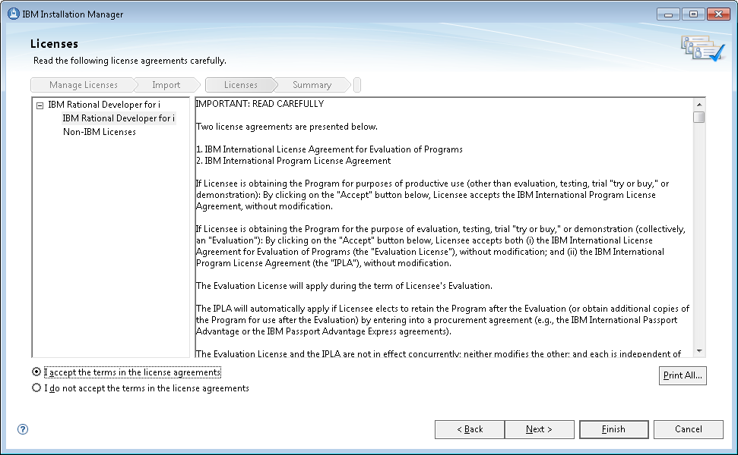

* Click on **Finish**

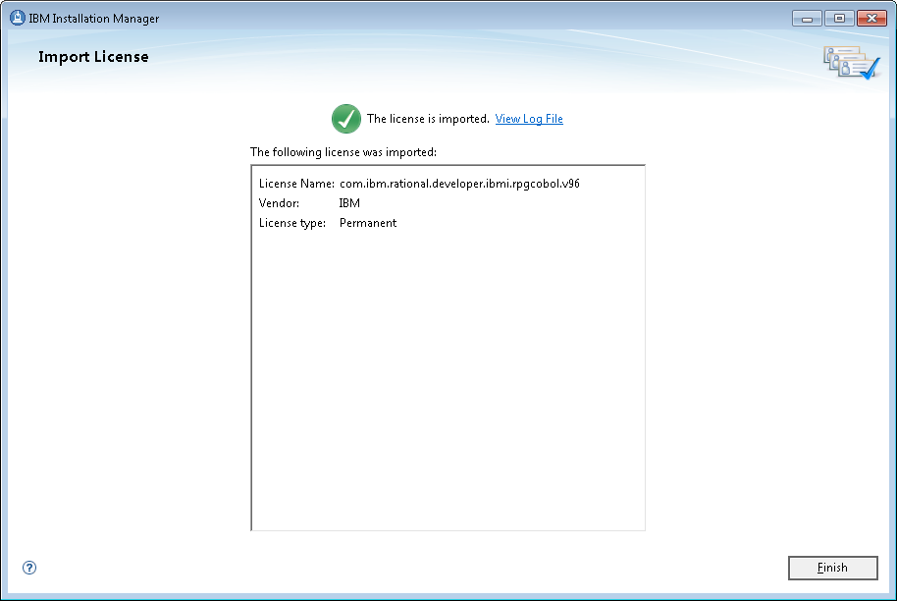

* Click on finish:

– You should see the start menu of ***IBM Installation Manager*** – DONE!