**Installation Guide for IBM Rational Developer for i Ver9 (RDi9)**

* Go to D drive and click on ***Launchpad.exe***

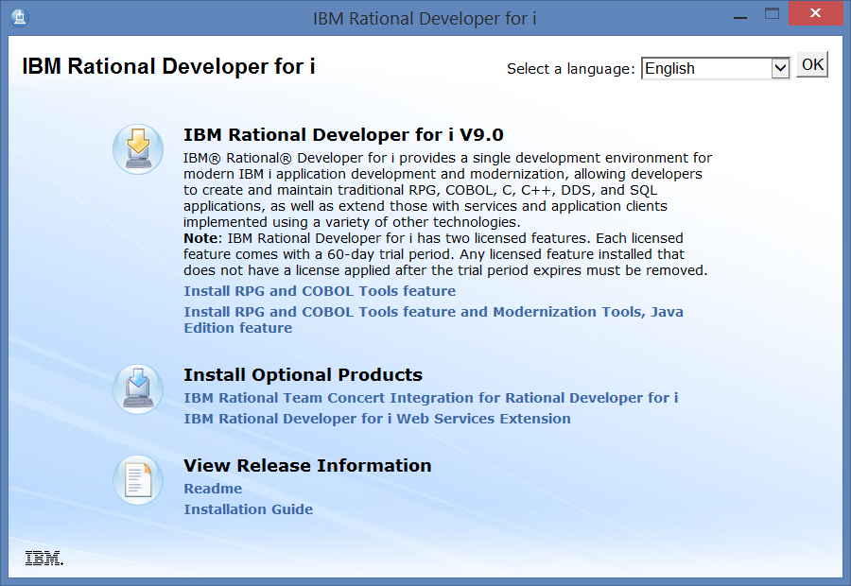

* Click on ***Install RPG and COBOL Tools feature***

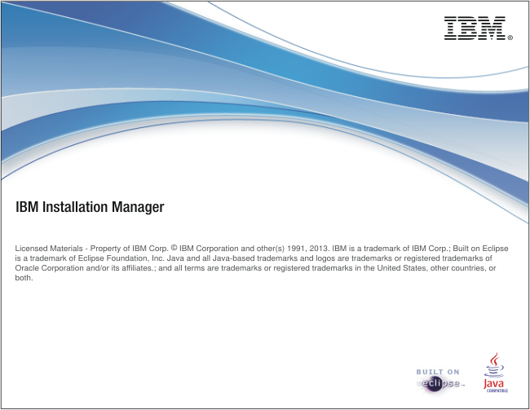

* Stayed at the above screen for a while
* Click on next

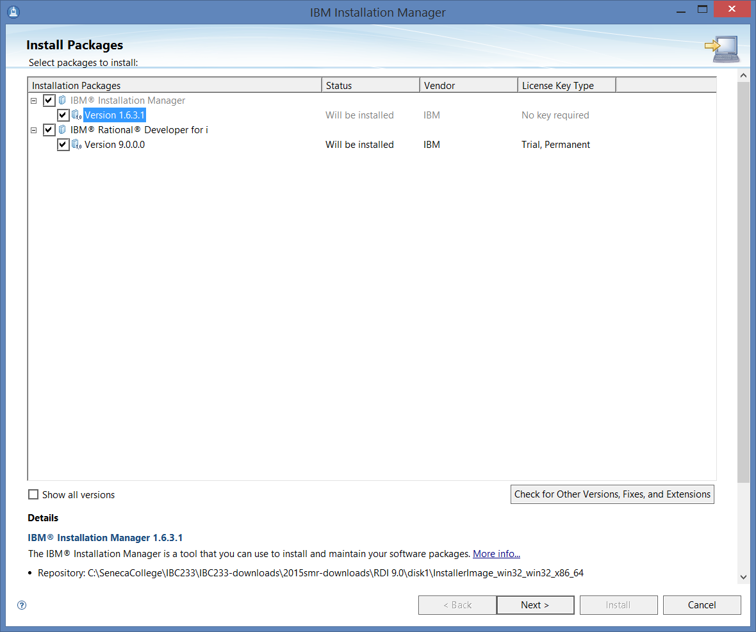

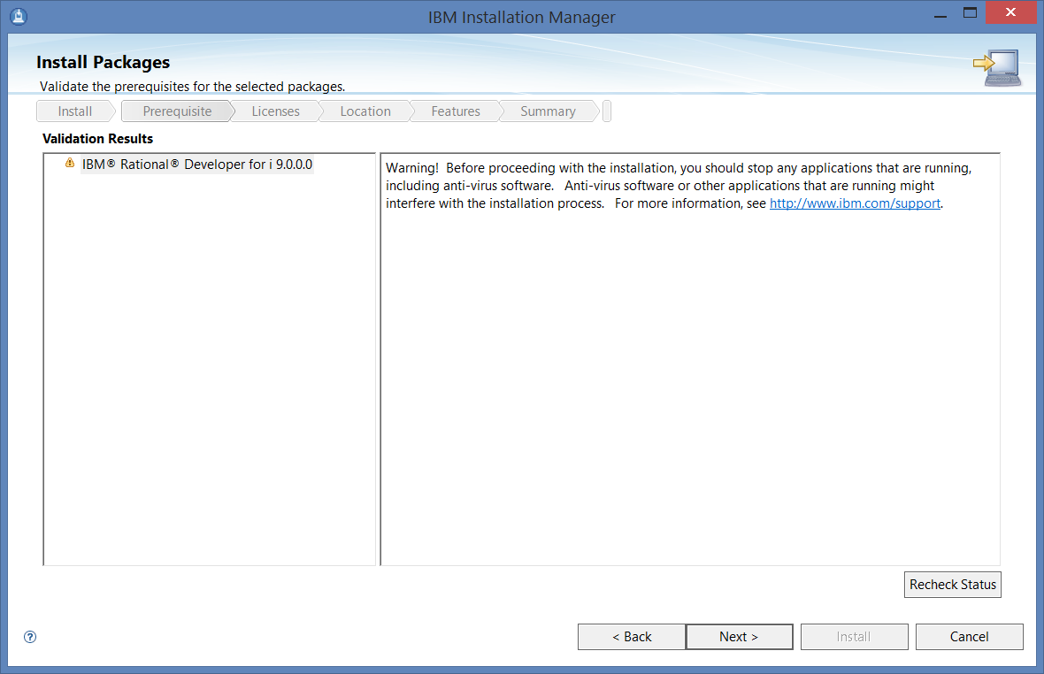

* Click on next

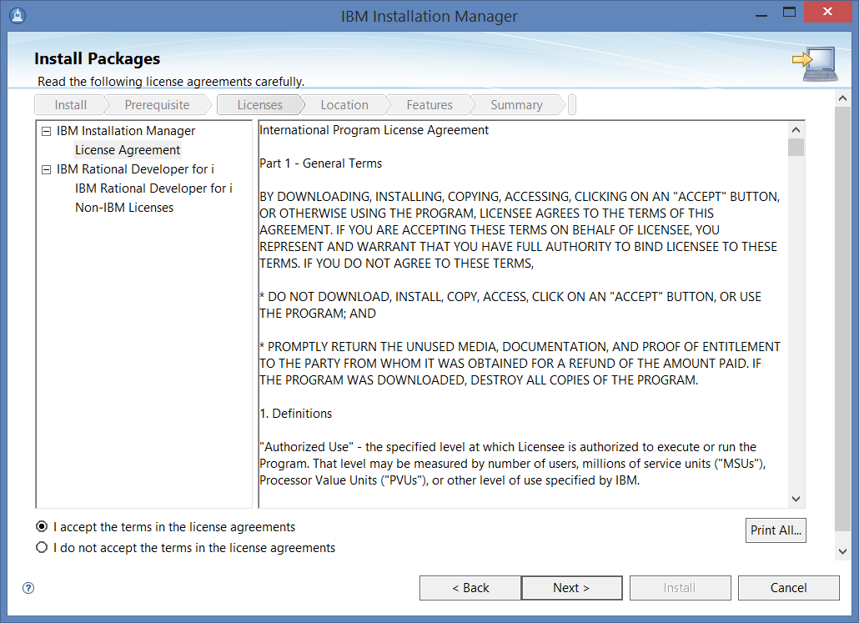

* Check ***I accept …*** and click on next

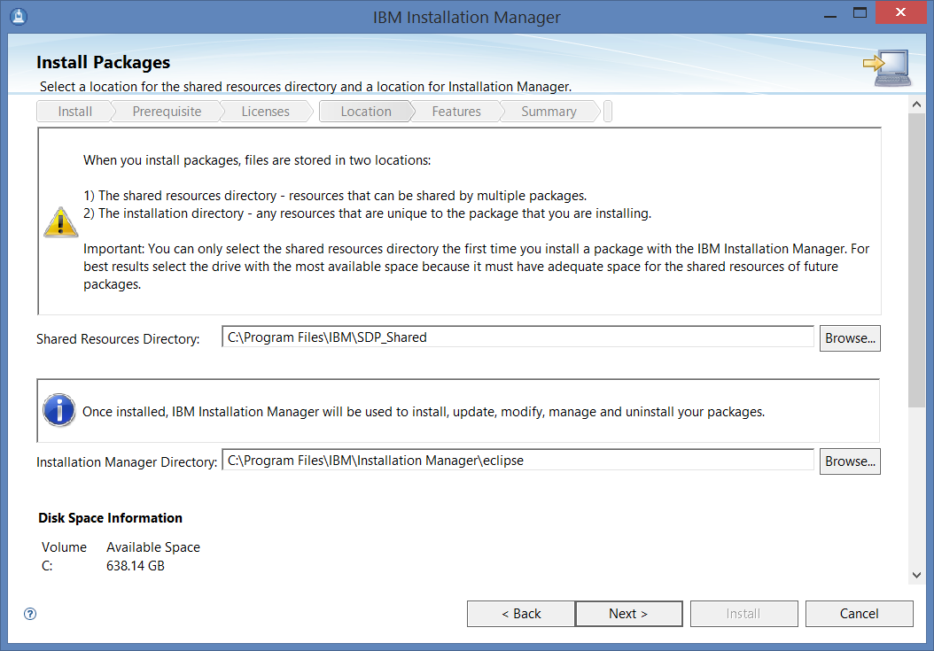

* Click on next

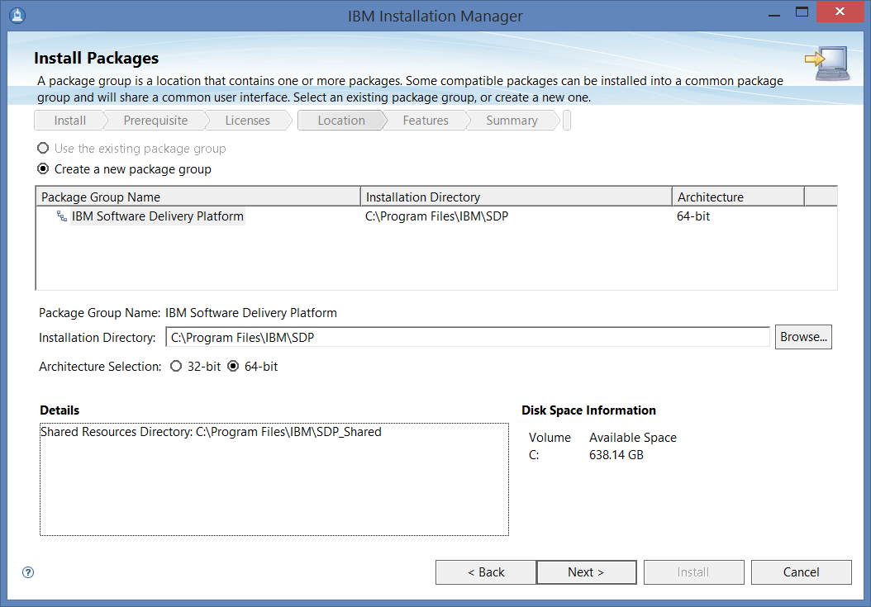

* Click on next

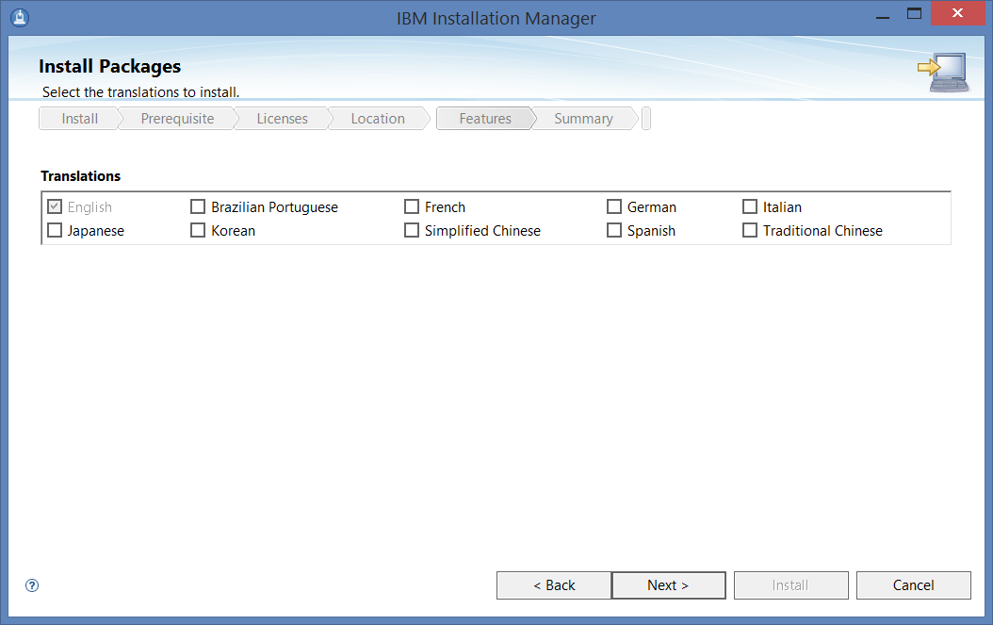

* Click on next

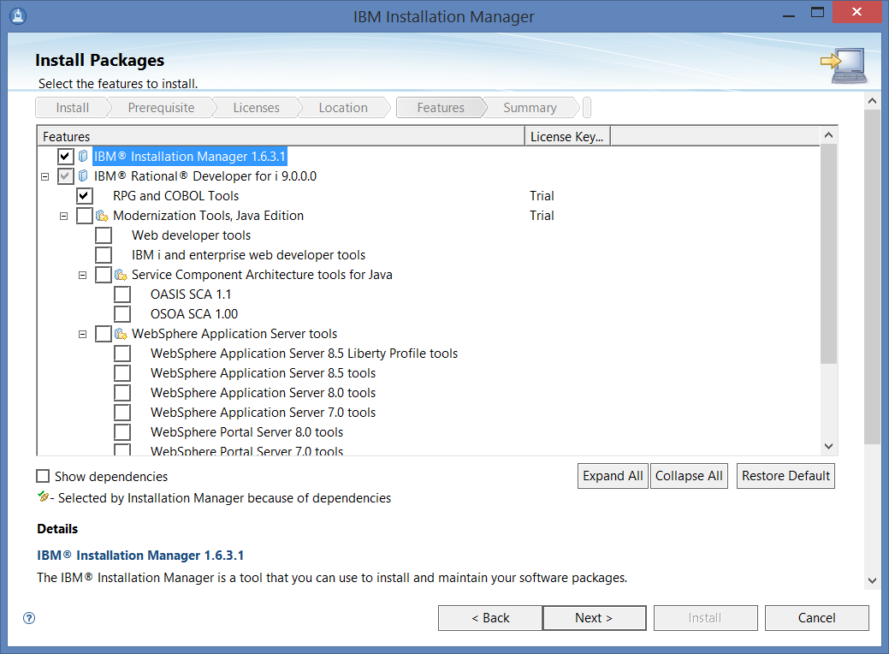

* Click on next

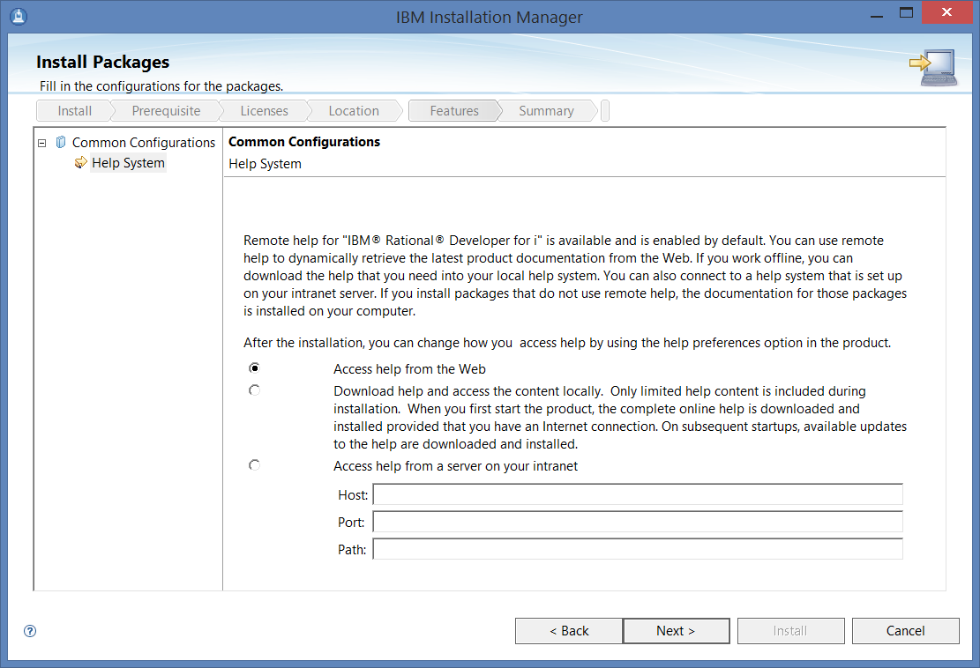

* Click on next

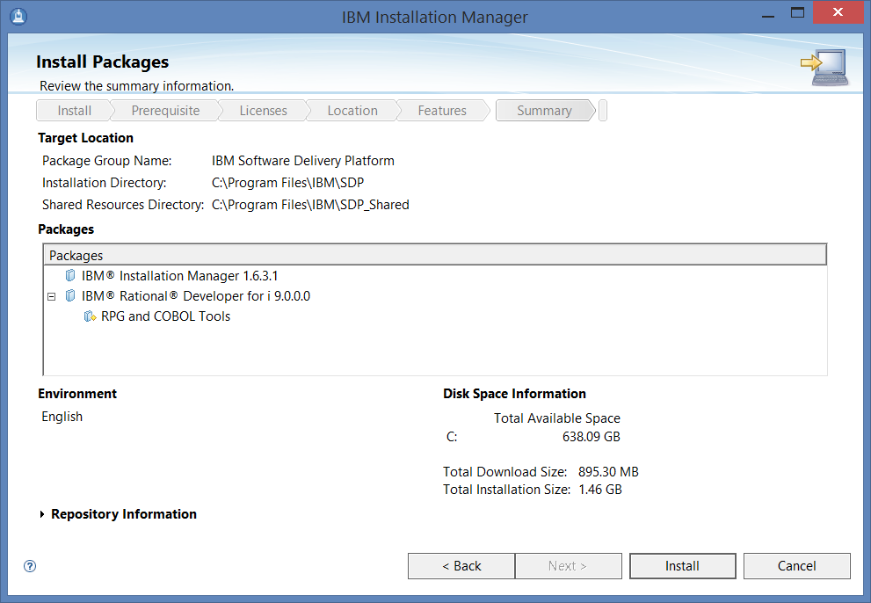

* Click on install and you should see this:

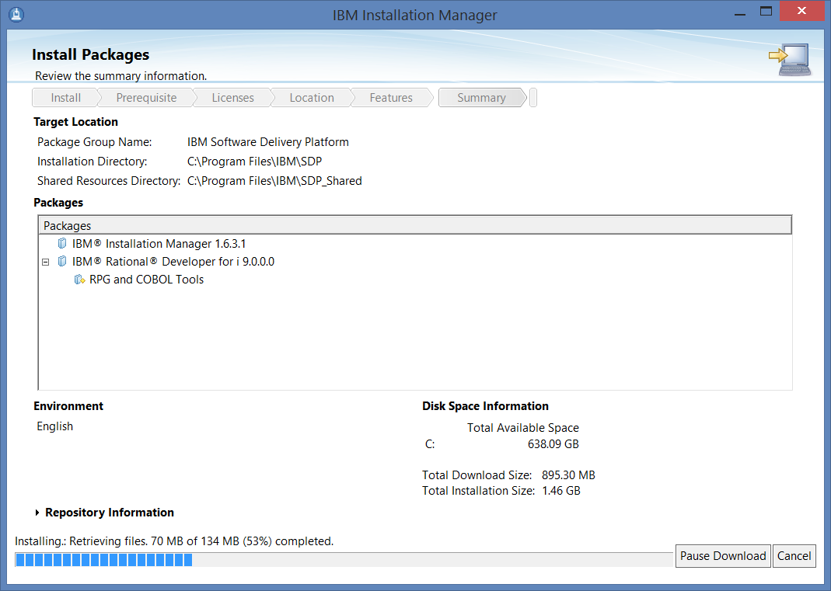

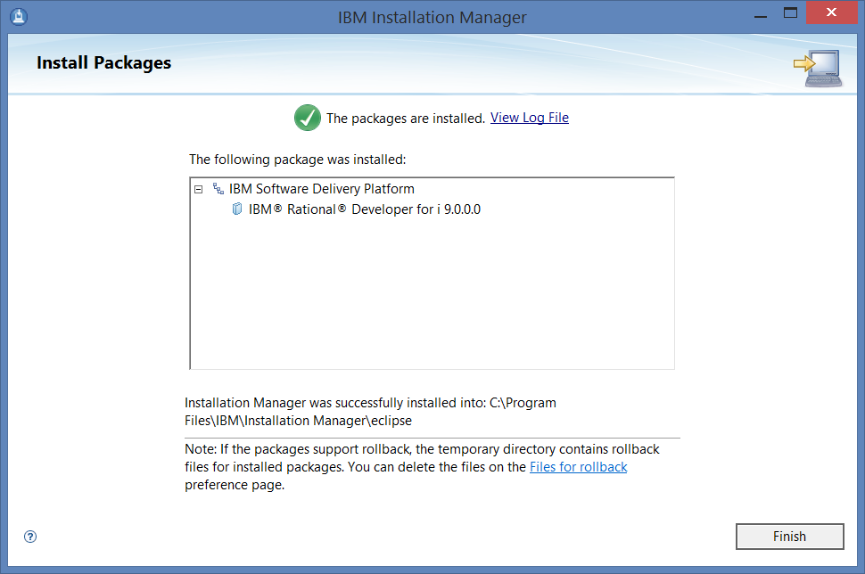

* Click on finish

**Install the activation kit**

* From your desk top, start the ***IBM Installation Manager***

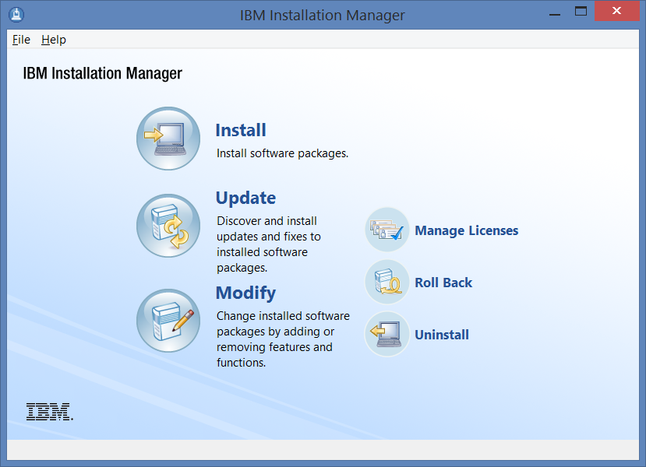

* Click on ***Manage Licenses***

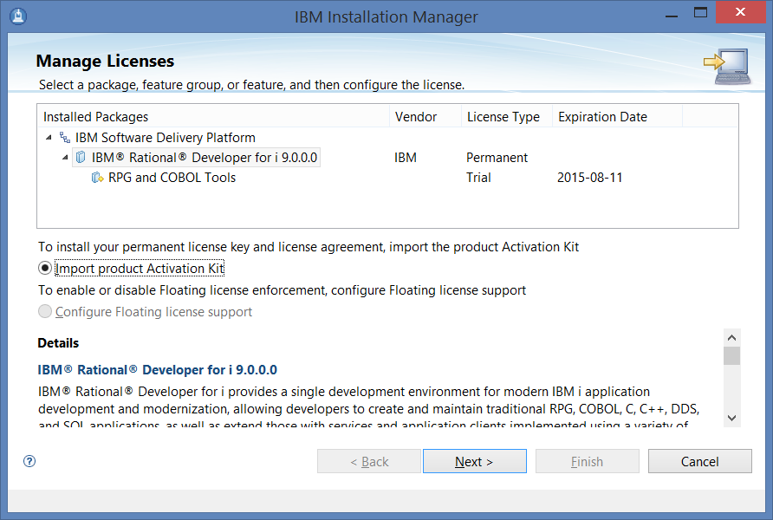

* Check the radio button of ***Import Product Activation Kit***, then click on next

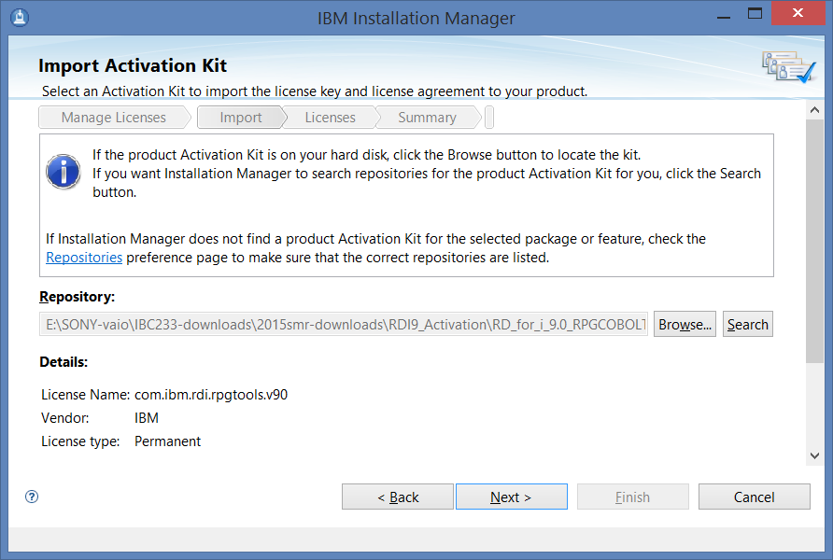

* Change repository to where the activation .JAR file is stored, then click on next

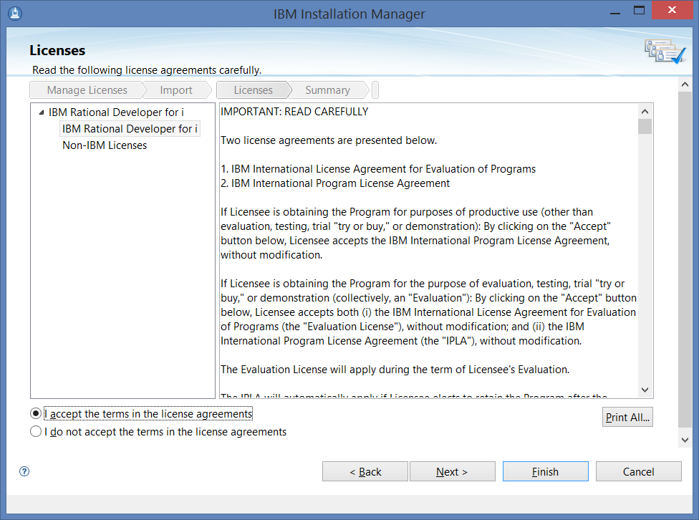

* Accept the terms of the license, click on Next then Finish

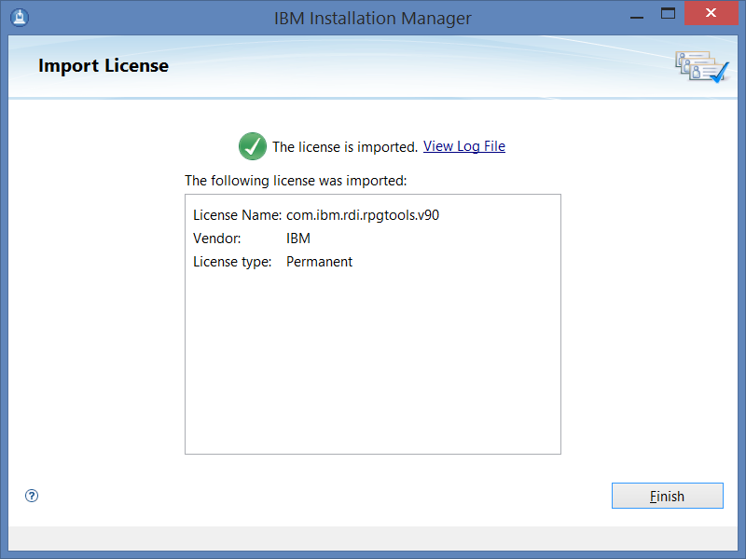

* Click on finish:

– You should see the start menu of ***IBM Installation Manager*** – DONE!