Create Queries to View Database Files
Interconnectivity using Client Access

Lab 5 is a prerequisite for this lab. Lab 5 suggestions for entering test data are crucial to providing meaningful results in this lab.

You must demonstrate this lab to your instructor during your lab period.

Start a ‘Green Screen’ (emulator) Session. From this point on, ‘Green Screen’ will refer to which ever emulator (Mocha or Client Access) program that you are running.

To illustrate different aspects of Query, your Marks file test data should include a number of course marks for records with matching student numbers in the Students file. Review the data in your files by running RUNQRY *n filename. To change data in a file, run UPDDTA. Be sure at least one student does not have any marks records (use F23 to delete a record). Be sure a few students have more than one course mark.

Part A Objectives:
- Examine the data member of your Students physical file
- Go Query menu
- Explore the features of Query/400 to create a formatted report of your STUDENTS file.

Lab Requirements: Four Reports

Report 1: STUQRY1 selecting FeesOwed > 0

Report 2: STUQRY3 joining Students file with Marks file and showing all records from Students file and
averages of final mark.

Report 3: STUQRY4 joining Students file with Marks file and showing all records from Students file without
marks.

Report 4: Printed Query Definition of your STUQRY3 query

We have used the WRKMBRPDM command to work with source physical files. This time we will use it to work with a data file. Enter WRKMBRPDM STUDENTS at the command line.
Take the option to display the Student member. The DSPPFM (Display Physical File Member) command, which this option invokes, shows the data as it is stored within records of the file member, unformatted, with no field separators.
The data displayed by DSPPFM may not be easy to read, but the command is useful for the rare occurrences when you need to examine the raw data. Use F10 and F11 to examine packed fields and hex codes. The find function is occasionally handy. Take the DBT544 database course to find out more.
Although DSPPFM gives you a quick way to view physical-file data, its lack of formatting and data conversion makes it unacceptable for end-user use or a permanent report. Fortunately, Query/400 is easy to use to create reports.
Query/400 is a menu-driven report generator for the iSeries that can create screen displays, printed output, or database files. In this lab, you will use the utility to generate a simple report of your database physical file.
To define a query, begin by enter STRQRY on the command line.
Select option 1, Work with queries, and press Enter.
From here, you can create a new query or take various options (e.g., Change, Copy, Display) on existing queries. Take option 1 to create a query named STUQRY1. Be sure to enter your library name for the Library part of the Query name parameter. Then press Enter.

The Define the Query screen lets you perform various design and selection options to tailor the query to the needs of the application.
Type options, press Enter. Press F21 to select all.
1=Select
Opt Query Definition Option
1 Specify file selections
Define result fields
Select and sequence fields
Select records
Select sort fields
Select collating sequence
Specify report column formatting
Type 1 to select each option you want to use. Notice that a 1 already appears in front of the Specify file selections option because, at the very least, you must tell Query/400 which file to use for the query.
Because this is a list-processing screen, you can type 1 in front of multiple options and Query/400 will process them one after another. Each option on this screen takes you to one or more lower-level screens where you supply information for that option. When you've finished specifying an option, you press Enter. Query/400 then saves your specifications and returns you to the Define the Query screen.
 | Tip | Remember, from within a Define the Query selection (e.g., Define result fields or Select records):  - Enter saves your work and returns you to the Define the Query screen  - F3 saves your work and takes you to the Exit this Query screen  - F12 backs up one screen or returns you to the Define the Query screen without saving your work
If you get to the Exit this Query screen by mistake, press F14 to return to the Define the Query screen.
At this point, there should be a 1 in front of only the Specify file selections option. Go ahead and press Enter.
You want to use your physical file, whose name is STUDENTS. If you couldn't remember the spelling of the name or you wanted to check a list of files, you could request prompting from the File entry field of the screen you are viewing. Do that now by pressing F4.
You should see the Select File screen with all files of the specified library (your current library) listed. Notice that no distinction is made here between source physical files and data files.
Move the cursor to the option field for your student file, STUDENTS. Type 1, and press Enter.
Notice that the prompt operation has copied the file name into the entry field of the Specify File Selections screen. The Library and Member defaults should be okay.
- Use Help to find out what the FORMAT parameter specifies. Is the default all right for your file?
Exit Help, and press Enter.
- What value is displayed now for the FORMAT parameter? __________________________
Read the message at the bottom of the screen and confirm.
You should now be back at the Define the Query screen. Is the screen any different? The greater-than symbol to the right of an option field indicates that the option has been taken. The symbol is just a reminder; you can go back to that option any time, if necessary, to add information or make changes.
Notice the function keys below the option list. Move the cursor to the function-key area, and press Help. Read through the descriptions of the function keys.
- What does F5 do? ______________________________________________________________
- What does F13 do? _____________________________________________________________
- What is the main difference between these two function keys? ____________________________
When you use F5 or F13, you can press F12 to return to the previous screen after viewing the display.
Exit Help. Display the report layout (F13).
- What is the report width? ___________________ (You may need to press F20 to go right in the display)
- Notice the column headers. Where do they come from? _________________________________
- How are the column headers aligned over the fields? ___________________________________
Notice that fields are separated on the format line, unlike the DSPPFM command output.
- How are the numeric fines and fees fields edited? __________________________________________________
Use the appropriate function key to shift your view to the right so you can see the entire report layout. When you are finished viewing the layout, exit and return to the Define the Query screen.
Task: suppress the current editing of the student number numeric field in your report and make the column headings easier to understand. To do so, you need to choose the option to Specify report column formatting. Go ahead and do that now.

The 'Specify Report Column Formatting' display divides the screen horizontally into zones for each field named on the left side of the display.

Specify Report Column Formatting
Type information, press Enter.
Column headings: *NONE, aligned text lines
Column
Field Spacing Column Heading Len Dec Edit
STUDNO 0 STUDENT 9 0
NUMBER
FIRSTNAME 2 First Name 15
LASTNAME 2 Last Name 20
More...
F3=Exit F5=Report F10=Process/previous F12=Cancel
F13=Layout F16=Edit F18=Files F23=Long comment

The column-heading values usually come from the COLHDG keyword contained in the physical-file object itself. If you do not specify COLHDG values in the source DDS (we did not), the system uses field names as column headings. In the query, if you want to change or clarify the column heading for the report, you can do that simply by typing over the values that have been taken from the file.
Let's change the column heading for the STUDNO field to "Student #" by typing over the old column heading. You could change any other column headings in the same way — by typing over what is already there. Notice that you can use up to three lines for each column heading; using multiple lines is a good idea when the data field is narrow but the column heading consists of several words.
Caution!! Do not press Enter yet!!
For each numeric field, you will select the edit function, F16. The function key applies to the field in whose horizontal zone the cursor is located when the key is pressed. The cursor does not have to be on the field name but can be anywhere within the (three-line) zone.

Move the cursor back up to the STUDNO field zone, and press F16. You should see a screen like the Define Numeric Field Editing screen shown below.

Define Numeric Field Editing
Field . . . . . . . . : STUDNO
Text . . . . . . . . : STUDENT NUMBER
Heading 1 . . . . . . : STUDENT
Heading 2 . . . . . . : NUMBER
Heading 3 . . . . . . :
Length . . . . . . . : 9
Decimal . . . . . . . : 0
Sample . . . . . . . : 999,999,999
Type choice, press Enter.
Edit option . . . . . 1 1=Numeric editing choices
2=Date or time editing choice
3=Edit code
4=Edit word

Take a minute to look at this screen. Notice that the field's name, heading, length, and number of decimal positions, as well as a sample showing current formatting, are displayed in the top part of the screen. As you make editing changes to the field, the sample changes accordingly.
As you can see, you have four choices for the type of editing you need to perform. For numeric fields that require no special spacing or insertion characters, you can use Edit option 1 to specify options such as thousands separator and leading zeros. Option 1 is the default, so just press Enter at this time.
You should see the Describe Numeric Field Editing screen shown below.

Describe Numeric Field Editing
Field . . . . . . : STUDNO
Type choices, press Enter.
Decimal point . . . . . . . . 1 1=. 2=, 3=: 4=$ 5=None
Thousands separator . . . . . 2 1=. 2=, 3=' 4=Blank 5=None
Show negative sign . . . . . Y Y=Yes, N=No
Left negative sign . . . .
Right negative sign . . . . -
Show currency symbol . . . . N Y=Yes, N=No
Left currency symbol . . . $
Right currency symbol . . .
Print zero value . . . . . . Y Y=Yes, N=No
Replace leading zeros . . . . Y Y=Yes, N=No
Replace with . . . . . . . 1 1=Blanks
2=Asterisks
3=Floating currency symbol
Single leading zero . . . . N Y=Yes, N=No
Notice some of the options available on this screen. For example, you can specify how to display a decimal point and thousands separator, whether to show negative signs, whether to display a currency symbol, and how to handle leading zeros.

For the Student number, you want to either eliminate the default comma thousands separator or override the setting of 999-999-999 achieved in an earlier lab., so move the cursor down one line and enter a 5, for None, for the Thousands separator option. Then press Enter.
Back at the Specify Report Column Formatting screen, you should notice an asterisk in the Edit column (to the far right) for field STUDNO. The asterisk tells you that the field has been edited.
Press F16 again. This time, the sample of the field shown on the Define Numeric Field Editing screen should have changed to reflect your request to eliminate the thousands-separator symbol; the sample should display the Student number as a nine-digit integer with no comma separators.
You can do the same thing for your phone number field. If it doesn’t show as (999) 999-9999 then you can page down until you see the PHONE field. Press F16 and use option 4 to add and editword. Change the default edit word from ‘bbbbbbbbbb’ where b is blank to the editword that we used in Lab 5 for the phone number on the display file.
Display the layout again. Do the numeric fields look better?
- What is the report width now? __________________
When you're finished looking at the layout, press Enter to continue with the Specify report column formatting function.
As you adjust the various query-definition specifications, it is useful to be able to examine a report with data. Fortunately, without leaving the Specify Report Column Formatting screen, you can run the report as it is currently defined by pressing F5. Press F5 at this time.
The display report should now be visible on your screen. It should look something like this.
Line ....+....1....+....2....+....3....+....4....+....5....+....6....+....7..
STUDENT First Name Last Name BIRTHDATE Phone
NUMBER
111111111 Dalton McGuinty 1955-11-22 (416) 325-1941 123456789 Your First Name Your Last Name 1967-07-07 (905) 443-4456 222222222 David Miller 1956-08-01 (416) 222-3333 333333333 Stephen Harper 1959-04-30 (613) 222-9933 444444444 Barack Obama 1961-08-04 (905) 666-9955 555555555 Tom Wong 1987-07-21 (416) 888-4444 987654321 William Seneca 1958-02-11 (905) 666-9999
The lines of the report are numbered serially on the far-left side. These line numbers would not appear if the finished query directed its output to a printed report. Also, remember that the default spacing between columns is two character positions. Knowing this, you can see which fields on this report you could shorten without losing data.
For example, let's say you need to reduce your report to a width of no more than 130 print positions. You can see that you could considerably shorten both the first-name and last-name fields of the sample report without cutting off any name characters. However, if new records with longer names were added to the file later on, the next query report could truncate part of a name, so you might want to shorten a less significant field than those containing the names. Shift right and examine the address fields of your report. You can probably shorten these fields without losing data.
When you have finished examining your report, press F12 to return to the Specify Report Column Formatting screen. Select one or two fields to shorten — perhaps the address fields. For each field you want to shorten, change its length value (Len) accordingly.
Look at the layout again. If necessary, shorten another field until the report lines fit within 130 print positions.
From the Specify Report Column Formatting screen, use the function key to display the report. Make sure you have not truncated data in the process of shortening fields and that the report will look all right when it is printed. If some data has been truncated, re-adjust print fields accordingly. If it is not possible to deal with the truncated data appropriately, we could also decide to omit one of the fields in the report.
If we are using the report to contact students by phone, we may decide to omit the address field.
On the Define the Query screen, a Select and Sequence fields option exists. Use this to select all the fields except the address field. Lengthen the First and Last Name fields so the entire name shows when someone needs to make a phone call.
When you are satisfied with your report, press Enter (not F3) from the Specify Report Column Formatting screen. Remember, if you go to the Exit this Query screen by mistake, you can press F14 to return to the Define the Query screen.
The query would run now without any further changes, but you may want to examine the output type to see where the report would be directed. To do so, on the Define the Query screen, move the cursor down to the "Select output type and output form" option and take that option.The screen you see now should look like the one shown below:

Select Output Type and Output Form
Type choices, press Enter.
Output type . . . . . . . . . . . 1 1=Display
2=Printer
3=Database file
Form of output . . . . . . . . . . 1 1=Detail
2=Summary only
Line wrapping . . . . . . . . . . N Y=Yes, N=No
Wrapping width . . . . . . . . . Blank, 1-378
Record on one page . . . . . . . N Y=Yes, N=No
Three options are available for Output type. Use the Help key to find out more about the three output types and to answer the following questions.

- If you kept the Display option for Output type, what would the output look like?
- If you took the Printer option, what screen would you see next?
- If you selected detailed output to a Database file, what would happen to report-break and summary-function output?

Change the output type to 2 for printer and press Enter.

If you intend to output to the printer (and you do), ensure that you format the report to be less than or equal to 132 characters wide because that is the maximum width for our printers. Some iSeries shops have printers that can output 198 characters per line. Some use laser printers that have much more flexibility than 132/198 column impact printers but at greater cost per page of output.
Press enter until you return to the Define the Query screen. From the Define the Query screen, press F3 to exit and save the query. You should see the Exit this Query screen, shown below.
The defaults here are set to save the definition and to run the query interactively. Also notice that values you provided when you took the option to create a query are used for the Query and Library names.
Because you will save the query definition, use the Field advance key to move the cursor down to the Text field and type in your full name followed by "Query 1 of STUDENT Physical File." Then press Enter. Because the Run option was set to 1, the query should now be running.
Exit this Query
Type choices, press Enter.
Save definition . . . Y Y=Yes, N=No
Run option . . . . . . 1 1=Run interactively
2=Run in batch
3=Do not run
For a saved definition:
Query . . . . . . . STUQRY1 Name
Library . . . . . DB233B40 Name, F4 for list
Text . . . . . . . .
Authority . . . . . *LIBCRTAUT *LIBCRTAUT, authorization list name,
*CHANGE, *ALL, *EXCLUDE, *USE

Type WRKSPLF and look at the results.

A summary of the Query steps:
- Go Query menu
- 1. Work with queries then, press F4 to see a list of existing queries.
- Create STUQRY1 query
- Specify file selections: STUDENTS FILE
- Select and Sequence Fields: all fields except Address.
- Specify Report Column Formatting: If you did not use column headings in your DDS code for your files (Lab 5), you will need to use Report Column Formatting to insert proper meaningful column headings. You can also change the column headings just for the run of this query and specify numeric editing.
- Define output type and Output form – change the default output to printer.

Display Spooled File
QUERY NAME . . . . . STUQRY1
LIBRARY NAME . . . . DB233B40
FILE LIBRARY MEMBER FORMAT
STUDENTS DB233B40 STUDENTS STUDENTSR
DATE . . . . . . . . 03/17/05
TIME . . . . . . . . 06:34:11
Query 1 of Student Physical File
DB233B40 Your Name Here
03/17/05 06:34:11 PAGE 1
STUDENT First Name Last Name Birth Phone CITY Prov Postal Fees Fines
NUMBER Date Number Code Owed Owed
111111111 Dalton McGuinty 1955-11-22 (416) 325-1941 Toronto ON M7A1A1 .00 .00
123456789 Your First Name Last Name 1979-11-22 (416) 491-5050 Toronto On M4R5R6 100.00 20.00
222222222 David Miller 1956-08-09 (416) 222-3333 Toronto ON L3R5A2 .00 .00
333333333 Stephen Harper 1959-04-30 (905) 222-3333 Ottawa ON M3E4T5 300.00 40.00
444444444 Barack Obama 1983-12-14 (416) 555-6666 Toronto ON M3L1E4 500.00 .00
555555555 Tom Wong 1979-02-04 (905) 666-7777 Toronto ON M16T5R .00 35.00
999999999 William Seneca 1984-01-01 (416) 555-1212 my city ON K9K9K9 .00 .00
* * * E N D O F R E P O R T * * *

Part B Objectives: Add selection criteria to the query and direct the report to the printer.

WoRK with OBJects using PDM – your library. If you don’t see STUQRY1, then press F5 to refresh.
What is the object type and attribute of the new object?

Use F23 to display more PDM options. Notice option 16. You can use this option to execute programs, query definitions, and stored DFU programs. Enter the Run option on your query definition object. A report should be displayed just as it was previously. Press F3 once you have examined it. PDM options make it easy to run a query definition or a program from the Work with Objects Using PDM screen.

As with other PDM options, you can request prompting on option 16. Type the option again for STUQRY1, and this time request prompting (press F4). You should see a screen similar to below:

Run Query (RUNQRY)
Type choices, press Enter.
Query . . . . . . . . . . . . . > STUQRY1 Name, *NONE
Library . . . . . . . . . . . > DB233B40 Name, *LIBL, *CURLIB
Query file:
File . . . . . . . . . . . . . Name, *SAME
Library . . . . . . . . . . *LIBL Name, *RUNOPT, *LIBL, *CURLIB
Member . . . . . . . . . . . . *FIRST Name, *RUNOPT, *FIRST...
+ for more values
Report output type . . . . . . . *RUNOPT *RUNOPT, *DISPLAY...
Output form . . . . . . . . . . *RUNOPT *RUNOPT, *DETAIL, *SUMMARY
Record selection . . . . . . . . *NO *NO, *YES

The RUNQRY command will run an existing query definition object (type *QRYDFN) when the object name is supplied for the Query parameter value. On the prompt screen for option 16, PDM has already filled in the object name based on the list-item name on which you took the option. (The command itself, RUNQRY, was selected based on the list item's object type.) You can change certain aspects of the defined query at runtime by supplying overriding parameter values on the RUNQRY command prompt screen. These changes affect only the current run and do not change the query definition.
What does the *RUNOPT value of the output type and output form do?
On the RUNQRY command prompt screen, change the value of the Report output type parameter so that the query output will be sent to the screen. Press enter.
You have overridden the Query definition parameter that indicated output went to the Printer. In addition, you can cause the query to prompt you for record selection when it begins to run by changing the Record selection parameter value to *YES. Use option 16 again on the *QRYDFN object and try that now.
Even if you did not use record selection in the query definition, by typing *YES you can add record selection at runtime. If you specified record selection in the query definition, you can change the selection criteria or cancel the predefined selection.
Press enter. After a pause, the Select Records screen should appear. The picture below shows that screen with a selection expression already entered.

Select Records
Type comparisons, press Enter. Specify OR to start each new group.
Tests: EQ, NE, LE, GE, LT, GT, RANGE, LIST, LIKE, IS, ISNOT...
AND/OR Field Test Value (Field, Number, 'Characters', or ...)
FEESOWED GT 0

Field Field Field
STUDNO ADDRESS1 FINESOWED
FIRSTNAME CITY
LASTNAME PROVINCE
BIRTHDATE POSTALCODE
PHONE FEESOWED
The expression instructs the query to select only those records having FEESOWED field values greater than 0. Records in input file
STUDENTS having feesowed values 0 or less than 0 will not be included in the report.

To find your report, work with your spooled files or output queue. Query/400 uses a printer file named QPQUPRFIL; if you look in the File column, the report should be easy to find.
- How many records were selected for your report?
Are the records in your file without feesowed included in the range that you selected?
Return to the Work with Objects Using PDM screen, and take the Work with option on your query definition object. (option 12)
- At what screen have you arrived? _________________________________
Take the option to change, and on the Query input field, press F4 for a list. From the prompt list, move the cursor down to the option field for your query, and type 2 to change. It's not necessary to erase the 2 on the line above. Press Enter.

When a query is saved, all the specifications for it are stored as you last left them. If you take the Change option, you can modify an existing query in any way necessary.

Let’s modify the report. There should be still a 2 beside Select output type and output form. Press enter.

Leave the line length as 132 as that is the maximum that our printer can print. Press Enter.
You should next see the Define Spooled Output screen.
- Based on previous experience, what do you think will happen to your report if you provide no value for the Spool the output field? (Not sure? Try Help.)
- Use Help to find out what happens when you leave the Form type field blank.
Unless your instructor/mentor tells you otherwise, leave Form type blank to default to the value specified in the printer device file. Leave the other values as they are, and press Enter.

For now, you will not print a cover page, so type N for the Print cover page option, and then press Enter. You should now see the Specify Page Headings and Footings screen.
Print the Standard page headings (leave the default at Y), and key in an appropriate page heading, such as
Students with Fees Owing
Lab 9 - STUQRY1 prepared by: (your name).
When you are finished, press Enter to return to the Define the Query screen.

Now – let’s change Select Records to add Feesowed > 0 as a permanent change to the query. Type a 1 beside Select Records. Add the FEESOWED GT 0 expression (as you entered it above). Press Enter. Now press F5 to see the results.

You have now included a page heading and selected records. From the Define the Query screen, press F3 to save and run the query.
This time, no changes should be needed from the Exit this Query screen (Save definition should be Y, and Run option should be 1), so simply press Enter to run the query. You should briefly see a "Query running . . ." message, followed by a message indicating successful completion from the Work with Queries screen.
Return to the Work with Objects Using PDM screen. You should still see your query definition listed even though it has been changed. Move the cursor up to the option field for your output queue, and work with the output queue.
Find the new file named QPQUPRFIL, and display it. If you aren't sure which spooled file is the more recent, use F11 to display date and time. Is it your query report? (The spacing will look different from when the report is printed because the printer form-control characters are ignored on the display.)
This report should have less records than the earlier version that did not use record selection. Also, in this report, you declined the cover page when you changed your query definition, but the RUNQRY prompted version shows a standard cover page (which would be printed as the first page). You should also see the page heading with your name, which you added to the new report.

Change this print file to redirect it to printer PRT01 or to the printer assigned by your instructor/mentor to print class lab projects. A summary of the Query steps:
- Change the STUQRY1 query
- Select records: FEESOWED greater than zero
- Select output type and output form:
- Printer output
- Print cover page . . . No
- Page heading
- Test using F5.

Part C
Objectives: Use Query/400 to create a report that contains information from 2 files.

Use DFU to add an additional record to the STUDENTS File.

Type UPDDTA STUDENTS and use the function key that allows you to insert a record. Provide the following information:

STUDENT NUMBER: 87654321
FIRST NAME: George
LAST NAME: Bush
BIRTHDATE: 1956-03-03
PHONE NUMBER: 556667777
ADDRESS1: 12 Queen St.
CITY: Toronto
PROVINCE: ON
POSTALCODE: L4R5T6
FEES OWED:
FINES OWED:

Exit from DFU by using the F3 key

Create a new query called STUQRY2

Specify file selections:
STUDENTS is the first file with a File ID of S
Use the function key to Add a file
MARKS is the second file with a File ID of M
Press Enter
Type of join: use F1-Help to find the join option that
Selects only those records that have matching records in all the joined files.
Press Enter
Specify How to Join Files:
Student number in one file equals the student number in the other file

Select and sequence fields:
STUDENT NUMBER, FIRST NAME, LAST NAME, PHONE NUMBER, COURSE CODE, FINAL MARK

Select sort fields
Sort on course code within student number
Note: Unlike DFU, Query does not automatically display records in the key sequence specified in the Physical or Logical file. For the sake of efficiency, Query displays records in arrival sequence unless you specify one or more sort fields here.

Specify report column formatting:
Position the cursor on the same line as the Student Number field
Use the function key to Edit, choose the option to specify an edit word.
Press F1 at the Edit Word input field -- the help text explains how to use it to
get the result below.
Repeat for the Phone Number.

Student FIRST NAME LAST NAME PHONE COURSE FINAL
Number NUMBER CODE MARK
999-999-999 XXXXXXXXXXXXXXX XXXXXXXXXXXXXXXXXXXX (999)999-9999 XXXXXX 999

Select report summary functions:
Specify an average for the Final Mark

Define report breaks:
What is a "report break"?
Why would you want to "break" on student number?
Extended Help on the Define Report Breaks screen has the answers.

Select output type and output form:
specify Printer output
Do not specify a Specify Cover Page...override 'Print cover page' to No
Specify a Page heading of
Students with Marks
Lab 9 - STUQRY2 prepared by (your name).

The final layout should look something like:
Student FIRST NAME LAST NAME PHONE COURSE FINAL
Number NUMBER CODE MARK
999-999-999 XXXXXXXXXXXXXXX XXXXXXXXXXXXXXXXXXXX (999)999-9999 XXXXXX 999

AVG 999

FINAL TOTALS
AVG 999

When you save the Query, specify text to identify what the query does. This text is often the same as the Page heading.

Run the report creating spooled file output.

Part D
Objectives:
- Use Query/400 to create a report that contains a different set of information from 2 files.

Copy STUQRY2 to STUQRY3

Specify file selections:
Modify the Type of join: use F1-Help to find the join option that
Selects every record in the Students file (the primary file), and includes any matching records from the Marks (secondary) file.

Press F5 to view the report on the screen. How is this output different from STUQRY2? What does the system do for Student records that have no matching Marks file records?

Select output type and output form:
Deep within this option, specify a Page heading of
All Students and their Marks
Lab 9 - STUQRY3 prepared by (your name).

When you save the Query, specify text to identify what the query does. This text is often the same as the Page heading.

Run the report creating spooled file output.

Part E
Objectives:
- Use Query/400 to create a report that contains another different set of information from 2 files.

Copy STUQRY3 to STUQRY4

Specify file selections:
Modify the Type of join: use F1-Help to find the join option that
Selects, from the Students primary file, only records that have
no match in at the Marks secondary file.

Press F5 to view the report on the screen. How is this output different from STUQRY2 or 3? Is there any point to selecting fields from the Marks file for output?

Select output type and output form:
Deep within this option, specify a Page heading of

Students WITHOUT Marks

Lab 9 - STUQRY4 prepared by (your name).

When you save the Query, specify text to identify what the query does. This text is often the same as the Page heading.

Run the report creating spooled file output.

In order to view your new query objects try the following command at the command line.

WRKOBJPDM DA233A40 STUQR*

What is the object type for a Query/400 object? ______________________

Print out the Query Definition of your STUQRY3 query.

Interconnectivity with Client Access

TASK: Transfer the data from the STUDENTS and MARKS files (which were created in a prior lab) to an HTML file.

In the Client Access workstation program, under the Actions menu, there is an item called "Receive File from host..." (this is also available from the IBM area of the Windows Start / Programs menu and is called "Data Transfer from AS/400"). This opens a window titled "Data Transfer from System i".

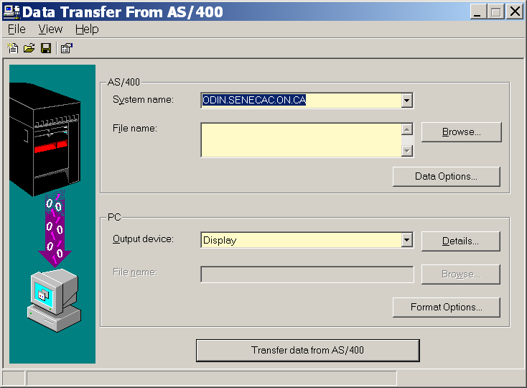

The menu item: File / Properties has a tab for Library List if you need it. In the "File Name" text box, you can Browse... for a file on the iSeries or just enter your DC233snn/STUDENTS file qualified name.

Make the Output device DISPLAY

Transfer the data to your screen. After reviewing the data sent, close the window. You should be back at the Data Transfer From iSeries window.

TASK: Transfer the DDS member you used to create the students file.
Have the output go to a file C:\temp\StudentsDDS

This time you need to include a member name.
The way to refer to a library, file and member is DC233snn/QDDSSRC(STUDENTS)

Transfer the data to your PC and check on the C drive using Notepad to see what was downloaded.

TASK: Download the STUDENTS and MARKS data into a single HTML page.

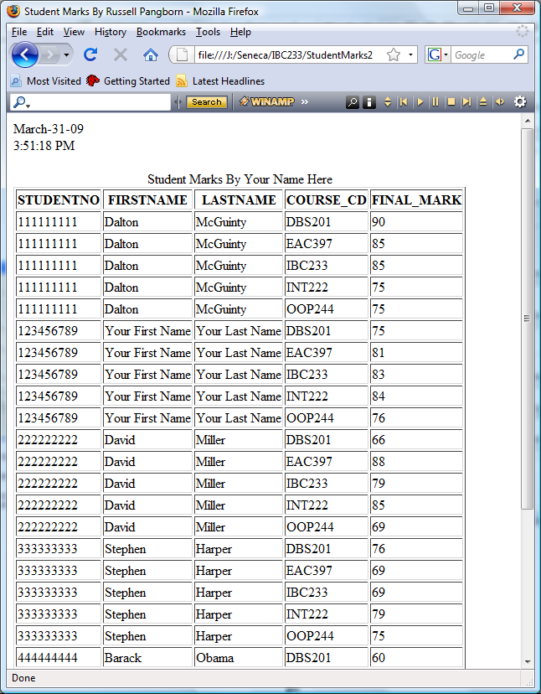

For this download, we are going to use the Browse feature.  Type in your library name and a slash.  Click on Browse.  Highlight STUDENTS and click on SELECT and then do the same with MARKS.  Click on OK |  | 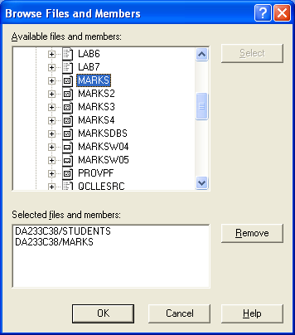
On the Data Transfer from iSeries screen Select  Data Options...  On the Change Data Options screen, click on DETAILS.  It opens a Receive Request Details dialogue where you can specify SQL clauses to format, select, and sequence your data.  Using the Select tab,  scroll through the fields and double click on STUDNO, FIRSTNAME, LASTNAME, COURSE_CD and FINAL_MARK  Click on the Where tab to specify the where clause. | 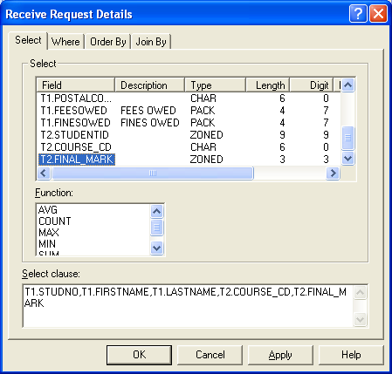

Click on STUDNO and then click on the “=” sign. A compare dialogue comes up. Use the drop down menu to select STUDENTID from the Marks file.

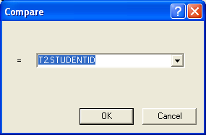

Use the Order By tab to get your data in course code within student number order.

You should have something similar to what shows below in your Change Data Options box.

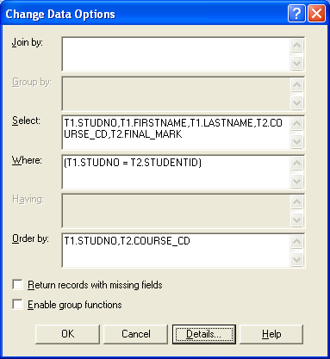

Click on OK

Check your output by indicating that the output should be directed to the DISPLAY.

After you confirm that the output is correct, change the output device to HTML using a file name of C:\temp\Student.html

Click on the Details... button beside the output device. A window opens allowing you control over various aspects of the HTML file to be created. You can use the Document, Table and Caption tabs to customize your HTML file. We want the Title to be Student Grades and require the date and time to show.

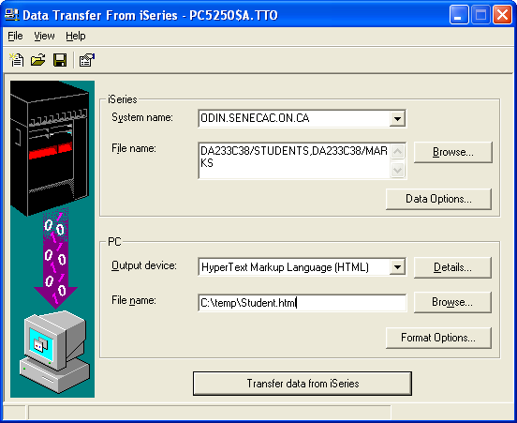

Transfer the data.

Open a browser and display the HTML file. Print out this HTML page.

Besides HTML files, PC Output device "File" allows data transfer into many different PC file formats such as MS Excel.

When you close the transfer request window, you have the option of saving the request permanently. We will not do that here. However, if you had to download files on a regular basis, you could do this. The PC could even run the file transfer unattended using a schedule program.

To demonstrate your lab:

Be prepared – have the following printouts available:

Report 1: STUQRY1 selecting FeesOwed > 0

Report 2: STUQRY3 joining Students file with Marks file and showing all records from Students file and averages of final mark.

Report 3: STUQRY4 joining Students file with Marks file and showing all records from Students file without marks.

Report 4: Printed Query Definition of your STUQRY4 query

and have your client access file transfer available to run.

