Lab Objectives
- Create Filters
- Code a Client Access sign on program and understand User Profiles
- Level Check error and Compiling with an object in use
- Retrieve system values, job attributes and user profile
- Send messages
- Monitor Messages

Lab Requirements
- Startup program runs on Client Access sign on
- Demonstrate Lab2 and Lab3 filters
- Demonstrate the basic Lab 4 CLLE program with option one working, (all features working due at start of lab in week 5)
- Demonstrate a filter command.

Part A – Working With Objects

Sign on to a Client Access and an RDp session.

In Client Access type WRKOBJPDM DK233A39 (substitute your library name here)
Work with Objects Using PDM SENM25

Library . . . . . DK233A39 Position to . . . . . . . .
Position to type . . . . .

Type options, press Enter.
2=Change 3=Copy 4=Delete 5=Display 7=Rename
8=Display description 9=Save 10=Restore 11=Move ...

Opt Object Type Attribute Text
ORDERRPG *PGM RPGLE
STUDENTS *PGM RPGLE
DK233A39 *OUTQ
EVFEVENT *FILE PF-DTA
ORDERDSP *FILE DSPF
QDDSSRC *FILE PF-SRC
QRPGLESRC *FILE PF-SRC
STUDENTS *FILE PF-DTA Student file by Student Number
Bottom
Parameters or command
===>
F3=Exit F4=Prompt F5=Refresh F6=Create
F9=Retrieve F10=Command entry F23=More options F24=More keys

You can look at the QDDSSRC program members in PDM by typing a 12 beside the name and pressing enter.

The same thing can be done in RDp

First right click on your library name and select the Show In Table option. Then double click on the Object Table tab to provide a full screen of object names, types, attributes and text comments.
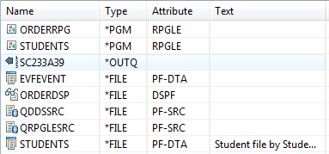

Double click on QDDSSRC
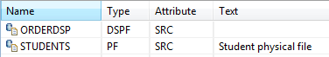

Click on the arrow showing below Remote Systems to go back to the objects view

Part B – Filter by Application

The following Lab2 and Lab3 RDp filters were demonstrated in class. Provide them in your workspace and be prepared to demonstrate them.
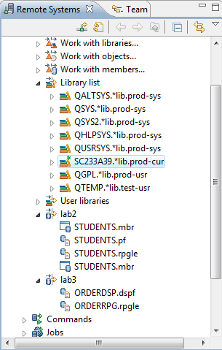 | In order to collect objects and members by application rather than member type do the following:  Under Objects  Work with members  Provide Library, File, Member name  Provide Filter name  Right Click Created Filter  Select Properties  Click on New Filter String  Provide Library, File, Member name  Repeat as necessary  Lab 2 Filter  STUDENTS.rpgle in QRPGLESRC in your library  STUDENTS.pf in QDDSSRC in your library  STUDENTLAB.txt in IBC233LIB/StudentLab  STUDENTLAB member  STUDENTS.mbr contains data allowing  use of Show in Table  Lab 3 Filter  You should be able to locate the required members by looking at the screen shot.

Start a ‘Green Screen’ (emulator) session. (Client Access Session).

Part C – Unsuccessful Compiles and unsuccessful program runs

Sometimes you have compiled and nothing seems to be happening. Rather than curse at the system, let us take a look at a situation where we want the system to reject the compile attempt.

Sign on to a second Client Access session. Start your ORDERRPG program and leave the program running with the first screen record showing. Do not exit from this program.

Go to your first Client Access session and compile your display file using option 14.

==>WRKMBRPDM QDDSSRC

14 ORDERDSP (indicate on the next screen you want to replace the existing object)

type SP where you had typed the 14 (a shortcut way of saying WRKSPLF at the command line)

Do you see a spooled file listing for your compile of the DDS code? ______________

If your output queue is cluttered lets remove all the spooled files in your output queue. (Don’t worry we have time and that compile you submitted isn’t going to happen for a while)

Type CLROUTQ DK233A39 (replace DK233A39 with your output queue name) A few spooled files may still show in other output queues, use option 4 beside all of them to remove them.

Should you be able to replace the display file object with a changed one while it is in use? _____________

That is why nothing is happening. Would this work if you switched over to your RDp session and did a compile on your MARKSDSP member? ______________

You can track what is happening with your compile that is not producing the usual spooled file listing very quickly.

At the command line type WRKSBMJOB (Work with Submitted Job)

You should see something indicating that an attempt is being made to compile your display file code. Here is what shows on my screen. I can use option 5 to “work with” and then use option 10 to “Display job log, if active, on job queue, or pending”

(note if you do not see this screen – the job may have been ended. You still have the dialogue showing below)

Work with Submitted Jobs SENM25
05/17/11 15:39:59
Submitted from . . . . . . . . : *USER

Type options, press Enter.
2=Change 3=Hold 4=End 5=Work with 6=Release 7=Display message
8=Work with spooled files

Opt Job User Type -----Status----- Function
ORDERDSP SC233A39 BATCH ACTIVE CMD-CRTDSPF

Bottom
Parameters or command
===>
F3=Exit F4=Prompt F5=Refresh F9=Retrieve F11=Display schedule data
F12=Cancel F17=Top F18=Bottom

You may just see the first message in the job log about compiling the DDS code.

>> CRTDSPF FILE(DK233C40/ORDERDSP) SRCFILE(SC233A39/QDDSSRC) SRCMBR(ORDERDSP) REPLACE(*YES)

Eventually you will see the second message in the job log

Cannot allocate object ORDERDSP in SC233A39 type *FILE.

If you wait too long, there will be a message that the job has ended.

If you did wait too long and do not see feedback shown above about the problem, you can look for a spooled file listing that will show the following messages:

* CPF2 143 40 Message . . . . : Cannot allocate object ORDERDSP in DK233A39 type *FILE.
* CPF7302 40 Message . . . . : File ORDERDSP not created in library DK233A39.

Fortunately there is a time out feature. Look at QPJOBLOG to find out when your job entered the system
(an information message) and when it was kicked out (an escape message)

How long does the system take trying to use your allocated object? ____________________

Now that your display file is not locked let us simulate another common problem new students face.

Open up RDp and add a new unnamed field to RECORD1. (the system will call it FIELD1)
Compile your display file.

The program brought in all the display file fields like BIKES and BLADES at compile time. There was no need to define them in the program. That is the advantage of externally described files. But now the compiled program will run and it does not agree with the display file anymore.

If this compiled successfully switch over to a client access session and try to run your program.

==>CALL ORDERRPG

The following message should appear:

Error message CPF4131 appeared during OPEN for file ORDERDSP (C S D F).

If you put your cursor on the error message and then press F1 and then press F10 on the next screen, you will see similar messages to the following in the job log:

Level check on file ORDERRPG in library DK233A39 with member *N.
Error message CPF4131 appeared during OPEN for file MARKSDSP.
Function check. RNX1216 unmonitored by ORDERDSP at statement 0001000001,
instruction X'0000'.

There are two ways you can fix this level check error.

- Recompile your program, so it picks up the new field.
- Remove the field from the display file code and recompile.

We could change the title from “Marks Calculator” to “IBC233 Marks Calculator”

Do you think it is necessary to get a level check error if a text constant is changed? _________________________

Why? _______________________________________________________________________________________

Part D – Write the Startup program – MONMSG Command.

Write a simple CL program called STARTUP that does the following:

- execute the program STRJOB in the library QGPL.
- Add IBC233LIB to the user portion of your library list.

Return to ‘Green Screen’ and display your library list.

What libraries are there in the User Portion of your library list?

Call your new program, STARTUP. Display your library list. What libraries are there in the User Portion of your library list?

Call your new program, STARTUP again. What you see is affectionately called the ‘Black Screen of Death’! Your program has crashed. Unlike Microsoft’s Blue Screen of Death, IBM’s BSD gives you a lot of information about why and where your program crashed – you just need to look!
Display Program Messages

Job 659632/DK233C40/SENECA#RV1 started on 05/07/07 at 09:13:37 in subsystem QI
CPF2103 received by procedure STARTUP. (C D I R)

Type reply, press Enter.
Reply . . . __________________________________________________________

F3=Exit F12=Cancel
The first line of the Black Screen of Death tells us what job was executing at the time of the crash. DK233C40 is the userid of the person signed on at the time. SENECA#RV1 was the name of the workstation that was used at the time of the crash. 659632 is the job number that uniquely identifies the interactive job. We’re told when DK233C40 signed on.

The 2nd line of the Black Screen of Death tells us what happened. The program STARTUP was running and crashed with the Error Message CPF2103. Every CL command has it’s associated error message. (C D I R) are the options that we have at our disposal. C means Cancel. D means Dump. I means Ignore. R means Retry.

To find out more about the error message, move your cursor to the 2nd line and press F1 for help.

Additional Message Information

Message ID . . . . . . : CPA0702
Date sent . . . . . . : 05/07/07 Time sent . . . . . . : 09:14:37

Message . . . . : CPF2103 received by procedure STARTUP. (C D I R)

Cause . . . . . : ILE Control language (CL) procedure STARTUP in module
STARTUP in program STARTUP in library LAURIN detected an error at statement
number 0000000400. Message text for CPF2103 is: Library IBC233LIB already
exists in library list. Use F10 (if available) or the Display Job Log
(DSPJOBLOG) command to see the messages in the job log for a more complete
description of what caused the error. If you still are unable to solve the
problem, please contact your technical support person.
Recovery . . . : This inquiry message can be avoided by changing the
procedure. Monitor for the error (MONMSG command) and perform error recovery
within the procedure. To continue, choose a reply value.
Possible choices for replying to message . . . . . . . . . . . . . . . :
More...
Press Enter to continue.

F1=Help F3=Exit F6=Print F9=Display message details
F10=Display messages in job log F12=Cancel F21=Select assistance level

As we can see from this screen, CPF2103 means that IBC233LIB already exists in your library list. Makes sense? We called STARTUP twice. The first time added IBC233LIB to our library list. The second time, the library already existed on the list, so the program crashed. Press F10 for more information.

Display All Messages
System: ZEUS
Job . . : SENECA#RV1 User . . : LAURIN Number . . . : 659632

4>> CALL LAURIN/STARTUP
Print at bottom of each spooled file page: LAURIN Cindy Laurin
Library IBC233LIB already exists in library list.
Function check. CPF2103 unmonitored by STARTUP at statement 0000000400,
instruction X'0000'.
CPF2103 received by procedure STARTUP. (C D I R)
CPF2103 received by procedure STARTUP. (C D I R)

Bottom
Press Enter to continue.

F3=Exit F5=Refresh F12=Cancel F17=Top F18=Bottom

This screen tells us the line number that the program crashed at. The source code for the program used to write the lab looks like this:
Columns . . . : 1 71 Edit DK233C40/QCLLESRC
SEU==> STARTUP
FMT ** ...+... 1 ...+... 2 ...+... 3 ...+... 4 ...+... 5 ...+... 6 ...+... 7
*************** Beginning of data *************************************
0001.00 pgm
0002.00
0003.00 call strjob
0004.00 addlible ibc233lib
0005.00
0006.00 endpgm
See where the 400 came from? What line did your program crash at? _________________________

Press F12 until you return to the original Black Screen of Death. We have the choice to C – Cancel, D – Dump, I – Ignore and R – Retry.

Typing R in the reply would ask the program to retry the command. Since nothing’s changed, there’s no point in R.

Typing C in the reply would stop the program from continuing. This is the usual answer to the Black Screen of Death.

Typing D in the reply would stop the program from continuing and give us a report (spooled file) listing the contents of all the variables at the time of the crash.

We’ll type I and press enter. I ignores the command and continues executing the program. The next line executed would be the ENDPGM.

Now let’s fix the problem.

We can stop Black Screens of Death with the MONitor MeSsaGe command. At the command line type MONMSG and press F4.
Monitor Message (MONMSG)

Type choices, press Enter.

Message identifier . . . . . . . _________ Name
+ for more values
Comparison data . . . . . . . . *NONE
Command to execute . . . . . . . __________

Bottom
F3=Exit F4=Prompt F5=Refresh F12=Cancel F13=How to use this display
F24=More keys
Command MONMSG not allowed in this setting.

The statement ‘Command MONMSG not allowed in this setting.’ means that this command does not work in the interactive environment and can only be used in a program.

The monitor message command monitors for specific error messages, traps the error message and executes what ever is in the command to execute. To use this command, you must place it right after the command that you are concerned about. Press F12 to cancel from this screen.

At the command line, type the ADDLIBLE command and press F4. Move your cursor to a black portion of the screen and press F1 for help. This will give you the extended help for the ADDLIBLE entry command. Page down until you see *ESCAPE messages. This is the list of error messages that the ADDLIBLE command can generate – CPF2103 is on the list!

Return to editing your STARTUP program. Use the MONMSG command to stop the black screen of death when the program is run twice. Leave the command to execute blank in this case. The next line of code (ENDPGM) will be execute.

Part E – User Profiles

Changing your User profile

If your user profile contains a program name in the initial program parameter, that program will run immediately upon sign on. Change your user profile to run the program STARTUP in your library.

In ‘Green Screen’ prompt the CHGPRF command: ===> CHGPRF F4

Look for the Initial Program parameter. The name of the program, and the library it is stored in, have to spelled correctly. Otherwise you will not be able to sign in. Let’s try an error first.

Say the program is called ST and the library is DA. Press enter.

You are given an informational message that indicates these things are not found. If you ignored the message, there will be a problem in signing in.

Try signing out and signing back in. You should get a screen indicating that the Job ended abnormally.

If this happens, you do not have to wait for an instructor to fix your account. You just need to enter a third parameter to override what is stored in your user profile.

At the sign on screen, enter *NONE for the program to be run when you sign on.

Now you should be able to sign in. WRKSPLF and examine the QPJOBLOG spooled file – it contains details of every one of your jobs that ended abnormally. Change your user profile to fix the problem. The program should really be STARTUP and the library name should be your student library, Dx233snn. Provide the fix, sign off and then sign in again.

Note: If you are still having problems signing in, include some safe information for the last two sign on screen parameters. The Menu parameter could be set to MAIN (In case you accidentally put the program name where the initial menu should go, the system will not find an initial menu with that name.) The library parameter on the sign on screen could be set to your student library or QGPL. These details are also in the cs/~ibc233 FAQ

Check your library list. You should always get IBC233LIB as part of your library list when you sign on. Check it out. Is it there? __________

The user profile describes the user to the system. Your password, initial program, initial menu and current library are all available to you to make changes. Some of that user profile description is not available to you for changing. Your status of being enabled or disabled, User Class and special authorities can only be changed by a Security Administrator. They would run the CHGUSRPRF command to change how you are depicted to the system. Only two user classes usually have the ability to run the CHGUSRPRF command. If a Security Administrator does not have access to the user profile object, then they will fail when using the CHGUSRPRF command. A security officer has the *ALLOBJ special authority and may change a user profile without being granted specific access to that user profile object.

Although you are not allowed to run the CHGUSRPRF command, you can investigate it. In your Client Access session type the following replacing DK233C40 with your user profile name:

CHGUSRPRF DK233C40 (Press F4)

Using the help key (F1) by placing in on the appropriate parameter answer the following:

Status *DISABLED

Can a Status of *DISABLED user sign on? ___________ still run a batch job? _____________

What are the user classes? ___________________ ______________________

___________________ ______________________

___________________

What does the QSECURITY system value have to be => in order to enforce the user class ________________

What would you set Limit Capabilities to in order to allow someone to not be able to change their initial program on the sign on screen and still allow them to type commands at the command line?

Limit Capabilities ____________________________

Press F10 to look at additional parameters and then page down to see them.

A very important parameter that may overrule what is specified in the user class parameter is called Special Authorities.
This can be set to multiple values indicating what a user is allowed to do on the system as long as the QSECURITY setting is greater than or equal to thirty.

Press F4 on this parameter to see the options:

The selections shown as other Values are really what provide capabilities for a user on the system. What are they?

_____________________ ________________________ _________________________

_____________________ ________________________ _________________________

_____________________ ________________________ _________________________

a *SECADM special authority allows someone to change a user profile. What else can they do?

_______________________________________________________________________________________

_______________________________________________________________________________________

What is this special authority and what user class automatically gets this special authority?

The user is given the authority to change, display, hold, release, cancel, and clear all jobs that are running on the system or that are on a job queue or output queue that has OPRCTL (*YES)

______________________________________________________________________________________________

Part F – Develop Display file – LAB4DF

A program is available for you to run. Your task is to duplicate it’s features. It is found in IBC233LIB. It will run for you if that library has been included on your library list.

==>CALL LAB4CL11

The program will not run because it is found in the LAB4LIB library.

Try to run the existing program LAB4CL11 in the LAB4LIB library using the qualified name. What did you type?

________________________________________________

You should get the following error message:

Display Program Messages

Job 440884/WS540A40/QPADEV000J started on 01/20/11 at 15:28:58 in subsystem
CPF4101 received by procedure LAB4CL11. (C D I R)

Put your cursor on the error message and press F1.

The first line below CALL LAB4LIB/LAB4CL11 should tell you what the problem is.
(if you don’t see the above line, you make be looking at a different type of message explaining the problem and you can press F10 to see the line above.)

What is the problem? ______________________________________________________________________

That occurs because the compiled display file that this program uses (LAB4DSP11) is not in any library that is part of your library list.

What is the command that will include LAB4LIB on your library list so when the LAB4CL11 program is running and tries to use the display file, it will be found?

___________________________________________________________________

Investigate what this program does. You will be given two weeks to complete this program with all the features working. But, you should be able to show this program next week with the display file finished and the first option working properly inside a loop to get the Lab 4a mark. Your instructor will let you know what is missing and needs to be fixed for the next week. This finished product will count as part of the lab 4b mark.

Your first task will be to develop the display file.

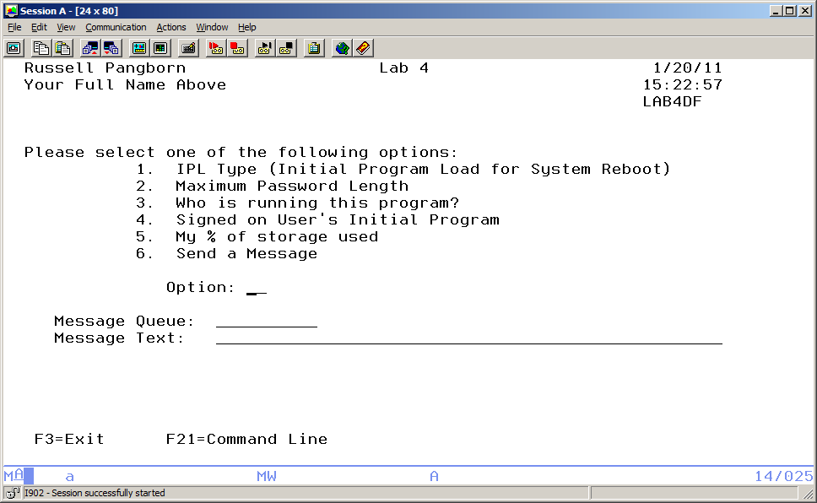

Design your display file to include the following:

Function Keys:
F3 – Exit F21 – Command Line F21 must be defined as a CF function key.

Include on the screen:
Your Full Name System Date
System Time Appropriate Title

Name of display file(LAB4DF)

An input/output field that allows 2 characters. This field is designed to hold the option entered. Possible values are:
1, 2, 3, 4, 5, 6, 01, 02, 03, 04, 05, 06. Include an error message if something else is entered. If there is an error, the option field should be reverse image and the cursor positioned on it.

An input/output field that allows 10 characters. This field is designed to the message queue where to send the requested message.

An input/output field that allows 50 characters. This field is designed to store the message needed for option 6.

A 70 character output only field. This field is designed to hold the text of for the selected request. This field is referred to as ‘request text’ below.

The OPTION field will use an indicator to show the field in Reverse Image and to position the cursor.
OPTION 2A B 14 25
A 30 DSPATR(RI)
A 30 DSPATR(PC)

This can be entered carefully below the option field when on the Source tab. Use an “I” to insert a line.

This can also be achieved by using the Properties tab when the focus is on the OPTION field.

The attributes tab is selected and Reverse Image is checked and then an add button is used. Once DSPATR(RI) has been added you can click on it to activate it and then click on the indicators tab.
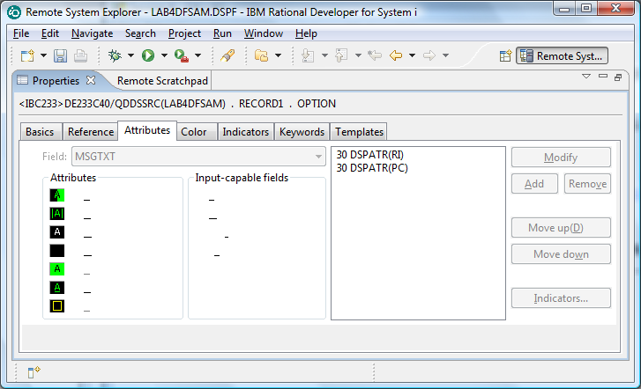

By entering 30 you are saying indicator 30 must be on in order to activate Reverse Image.
If you put an “N” in the first box, you would be saying indicator 30 has to be off in order to activate Reverse Image.

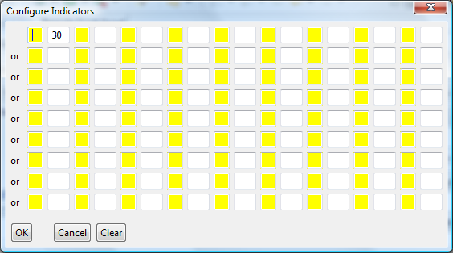

Your program can turn on indicator 30 if someone enters an invalid option.

You can also click on the Text “A valid option must be entered” in order to get the text to appear beside
the option field only when indicator 30 is on.

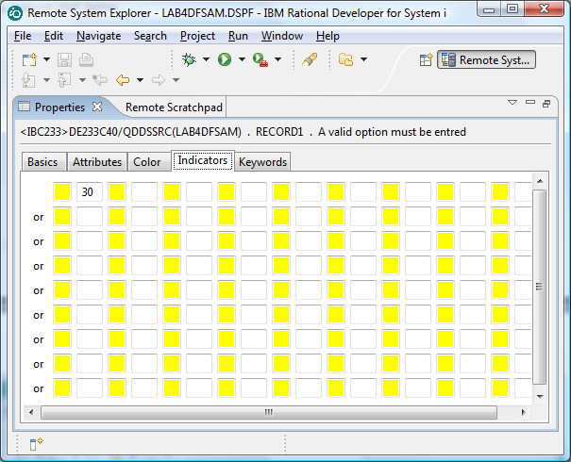

Part G – Develop CLLE Program – LAB4CL

Here is some skeleton code you can enter that gets option one working from last semester’s CLLE lab4.
This code reports on the security level setting.

This code has been discussed in class.

You need to change it so that it reports information on the IPL type.

PGM
DCLF LABDF
DCL &Security *Char 2

/*** M A I N L I N E *****/
SndRcvf

DoWhile (&In03 = '0')

Select
When (&Option = '1' *or &option = '01') CallSubr OPTION1

Otherwise ChgVar &in30 '1'
EndSelect

SndRcvf
Enddo

/*** S U B R O U T I N E S *****/
SUBR OPTION1
RtvSysVal SYSVAL(QSecurity) RTNVAR(&Security)
Select
When (&Security = '10' ) +
ChgVar &MsgTxt ('Security Level is 10 and not supported')
When (&Security = '20' ) +
ChgVar &MsgTxt ('Password security only at level' *Bcat &Security)
When (&Security = '30' ) +
ChgVar &MsgTxt ('Password and object security at level 30')
When (&Security = '40' ) +
ChgVar &MsgTxt ('Password, object, and operating system integrity at level 40')
When (&Security = '50' ) +
ChgVar &MsgTxt ('Password, object, and enhanced operating +
system integrity at level 50' )
EndSelect
EndSubr
ENDPGM

Let’s look at the spooled files generated when we compile in RDp (not available in RDi)

Right click on My spooled files and use the refresh key

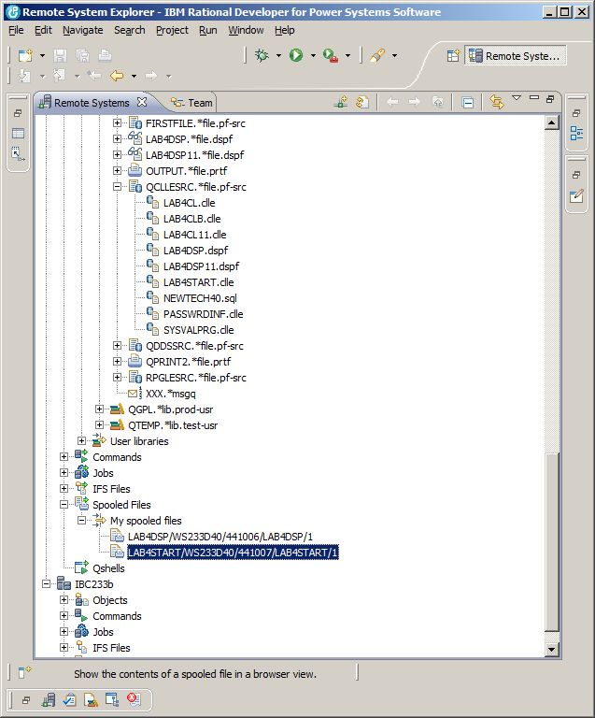

Select your spooled file from your CLLE compile and right click to select “Show the spooled file contents”

My spooled file and program were called LAB4START. I can double click on the tab to see the Text of my listing.

(The other option is an Image tab beside the Text tab – but you may have to wait a bit for this)
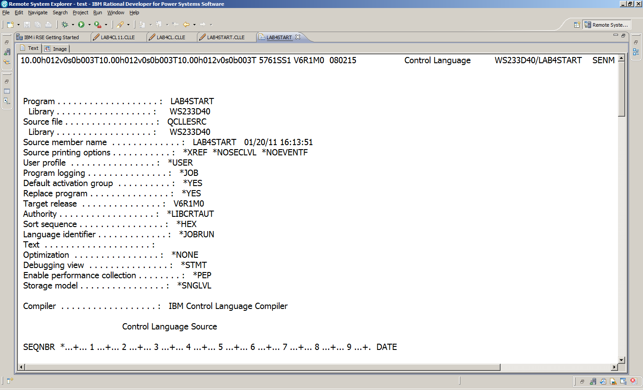

Text is good enough for me and I can scroll down to see if the program object was created in my library.

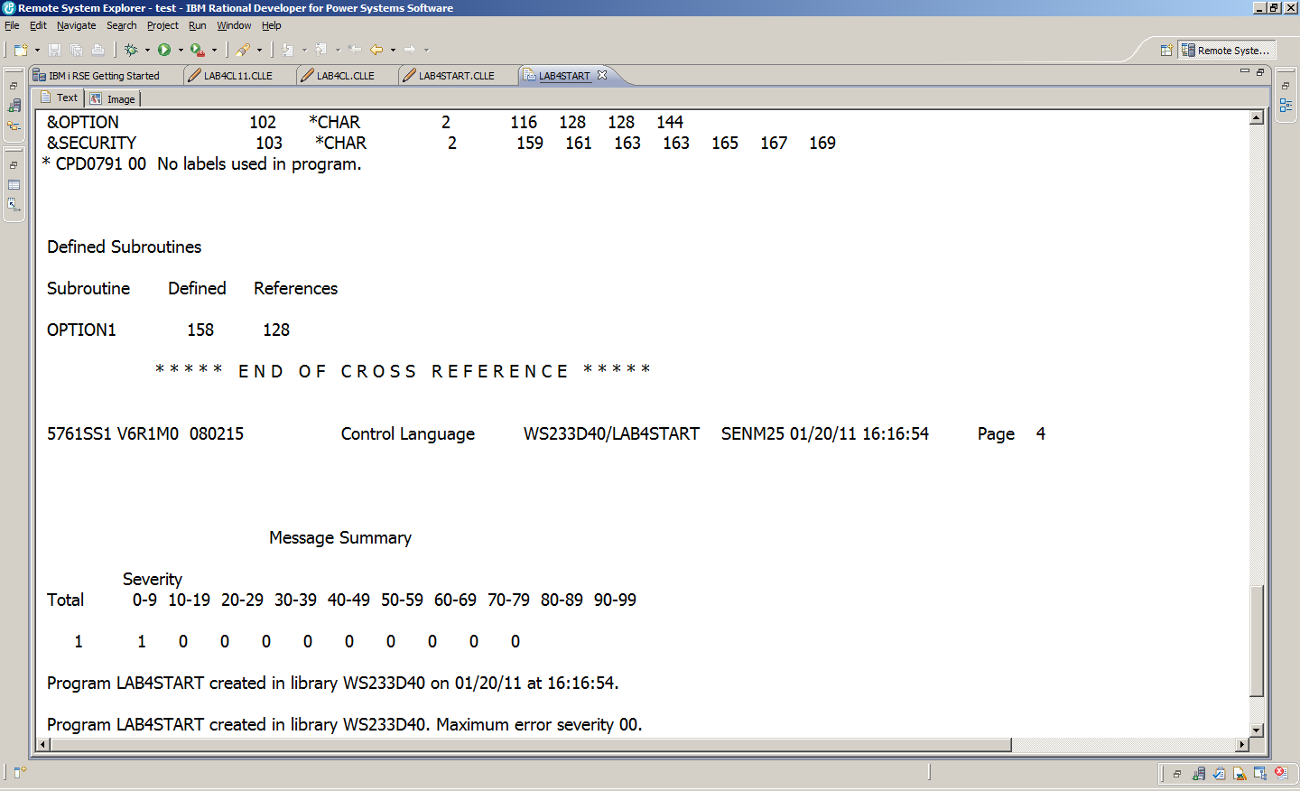

Create a Command to get rid of all spooled files.

Unfortunately as we work things out, there will be a lot of unsuccessful compiles. The output queue gets crowded and it is tough to find the latest spooled file. We can get rid of most of them in RDp with the CLROUTQ command. (Clear OutQ)

This command is handy to have always as part of our saved workspace.

In the Remote Systems tab, Expand Your Commands and provide the command to clear out your output queue.

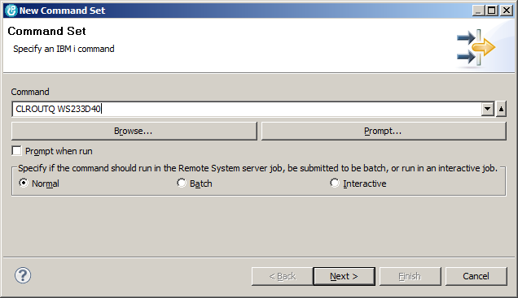

Provide an appropriate name.
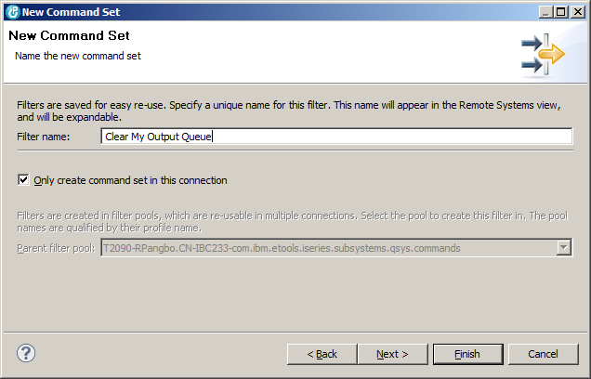

Run your command.

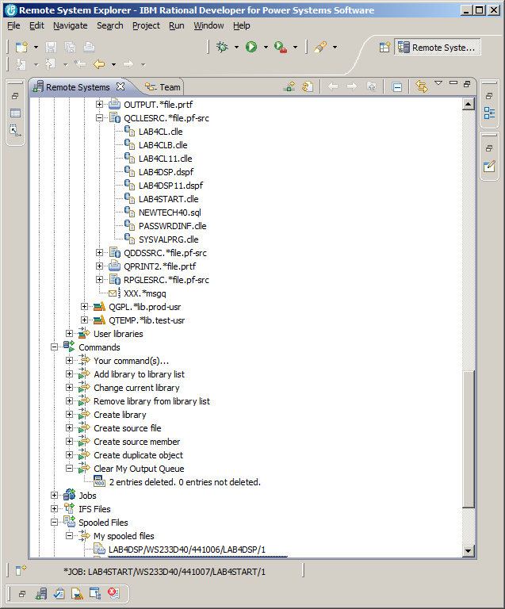

If you have your workspace on a USB or on a laptop, it should be available next session to deal with your cluttered output queue. Don’t collect a lot of old spooled files in your output queue!

