Lab Objectives
- Look at commands that are similar to the ones required to complete lab 4
- Select the appropriate Lab 4 command and parameter after looking at similar commands

Lab Requirements
- Lab 4 runs with all options working

Part A – Investigating Lab4 commands

RTVJOBA

Open your CLLE partially done program and type the following:

When (&Option = '3' *or &option = '03') Do

RtvJobA Press the prompt key (F4) and examine the possible information you can retrieve from a
running job. (we are going to try getting info about the output queue)
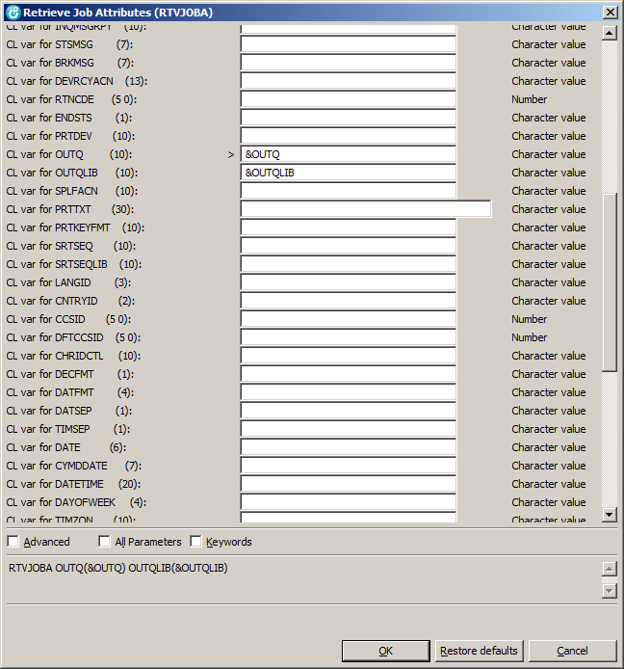

The keyword notation of how to use this command appears at the bottom of this screenshot. That is the code that will be placed in your program.

In Lab 4a, we had a subroutine executed when someone selected option 1. This time we will show sample code (with a different command featured then the actual lab) that will determine the output queue for the current job. This sample code will provide a solution inline, without using a subroutine.

Let’s pretend that this is option three.

Select
When (&Option = '1' *or &Option = '01') CallSubr OPTION1
..
When(&Option = ‘3’ *or &Option = ‘03’) DO

RTVJOBA OUTQ(&OUTQ) OUTQLIB(&OUTQLIB)
/* note this shows at the bottom of the preceding screen shot */

CHGVAR &MsgTxt ('Output queue for the current job is' +
*Bcat &OUTQ +
*Bcat ‘in the ‘ +
&OUTQLIB *Bcat ‘Library’)
EndDo
When( …)
…
Otherwise ChgVar &in30 '1'
EndSelect

This Select statement needs some added support at the top of your program. There are two new fields that need to be declared. The screenshot for the RTVJOBA command lets you know the type and size required for these declarations.
What are the required declarations?

______________________________________________

______________________________________________

The result of selecting option three would show something like the following:

Output queue for the current job is DK233A39 in the DK233A39 Library

RTVUSRPRF

You can get information about the user profile for the current user that is signed in to an interactive session.
The Retrieve User Profile command can tell information like the “initial menu” setting for a user.

We are going to prompt the command to find out all the useful user profile information that is retrievable.

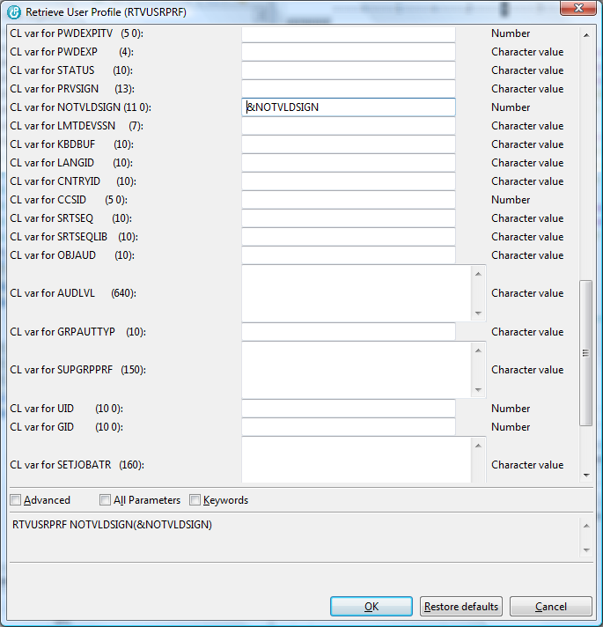

Note the actual command shows at the bottom of the screenshot again.

This time we are not sure what NOTVLDSIGN is telling us. The F1 key does not supply immediate context sensitive help.

You can try prompting the command in Client Access and with your cursor on the appropriate parameter, get more information about that parameter.

Prompting in Client access and using the F1 key on the NOTVLDSIGN parameter.
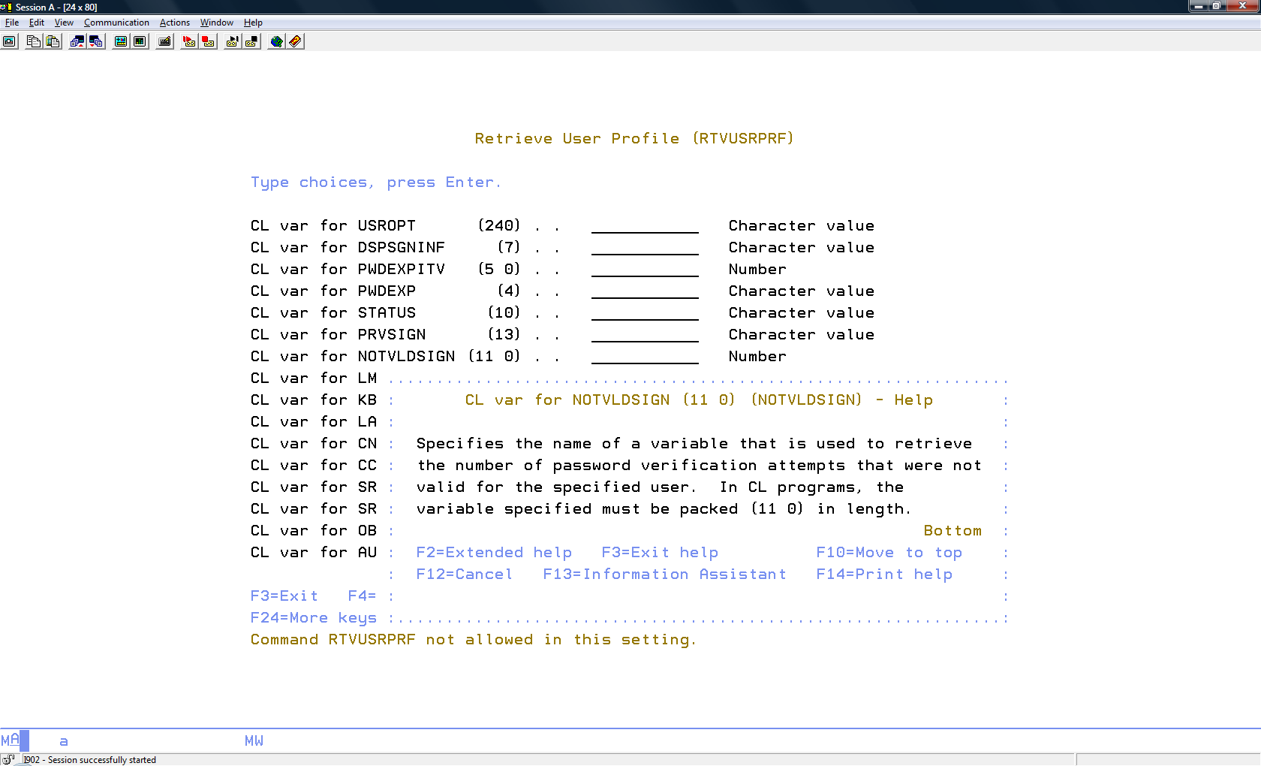

Here is the command used in a select statement:

When (&Option = '4' *or &option = '04') Do
RTVUSRPRF NOTVLDSIGN(&NOTVLDSIGN)
ChgVar &NotVldSC &NotVldSign
ChgVar &MsgTxt ('Not Valid Signon number is ' *Cat &NotVldSC)
ENDDO

Show the two fields need to be declared at the top of the program to support option 4.

___________________________________________

___________________________________________

RTVSYSVAL.

You can use the same strategies explored with RTVJOBA and RTVUSRPRF to investigate system values

This program requires retrieving a system value, user profile information, job attributes for options 1 to 5. Option 6 involves sending a message and using the message queue and message text fields that appear at the bottom of the screen.

Let’s look at option 6.

In order to send a message the message text field should not be blank and the message queue field should not be blank or the name of an invalid message queue (doesn’t exist or you don’t have authority to it)

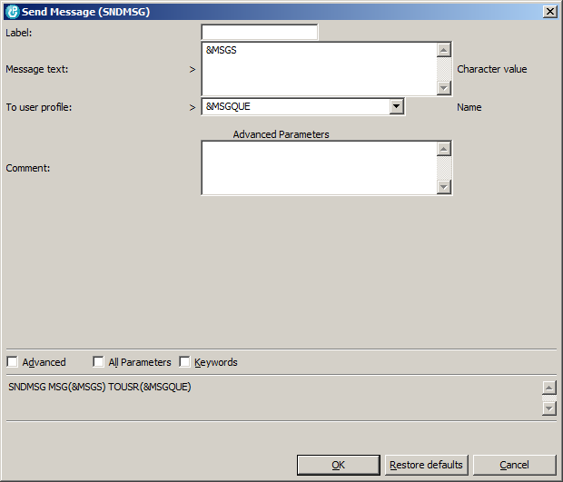

Here is some display file code to help deal with a blank message queue:

When your CLLE program discovers that option six is being used and you have not typed anything into the MSGQUE filed on the screen, it can turn on indicator 31.

ChgVar &in31 '1'

Your display file code should be set up to behave a certain way when indicator 31 is on.

A MSGQUE 10A B 16 22
A 31 DSPATR(RI)
A 31 DSPATR(PC)
A 31 16 35 'Please enter a Message Queue'

When 31 is on (shows at left) then the cursor is positioned in the message queue field which shows in Reverse Image.

When 31 is on the message Please enter a Message Queue will show beside the message queue on line 16.

Remember you do not want to leave indicator 31 on when subsequent options are selected.

The same can be done for the field that holds the message text (&MSGS) and for the field that could hold an invalid option. Obviously different indicators need to be selected for use.

Making the Command Line available while your program is running.

Your screen record needs allow the user to press the F21 key.

Your program can check for this key being used somewhere in your Select statement. The API program that will support the use of a command line while your program is running is QUsCmdLn. You just need to call this at the appropriate time.

Looping

A good model to follow with reading files and presenting interactive screens is the following:

SNDRCVF

DoWhile /* (something to do with the F3 key) */

….

SNDRCVF
ENDDO
/* summary or cleanup operations */

Initializing

You probably need to reset fields at some point in your loop. It is suggested that most of this can be done in an Initialize subroutine.

