BTI220 Lab 3
Released On: June 3, 2015
Due On: June 12, 2015 - 23:59
Point: 2%

Objective:
- Practice with web development.
- Create the HTML5 page.
- Practice HTML5 basics.
- Publish webpages.

Basic Requirements:
You are going to create a web page introduction.html (and more optional pages) to practice basic HTML5 syntax and view the page on browser.

Steps:
- Connect to your account on zenit.senecacollege.ca using a secure connection (SSH, or putty). Go to your lab 3 directory public_html/labs/lab03 directory (Unix command: cd public_html/labs/lab03).
- Use pico, vi, or other text editor to create an HTML5 file. Name it as “introduction.html”.
- Or, you create the introduction.html on your local machine and transfer it to the corresponding folder (i.e., public_html/labs/lab03)

Note: the structure will be public_html/labs/lab03/introduction.html, refer to the figure in the section below.

- In the page “introduction.html”, create a link (text with “HOME”) directing back to the index.html page which is under the directory “public_html”.

- More requirements for the introduction.html files are available below in section 5.
- Test this page in browser using this url: https://zenit.senecac.on.ca/~yourlogin/labl/lab03/introduction.html .

File Structure:
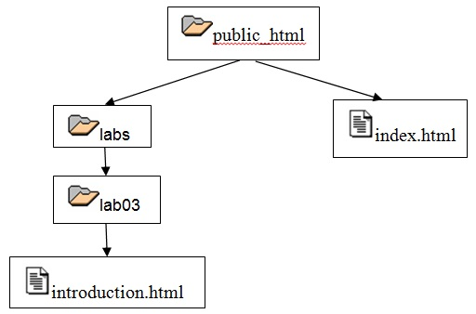

Requirements for “introduction.html”:

- Practice/ try/ include the HTML5 tags as many as possible.
- Required to include the following in your page(s):
- Introduction to yourself (text), applying appropriate presentations (tags)
- Your photo (or other picture)
- your email (hyperlink)
- Text hyperlink (to any page/website)
- image hyperlink (to any page/website)
- Named anchor (navigation within the page)
- unordered list
- ordered list
- definition list
- nested list
- table
- Navigation link “HOME” back to “index.html” under “public_html” directory.

- Use comments when needed.
- Show proper indentation on your HTML code.

Validate your page with W3C
- Type the following in your browser url location http://validator.w3.org/
- type the url for your page introduction.html.html - https://zenit.senecac.on.ca/~yourlogin/introduction.html
- Click on "More Options" and check "Show Source"
- Click on "Check" - you should get "Passed, 1 warning(s)"
- If you get any errors, go back to step 2 - modify your index.html - and validate again

Evaluation:
The evaluation for lab3 will be based on adherence to all of the requirements outlined above including:
- adherence to the coding standards, pass the W3C validation
- quality of the HTML technical features/usage (syntax, readability, documentation and indentation)
- the links work properly as instructed
- follow the file structure described above in section 4
- the effort, including the tags/ elements described in section 5
- the overall appearance, organization and presentation.
Submission:
- No explicit submission, no email, no print out…
- Leave it on zenit account, I will check it after the due date.
- Don’t update the file after due date. Otherwise, your lab will be view as late.

Important:
Make sure everything you include on your page has no copyright issue, i.e., either you have the copyright or you are allowed to use it on your page.

