**BTI220 Lab 1**

**Released On:** May 19, 2015

**Due On:** May 29, 2015 - 23:59

**Point:** 1%

**Objective:**

Practice JavaScript Basics

**Specifications:**

Create an Income Tax Calculator using JavaScript. The income tax will be calculated as follows:

1. The **income tax** for a person is the total of the base tax and the extra tax.
2. The Tax Calculator **repeatedly** asks user to input and report the corresponding information until  
   user inputs a negative number for base tax to stop.
3. The **input** includes:
   * base tax. Everybody pays a base tax.
   * yearly income. The extra tax is calculated based on the yearly income of the person applying the following rules:  
     a. For the first $40000 (inclusive) of the yearly income, the extra tax is 15%.  
     b. For the yearly income over $40000 but less than $80000 (inclusive), the extra tax is 30%.  
     c. For the yearly income over $80000, the extra tax is 50%.
4. Your program **reports** the base tax, extra tax, and the total tax of a person.  
   Sample run:  
   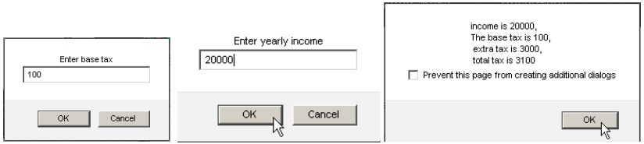

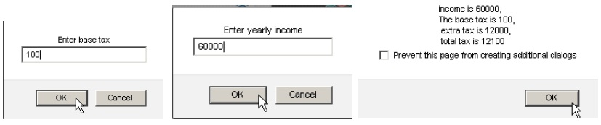

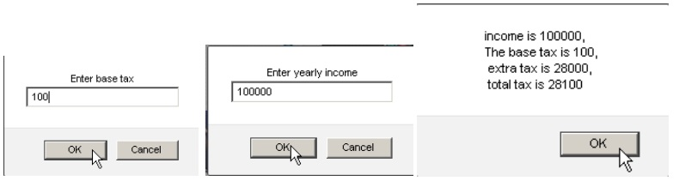   
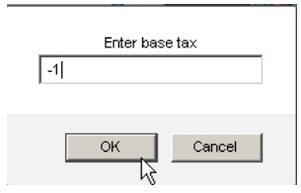terminates the program

**Submission:**

Login on your zenit account, and upload your lab 1 files under the public_html/labs/lab01 directory before the due date.  
You need to submit 2 files:  
(1) the source code of JavaScript (lab1.js), and  
(2) a file with the screenshots as your program runs with input and output, like the sample run in this  
document.

**Note:** don’t change any file after due date. Otherwise, your lab will be viewed as late.

**Academic Policy:**

Seneca's Academic Policy will be strictly enforced. <http://www.senecacollege.ca/academicpolicy/index.html>  
This is an individual lab. Please do not try to convince me that any two of you may have the same code.

**Student Oath:**  
A signed declaration of honesty must be included in your submission. Put the following declaration as  
comment in the beginning of your JavaScript program.

/*********************************************************************************

*

* I declare that this assignment is my own work in accordance with Seneca

* Academic Policy. No part of this assignment has been copied manually or

* electronically from any other source (including web sites) or distributed to

* other students.

*

*

* Name: __________________________ Student ID: __________________

*

********************************************************************************/