**BTI220 Lab 2**

**Released On:** May 26, 2015

**Due On:** June 4, 2015 - 23:59

**Point:** 1%

**Objective:**

Practice JavaScript String, Array, and functions.

**Specifications:**

You are asked to write a JavaScript program (name it **lab2.js**) to get the average mark of a class with 40 students and report who got the highest mark. Refer to sample runs.

1. Required to use arrays, though you could do it without arrays.
2. User repeatedly input a student’s name and mark.
3. You need to validate the name based on the following rule:
   * The name can only include the
     + alphabet letters (lowercase or uppercase),
     + apostrophe (‘),
     + dash (-),
     + comma (,)
     + white space ( ).
   * All other characters are considered invalid.
   * If user inputs invalid data, your program should ask user to re-input it until user inputs a valid name.
4. You DO NOT need to validate the mark. But the mark could be float number with decimals.
5. User inputs “END” for student name or finishes the 40 students input to terminate the program and report the information as below.
6. If the first name input is “END”, your program reports “No input. Good bye” in two lines as sample run #1.

**Hint**: you can use \’ to display the apostrophe(‘) in your program.

**Note**: Please TEST your program according to the sample runs below, with the numbers and the invalid inputs.

**Sample run #1:** First input is “END”

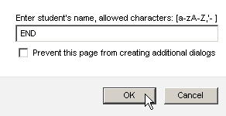 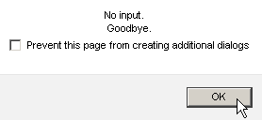

**Sample run #2:** pay attention to name validation

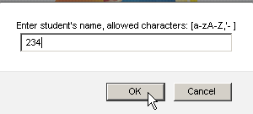 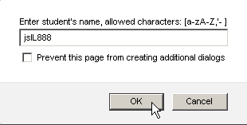

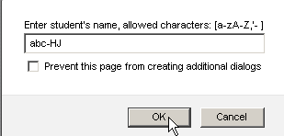 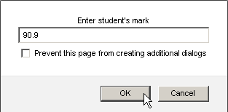

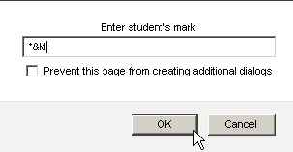 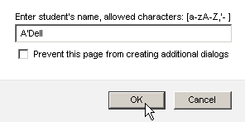

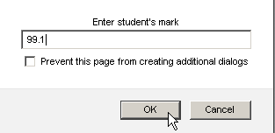 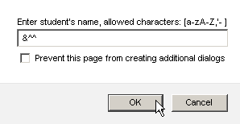

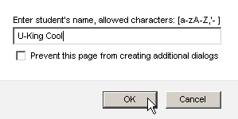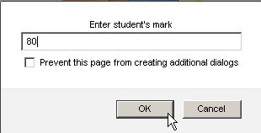

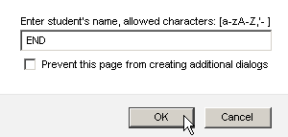 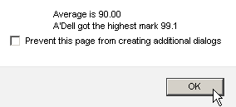

**Submission:**

Save you JavaScript code into a file named **lab2.js**. upload the file into the lab03 folder on your account before the due date.

You need to submit 2 files:

(1) the source code of javascript (**lab2.js**), and

(2) a file with the screenshots as your program runs with input and output, like the sample run in this document.

**Note:** Do not update your **lab2.js** after the due date. Otherwise, your lab2 will be viewed as late.

**Academic Policy:**

Seneca's Academic Policy will be strictly enforced. <http://www.senecacollege.ca/academic-policy/index.html>

This is an individual lab. Please do not try to convince me that any two of you may have the same code.

**Student Oath:**

A signed declaration of honesty must be included in your submission. Put the following declaration as comment in the beginning of your JavaScript program.

/*********************************************************************************

*

* I declare that this assignment is my own work in accordance with Seneca

* Academic Policy. No part of this assignment has been copied manually or

* electronically from any other source (including web sites) or distributed to

* other students.

*

*

* Name: __________________________ Student ID: __________________

*

********************************************************************************/