**Released on**: Sunday, Sept. 27th, 2015

**Due on:** Sunday, Oct. 18th, 2015 23:59

**Value:** 6% of final mark

**Late penalty**: 10% for the 1st delay day; 5% for each day thereafter

**OVERVIEW**

You will create a JavaScript program named **a1.js** for an online bookstore. Your program will provide the input for a list of books information and query the book list for by book name.

**OBJECTIVES**

* Practice JavaScript basics and programming skills
* Understand and apply the concepts of function and object in JavaScript.

**SPECIFICATIONS**

1. Repeatedly input book information in the format of

Book Name, Author Name, Year of the book, Price of the book

Where

Book Name is a string, e.g., The Last Lecture

Author Name is a string, e.g, Randy Pausch

Year of the book is a whole number, e.g., 2008

Price of the book is a non-negative float number, e.g, 26.80

So the valid input is like:

*The Last Lecture, Randy Pausch, 2008, 26.80*

1. Validate the input follows the above format. Four pieces of information are delimited by comma (,). More or less information will be considered invalid. Your program will prompt for reinput.
2. Parse the above one-line input into the following four fields:

Book Name, Author Name, Year of the book, Price of the book.

1. Validate “year of the book” as a whole number and “price of the book” as a non-negative float number.

**Note**: if any input information is invalid, all the information of the current book will **NOT** be written to the book object.

1. Do NOT need to validate book name or author name.

1. Only if all the information is valid, the four pieces of information will be written to a book object. And all the input books will fill a list (array) of objects. Require to design the book object and the array of the book objects.
2. Input “END” or any combination of lower case or upper case of “end” (e.g., End, eNd, enD…) will finish the input of the books and start querying the book information.

Note that, after finishing the input, all the book information has been stored in the array (list) of book objects.

1. Query the book information by book name. This query is case INSENSITIVE, which means (“a” may match “a” or “A”). If the query book name matches ANY PART of the book name, it is considered match. For example, query: last

Or query: lecture

Will both match the book name:

The Last Lecture

Display all the information of all the matched books.

The Last Lecture, Randy Pausch, 2008, 26.80

1. If the query book is not in the book list, display “(the query name) is not found”. Refer to sample run.
2. If query book name is empty, all the books of the book list will be displayed.
3. Input query book as “END”, “end”, “End”, or any combination of “END”, will stop query and terminate the program.

**REQUIREMENTS**

1. Create and apply at least three meaningful functions in your program.
2. Design and use the Object (book) and Array of Objects (array of book objects).
3. Fully test your program with different scenarios. Refer to the sample run. You can have different wording. However, you need to cover the above-described different cases.
4. Errors (Exceptions) or unimplemented functionalities may cause INC (Incomplete) of your assignment.

**Sample Run:**

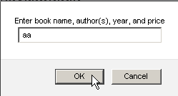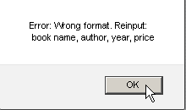

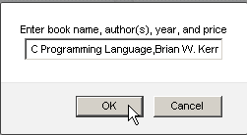

**Note:** This complete input is: C Programming Language, Brian W. Kernighan, 1988, 57.13

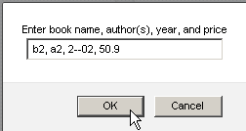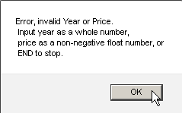

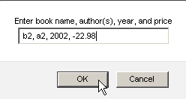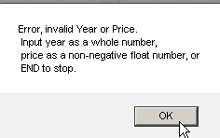

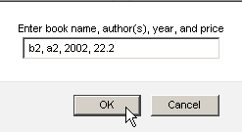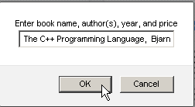

**Note:** This complete input is: The C++ Programming Language, Bjarne Stroustrup, 2013, 73.59

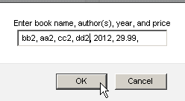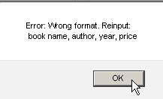

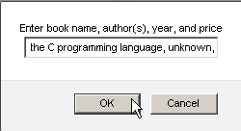

**Note:** This complete input is: the C programming language, unknown, 1999, 19.99

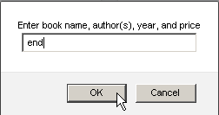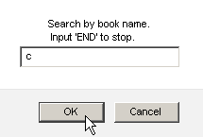

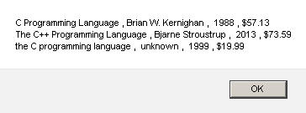

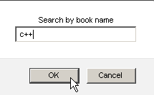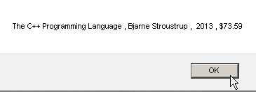

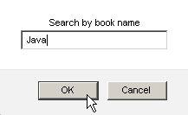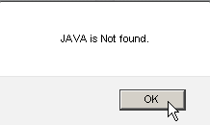

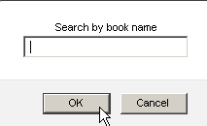 **Note**: empty query string, display all book information

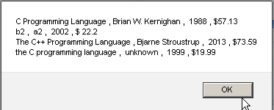

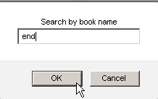 terminates the program.

**Student Oath:**

In the **a1.js** file, add the following declaration at the top of your code:

/*********************************************************************************

* INT222 - Assignment #1 *

* I declare that this assignment is my own work in accordance with Seneca *

* Academic Policy. No part of this assignment has been copied manually or *

* electronically from any other source (including web sites) or distributed to *

* other students. *

* *

* Name: ______________________ Student ID: ______________ Date: ________________*

*

*********************************************************************************/

**SUBMISSION**

Submit your **as1.js** file onto the Blackboard before the due date.