**INT222 - Lab 02: JavaScript (ver 1.2)**

**Released On:** Sept 22, 2015

**Due On:** Thursday, Oct 1, 2015 - 23:59

**Point:** 1.5% of final mark

**Objective:** Practise JavaScript basic syntax, built- in functions, and properties and methods of built-in objects.

Write a JavaScript program **lab2.js** to perform the following tasks. No validation is required for any of steps below – assume that the user will enter valid information.

**Step 1:**

1. Open a Firefox Scratchpad. Create comment line(s) for each of the steps in lab2 using block comments, indicating the start point of each step.
2. Declare the following global variables without any value assigned:

**e1, e2, e3, e4, e5, user, result**

1. Run the code the Firefox Scratchpad. Open the **Browser Console** in Firefox (by **ctrl+shift+J**) for monitoring runtime errors and console log. Watch errors or exceptions which will be showed in Scratchpad and/or Brower Console when running the code. Fix the errors and re-run your code until all errors are fixed.

**Step 2:**

1. Create a function named **capFirstLetter** using the function declaration syntax. The function receives a single parameter of String. Update / change the first letter of the string to upper case and other letters to lower case. The function returns the updated String.
2. Write code to prompt the user to enter his/her first name, and by default use your first name. Accept the entered name in **e1**.
3. Update / change the first letter in e1 to upper case and other letters to lower case by invoking the **capFirstLetter()** function.
4. Repeat step 1.c.
5. Hint: use the property and methods of String object – length, substr(from, length), substring(from, to) , toUpperCase() and/or toLowerCase().

**Step 3:**

1. Create a function named **getAge** using the function expression syntax. This function receives one parameter of integer, which is the year of a person’s birth day. The function returns the age which is calculated based on the year entered.
2. Prompt the user to enter the year of the user’s birth day – accept the number in **e2**. For the default value, use the year when you was born.
3. Calculate the age by calling the getAge() function and assign the number of age back to **e2**.
4. Repeat step 1.c.
5. Hint: for getting the number of the current year, use the code:

***(new Date()).getFullYear()***

**Step 4:**

1. Prompt the user to enter the school the user is attending and assign the input to **e3**. For default, use ***Seneca College***.

**Step 5:**

1. Prompt the user to enter the courses (in lower case separated by comma) the user is studying - accept the string in **e4**. For the default value, use ***int222,ibc233,dbs201,oop244***.
2. Split **e4** and store the result back in **e4**.
3. Prompt the user to enter a course to add to the user’s study list – accept the course in **e5**. For the default value, use ***eac150***. Then add the course (**e5)** at the end of the course array (e4).
4. Repeat step 1.c.
5. Hint: use the split() method of String object; use the push() method of Array object.

**Step 6:**

1. For the courses stored in e4, do the following operations.
   * Update / change each course in the array to upper case.
   * Sort the courses in the array in alphabetical order.
2. Repeat step 1.c.
3. Hint: use sort() method of Array object.

**Step 7:**

1. Create a JavaScript object with appropriate property names and the values which have been collected in variables e1, e2, e3 and e4; assign the object as value of the variable **user**.

**Step 8:**

1. Concatenate properties and values of the user object to form a string ~~by using for-in loop~~. Assign the string value to the variable **result**.
2. Use **alert()** to show the user info in the **result** in a popup window as following:

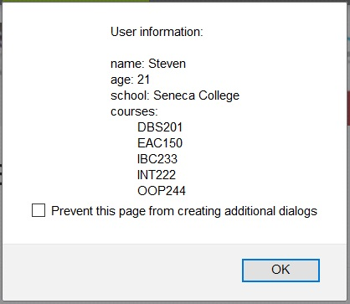

1. In addition show above message in Firefox web/browser console using console.log() function:

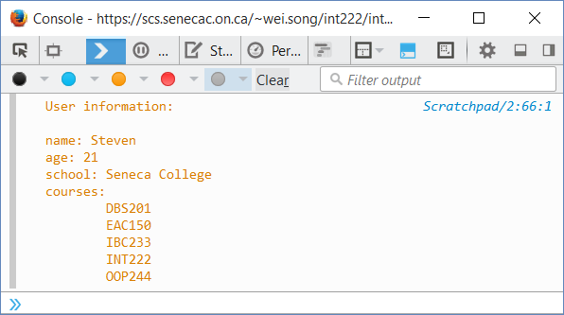

1. Repeat step 1.c.
2. Hint: use ‘\n’ and ‘\t’ to create multiple lines and indents in a popup window/web console.

**Step 9:**

1. Check the value of each variable (**e1, e2, e3, e4, e5, user, result)** by highlighting the variable and click the “Inspect” button in Scratchpad.

**Advanced**

* Go to **JSLint** Website <http://www.jslint.com/> or <http://old.jslint.com/>. Copy the code of **lab2.js** into the **source** area of the **JSLint** to validate your JavaScript code. Update your code to get no warning and no error for the **JSLint** check.
* When necessary, add ***'use strict';*** statement into your function(s) or the file to declare JavaScript strict mode (Search MDN for more information).
* If you use JavaScript built-in (global) function, such as alert and console.log, put the function names (separated by space) into the field of “Global variables…” field at bottom of the **JSLint** page.

**Submission:**

* Save your file as **lab2.js**. add the following declaration at the top of your code:

/*********************************************************************************

* INT222 – Lab #2

* I declare that this assignment is my own work in accordance with Seneca

* Academic Policy. No part of this assignment has been copied manually or

* electronically from any other source (including web sites) or distributed to

* other students.

*

* Name: ______________________ Student ID: ______________ Date: ________________

*

********************************************************************************/

* Login on your zenit account, and upload your **lab2.js** under the **public_html/labs/lab02** directory before the due date of lab2.