**INT222 - Lab 07: AJAX**

**Released On**: Nov 30, 2015

**Due On**: Saturday, Dec 5, 2015 - 23:59

**Point:** as an alternative lab for lab05B or lab06.

**Objective**

* to practice an AJAX call to a Web service

**Instructions**

1. Create an HTML5 page named lab07.html. Create folder labs/lab07 and place this file in the folder on your zenith account. Make sure that the folder has appropriate permission.
2. The created HTML page will load data with an AJAX call to a web service which is simulated by a static JSON file: <https://zenit.senecac.on.ca/~wei.song/int222/json/students.json>
3. You have to upload the HTML file to the ZENIT server to make the AJAX code work.
   * ATTN: Your AJAX code may not work on you PC because a cross-domain AJAX call is usually not allowed (for security reason).
4. You can choose to use internal or external JavaScript code for the AJAX call.
5. The required HTML page is showed below.

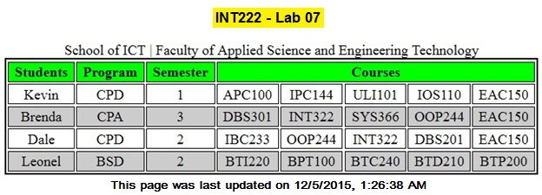

**Submission**

* Login on your zenith account, and upload your Lab 06 files (lab07.html & lab07.js) under the **public_html/labs/lab07** directory before the due date.
* Note: the lab may not be marked if it is submitted after the due date.