## INT222 - Lab 02: JS Objects and HTML basics (Ver 2.0)

## Due date

Section D: Wednesday, Oct 5, 2016 - 23:59

Grade value: 5% of your final course grade

## Objective

Work with JavaScript built-in and user-defined objects, and basic HTML.

## Specifications

The lab contains three parts. You’ll create two JavaScript files for part “A” and “B” and one HTML document for part “C”. Complete the three parts of the lab as specified below.

**Part A – 3 marks**

Write a JavaScript program **lab02a.js** to perform the following tasks. No validation is required for user input – assume that the user will enter valid information.

Open a Firefox Scratchpad. Create comment line(s) for each of the Steps in lab02a.js using block comments, indicating the start point of each Steps. e.g.

/\*\*\*\*\*\*\*\*\*\*\*\*\*\*\*\*\*\*\*\*\*\*\*\*\*\*\*\*\*

\* Step 1

\*\*\*\*\*\*\*\*\*\*\*\*\*\*\*\*\*\*\*\*\*\*\*\*\*\*\*\*\*/

To run all JavaScript code in Scratchpad, click on the ***Run*** button. To run a part of the code, highlight the part of code and click on the ***Run*** button . You’re requested to keep a **Browser Console** open to monitor console logs and run-time errors when running JavaScript code. Variable values will be kept in memory after a piece of code is run. So, usually, you need to initialize variables to ensure the part of code can repeatedly give the same result.

**Step 1:**

1. Declare the following global variables without any value assigned:

**e1, e2, e3, e4, e5, e6, e7, str**

1. Run the code the in Firefox Scratchpad to test if you code has error or appropriate output. Fix the errors before going to the next step.

**Step 2:**

1. Create a function named **capFirstLetter** using the function declaration syntax. The function receives a single parameter of String type. Update / change the first letter of the string to upper case and other letters to lower case. The function returns the updated String.
2. Write code to prompt the user to enter first name, and use your first name as default value. Accept/store the entered name in **e1**.
3. Update / change the first letter in **e1** to upper case and other letters to lower case by invoking the function.
4. Repeat step 1.b (run the code and check for errors and/or outputs).
5. Hint: use the property and methods of String object – length, substr(from, length), substring(from, to) , toUpperCase() and/or toLowerCase().

**Step 3:**

1. Create a function named **getAge** using the function expression syntax. This function receives one parameter of integer (number type), which is the year of a person’s birth day. The function returns the age which is calculated based on the year entered.
2. Prompt the user to enter the year of the user’s birth day – accept the number in **e2**. For the default value, use the year when you were born.
3. Calculate the age by calling the getAge() function and assign the number of age back to **e2**.
4. Repeat step 1.b (run the code and check for errors and/or outputs).
5. Hint: for getting the number of the current year, you must use the code:

***(new Date()).getFullYear()***

**Step 4:**

1. Prompt the user to enter the college name the user is attending and assign the input to **e3**. For its default value, use ***seneca college***.
2. Change the first letter of each word of the string in variable e3 to upper case and other letters to lower case.
3. Repeat step 1.b (run the code and check for errors and/or outputs).
4. Hint: use the split() method of String and the capFirstLetter()function you created.

**Step 5:**

1. Prompt the user to enter 5 favorite sports (in lower case separated by comma) - accept the string in **e4**. Use ***hockey,football,basketball,tennis,golf*** as default value for the prompt.
2. If the string in **e4** contains “***football”***, replace it with the string “***soccer”***
3. Split the sports in **e4** into an array and store the array back in **e4**.
4. Prompt the user to enter an extra favorite sport with the default value “***formula 1***” – accept it in **e5**. Then add the sport (**e5)** at the end of the course array (**e4**).
5. Repeat step 1.b (run the code and check for errors and/or outputs).
6. Hint: use the split() and replace() method of String; use the push() method of Array.

**Step 6:**

1. For the courses stored in **e4**, do the following operations.
   * Update / change each sport string in the array to upper case.
   * Sort the courses in the array in alphabetical order.
2. Repeat step 1.b (run the code and check for errors and/or outputs).
3. Hint: use sort() method of Array object.

**Step 7:**

1. Create a function named **getDateString**(). This function receives one parameter of Date type and returns date string with the format of **yyyy-mm-dd**. e.g. 2016-09-20.

Note: if the number of the month (mm) or date (dd) is less than 10, a ‘0’ is needed before the number.

1. Create a date object with current date and time, and store it to **e6**.
2. Get current date string with the format of yyyy-mm-dd by calling the **getDateString**() function and passing **e6** as parameter. Store the date string in **e7**.

**Step 8:**

1. Concatenate all the variables **e1, e2, e3, e4 and e7** with appropriate text in variable **str**.
2. Useone statement **console.log(str);** to get the following output:

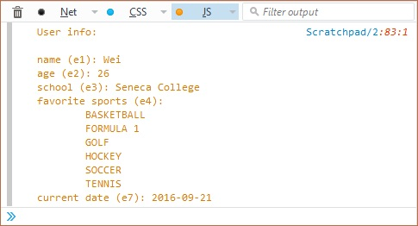

1. Save your file as **lab02a.js**.
2. Hint: use ‘\n’ and ‘\t’ to create multiple lines and indents in browser/web console.

**Part B – 2 marks**

Click [this link](https://scs.senecac.on.ca/~wei.song/int222/labs/lab02b.js.zip) to download a JS file named **lab02b.js,** which contains some given code, including an array (named **courses**) of course objects and a prototype object (named **student**) for creating student objects. Do not change the given code. Write your code beneath the given code and complete the following tasks:

**Task 1:**

1. Remove the last course object form the given array courses and store the removed object to a variable.
2. Output a message to browser console to show which course was removed from the array. Please see the screenshot of outputs on the browse console below.
3. Create 4 course objects that have the same properties as the course objects in the array have. Store the 4 course objects in the variables **ibc233**, **oop244**, **int222** and **dbs201** and give appropriate values for their properties.
4. Add these course objects in the array **courses**.
5. Use for loop to loop through the course array and output the information of the course objects in the array to browser console. Please refer the screenshot below.

**Task 2:**

1. Create 4 student objects based on the given prototype **student**. Give appropriate property values for all student objects.
2. Create an array named **students** and add all the student objects into the array.
3. Use the [forEach method](https://scs.senecac.on.ca/~wei.song/int222/lectures/INT222-Lecture3.pdf#page=41) to iterate the array students and output the information of the student objects to the browser console. Please refer the screen below.

After complete the two tasks, save your JavaScript code to file **lab02b.js**. Click the image to open it full-size in a new tab/window.

[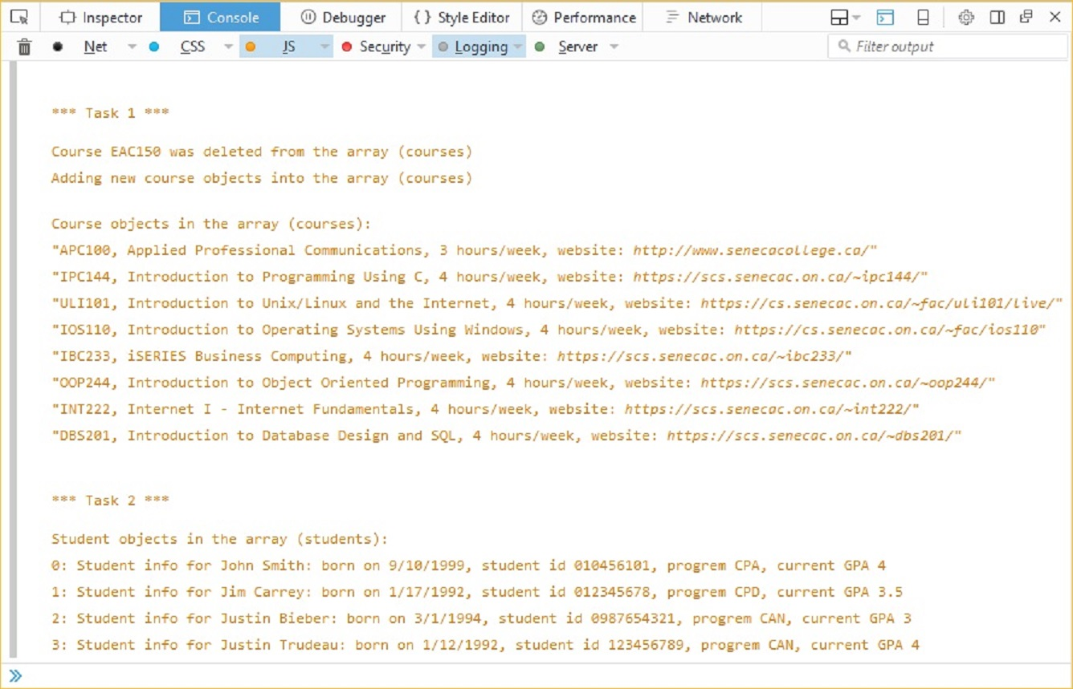](https://scs.senecac.on.ca/~wei.song/int222/labs/lab02b-output.jpg)

**Part C – 3 marks**

Create an **HTML5 document** named **lab02c.html**. Write your new code within the <**body**></**body**> tags and complete the following tasks. NOTE: Complete the tasks in order to ensure that your page looks exactly like the expected result (see Part C Output Sample below):

**Task 1**

1. Change the page title to **"???’s HTML Playground**” and use your name to replace “???”, e.g. **“Pat’s HTML Playground”.**
2. Show a **level-1 heading** at the top of the page with the text: **???’s HTML Playground** (where ??? is your name)
3. Show a paragraph with the text: **"Welcome to ???'s HTML Playground! Here, we will show some examples of common HTML Elements:"**

**Task 2**

1. Create 4 page **divisions**, with the following id attributes: "**partA**", "**partB**", "**partC**", "**partD**"
2. In the "**partA**" division, create the following elements:

* A **level**-**2 heading** with the text: **"<blockquote>...</blockquote>"** (Hint: You will have to make use of the &lt; and &gt; HTML entities to show the characters: < and >
* A **paragraph** element, containing the text: "**Here is a paragraph tag, sitting above our blockquote element"**
* A **blockquote** element, containing the text: "**I'm in a blockquote! – ???**", where ??? is a short quote
* A **paragraph** element, containing the text: "**Here is a paragraph tag, sitting below our blockquote element"**
* A **horizontal** **rule** tag helping to show the end of this segment

1. In the "**partB**" division, create the following elements:

* A **level-2 heading** with the text: **"<pre>...</pre>"** (Hint: You will have to make use of the &lt; and &gt; HTML entities to show the characters: < and >
* A **paragraph** element, containing the text: "**Here is a paragraph tag, sitting above our pre element"**
* A **pre** element , containing the text (and preserving the whitespace):

var sayHi = function(message){

console.log(message);

}

sayHi("Hello from pre!");

* A **paragraph** element, containing the text: "**Here is a paragraph tag, sitting below our pre element"**
* A **horizontal** **rule** tag helping to show the end of this segment

1. In the "**partC**" division, create the following elements:

* A **level-2 heading** with the text: "**Presentation Tags: <b>, <em>, <i>, <u>"** (Hint: You will have to make use of the &lt; and &gt; HTML entities to show the characters: < and >
* A **paragraph** element, making use of the **<b>, <em>, <i>, & <u>** tags, resulting in the text: **"Here is a paragraph with bold items, emphasized items, italic items, underlined items."**
* A **paragraph** element, making use of the <**b>, <em>, <i>**, & **<u>** tags all at once, resulting in the text: **"Here's another with all 4 in one"**
* A **horizontal** **rule** tag helping to show the end of this segment

1. In the **"partD**" division, create the following elements:

* A **level-2 heading** with the text: "**Lists: <ol>, <ul>, <dl>**" (Hint: You will have to make use of the &lt; and &gt; HTML entities to show the characters: < and >
* A **Ordered** **List** element containing two List Items listing two separate sports, ie: "**Baseball**" and "**Football**"
  + Nested within the first Ordered **List** **Item**, add an **Unordered** **List** element containing two **list** **items** showing teams that play the first sport, ie "**Blue Jays**" and "**Yankees**"
  + Nested within the second Ordered **List** **Item**, add an **Unordered** **List** element containing two **list** **items** showing teams that play the second sport, ie "**Argonauts**" and "**Tiger**-**Cats**"
* A **Definition List** element, containing two **definitions**:
  + One definition with the title "**HTML**" and description "**HTML, which stands for HyperText Markup Language, is the most basic building block of a webpage and used for creating and visually representing a webpage.".** The description must also contain a link to: <https://developer.mozilla.org/en-US/docs/Web/HTML> using the text "**source**". Make sure this link opens in a new tab/window.
  + A Second definition with the title "**CSS**" and description " **Cascading Style Sheets (CSS) are a stylesheet language used to describe the presentation of a document written in HTML or XML"**. The description must also contain a link to: <https://developer.mozilla.org/en-US/docs/Web/CSS> using the text "**source**". Make sure this link opens in a new tab/window.

**Task 3**

1. Validate your HTML using: [https://validator.w3.org/#validate\_by\_input](https://validator.w3.org/" \l "validate_by_input) and fix any errors – your submitted HTML file must not contain any errors.

Part C – Output Sample (click the image to see larger version)

[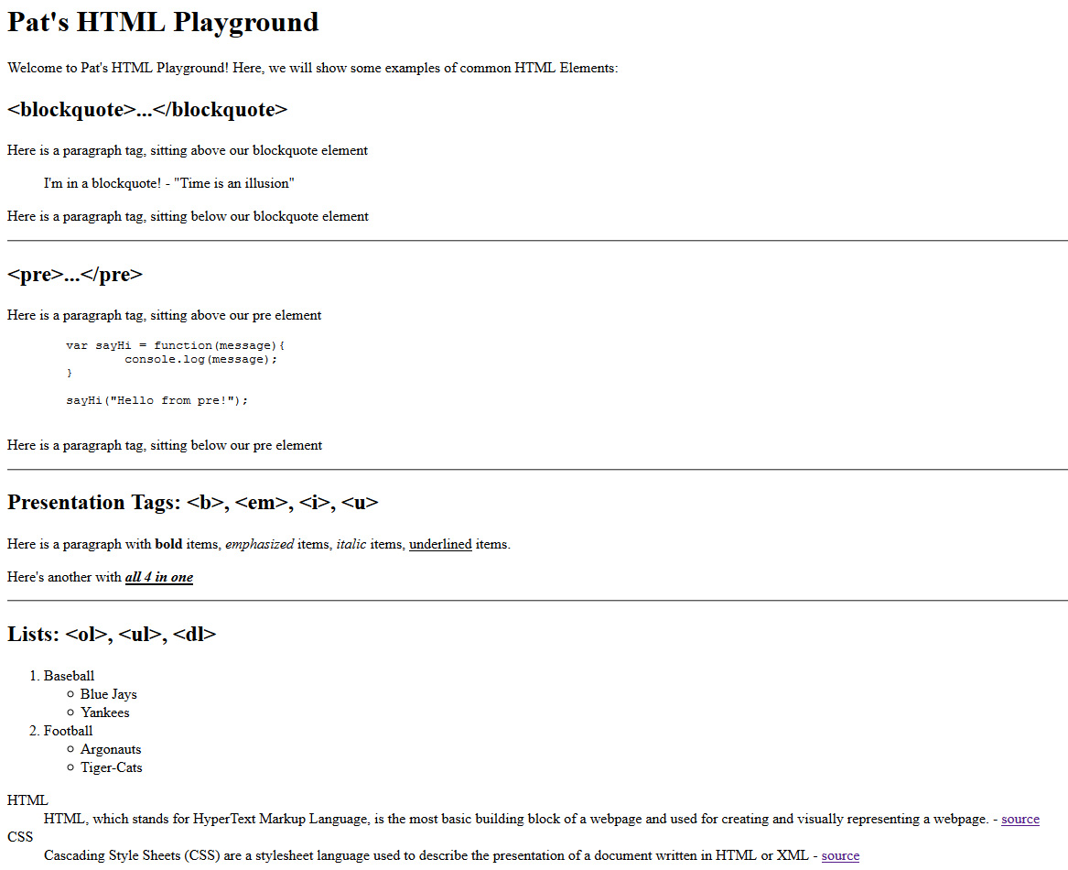](https://scs.senecac.on.ca/~wei.song/int222/labs/lab02c-output.jpg)

## Lab submission

* Add the following declaration at the top of your **lab02a.js** and **lab02b.js** files:

/\*\*\*\*\*\*\*\*\*\*\*\*\*\*\*\*\*\*\*\*\*\*\*\*\*\*\*\*\*\*\*\*\*\*\*\*\*\*\*\*\*\*\*\*\*\*\*\*\*\*\*\*\*\*\*\*\*\*\*\*\*\*\*\*\*\*\*\*\*\*\*\*\*\*\*\*\*\*\*

\* INT222 – Lab 02

\* I declare that this assignment is my own work in accordance with Seneca

\* Academic Policy. No part of this assignment has been copied manually or

\* electronically from any other source (including web sites) or distributed to

\* other students.

\*

\* Name: \_\_\_\_\_\_\_\_\_\_\_\_\_\_\_\_\_\_\_\_\_ Student ID: \_\_\_\_\_\_\_\_\_\_\_\_\_\_ Date: \_\_\_\_\_\_\_\_\_\_\_\_\_\_\_

\*

\*\*\*\*\*\*\*\*\*\*\*\*\*\*\*\*\*\*\*\*\*\*\*\*\*\*\*\*\*\*\*\*\*\*\*\*\*\*\*\*\*\*\*\*\*\*\*\*\*\*\*\*\*\*\*\*\*\*\*\*\*\*\*\*\*\*\*\*\*\*\*\*\*\*\*\*\*\*/

* Add the following declaration at the top of your **lab02c.html** file:

<!-- \*\*\*\*\*\*\*\*\*\*\*\*\*\*\*\*\*\*\*\*\*\*\*\*\*\*\*\*\*\*\*\*\*\*\*\*\*\*\*\*\*\*\*\*\*\*\*\*\*\*\*\*\*\*\*\*\*\*\*\*\*\*\*\*\*\*\*\*\*\*\*\*\*\*

\* INT222 – Lab 02

\* I declare that this assignment is my own work in accordance with Seneca

\* Academic Policy. No part of this assignment has been copied manually or

\* electronically from any other source (including web sites) or distributed to

\* other students.

\*

\* Name: \_\_\_\_\_\_\_\_\_\_\_\_\_\_\_\_\_\_\_\_\_ Student ID: \_\_\_\_\_\_\_\_\_\_\_\_\_\_ Date: \_\_\_\_\_\_\_\_\_\_\_\_\_\_\_

\*

\*\*\*\*\*\*\*\*\*\*\*\*\*\*\*\*\*\*\*\*\*\*\*\*\*\*\*\*\*\*\*\*\*\*\*\*\*\*\*\*\*\*\*\*\*\*\*\*\*\*\*\*\*\*\*\*\*\*\*\*\*\*\*\*\*\*\*\*\*\*\*\*\*\*\* -->

* Compact your files **lab02a.js, lab02b.js** and **lab02.html** into a zip file named **lab02-<your name>.zip**.
* Submit the zip file to the Blackboard (My.Seneca).

## Important note

* NO LATE SUBMISSIONS for labs. Late Lab submissions will not be accepted and will receive a grade of zero (0).
* After the end (23:59) of the due date, the lab submission link on the Blackboard will be no longer available.
* All INT222 labs are subject to change after released. It's your responsibility to keep your lab assignments up to date before the lab is submitted.