**Using the Microsoft DreamSpark WebStore to get Software**

This document discusses the Microsoft DreamSpark WebStore, in the context of web app and web service development.

This document was updated on September 1, 2016.

**What is DreamSpark?**

From the “what is DreamSpark?” page:

DreamSpark is a Microsoft Program that supports technical education by providing access to Microsoft software for learning, teaching and research purposes.

As a Seneca student, in the School of ICT, you have access to the Microsoft software you need for development and testing, including Visual Studio, SQL Server, Windows Server, and Windows client.

DreamSpark *replaces* the “Software Downloads” and “MSDNAA License” schemes that were used in the past.

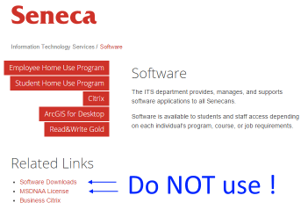

To get software, sign in to our school-specific DreamSpark WebStore, described next.

.

**Sign In to the DreamSpark WebStore**

[Follow this link](https://e5.onthehub.com/WebStore/Security/Signin.aspx?ws=37c5af0e-ff14-e511-940d-b8ca3a5db7a1) to our school-specific sign in page.

Before continuing, ensure that the WebStore name is “Seneca College – Newnham – DreamSpark”.

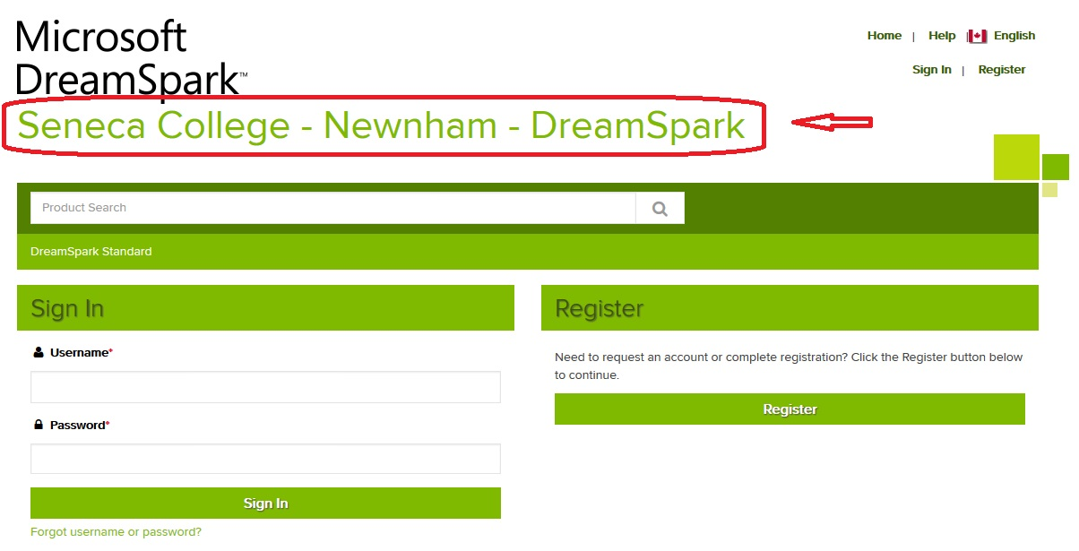

If you have credentials, sign in.

If not, then you should have received an email invitation to “complete your registration” from DreamSpark (on domain e5.onthehub.com). Respond to that, and you will be able to create credentials.

If you have not received an invitation, then send an email to servicedesk@senecacollege.ca, and request access to the DreamSpark Premium WebStore. Identify yourself as a School of ICT student. The IT Services technician (probably Ravi) will verify your eligibility, and generate the invitation email.

After sign in, choose to view the items in the “**DreamSpark Premium**” WebStore. The center panel will show a product selector. We will be interested in Visual Studio 2015. (Click the image to open it full-size in its own tab/window.)

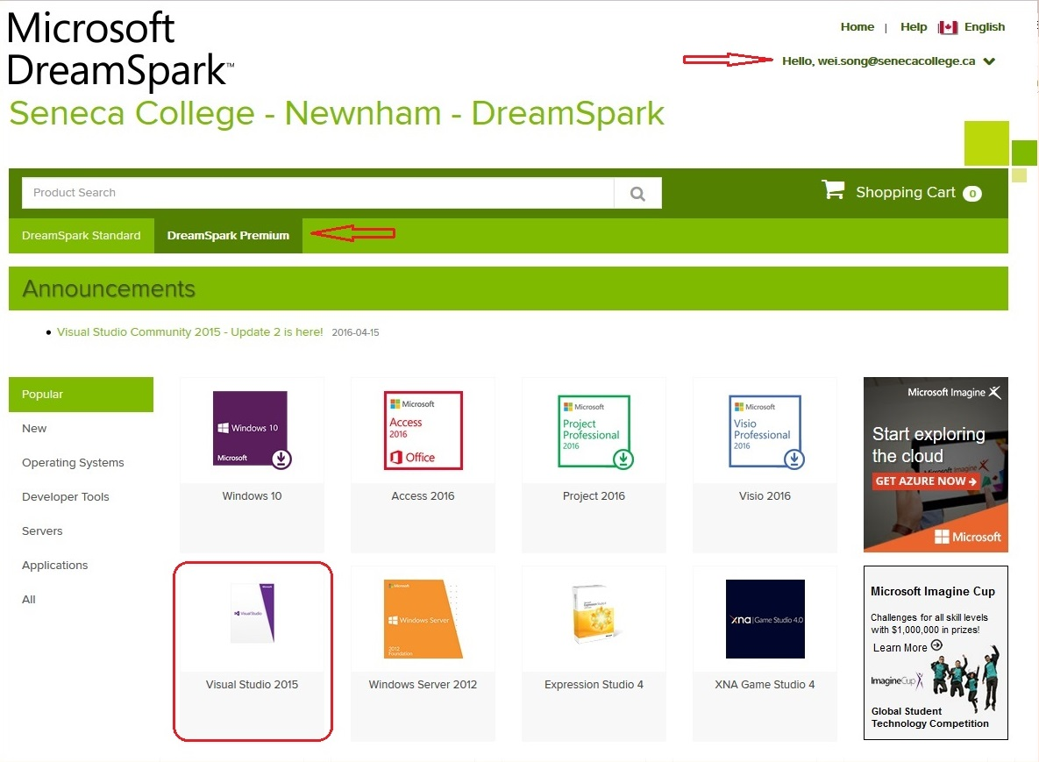

.

Select the Visual Studio 2015 item, and it will display a list of products in that category.

Your professor recommends the “Enterprise” version. It includes [CodeLens](https://msdn.microsoft.com/en-us/library/dn269218.aspx), which is really helpful.

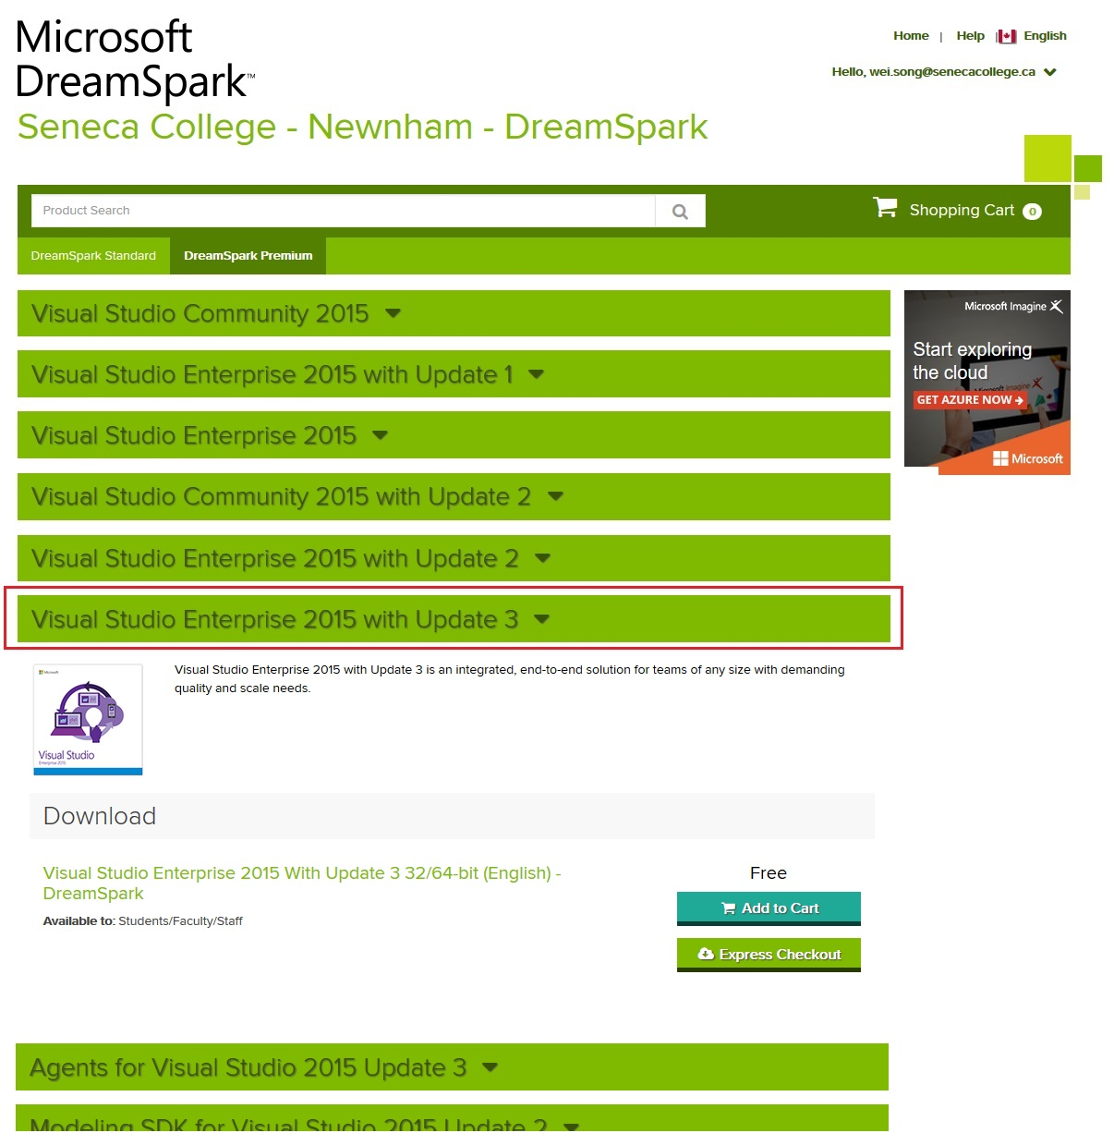

.

Continue the process to select, “checkout”, and download the product. During “checkout”, it will display your own unique product key, which you must enter after installation.

The item will be downloaded as an ISO image. Your computer will need software to “mount” the ISO image, so that you can install the software. (Maybe your computer already has this kind of software. If not, your professor has used a product named [Virtual CloneDrive](http://www.slysoft.com/en/virtual-clonedrive.html) in the past, and has been satisfied with it.)

After installation, start Visual Studio, and open the Help > About Microsoft Visual Studio dialog.

The left side will tell you which version is installed. The “REL” string in the version number tells you that this is the original release version. You should anticipate that future updates will modify that string.

In the upper-right area, there is a link to “License status”. Follow that link, and enter your own unique product key.



