## WEB222 Assignment 3 - HTML

## Due date

All sections: Saturday, ~~Oct 21~~ Nov 25, 2017 - 23:59

Grade value: 5% of your final course grade

## Objective

Practise HTML coding and update the DOM using the innerHTML property

## Specifications

In this assignment, you’ll build up a simple website by updating HTML and JavaScript code from a provided website file package. Download and unzip the **assign3-template.zip** file from MySeneca/Blackboard under the  Assignments section. Inside the package, you’ll find eight html files - **index.html, audio.html, dom.html, honesty.html, images.html, lists.html, table.html,**  **video.html,** and three folders, under which there are image, autio, video and JavaScript files. Open any of the HTML files using web browser, you will find a menu on the top of the web page:

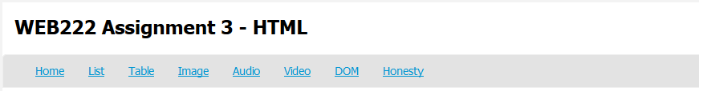

Each item/link on the menu is corresponding to an HTML file listed above. Note: the **Home (**page) item is linked to the **index.html** file. To start, open the package folder in Visual Studio Code (<https://code.visualstudio.com>). Complete all the item/web pages based on the instructions below:

The **Assignment 3 Home** page – **index.html**

1. Add a professional greeting to the visitor, e.g. "Welcome to my website, I will be demonstrating HTML5 & CSS3 principles and techniques...".
2. Add a short paragraph that introduces this website, e.g. "This site contains 8 pages, including: Home, List, Table"...NOTE: The paragraph must include **relative links** to all other pages of the website.
3. Add a short paragraph introducing HTML 5.
4. Show source code of a simple HTML5 document/web page in the index.html page.

The **HTML Lists** page – **list.html**

1. Create an unordered list of Seneca campuses.
2. Create a definition list with meaningful items.
3. Create a nested list about Canada’s provinces, and/or cities and/or sport teams. The nested list should contain at least one ordered list and at least one unordered list.
4. Add names or short words for all lists using heading tags as list titles.
5. Create 2 horizontal lines as dividers for the three lists.

The **HTML Tables** page – **table.html**

1. Create two HTML tables with meaningful contents of Seneca campuses, and/or buildings, and/or programs, and or courses and or marks:
   * The 1st table should be composed of the elements: <table border=1>, <tr>, <th>, <td>, <caption>
   * The 2nd table should be composed of the elements: <table border=1>, <tr>, <th>, <thead>, <tfoot> and <tbody>
2. Create one horizontal line to divide the two tables
3. Apply at least one of the “**rowspan**” or “**colspan**” attribute to <th> or <td> tag(s).

The **HTML Image** page – **image.html**

1. Find the image  and its URL from Seneca <http://www.senecacollege.ca/> website. Without download this image file, show the image in your web page. When the image is not available online, show text “Seneca 50” on the page.
2. Make the image a hyperlink to the Seneca website.
3. Find the provided image file **ict-student.jpg** under the **photo** folder. Show the image in your web page. When the image is not available, show text “ICT Student, Seneca College” on the page. Make the image a hyperlink to [the ICT School website](https://ict.senecacollege.ca/).
4. Set the same height for the 2 images with the value not greater than 200 (px).

The **HTML5 Audio** page– **audio.html**

1. Create an <audio> element to play the provided file **music.mp3** under the **media** folder.
2. The player mush have controls and automatically start when page is loaded.
3. The <audio> element must be created in <figure> element with <figcaption>.
4. Update the page title to “HTML5 Audio”.

The **HTML5** **Video** page– **video.html**

1. Create an <video> element to play the provided file **seneca_college.mp4** under the media folder.
2. The player mush have controls and the audio will start over again, every time it is finished..
3. The < video > element must be created in <figure> element with <figcaption>.
4. Update the page title to “HTML5 Video”.

The **“Updating DOM …”** page– **dom.html**

1. In the provided **myscript.js** file (js/myscript.js), there are one JavaScript object **logoImage** and one array **players**, in which each Player object has the properties: number, nationCode, player, position and age.
2. Use JavaScript and DOM with the data of the **logoImage** object and the **players** array to update the dom.html page. The completed page is showed as following:

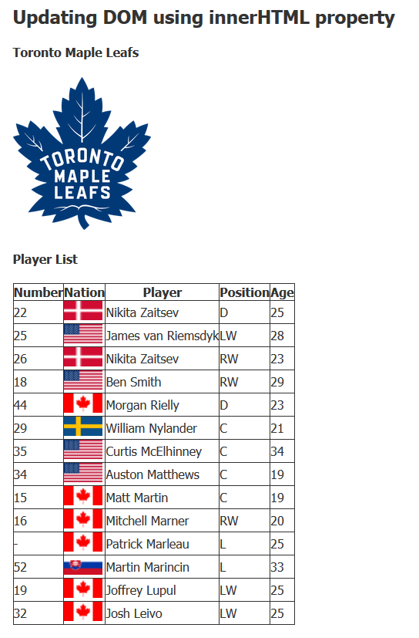

1. To display the national flag images for players in the table, use the provide image files under the “**photo/country**” folder. Note: **the** national flag images are named with nation code which is the same as the **notionCode** property of the object in the array **players**.
2. Be sure to write to your container(s) after the window has completely loaded.

The **"Honesty"** page– **honesty.html**

1. Add date and your name in the provided places to complete the honesty declarations.
2. Update the footer of each page with your full name.

**Other Requirements**

* All tags/attributes must be in lower case.
* All HTML pages must pass [the W3C's HTML Validation](https://validator.w3.org/#validate_by_input).
* Any error(s) for HTML validation will result in **25% penalty** for the grade of your lab.
* Warnings are allowed for HTML validation.

## Assignment submission

* Compact all your files including all directory structures into a zip file named **assignment3.zip**. Submit the **zip** file to the Blackboard (My.Seneca).

## Important note

* NO LATE SUBMISSIONS for assignments. Late assignment submissions will not be accepted and will receive a grade of zero (0).
* After the end (23:59) of the due date, the assignment submission link on the Blackboard will no longer available.