## INT222 - Lab 06: DOM and AJAX (Ver 1.1)

## Due date

Section D: Thursday, Dec 8, 2016 - 23:59

Grade value: 5% of your final course grade

## Objective

* To work on JavaScript coding with DOM
* to practice an AJAX call to a Web service

## Specifications

Download and unzip [the **Lab06.zip** file](https://scs.senecac.on.ca/~wei.song/int222/labs/lab06.zip), complete the coding tasks instructed as followings:

**Part A: JavaScript coding with DOM**

Part A is related to three files: **lab06.html**, **lab06.css** and **lab06.js**. Run the **lab06.html** in browser and view the source, you’ll find the **lab06.css** and **lab06.js** have already been embedded/referenced in the html file. In the **lab06.js** file, there is an array of Country objects which is available to use. Your work is to do the coding in the **lab06.js** file (you may add code to lab06.html if needed) and implement the tasks described below:

1. When user double click anywhere in the box of the div element, append a new paragraph in the div box.
2. When user double click anywhere in the box of the form element, change the form's background color to lightblue.
3. When user click the word “Male” or “Female”, the corresponding radio button should change the state – checked or unchecked.
4. Once the html page is loaded into the browser, populate the options (items) for the Country dropdown list using the array of Country objects in the lab06.js. The option should show country names, and the option values should be the 2-letter country codes from the country objects.

**Part B: Practice AJAX call**

Part B is related to two files: **lab06ajax.html** and **lab06ajax.json**. the **lab06ajax.html** file contains part of JavaScript code which mimic a call to web service (static JSON file **lab06ajax.json**) using AJAX. Your tasks are to complete the two missing parts in the JavaScript code:

1. Update the url for the JSON file, so the AJAX code can fetch the data.
2. Parse the fetched JSON data and represent the data on the space provided on the HTML page. This is the screenshot:

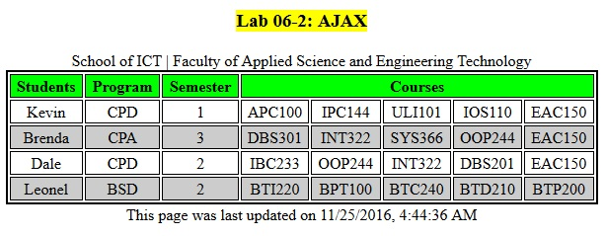

**Notes:**

* You must upload the **lab06ajax.html** and **lab06ajax.json** to the folder **public_html** on your Seneca Matrix or Zenit account, then the AJAX application can be run and tested.
* You must update the link to the remote **lab06ajax.html** file with absolute URL on you **Part A lab06.html** page, so your **Part B** can be tested and marked.

## Lab submission

* Compress the three files **lab06.html**, **lab06.css** and **lab06.js** to zip file **lab06.zip** and submit it to the Blackboard (My.Seneca).

## Important note

* NO LATE SUBMISSIONS for labs. Late Lab submissions will not be accepted and will receive a grade of zero (0).
* After the end (23:59) of the due date, the lab submission link on the Blackboard will no longer available.
* All INT222 labs are subject to change after released. It's your responsibility to keep your lab assignments up to date before the lab is submitted.