1. 搭建环境 安装python
2. 用安装qt时自带的Strawberry Perl，不用 ActiveState Perl,因为这个难下载
3. 不用安装ruby也可以，我没安装过ruby
4. 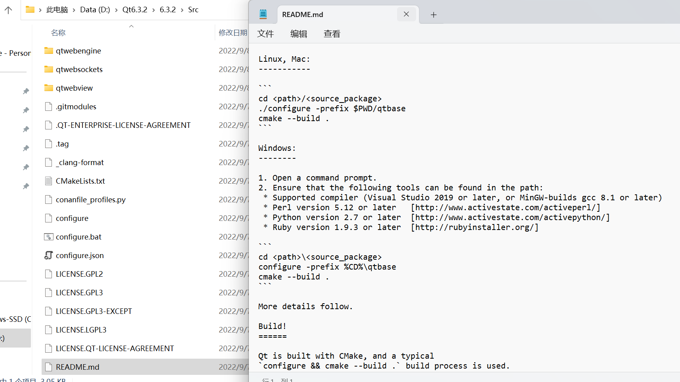

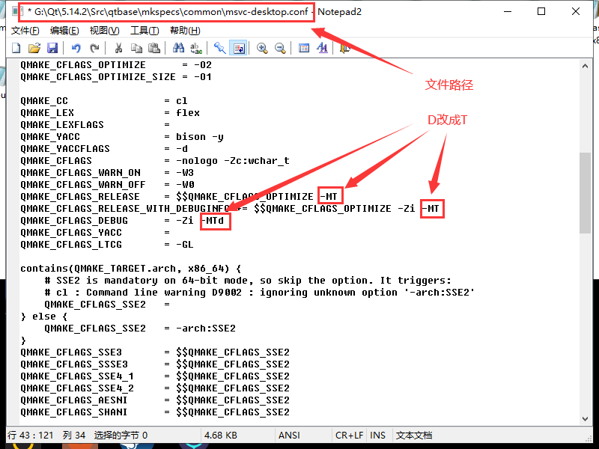

1. 编译配置

mingw:

configure.bat -static -release -confirm-license -opensource -opengl desktop -platform win32-msvc -prefix "安装路径" -sql-sqlite -sql-odbc -qt-zlib -qt-pcre -qt-libpng -qt-libjpeg -qt-freetype -make libs -nomake tools -nomake examples -nomake tests -skip qt3d -skip qtcanvas3d -skip qtdatavis3d -skip qtlocation -skip qtwayland -skip qtwebchannel -skip qtwebengine -skip qtwebsockets -skip qtwebview

msvc:

configure.bat -confirm-license -opensource -static -debug-and-release -platform win32-msvc -prefix "安装路径" -mp -sql-odbc -qt-sqlite -qt-pcre -qt-zlib -qt-libpng -qt-libjpeg -qt-freetype -qt-harfbuzz -opengl dynamic -qml-debug -nomake tests -no-compile-examples -nomake examples

2.编译

msvc：nmake

mingw：mingw32-make -j2

3.安装

msvc：nmake install

mingw：mingw32-make install

4.

