**Ilastik-based 3D Granule Measurement Instructions:**

The goal of this document is to explain how to perform the analysis which measures the distance from smFISH spots and scFvGFP to the surface of germ granules. The germ granules are segmented using an Ilastik-based method.

**Programs needed:**

* ImageJ/FIJI
  + Need to download the Ilastik plugin for importing HDF5
* Ilastik
* Python

**Relevant files:**

* All code can be downloaded from Github: <https://github.com/wstainier/mRNA_distance_measurements>

**Preparation steps:**

* Perform FISH-QUANT on the images based on the method detailed in https://doi.org/10.1038/nmeth.2406
* You will need to split the channels of all the images you are analyzing (as you will only be using the germ granule channel for the Ilastik based segmentation)
  + The script “**SplitChannels_mApple.ijm**” in ImageJ_macros folder on Github will split all the images in a selected folder into 3 channels and save them with ‘postscripts’ specified in the script

**Step 1: Ilastik-based Segmentation**

*Contact the authors for details regarding the trained program in ilastik for germ granule segmentation*

1. Open the Ilastik project
2. Go to 4. Prediction Export tab, and make sure that you have selected “Source: Simple Segmentation” from the dropdown
   1. Also click “Choose Export Image Settings…” and **make sure that your Output has “Data Type: uint8)** and that the file format for the Output File is hdf5
3. Go to 5. Batch Processing and “Select Raw Data Files…”
   1. Select all the files that you want to segment at once
4. Click “Process all files” and wait for it to run
   1. Change output path as needed
   2. Make sure to keep “/{nickname}_Simple_Segmentation.h5” as part of your file name as this is the necessary file name pattern for downstream processing in the ImageJ macro
5. To visualize the outputs, use the ImageJ “ilastik” plugin tool (ilastik > Import HDF5)
   1. The pixel values will be 1 for the background and 2 for the granule signal

**Step 2: FIJI-based Image Processing**

*This step creates a series of folders and saved images* ***based on the Ilastik segmentations*** *that will aid in the processing of the 3D granule surface distance measurements. Note that this step can take quite a while to run for each image. However, it is fully automated for an entire folder of images so you can let it run in the background.*

1. In FIJI, run the macro named “**ILASTIK_3DObjectProcessing.ijm**”
   1. The first step of this macro is to select the folder you want to run the code on. The code will run on **all the files** (i.e. the .h5 files) in the folder. So, you might want to make a temporary folder to store the segmentations you want to process.
   2. The second step is to select the output folder for the directories and files created while running this code
2. The output from this will be stored in a chosen output directory. Each image will have its own folder with subfolders that were just created in the ImageJ macro.

**NOTE: BEFORE RUNNING THE CODE, YOU NEED TO MAKE SURE THAT YOUR OPTIONS FOR THE 3D-OBJECT COUNTER PLUGIN ARE THE SAME AS THE SCREENSHOT BELOW**

* To access this, go to 3D OC Options in FIJI

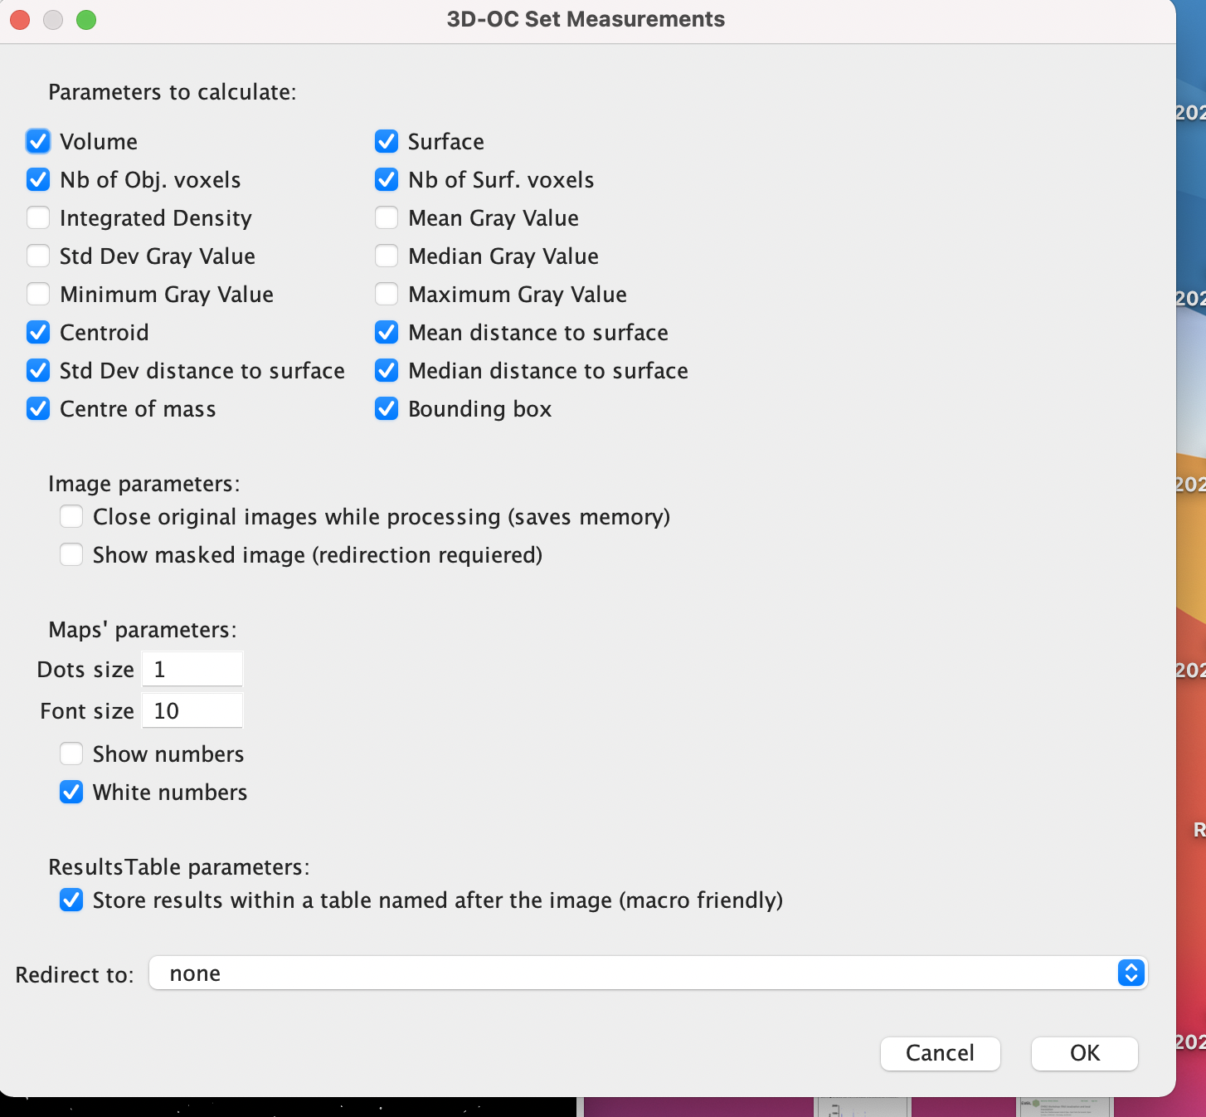

**Step 3: Extracting the coordinates from ‘Results’ files using a Python script**

*This step is required to make the CSV files that will be used to do the distance measurements in the following step.*

1. Run the Python script named “**getCoordinatesBio_All3D_DENSE.py**”
2. The script will ask you to input the path of the folder (i.e. image) you are interested in analyzing. Input the path for the folder which is in the chosen output directory from Step 2. The name of the folder is the name of the image that has been analyzed (with the addition of a “_Ilastik” at the end)
3. You will also need to input the number of slices in the image you are analyzing

**Step 4:** **Extracting data from FISH-QUANT**

*This step is needed to get the x,y,z sub-pixel coordinates of certain populations of mRNA and scFv from the FISH-QUANT results files.*

1. Go to the folder with the FISH-QUANT results for the image you are analyzing
2. Make different files (need to be CSV files) with the following names and save them within the folder for your particular image (i.e. name of the image that has been analyzed with the addition of a “_Ilastik” at the end)
   1. One file will have the x, y, z coordinates of ALL the mRNA 🡺 “**FQ3DCoordinatesTotalmRNA.csv**”
   2. One file will have the x, y, z coordinates of the translated mRNA 🡺 “**FQ3DCoordinatesmRNATranslate.csv**”
   3. One file will have the x, y, z coordinates of the scFv GFP that are associated with mRNA 🡺 “**FQ3DCoordinatesC3.csv**”
   4. You can also make a file with the x, y, z coordinates of the mRNA that are not translated 🡺 “**FQ3DCoordinatesmRNANotTranslate.csv**”

*Note that when making the files, they should have no other information in them than the x, y, z coordinates.* ***ALSO, make sure to put x, y, z in the correct orientation (1st column* x*, 2nd column* y*, 3rd column* z*).*** *FISH-QUANT has it in the y, x, z column order so you need to change it.*

**Step 5: Running the distance measurements**

*This step is to do the actual measurements that will be the basis for the data visualization. You need to run individual Python scripts for each group of points you want to perform the measurements on (i.e. total mRNA, translated mRNA, etc.).*

1. Run a series of Python scripts. In whatever order you want, you can run “**3DSurface_mRNANotTranslate_distanceMeasurement_DENSE.py**”, “**3DSurface_mRNATotal_distanceMeasurement_ DENSE.py**”, “**3DSurface_mRNATranslate_distanceMeasurement_ DENSE.py**”, and “**3DSurface_Translation_distanceMeasurement_ DENSE.py**”
2. The script will ask you to input the path of the folder (i.e. image) you are interested in analyzing. Input the path for the folder which is in the chosen output directory from Step 2. The name of the folder is the name of the image that has been analyzed (with the addition of a “_Ilastik” at the end)
3. Note down the number of “consistent” points. You will need to adjust your level of total translation in the image slightly compared to FISH-QUANT. The new “image-wide/theoretical” translation for that image is *the number of consistent translating mRNA* divided by *the number of consistent total mRNA*.
   1. Consistent points are defined as points which are closest to granules which are not touching the borders of the image (in *x*, *y*, or *z*)
   2. Also note that the “edge case” percentage is based on all points, not only the consistent points
4. The file you are interested in analyzing further is the file named (for example) “**ALL_DENSE_3D_Surface_Consistent_and_mRNANotTranslateDistance.csv**”. This file contains information about the consistent points, including their “Adjusted Distance to DENSE 3D Surface” (negative inside the granule, positive outside)
   1. The other files generated while running the code are also helpful if there are any errors, or if you want to delve further into particular points.