**City of Los Angeles Homeless Project**

**DSO 545: Statistical Computing and Data Visualization**

**Prof. Abbass Sharif**





**Contributors**

William Staudenmeier

Tianqi He

Hanci Wang

Tarun Gorowara

Gyan Prakash

**Executive Summary**

The main objective of this project is to collect, clean, and use geospatial analysis

and predictive modeling to quantify need, demand, and potential impact of different

homelessness intervention strategies.

In order to understand this problem, we visualized a host of variables and discerned the signal from noise. We spotted that homelessness and violent crime are spatially correlated i.e., areas with large number of homeless people tend to have higher rates of violent crime.

We recommend that the city build shelters strategically so as to disperse the homeless population away from downtown and city centers. This will not only dilute crime but also create new economic opportunities. Additionally, it is crucial for the city to spend on job assistance programs so that these people can escape the trap of homelessness. Skill training workshops, financial awareness sessions, etc., can go a long way in solving this issue. If they still can’t find a job, the city should consider opening and creating public jobs to provide them with a means of livelihood.

**Introduction**

Homelessness in Los Angeles County is on the rise. Earlier this year, the Los Angeles Times reported that the number of homeless people in the county is expected to surge 23% to almost 58,000 in 2017.

A number of reasons have been attributed to this rise:

* Drug and alcohol abuse is certainly one of the major causes.
* It has also been widely reported that homelessness is increasing because of the unsustainable rents which have come to plague Southern California in recent years.

However, if we look at Basic Allowance for Housing (BAH) for this decade, which are basically livable rents compiled by Bureau of Labor Statistics in conjunction with Department of Defense, we do not find any surprising uptick in home rents. In fact, BAH declined for 2 of the last 7 years.

A report released by the Urban Institute Think Tank, earlier this year, claims that violent crime can reduce the growth of new businesses. Areas with high rates of violent crime tend to have fewer retail and service businesses, and fewer new jobs.

While the top 5 communities in terms of the number of unsheltered population have virtually remained the same over the last 3 years, there’s a noticeable migration pattern, nonetheless. Our visualizations revealed that homeless people have been migrating to downtown and beach communities from the peripheries of the county. Co-incidentally, these are also the areas where new shelters have sprung up in recent years.

This ties back to the word put forward by Berg and Bodvarsson in their book, *The Economics of Immigration*. The authors advocate the idea that migration happens due to a certain set of push and pull factors. Push factors such as crime, unemployment, natural hazards, etc., compel people to migrate to greener pastures. Which have a combination of pull factors, which comprise better public services, vibrant economy, attractive climate and so on.

Our research on the New York City’s model of tackling homelessness showed that while the city almost quadrupled its annual spending on shelters between 2005 and 2016, homelessness actually went up by 33%. It was an act of kindness by the city which ended up having unintended consequences. It is therefore, important that the City of Los Angeles learns from those mistakes and chooses to show its kindness strategically.

**Data Sources**

Homeless census data (2015-2017）

311 Call records data

Crime records data

Shelter Enrollment data

NYC Case Study: <http://www.icphusa.org/new_york_city/rapidly-rehousing-homeless-families/>

Homeless Shelter and Services census tract shapefiles

**Github**

You can access our data, code, this report and presentation through Github:

https://github.com/wstaude2/DSO-545-Final-Project-Group-7

**Goals**

* What’s causing the increases in homelessness?
* How can the City of LA deal with these problems strategically?
* Why do we care?

**Insights/Analysis**

**Homelessness and Violent Crime**

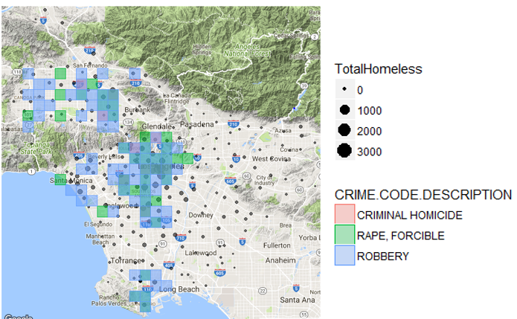

Violent crime is spatially correlated with homelessness. In areas with the highest homeless population, there’s also the largest concentration of violent crime, specifically homicide, rape and robbery. Particularly, in downtown areas of LA, where the homeless population is over 3000, there’s an overlap of all three types of violent crime. This correlation between violent crime and homelessness not only discourages economic growth but also encourages more crime and homelessness over time. It’s very important to address the problem of homelessness to stop this vicious cycle.

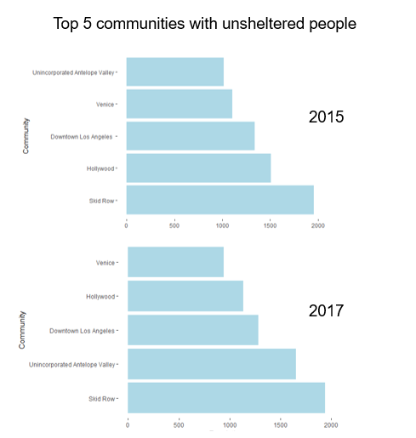

Despite the city’s great efforts to combat homelessness, the top five largest unsheltered homeless communities have remained the same for the past two years as shown above. That doesn’t mean migration hasn’t occurred in recent years.

**Migration: 2015 - 2017**

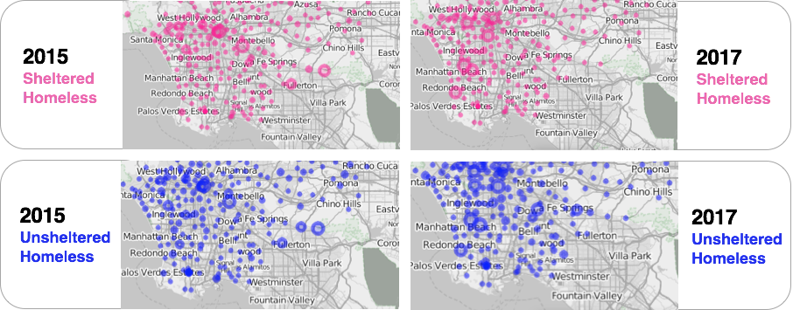

We analyzed the homeless density from 2015-2017 and saw an interesting migration from the border peripheries of the county to the downtown areas and beach communities near Santa Monica. This was not just the case for the sheltered homeless population but for the unsheltered homeless population as well. Then, we moved on to analyze the causes for this migration.

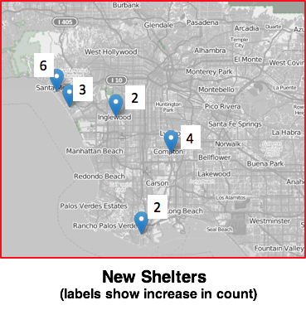

This graph illustrates the top 5 communities where most new shelters were built in 2017. It can be clearly seen that a total of 17 new shelters were established in Santa Monica, Compton, El Monte ,Venice and Inglewood. Most of which are located in Southern and Western Los Angeles. If we look back to the previous analysis, we can also learned that homeless population are migrating to the same areas. Thus, one reasonable assumption could be that new shelters are actually attracting homeless migration from other parts of Los Angeles.

To verify our assumption, we conducted interviews with some homeless people on LA streets and made phone calls to several shelters. Through our conversations, we discovered that a huge influx of the homeless population comes from different parts of California and even other states, as far away as Georgia. In addition, the theories suggested by Berg and Bodvarsson in their book, *Economics of Immigration*, also supports our assumption. The authors point out that there are several push and pull factors that lead to immigration. Certain push factors include crime, insecurity, lack of employment and natural hazards. Also, pull factors include service, food and pleasant climates. The University of Chicago tied the economics of immigration to homelessness, showing that homeless people also migrates because of similar push and pull factors. This study, together with our interviews, strongly supports our assumption that homeless people are moving to the places where new sheltered are builts and better environment are provided. Therefore, here we raised one concern: the fact that City of los Angeles is investing so much on its shelters may actually be encouraging homeless migration from the border of or outside of Los Angeles.

**Case Study: New York City**

Investing more money into the shelter system may not necessarily be the right answer. As this may increase homelessness by encouraging migration as a result. Recently, New York City tried to reduce homelessness by moving families immediately from shelters to permanent housing. This strategy is known as “rapid rehousing/housing first”. While the concept is simple and works for the short-term; these families are no longer homeless. However, there is little long-term evidence to support that these families will be able to maintain living in a house. From 2005 to 2016, New York City’s annual shelter spending tripled from $75 million to $275 million dollars. The purpose of this program was to decrease long-term, unsheltered homelessness. However, the opposite effect happened. According to the Daily Shelter Census of NYC Homeless Families, we see a steady rise in the number of families over the past decade. During the impact period from 2011 to 2014, we see a 33% increase in the number of homeless families. Had the city invested in the shelter system more strategically, the city could have given these families a better opportunity to succeed. This could be by placing families in areas with less crime, better employment opportunities, or easier access to public services. This is something that the City of Los Angeles needs to be aware of to not make this mistake, which we will address in our conclusion.

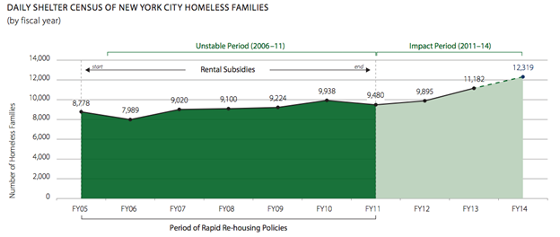

Source: http://www.icphusa.org/new_york_city/rapidly-rehousing-homeless-families/

**Recommendations**

Through our data analysis, we discovered several insights which we believe can help the City of Los Angeles’s alleviate crime, increase economic opportunities, and ultimately reduce homelessness. We hope the analysis and recommendations will help the management team strategically allocate resources and delegate tasks to other departments. From the data, we identified areas with the highest homeless population are spatially correlated with violent crime. In addition, we saw that the homeless density in LA County over the past three years correlated with a rise in migration from the border peripheries of the county to the downtown areas and beach communities.

Our main recommendations from the above analysis:

1. Our recommendation is for the City of Los Angeles to invest its kindness strategically outside of problem areas such as Downtown LA to create a pull mechanism to diminish homeless density, and give the authorities a better chance at dealing with violent crime in these neighborhoods. This will in turn open new areas of new economic growth.
2. The city should also require that its sheltered homeless participate in mandatory job assistance programs. Similar to Franklin D. Roosevelt’s job assistance program during the Great Depression and the NYC job assistance program of the 80s that actually did reduce homelessness in great numbers.
3. For those individuals that can’t get a job working for a private company, the city could provide them the city doing beautification or any number of honorable tasks.