EE492/692F Digital Electronics
Department of Electrical and Biomedical Engineering
University of Nevada, Reno

Acquiring and importing Symbols, Footprints, and pads.

Please note, this is a guide created from the personal experience and forum research of a previous student of EE428. It is a working method but may not be the desired method in all cases, and there may be better ways to complete the processes described or achieve the goals disused. I encourage finding even better methods, but this worked for me.

Getting files

You can acquire models from many websites such as https://www.ultralibrarian.com/ or https://www.snapeda.com/. Find a part with the desired part symbols for Capture, and if desired the various allegro PCB footprints, pads, 3D models etc. Some websites may prompt you on the software the model will be used in, or it may have a file translator (most times a .bat file). Once unzipped, the contents of the file will look similar to the following. For this example I will be using a download from SnapEDA for the MAX1771.
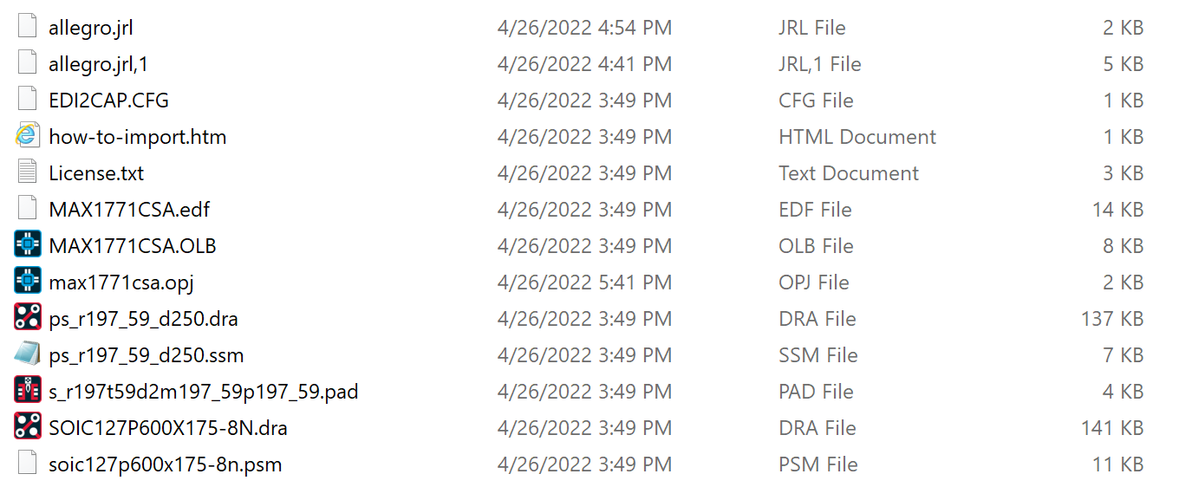
Fig 1. Unzipped file for import

The follwing is a breakdown of the files needed for both Capture and PCB design.
- .OLB
This like discussed in previous lessons is a library file, this contains the pin assignments and the part symbol used in Capture, as well as the part properties including the PCB footprint.
- .psm
This is the binary file containing information for the PCB footprint and model of its respective symbol in Capture.
- .dra
This is a draing file, and can be editied in the symbol editor. Looking at figure 1, there is two .dra files. Since this component has a surface mount design, one of the drawings is the shape of the pad trace to be added to the pcb used in the .pad file, and one is the footprint for the SMD component itself.

- .pad
This is the padstack for use in the pad editor, this relays the phisical design of the pad itself to the stackup which is the portion of the PCB editor that controlls external and internal layers including dialectrics, conductors, power planes as well as ground planes.
- .edf
This is an electronic design information file. This file can be used through the OrCAD capture import feature by following File>Import>EDIF and will create a DSN file which contains the .OLB for the part.

Preparing parts for the PCB editor

This section is mainly in regards to making PCB footprints (imported or from the base library) work with manually created symbols. To confirm matching for the PCB footprint and the symbol you can use the “show footprint” feature when right clicking the part. If not this can be corrected by modifying the pins in the symbol editor by right clicking the part and selecting “edit part” form the new tab navigate to the properties bar and select edit pins. Make sure that both the pin names and numbers match, otherwise a netlist error will occur. This will present itself later as a part that shows in the refrence designator list, but when you try to place it in the PCB editor a part footprint will not show.
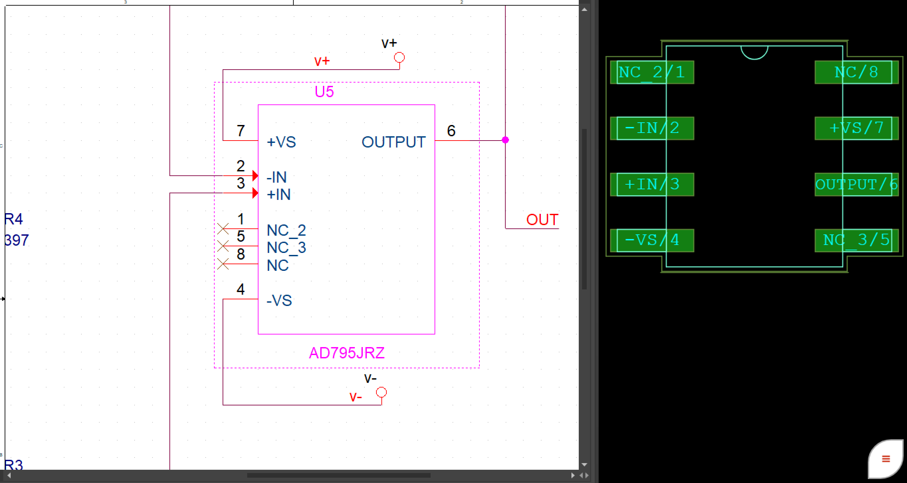
Fig 2. Show footprint inside sample project using AD795.
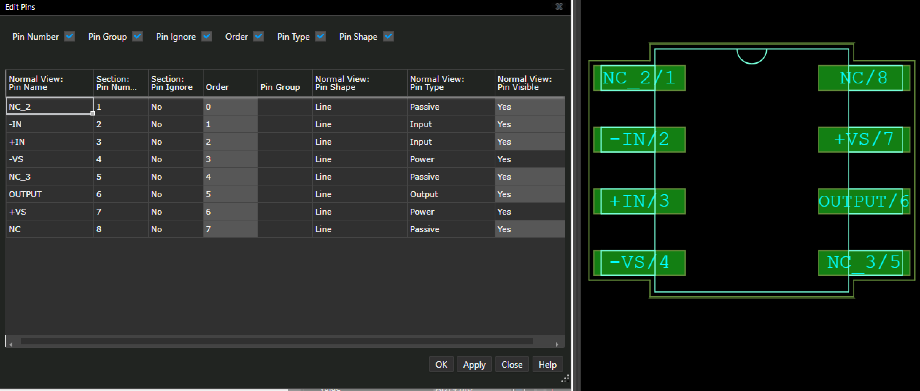
Fig 3. Edit pins veiw and pcb footprint.
Adding parts to the PCB footprint library

Adding the footprint and pads

