Dashboard

Dashboard presents a totally view about all of projects exist on the system. By visual items and sensible arrangement of project’s attributes, OOPMS Dashboard shall support Project Manager to supervise and monitor their software projects most efficiently.

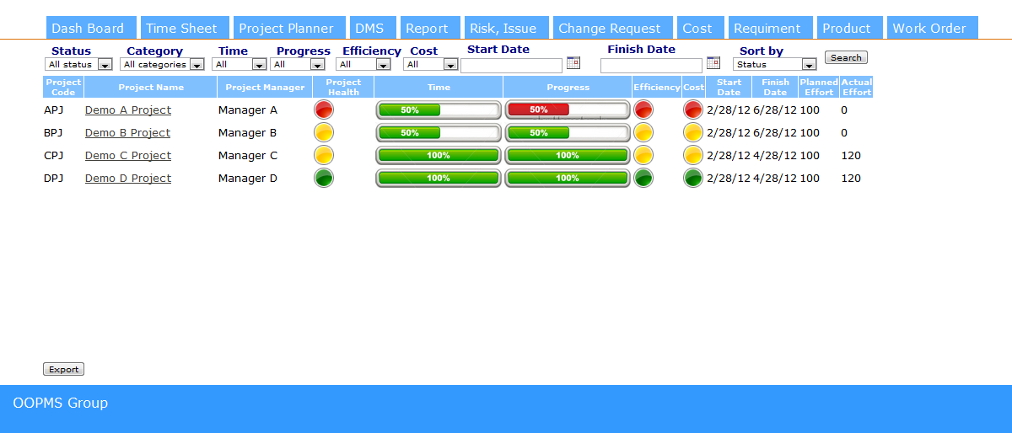

1. Filter Project:

This function allows User to filter project list of Dashboard.

User can filter by:

* Status: present status of project. Ex: closed, cancelled, tentative, on-going.
* Category: present kind of category of the project. Ex: development, maintenance.
* Status of time, progress, efficiency, cost. Ex: good, normal, bad.
* Start date or finish date of project.

1. Keep Track of Project Status:

This function allows User to monitor and keep track of status of projects.

Dashboard presents general information of each project.

Include:

* + Project code
  + Project name
  + Project manager
  + Project health
  + Time
  + Progress
  + Efficiency
  + Cost
  + Start date
  + Finish date
  + Planned effort
  + Actual effort

1. Export Dashboard:

This function provide user feature to export dashboard to a specific file.

Planner

Planner system support user to manage tasks of project.

Project manager can create and assign tasks to team members. He/ She also can update information and even delete the task.

With team members, they can keep track of their tasks and update status of the tasks.

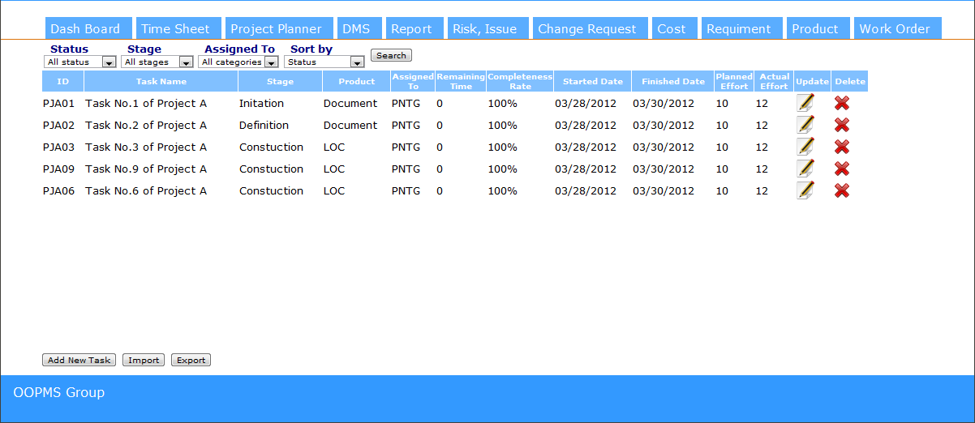

1. Filter task:

This function allows User to filter task list of Planner.

User can filter by:

* Status: present status of task. Ex: closed, cancelled, tentative, on-going.
* Stage: present the stage that the task belongs to. Ex: initiation, definition, solution, construction, transition and termination.
* Assigned to: present the name of team member that the task belongs to.

1. Keep Track of Task Information:

This function allows User to monitor and keep track of status of tasks.

Main page of Planner presents general information of each task.

Include:

* + Task ID
  + Task name
  + Stage
  + Product
  + Assigned to
  + Remaining time
  + Completeness rate
  + Start date
  + Finish date
  + Planned effort
  + Actual effort

1. Create New Task, Update task, Delete task:

This function allows project manager to add new task to task list, update and delete task. Team members also can update their task that are assigned to.

1. Import Task:

This function allows project manager ability to import tasks to task list by a Microsoft Project file. (\*.mpp)

1. Export Report:

The system shall export a general report about status of project’s task.