## Admin Create New Project

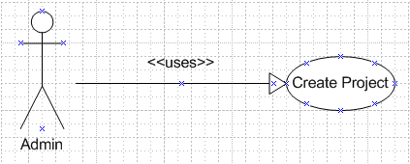

Figure xx Admin create new project Use Case model

Use Case scenario:

Table x Admin create new project scenario

|  |  |  |
| --- | --- | --- |
| User Case ID | UC_A.1 | |
| Name | **Admin Create new Project Use Case** | |
| Goal | This function allows admin to create a new project. | |
| Actors | **Admin** | |
| Pre-conditions | Logged user with admin role | |
| Post-conditions | None | |
| Main Flow | 1. Choose tab Project Management  3. Fill in Project’s information then select button “Submit” | 2. Select link “Create New Project” |
|  |  | |
| Open Issues | N/A | |

## Admin Search Project

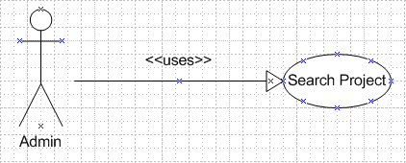

Figure xx Search Project Use Case model

Use Case scenario:

Table x Search Project scenario

|  |  |  |
| --- | --- | --- |
| User Case ID | UC_A.2 | |
| Name | **Admin Search Project Use Case** | |
| Goal | This function allows admin to search project | |
| Actors | **Admin** | |
| Pre-conditions | Logged user with admin role | |
| Post-conditions | None | |
| Main Flow | 1. Choose tab Project Management  3. Click button “Search” | 2. Select search condition |
|  |  | |
| Open Issues | N/A | |

## Admin Edit Project

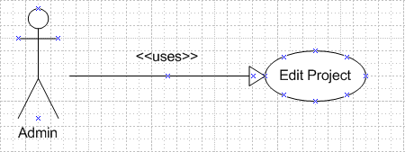

Figure xx Admin Edit Project Use Case model

Use Case scenario:

Table x Admin Edit Project scenario

|  |  |  |
| --- | --- | --- |
| User Case ID | UC_A.3 | |
| Name | **Admin Edit Project Use Case** | |
| Goal | This function allows admin to edit information of a project | |
| Actors | **Admin** | |
| Pre-conditions | Logged user with admin role | |
| Post-conditions | None | |
| Main Flow | 1. Choose tab Project Management  3. Click button “Search”  5. Select link “Change Project Info” | 2. Select search condition  4. Choose the project want to edit  6. Change Project’s information then select button “Save Change” |
|  |  | |
| Open Issues | N/A | |

## Admin Manage Module

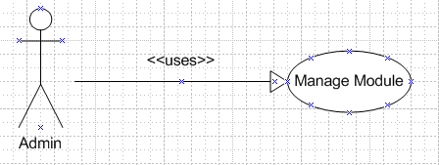

Figure xx Admin Manage Module Use Case model

Use Case scenario:

Table x Admin Manage Module scenario

|  |  |  |
| --- | --- | --- |
| User Case ID | UC_A.4 | |
| Name | **Admin Mange Module Use Case** | |
| Goal | This function allows admin to manage a project’s modules usage | |
| Actors | **Admin** | |
| Pre-conditions | Logged user with admin role | |
| Post-conditions | None | |
| Main Flow | 1. Choose tab Project Management  3. Click button “Search”  5. Select link “Modules Management” | 2. Select search condition  4. Choose the project want to edit  6. Choose modules and then select button “OK” |
|  |  | |
| Open Issues | N/A | |

## Admin Team Management

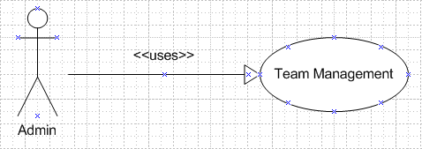

Figure xx Admin Team Management Use Case model

Use Case scenario:

Table x Admin Team Management scenario

|  |  |  |
| --- | --- | --- |
| User Case ID | UC_A.5 | |
| Name | **Admin Team Management Use Case** | |
| Goal | This function allows admin to manage a project’s team members | |
| Actors | **Admin** | |
| Pre-conditions | Logged user with admin role | |
| Post-conditions | None | |
| Main Flow | 1. Choose tab Project Management  3. Click button “Search”  5. Select link “Team Management” | 2. Select search condition  4. Choose the project want to edit  6. Edit Project’s team member then select button “Save Change” |
|  |  | |
| Open Issues | N/A | |

## Admin Search User

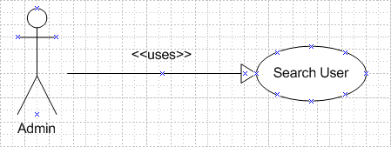

Figure xx Admin Search User Use Case model

Use Case scenario:

Table x Admin Search User scenario

|  |  |  |
| --- | --- | --- |
| User Case ID | UC_A.6 | |
| Name | **Admin Search User Use Case** | |
| Goal | This function allows admin to search user | |
| Actors | **Admin** | |
| Pre-conditions | Logged user with admin role | |
| Post-conditions | None | |
| Main Flow | 1. Choose tab User Management  3. Click button “Search” | 2. Select search condition |
|  |  | |
| Open Issues | N/A | |

## Admin Create User

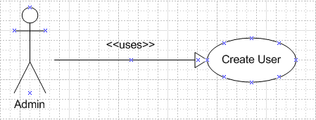

Figure xx Admin Create User Use Case model

Use Case scenario:

Table x Admin Create User scenario

|  |  |  |
| --- | --- | --- |
| User Case ID | UC_A.7 | |
| Name | **Admin Create User Use Case** | |
| Goal | This function allows admin to create new user | |
| Actors | **Admin** | |
| Pre-conditions | Logged user with admin role | |
| Post-conditions | None | |
| Main Flow | 1. Choose tab User Management  3. Fill in User’s information then select button “Submit” | 2. Select link “Create New User” |
|  |  | |
| Open Issues | N/A | |

## Admin Edit User

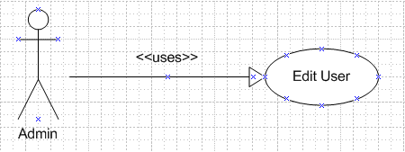

Figure xx Admin Edit User Use Case model

Use Case scenario:

Table x Admin Edit User scenario

|  |  |  |
| --- | --- | --- |
| User Case ID | UC_A.8 | |
| Name | **Admin Edit User Use Case** | |
| Goal | This function allows admin to edit information of an user | |
| Actors | **Admin** | |
| Pre-conditions | Logged user with admin role | |
| Post-conditions | None | |
| Main Flow | 1. Choose tab User Management  3. Click button “Search”  5. Change User’s information then select button “Save Change” | 2. Select search condition  4. Choose the user want to edit |
|  |  | |
| Open Issues | N/A | |

## Admin Change User’s Status

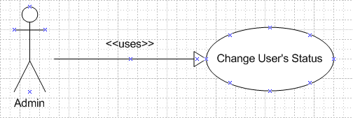

Figure xx Admin Change User’s Status Use Case model

Use Case scenario:

Table x Admin Change User’s Status scenario

|  |  |  |
| --- | --- | --- |
| User Case ID | UC_A.9 | |
| Name | **Admin Change User’s Status Use Case** | |
| Goal | This function allows admin to active, inactive or delete an user | |
| Actors | **Admin** | |
| Pre-conditions | Logged user with admin role | |
| Post-conditions | None | |
| Main Flow | 1. Choose tab User Management  3. Click button “Search” | 2. Select search condition  4. Select button “Active”, ”Inactive” or “Delete” |
|  |  | |
| Open Issues | N/A | |

## Register New Account

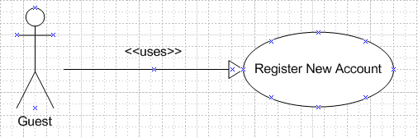

Figure xx Register New Account Use Case model

Use Case scenario:

Table x Register New Account scenario

|  |  |  |
| --- | --- | --- |
| User Case ID | UC_A.10 | |
| Name | **Register New Account Use Case** | |
| Goal | This function allows guest to register a new account | |
| Actors | **Guest** | |
| Pre-conditions | None | |
| Post-conditions | None | |
| Main Flow | 1. User goes into PMS Homepage    3. Fill in User’s information then select button “Submit” | 2. Select link “Register New Account” |
|  |  | |
| Open Issues | N/A | |

## Reset Password

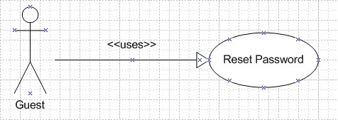

Figure xx Reset Password Use Case model

Use Case scenario:

Table x Reset Password scenario

|  |  |  |
| --- | --- | --- |
| User Case ID | UC_A.11 | |
| Name | **Reset Password Use Case** | |
| Goal | This function allows user to reset password when they forget password | |
| Actors | **Guest** | |
| Pre-conditions | None | |
| Post-conditions | None | |
| Main Flow | 1. User goes into PMS Homepage    3. Fill in Username and select button “Reset Password” | 2. Select link “Forget Your Password |
|  |  | |
| Open Issues | N/A | |