## Create New Project

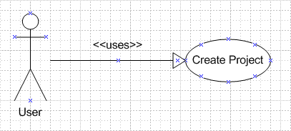

Figure xx Create new project Use Case model

Use Case scenario:

Table x Create new project scenario

|  |  |  |
| --- | --- | --- |
| User Case ID | UC_P.1 | |
| Name | **Create new Project Use Case** | |
| Goal | This function allows user to create a new project. | |
| Actors | **User** | |
| Pre-conditions | Logged user | |
| Post-conditions | None | |
| Main Flow | 1. Select link “Create New Project” | 2. Fill in Project’s information then select button “Submit” |
|  |  | |
| Open Issues | N/A | |

## Edit Project

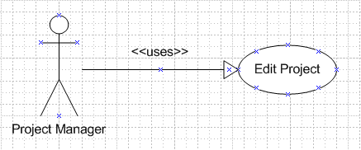

Figure xx Edit Project Use Case model

Use Case scenario:

Table x Edit Project scenario

|  |  |  |
| --- | --- | --- |
| User Case ID | UC_P.2 | |
| Name | **Edit Project Use Case** | |
| Goal | This function allows project managers to edit information of their project | |
| Actors | **Project Manager** | |
| Pre-conditions | Logged user that is a project manager | |
| Post-conditions | None | |
| Main Flow | 1. Choose tab “Dash Board"  3. Select link “Change Project Info” | 2. Choose the project want to edit  4. Change Project’s information then select button “Save Change” |
|  |  | |
| Open Issues | N/A | |

## Manage Module

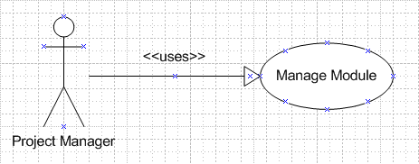

Figure xx Manage Module Use Case model

Use Case scenario:

Table x Manage Module scenario

|  |  |  |
| --- | --- | --- |
| User Case ID | UC_P.3 | |
| Name | **Manage Module Use Case** | |
| Goal | This function allows project manager to manage a project’s modules usage | |
| Actors | **Project Manager** | |
| Pre-conditions | Logged user that is a project manager | |
| Post-conditions | None | |
| Main Flow | 1. Choose tab “Dash Board”  3. Select link “Modules Management” | 2. Choose the project want to edit  4. Choose modules and then select button “OK” |
|  |  | |
| Open Issues | N/A | |

## Team Management

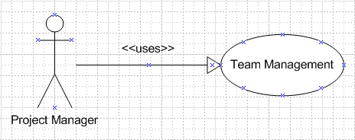

Figure xx Team Management Use Case model

Use Case scenario:

Table x Team Management scenario

|  |  |  |
| --- | --- | --- |
| User Case ID | UC_P.4 | |
| Name | **Team Management Use Case** | |
| Goal | This function allows project manager to manage a project’s team members | |
| Actors | **Project Manager** | |
| Pre-conditions | Logged user that is a project manager | |
| Post-conditions | None | |
| Main Flow | 1. Choose tab “Dash Board”  3. Select link “Team Management” | 2. Choose the project want to edit  4. Edit Project’s team member then select button “Save Change” |
|  |  | |
| Open Issues | N/A | |

## Change Budget

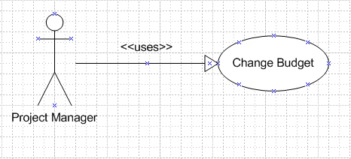

Figure xx Change Budget Use Case model

Use Case scenario:

Table x Change Budget scenario

|  |  |  |
| --- | --- | --- |
| User Case ID | UC_P.5 | |
| Name | **Change Budget Use Case** | |
| Goal | This function allows project manager to manage a project’s budget | |
| Actors | **Project Manager** | |
| Pre-conditions | Logged user that is a project manager | |
| Post-conditions | None | |
| Main Flow | 1. Choose tab “Cost”    3. Select button “OK” on the commit window. | 2. Fill the budget value then select button “Change Budget” |
|  |  | |
| Open Issues | N/A | |

## Add Expense

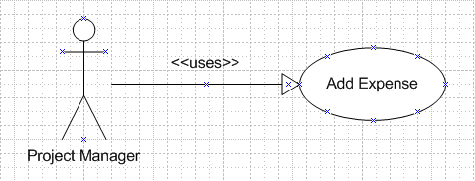

Figure xx Add Expense Use Case model

Use Case scenario:

Table x Add Expense scenario

|  |  |  |
| --- | --- | --- |
| User Case ID | UC_P.6 | |
| Name | **Add Expense Use Case** | |
| Goal | This function allows project manager to add a project’s expense | |
| Actors | **Project Manager** | |
| Pre-conditions | Logged user that is a project manager | |
| Post-conditions | None | |
| Main Flow | 1. Choose tab “Cost”  3. Fill in the expense’s information then select button “Submit” | 2. Select “Add new Expense” |
|  |  | |
| Open Issues | N/A | |

## Edit Expense

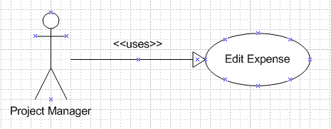

Figure xx Edit Expense Use Case model

Use Case scenario:

Table x Edit Expense scenario

|  |  |  |
| --- | --- | --- |
| User Case ID | UC_P.7 | |
| Name | **Edit Expense Use Case** | |
| Goal | This function allows project manager to edit a project’s expense | |
| Actors | **Project Manager** | |
| Pre-conditions | Logged user that is a project manager | |
| Post-conditions | None | |
| Main Flow | 1. Choose tab “Cost”  3. Fill in the expense’s information then select button “Save Change” | 2. Select the expense want to edit |
|  |  | |
| Open Issues | N/A | |

## Delete Expense

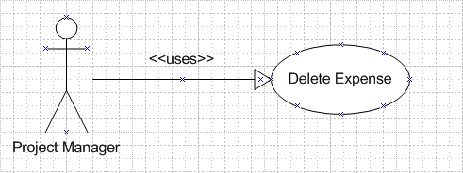

Figure xx Delete Expense Use Case model

Use Case scenario:

Table x Delete Expense scenario

|  |  |  |
| --- | --- | --- |
| User Case ID | UC_P.8 | |
| Name | **Delete Expense Use Case** | |
| Goal | This function allows project manager to delete a project’s expense | |
| Actors | **Project Manager** | |
| Pre-conditions | Logged user that is a project manager | |
| Post-conditions | None | |
| Main Flow | 1. Choose tab “Cost”    3. Select button “Delete” | 2. Select the checkbox at the begin of the expenses’ row you want to delete |
|  |  | |
| Open Issues | N/A | |

## Add Risk, Issue

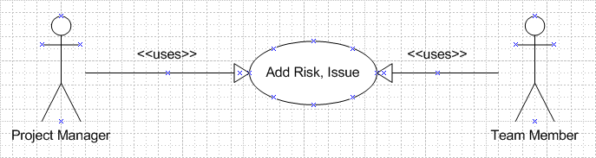

Figure xx Add Risk, Issue Use Case model

Use Case scenario:

Table x Add Risk, Issue scenario

|  |  |  |
| --- | --- | --- |
| User Case ID | UC_P.9 | |
| Name | **Add Risk, Issue Use Case** | |
| Goal | This function allows project manager and team member to add a project’s risk or issue | |
| Actors | **Project Manager, Team Member** | |
| Pre-conditions | Logged user that is a project manager or team member | |
| Post-conditions | None | |
| Main Flow | 1. Choose tab “Risk, Issue”    3. Fill in the information then select button “Submit” | 2. Select link “Add new Risk” or “Add new Issue” |
|  |  | |
| Open Issues | N/A | |

## Edit Risk, Issue

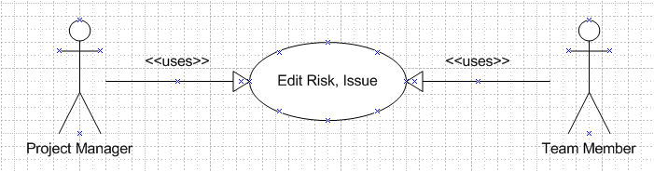

Figure xx Edit Risk, Issue Use Case model

Use Case scenario:

Table x Edit Risk, Issue scenario

|  |  |  |
| --- | --- | --- |
| User Case ID | UC_P.10 | |
| Name | **Edit Risk, Issue Use Case** | |
| Goal | This function allows project manager and team member to edit a project’s risk, issue | |
| Actors | **Project Manager, Team member** | |
| Pre-conditions | Logged user that is a project manager or team member | |
| Post-conditions | None | |
| Main Flow | 1. Choose tab “Risk, Issue”  3. Fill in the information then select button “Save Change” | 2. Select the risk or issue want to edit |
|  |  | |
| Open Issues | N/A | |

## Delete Risk, Issue

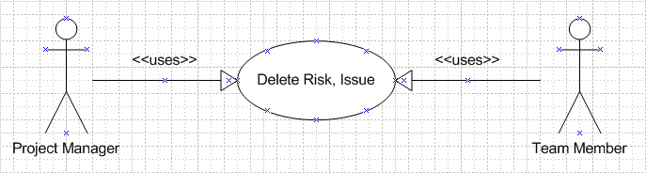

Figure xx Delete Risk, Issue Use Case model

Use Case scenario:

Table x Delete Risk, Issue scenario

|  |  |  |
| --- | --- | --- |
| User Case ID | UC_P.11 | |
| Name | **Delete Risk, Issue Use Case** | |
| Goal | This function allows project manager and team member to delete a project’s risk, issue | |
| Actors | **Project Manager, Team member** | |
| Pre-conditions | Logged user that is a project manager or team member | |
| Post-conditions | None | |
| Main Flow | 1. Choose tab “Risk, Issue”    3. Select button “Delete” | 2. Select the checkbox at the begin of the row you want to delete |
|  |  | |
| Open Issues | N/A | |

## Add Change Request

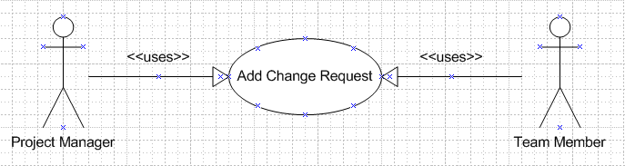

Figure xx Add Change Request Use Case model

Use Case scenario:

Table x Add Change Request scenario

|  |  |  |
| --- | --- | --- |
| User Case ID | UC_P.12 | |
| Name | **Add Change Request Use Case** | |
| Goal | This function allows project manager and team member to add a project’s change request | |
| Actors | **Project Manager, Team Member** | |
| Pre-conditions | Logged user that is a project manager or team member | |
| Post-conditions | None | |
| Main Flow | 1. Choose tab “Change Request”  3. Fill in the request’s information then select button “Submit” | 2. Select link “Add new Change Request” |
|  |  | |
| Open Issues | N/A | |

## Edit Change Request

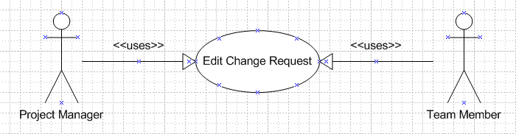

Figure xx Edit Change Request Use Case model

Use Case scenario:

Table x Edit Change Request scenario

|  |  |  |
| --- | --- | --- |
| User Case ID | UC_P.13 | |
| Name | **Edit Change Request Use Case** | |
| Goal | This function allows project manager and team member to edit a project’s change request | |
| Actors | **Project Manager, Team member** | |
| Pre-conditions | Logged user that is a project manager or team member | |
| Post-conditions | None | |
| Main Flow | 1. Choose tab “Change Request”  3. Fill in the request’s information then select button “Save Change” | 2. Select the request want to edit |
|  |  | |
| Open Issues | N/A | |

## Delete Change Request

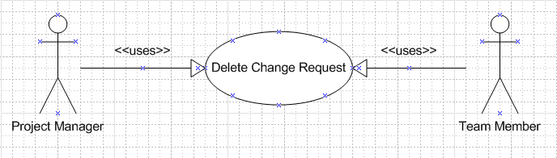

Figure xx Delete Change Request Use Case model

Use Case scenario:

Table x Delete Change Request scenario

|  |  |  |
| --- | --- | --- |
| User Case ID | UC_P.14 | |
| Name | **Delete Change Request Use Case** | |
| Goal | This function allows project manager and team member to delete a project’s change request | |
| Actors | **Project Manager, Team member** | |
| Pre-conditions | Logged user that is a project manager or team member | |
| Post-conditions | None | |
| Main Flow | 1. Choose tab “Change Request”    3. Select button “Delete” | 2. Select the checkbox at the begin of the row you want to delete |
|  |  | |
| Open Issues | N/A | |

## Add Product

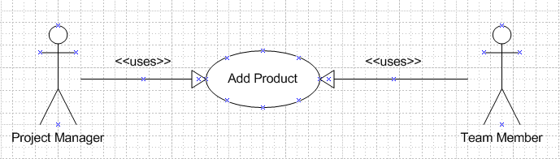

Figure xx Add Product Use Case model

Use Case scenario:

Table x Add Product scenario

|  |  |  |
| --- | --- | --- |
| User Case ID | UC_P.15 | |
| Name | **Add Product Use Case** | |
| Goal | This function allows project manager and team member to add a project’s product | |
| Actors | **Project Manager, Team Member** | |
| Pre-conditions | Logged user that is a project manager or team member | |
| Post-conditions | None | |
| Main Flow | 1. Choose tab “Product”  3. Fill in the product’s information then select button “Submit” | 2. Select link “Add new Product” |
|  |  | |
| Open Issues | N/A | |

## Edit Product

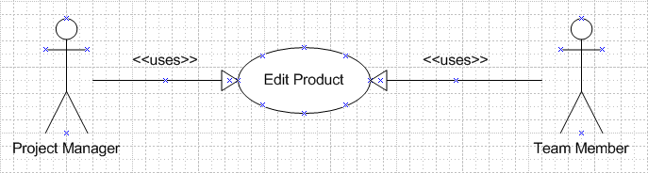

Figure xx Edit Product Use Case model

Use Case scenario:

Table x Edit Product scenario

|  |  |  |
| --- | --- | --- |
| User Case ID | UC_P.16 | |
| Name | **Edit Product Use Case** | |
| Goal | This function allows project manager and team member to edit a project’s product | |
| Actors | **Project Manager, Team member** | |
| Pre-conditions | Logged user that is a project manager or team member | |
| Post-conditions | None | |
| Main Flow | 1. Choose tab “Product”  3. Fill in the product’s information then select button “Save Change” | 2. Select the product want to edit |
|  |  | |
| Open Issues | N/A | |

## Delete Product

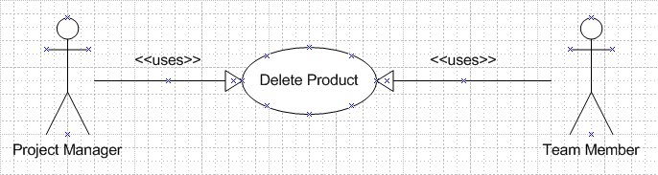

Figure xx Delete Product Use Case model

Use Case scenario:

Table x Delete Product scenario

|  |  |  |
| --- | --- | --- |
| User Case ID | UC_P.17 | |
| Name | **Delete Product Use Case** | |
| Goal | This function allows project manager and team member to delete a project’s product | |
| Actors | **Project Manager, Team member** | |
| Pre-conditions | Logged user that is a project manager or team member | |
| Post-conditions | None | |
| Main Flow | 1. Choose tab “Product”    3. Select button “Delete” | 2. Select the checkbox at the begin of the row you want to delete |
|  |  | |
| Open Issues | N/A | |

## Add Stage

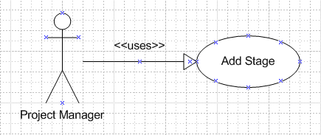

Figure xx Add Stage Use Case model

Use Case scenario:

Table x Add Stage scenario

|  |  |  |
| --- | --- | --- |
| User Case ID | UC_P.18 | |
| Name | **Add Stage Use Case** | |
| Goal | This function allows project manager to add a project’s stage | |
| Actors | **Project Manager** | |
| Pre-conditions | Logged user that is a project manager | |
| Post-conditions | None | |
| Main Flow | 1. Choose tab “Work Order”  3. Fill in the stage’s information then select button “Submit” | 2. Select “Add new Stage” |
|  |  | |
| Open Issues | N/A | |

## Edit Stage

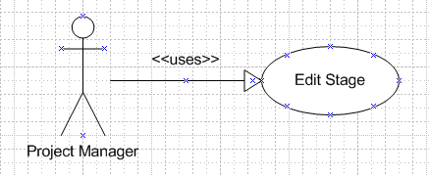

Figure xx Edit Stage Use Case model

Use Case scenario:

Table x Edit Stage scenario

|  |  |  |
| --- | --- | --- |
| User Case ID | UC_P.19 | |
| Name | **Edit Stage Use Case** | |
| Goal | This function allows project manager to edit a project’s stage | |
| Actors | **Project Manager** | |
| Pre-conditions | Logged user that is a project manager | |
| Post-conditions | None | |
| Main Flow | 1. Choose tab “Work Order”  3. Fill in the stage’s information then select button “Save Change” | 2. Select the Stage want to edit |
|  |  | |
| Open Issues | N/A | |

## Delete Stage

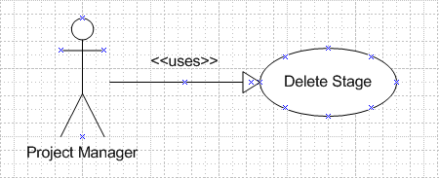

Figure xx Delete Stage Use Case model

Use Case scenario:

Table x Delete Stage scenario

|  |  |  |
| --- | --- | --- |
| User Case ID | UC_P.20 | |
| Name | **Delete Stage Use Case** | |
| Goal | This function allows project manager to delete a project’s stage | |
| Actors | **Project Manager** | |
| Pre-conditions | Logged user that is a project manager | |
| Post-conditions | None | |
| Main Flow | 1. Choose tab “Work Order”    3. Select button “Delete” | 2. Select the checkbox at the begin of the stages’ row you want to delete |
|  |  | |
| Open Issues | N/A | |

## Add Deliverable

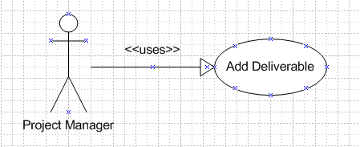

Figure xx Add Deliverable Use Case model

Use Case scenario:

Table x Add Deliverable scenario

|  |  |  |
| --- | --- | --- |
| User Case ID | UC_P.21 | |
| Name | **Add Deliverable Use Case** | |
| Goal | This function allows project manager to add a project’s deliverable | |
| Actors | **Project Manager** | |
| Pre-conditions | Logged user that is a project manager | |
| Post-conditions | None | |
| Main Flow | 1. Choose tab “Work Order”  3. Fill in the deliverable’s information then select button “Submit” | 2. Select “Add new Deliverable” |
|  |  | |
| Open Issues | N/A | |

## Edit Deliverable

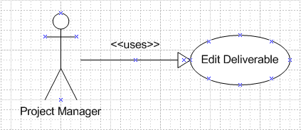

Figure xx Edit Deliverable Use Case model

Use Case scenario:

Table x Edit Deliverable scenario

|  |  |  |
| --- | --- | --- |
| User Case ID | UC_P.22 | |
| Name | **Edit Deliverable Use Case** | |
| Goal | This function allows project manager to edit a project’s deliverable | |
| Actors | **Project Manager** | |
| Pre-conditions | Logged user that is a project manager | |
| Post-conditions | None | |
| Main Flow | 1. Choose tab “Work Order”  3. Fill in the deliverable’s information then select button “Save Change” | 2. Select the Deliverable want to edit |
|  |  | |
| Open Issues | N/A | |

## Delete Deliverable

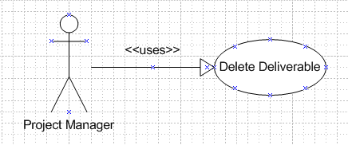

Figure xx Delete Deliverable Use Case model

Use Case scenario:

Table x Delete Deliverable scenario

|  |  |  |
| --- | --- | --- |
| User Case ID | UC_P.23 | |
| Name | **Delete Deliverable Use Case** | |
| Goal | This function allows project manager to delete a project’s deliverable | |
| Actors | **Project Manager** | |
| Pre-conditions | Logged user that is a project manager | |
| Post-conditions | None | |
| Main Flow | 1. Choose tab “Work Order”    3. Select button “Delete” | 2. Select the checkbox at the begin of the deliverables’ row you want to delete |
|  |  | |
| Open Issues | N/A | |

## View Info

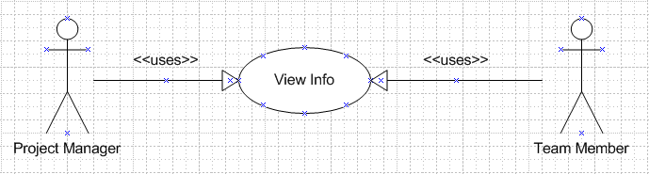

Figure xx View Info Use Case model

Use Case scenario:

Table x View Info scenario

|  |  |  |
| --- | --- | --- |
| User Case ID | UC_P.24 | |
| Name | **Delete Product Use Case** | |
| Goal | This function allows project manager and team member to view a project’s information | |
| Actors | **Project Manager, Team member** | |
| Pre-conditions | Logged user that is a project manager or team member | |
| Post-conditions | None | |
| Main Flow | 1. Choose tab “Dash Board” | 2. Select a project’s name |
|  |  | |
| Open Issues | N/A | |

## Change Password

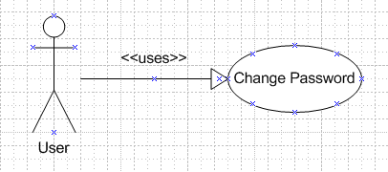

Figure xx Change Password Use Case model

Use Case scenario:

Table x Change Password scenario

|  |  |  |
| --- | --- | --- |
| User Case ID | UC_A.25 | |
| Name | **Change Password Use Case** | |
| Goal | This function allows user to change password | |
| Actors | **Guest** | |
| Pre-conditions | Logged user | |
| Post-conditions | None | |
| Main Flow | 1. Select link “Change Your Information” | 2. Fill in “Old Password”, “New Password”, “Retype New Password” and then select button “Reset Password” |
|  |  | |
| Open Issues | N/A | |

## Edit User’s Information

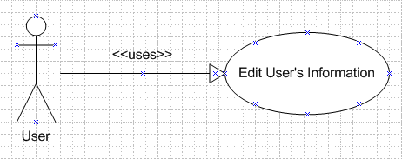

Figure xx Edit User’s Information Use Case model

Use Case scenario:

Table x Edit User’s Information scenario

|  |  |  |
| --- | --- | --- |
| User Case ID | UC_A.26 | |
| Name | **Edit User Use Case** | |
| Goal | This function allows users to edit their profile | |
| Actors | **User** | |
| Pre-conditions | Logged user | |
| Post-conditions | None | |
| Main Flow | 1. Select link “Change your Information” | 2. Change User’s information then select button “Save Change” |
|  |  | |
| Open Issues | N/A | |