Document Administration
Recipient
Department Name

For the attention of
Department Name

Info

Sagem Orga GmbH

IP UICC Implementation

Implementation Specification

Document Id:
Archive: 3
Product/project/subject: UICC (UICC)
Category of document: ISS (Implementation Specification)
Consecutive number:
Version: X1.00.8
Date: 25.01.2010
Authors: Hanno Dietrich, Daniel Baldin
Confidentiality: Confidential

Checked report: not applicable
Authorized (Date/Signature): not applicable
Accepted (Date/Signature): not applicable

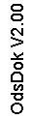
Document Organisation
©Sagem Orga GmbH, Paderborn, 2010

i Notation

None of the notations used in this document need extra explanation.

ii Official Documents and Standards

No superior, related valid documents or standards were used when creating this document.

iii Revision History

Version | Date | Type of change | Author / team
X1.00.1 | 25.01.10 | First draft edition | Hanno Dietrich
X1.00.2 | 11.02.10 | Internet Standard Compliance check done, Further information in the interface of lwIP provided | Daniel Baldin
X1.00.3 | 02.05.10 | Added UML Diagrams for the EEM CDC Implementation. Added implementation design of the lwIP4/6 Integration process | Daniel Baldin
X1.00.4 | 25.06.10 | Updated the current implementation status of the lwip IPv4 and IPv6 integration as well as the status on the missing IPv6 features. | Daniel Baldin
X1.00.5 | 28.07.10 | Added details of the adaptations made to the lwip stack inside the network interface, address resolution and higher level protocol sections. | Daniel Baldin
X1.00.6 | 10.06.11 | Added the documentation of the TLS framework | Daniel Baldin
X1.00.7 | 10.06.11 | Added details on the IP-Stack interfaces for porting the IP-Stack to different operating systems. | Daniel Baldin
X1.00.8 | 22.12.12 | Fixed typos. Cleanup | Daniel Baldin

Table of Contents

Document Organisation 3
i Notation 3
ii Official Documents and Standards 3
iii Revision History 3
Table of Contents 4
1 Introduction 5
2 Target Configuration 6
2.1 ETSI Internet Protocol Requirements 6
2.2 Adaptation to PC Environment 7
3 Ethernet Emulation Model 8
3.1 USB Descriptors for CDC/EEM 8
3.2 EEM Handler Design 11
4 Internet Protocol Stack 13
4.1 Internet Standards Compliance 13
4.2 IPv6 Implementation Status 14
4.3 IPv4 and IPv6 mutual integration 15
4.3.1 LwIP adaptations 15
4.3.2 Network Interface changes 17
4.3.3 Address Resolution Framework changes 18
4.3.4 Upper protocol layer adaptations 20
4.3.5 Source Code Optimizations 23
4.4 Protocol Details 23
4.4.1 IPv6 23
4.4.1.1 ICMPv6 / NDP 23
4.4.2 TLS 24
4.4.2.1 Supported Protocols/Algorithms 26
4.4.2.2 TLS Connection Control Structure 27
4.4.2.3 Changing the Server Certificate 29
4.4.2.4 TLS Certificate Validation 32
4.4.2.5 TLS API 33
4.5 IP-Stack Interfaces 36
4.5.1 S3FS9CI EEM Device Driver Interface 37
4.5.2 Hashing Interface 41
4.5.3 Crypto Interface 43
4.6 IP-Stack Timers 44
4.7 Application Programming Interface 45
4.8 Application Implementation Example 48
5 Cross-Layering Approaches 51
References 52
I Bibliography 52
II Summary of abbreviations 53

Introduction

This document describes the design decisions made for the implementation of an IP stack on a UICC in the context of the “Configurable IP Stack for Smart Cards”[1].

Target Configuration

The implementation targets a prototype of a smart card (or Integrated Circuit Card - ICC) with an IP stack according to the relevant ETSI standards for a UICC.

Because no terminal currently exists which implements these ETSI standards a PC will be used to demonstrate the IP UICC communication. As a consequence the ETSI defined configuration has to be partially adapted to the PC environment.

For the same reason it is not required for the IP UICC to contain any functions not related to the IP stack implementation and a light application layer for driving the communication.

ETSI Internet Protocol Requirements

USB:
SCP 102 600:
Smart Cards; Characteristics of the USB Interface, Release 7:

Classes:
- Smart Card ICCD (APDU Transfer)
- Mass Storage
- CDC Ethernet Emulation Model (EEM)

Internet:
SCP 102 483:
Internet Protocol connectivity between UICC and terminal, Release 7

Internet Protocol (SCP 102 483):
- IP V6 (Internet Protocol Version 6)
ICMPv6 (Internet Control Message Protocol)
NDP (Neighbor Discovery Protocol)
- IP V4 (Internet Protocol Version 4)
ICMPv4 (Internet Control Message Protocol)
ARP (Address Resolution Protocol)
- TCP (Transport Control Protocol)
- UDP (User Datagram Protocol)
- DHCP (Dynamic Host Configuration Protocol)
UICC: Client Mode, Terminal: Server Mode (optional)
- TLS (Transport Layer Security, optional)
- DNS (Domain Name System, optional)

Addressing
MAC Address
- UICC 82-xx-xx-xx-xx-xx Terminal yy-xx-xx-xx-xx-xx

IPv6
- Stateless Configuration (Prefix: Network Gateway, UICC Interface ID: generated)

IPv4
- Default: UICC : 192.168.0.1 / Terminal: 192.168.0.2
- Optional: via DHCP Server in Terminal
- UICC Ports: smarcard-port: 3516/TCP,UDP
smarcard-tls: 4116/TCP,UDP

Name resolution (local):
- Pre-defined names: localterminal, localuicc
- Terminal à UICC: DNS Update by UICC

Adaptation to PC Environment

The demonstration of the IP UICC implementation will make use of a standard Linux PC instead of a cellular handset. The Linux O/S has mainly been chosen because WindowsTM does not contain an USB EEM driver while Linux does.

As a consequence of using a PC the IP configuration has to be changed where it is specific to the UICC – handset interface because they arel not be available on a standard PC. From the information currently available this change only relates to the predefined IPv4 addresses and local name which will not be available on the PC.

As opposed to cellular handsets the power supply of the IP UICC by a PC is not critical so that the power saving mode required following every UICC message processing may not be activated for the demonstration. This will ease the use of UICC timers needed for the protocol implementation.

Ethernet Emulation Model

USB Descriptors for CDC/EEM

The TP UICC implements a single USB Class with a single Interface, i.e. the Communication Device Class (CDC) using Ethernet Emulation Model (EEM) [4]. During Enumeration the CDC/EEM implementation makes use of the following descriptors:

Offset | Field | Size | Value | Description
0 | bLength | 1 | '12' | Size of this descriptor in bytes
1 | bDescriptorType | 1 | '01' | DEVICE
2 | bcdUSB | 2 | '0200' | USB Specification Release Number in Binary-Coded Decimal (e.g. 2.10 is 210H)
4 | bDeviceClass | 1 | '02' | Communication Device Class
5 | bDeviceSubClass | 1 | '00' | Communication Device Sub Class – none, described in Interface descriptor
6 | bDeviceProtocol | 1 | '00' | Protocol code – none, defined in Interface descriptor
7 | bMaxPacketSize0 | 1 | '40' | Maximum packet size for endpoint zero (64?)
8 | idVendor | 2 | '1A6F' | Sagem Orga USB Vendor ID
10 | idProduct | 2 | ‘FFFF’ | Product ID (test)
12 | bcdDevice | 2 | ‘0100’ | Release number
14 | iManufacturer | 1 | '01' | Index of string descriptor describing  manufacturer
15 | iProduct | 1 | '00' | Index of string descriptor describing product
16 | iSerialNumber | 1 | '00' | Index of string descriptor describing device’s serial number
17 | bNumConfigurations | 1 | ‘01’ | Number of possible configurations
Device Descriptor

Offset | Field | Size | Value | Description
0 | bLength | 1 | '09' | Size of this descriptor in bytes.
1 | bDescriptorType | 1 | '02' | CONFIGURATION
2 | wTotalLength | 2 | '0020' | Total length of data returned for this configuration. Includes the combined length of all descriptors (configuration: 9, interface: 9, endpoints: 7+7, and class- or vendor-specific: 0) for this configuration.
4 | bNumInterfaces | 1 | '01' | No Alternate Setting is supported for BOT.
5 | bConfiguration | 1 | '01' | This Configuration
6 | iConfiguration | 1 | '00' | No string descriptor
7 | bmAttributes | 1 | '80' | b7=1=rfu,  b6=0=not self powered,  b5=0=no remote wake-up
8 | bMaxPower | 1 | '19' | Maximum power consumption expressed in 2mA (here: 2x25=50 mA)  (For USB Inter-Chip UICC this value is set to 4 or less)
Configuration Descriptor

Offset | Field | Size | Value | Description
0 | bLength | 1 | '09' | Size of this descriptor in bytes.
1 | bDescriptorType | 1 | '04' | INTERFACE
2 | bInterfaceNumber | 1 | '00' | This interface (zero-based)
3 | bAlternateSetting | 1 | '00' | No Alternate Setting is supported
4 | bNumEndpoints | 1 | '02' | Number of endpoints (excluding endpoint zero) used (1 IN + 1 OUT Bulk endpoint)
5 | bInterfaceClass | 1 | '02' | Communication Device Class
6 | bInterfaceSubClass | 1 | '0C' | Communication Device Subclass EEM
7 | bInterfaceProtocol | 1 | '07' | EEM
8 | iInterface | 1 | '00' | Index of String Descriptor describing this interface (no descriptor available in this case)
Interface Descriptor

Offset | Field | Size | Value | Description
0 | bLength | 1 | '07' | Size of this descriptor in bytes.
1 | bDescriptorType | 1 | '04' | ENDPOINT
2 | bEndpointAddress | 1 | '01' | Out-Endpoint (b7=0), Endpoint number = 1
3 | bmAttributes | 1 | '02' | Bulk Endpoint
4 | wMaxPacketSize | 2 | '0040' | Maximum packet size for this Endpoint
8 | bInterval | 1 | '00' | ETSI 102 600: Does not apply to bulk endpoints.
Endpoint Descriptor (Bulk-Out)

Offset | Field | Size | Value | Description
0 | bLength | 1 | '07' | Size of this descriptor in bytes.
1 | bDescriptorType | 1 | '04' | ENDPOINT
2 | bEndpointAddress | 1 | '82' | IN-Endpoint (b7=1), Endpoint number = 2
3 | bmAttributes | 1 | '02' | Bulk Endpoint
4 | wMaxPacketSize | 2 | '0040' | Maximum packet size for this Endpoint
8 | bInterval | 1 | '00' | ETSI 102 600: Does not apply to bulk endpoints.
Endpoint Descriptor (Bulk-In)

Offset | Field | Size | Value | Description
0 | bLength | 1 | '09' | Size of this descriptor in bytes.
1 | bDescriptorType | 1 | '03' | STRING
2 | wLANGID[0] | 2 | '0409' | Language = US English
String Descriptor at index zero (Language = US English)

Offset | Field | Size | Value | Description
0 | bLength | 1 | '09' | Size of this descriptor in bytes.
1 | bDescriptorType | 1 | '03' | STRING
2 | bString | 2 | '0053  0061  0067  0065  006D  0020  004F  0072  0067  0061’ | S  a  g  e  m  O  r  g  a
String Descriptor at index one (Vendor = “Sagem Orga” in UNICODE)

EEM Handler Design

This section describes the design of the EEM Handler. Although a class diagram is used here the implementation is done in plain C.
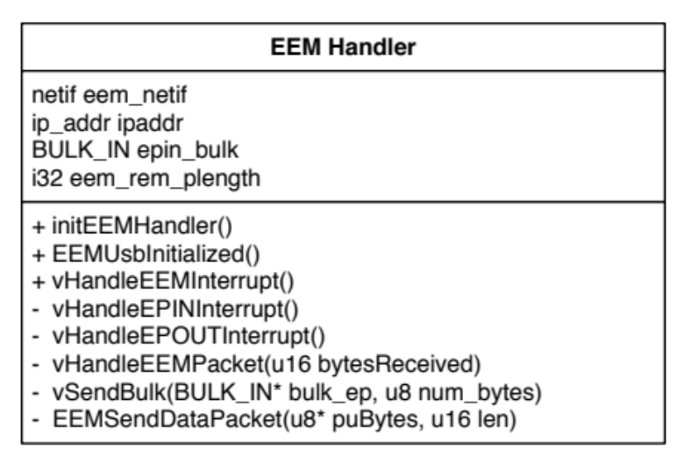
Figure 1: EEM Device Driver Class Description

The EEM Handler will be implemented in the file called EEM_Handler.c. It will contain the interrupt handling methods for EEM interrupts as given in the class diagram above. The first functionality of the EEM handler is to receive incoming EEM frames from the USB FIFO. It therefore reads the USB Fifo until the whole EEM packet is received. This can be done directly inside the EEM interrupt handler or by a DMA transfer initiated by the EEM component. Depending on the configuration the packet will then be decoded directly or later based on the scheduling decisions made by the underlying OS.

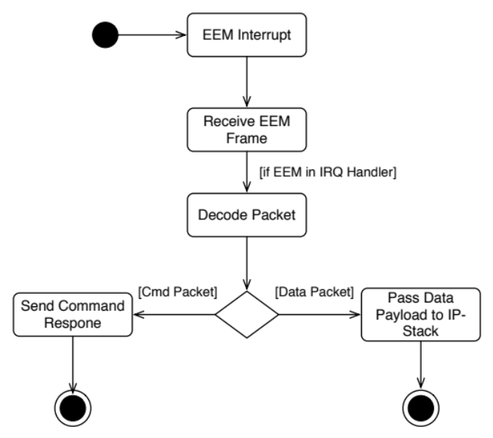
Figure 2: EEM Device Driver Receiver Activity

The EEM Handler basically implements the state machine shown below. Incoming Packets are first checked for the packet size and for available memory. The maximal packet size allows the system to drop packets on the emulated MAC layer, which are definitely not worth storing since they do not contain data, which is addressed to the system. This value may be determined by some means (e.g. communication logs).

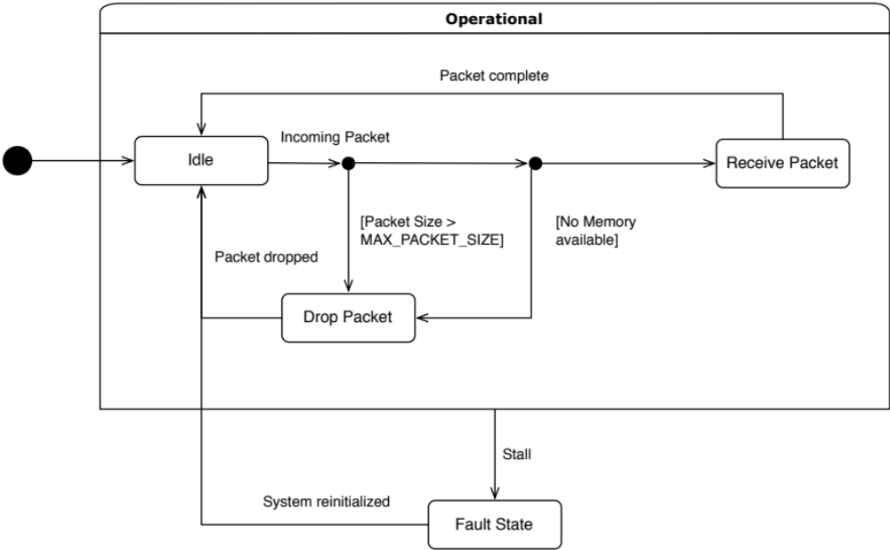
Figure 3: EEM Device Driver State Machine

Internet Protocol Stack

The implementation of the internet protocols is based on the lwIP TCP/IP Stack developed by Adam Dunkels [5] which is maintained in the lwIP GNU project [6].

With the exception of TLS all ETSI required protocols are at least partially available, however untested. TLS, which is optional according to the ETSI requirement, has been added during this project runtime. The following figure gives an overview of the overall IP-Stack implementation:
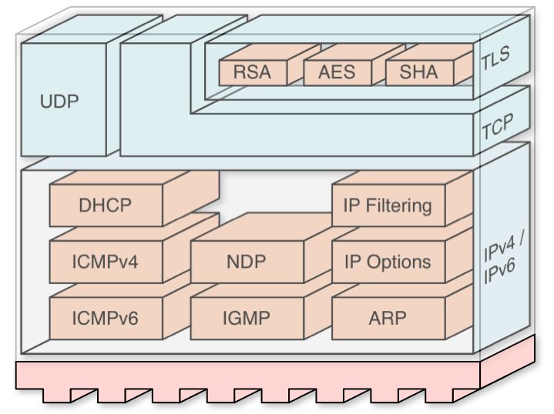

Internet Standards Compliance

Because the lwIP code is taken as the basis for the implementation and no detailed documentation about the implementation scope exists a completeness analysis needs to be done in the context of this project based on RFC 1122[7].

The following table serves as a starting point only and will be refined in the course of the project. It also shows the current implementation status of the missing or adapted protocols and functionalities.

Feature | Support | Current Status
IP and TCP checksums | X | X
IP fragment re-assembly | X | X
IP options | - | (partial)
Multiple interfaces | (X) | X
UDP | (X) | X
Multiple TCP connections | X | X
TCP options | (x) | (x)
Variable TCP MSS | X | X
RTT estimation | (x) | (x)
TCP flow control | X | X
Sliding TCP window | X | X
TCP congestion control | (x) | (x)
Out-of-sequence TCP data | X | X
TCP urgent data | (x) | (x)
Data buffered for retransmit | X | X
Table 1: Main TCP/IP features

The supported protocols of lwIP v.1.3.2 corresponding to RFC 1122[7] are given in table 2:

Protocol | Supported? | Current Status
IPv4 | X (xor IPv6) | X (concurrent)
IPv6 | X (partial) (xor IPv4) | X (concurrent)
ICMP | X (ECHO only) | X (ECHO+Status Messages)
UDP | X (IPv4 only) | X (all IP versions)
TCP | X (IPv4 only) | X (all IP versions)
DHCP | X | X
ARP | X | X
NDP | - | X
UICC | - | -
TLS | - | X (TLS v1.0, no extensions, certificate validation)
DNS | X (IPv4 only) | X (IPv4 only)
ICMPv6 | (ECHO) | (DAD, NSM, NAD, ECHO)
Table 2: Supported protocols of the current implementation and lwIP v1.3.2

The original version of lwIP only supported only one version of the IP protocol at a time. This needed to be adapted to allow IPv4 and IPv6 to be used concurrently.

IPv6 Implementation Status
This section needs to be completed during the development phase. It will show the initial and the current implementation status of the additional IPv6 features.

Feature | lwIP v1.3.2 Support | Current Status
IPv6 Header | X | X
Hop by Hop Options Extension | - | -
Routing Type 0 Extension (optional) | - | -
Fragment Extension (optional) | - | -
Destination Options Extension (optional) | - | -
ICMPv6 (must exist for IPv6) | (ECHO) | (NSM, NAD, DAD, ECHO)
Path MTU Discovery (not needed) | - | -
ICMPv6 NSM | - | X
ICMPv6 NAD | - | X
AR Resend | - | X
ICMPv6 SRA | - | -
ICMPv6 RA | - | X
Table 3: Main IPv6 features and current status
Path MTU Discovery is not implemented for IPv6. As the RFC states: “It is strongly recommended that IPv6 nodes implement Path MTU Discovery [RFC-1981], in order to discover and take advantage of path MTUs greater than 1280 octets. However, a minimal IPv6 implementation (e.g., in a boot ROM) may simply restrict itself to sending packets no larger than 1280 octets, and omit implementation of Path MTU Discovery.“ The implementation targets very small devices such that this feature is not implemented.

IPv4 and IPv6 mutual integration

The lwIP Implementation v1.3.2 doesn’t support IPv4 and IPv6 concurrently. The developer has to choose to either use IPv4 or IPv6 during compile-time. This is done by choosing the directory of the IP implementation inside the build system in order to use the lwIP component either with IPV4 or IPV6 support.

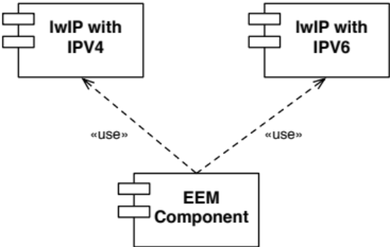
Figure 4: IPv4 and IPv6 exclusive or implementation by using different lwIP implementations
The following changes have been made in order to allow a network interface inside the lwIP implementation to use both protocols at runtime.

LwIP adaptations

Both IP protocol implementations use the same names for methods and structures to ease the exchange of each other during configuration time. Both implementations needed to be changed to use distinct names. All occurrences of these references needed to be changed. One possibility to add both Protocol versions to the final binary is to compile and link the configurations for IPv4 and IPv6 separately.
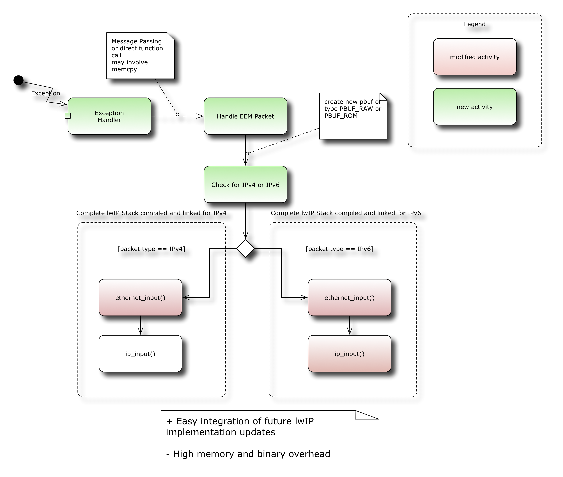
Figure 5: IPv4 and IPv6 coexistence by renaming method names after linking the separate configurations (Not used inside the implementation)

This can easily be done by using different name spaces inside the linked object files as depicted in Figure 5, but suffers from a huge binary and memory overhead. Since the reduction of such overheads is the major design goal for this project the chosen design features a full integration of both protocol versions as depicted in Figure 6.

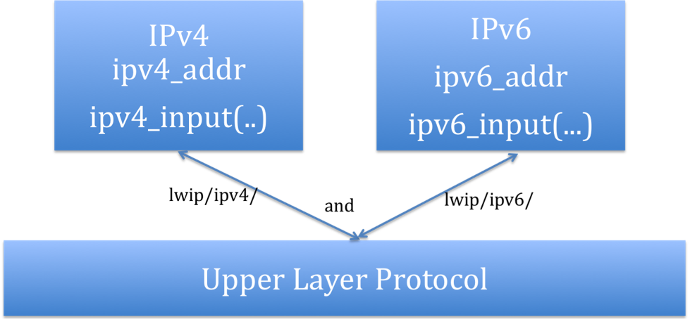
Figure 6: IPv4 and IPv6 coexistence implemented

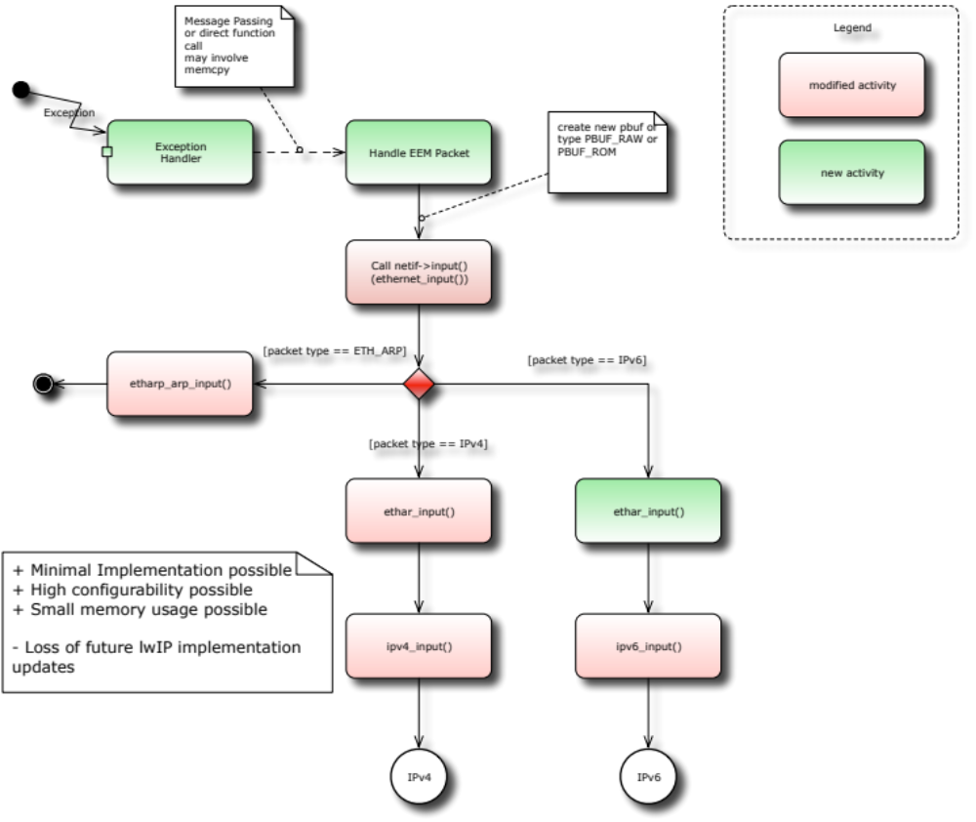
Figure 7: Changes inside the lower protocol stack to feature the support of IPv4 and IPv6 at the same time
The full integration compromises a complete adaptation of the lower level protocol functionalities to support both protocol versions as seen in Figure 7. Additional changes are denoted in the following sections.

Network Interface changes

The network interface structure netif is used by lwIP to describe physical or virtual network interfaces such as an ethernet adapter or a serial adapter. Any kind of adapter can be interfaced by this structure by lwIP. Therefore the structure contains pointers to methods for low level input and output to and from the adapters. Inside this project the virtual Ethernet Emulation Model (EEM) network adapter is interfaced by this structure.

For the integration of both IP versions the network interface needed to be changed as well. The network interface got an additional address field for the IPv6 address and IPv6 network mask. The status of the IPv6 address will be marked inside an enumeration field to allow the implementation to distinguish between tentative, valid and invalid IPv6 addresses of the network interface (see [12]). Additionally the ip_output() method has been replaced by two different methods for outputting either IPv4 or IPv6 packets. The corresponding code which used this function for outputting higher level packets using the IP Framework needed to be adapted to either use the IPv4 or the IPv6 output method depending on the target address space (see 4.3.4).

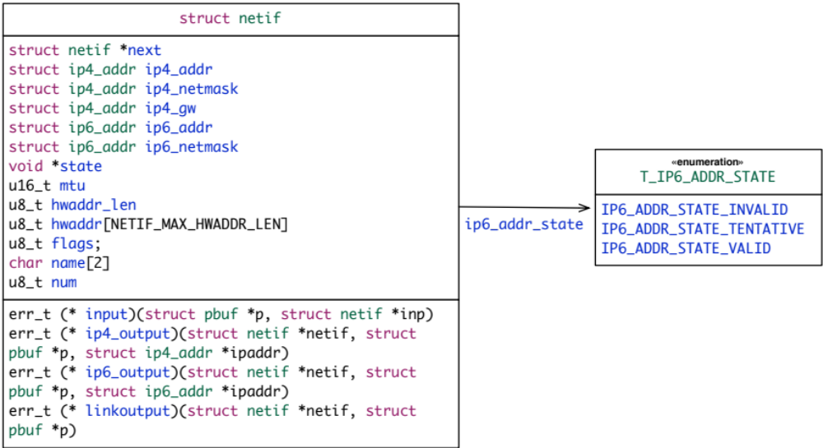

Figure 8: The new network interface structure netif, which integrates IPv4 and IPv6 addresses

Address Resolution Framework changes

The lwIP v.1.3.2 address resolution framework has been written to only support the ARP protocol. In order to efficiently support the IPv6 address resolution the original framework has been decomposed into two parts as depicted in figure 6. One part contains the common address translation and database methods used by both address resolution techniques (NDP, ARP). These methods had to be adapted to support both IP versions. Depending on the IP version the appropriate lower level protocol function is called.

One important feature, which was not persistent in the lwIP v1.3.2 implementation, was the automatically retransmission of address translation queries. This feature has been added inside the periodically called method ethar_tmr() (see 4.5).
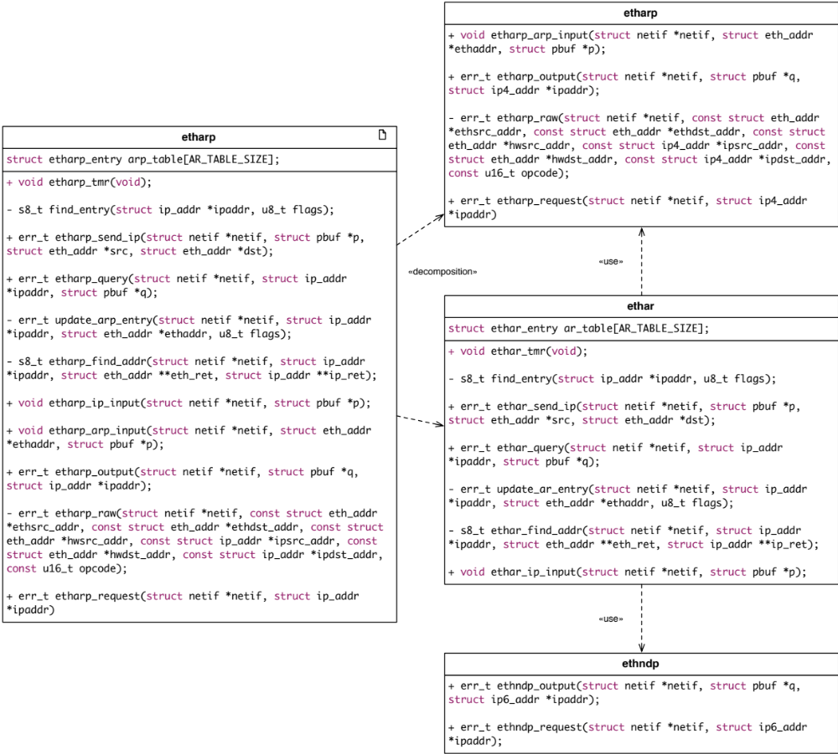
Figure 9: Decomposition of the ARP Framework to support both IPv4 and IPv6 address translations

Theoretically it might also be possible to do the address translation for IPv6 addresses using the ARP protocol since the address field length inside the ARP protocol is dynamic. This would allow the stack to be built without ICMPv6 support to decrease the binary size. However, this implies that the host needs to be aware of this situation. Most hosts will not support this way of translating IPv6 addresses so this might be an optional feature for a later version of the IP-Stack.

The address resolution table also needed to be adapted to contain both IPv4 and IPv6 addresses. Both translation entries are held in the same table for memory and binary efficiency. Thus, both translation entries share the same pre-emption window, which means that IPv6 addresses may be replaced by newer IPv4 addresses translation entries and vice versa.
Additionally the AR-Cache entry size increased since every entry may either be an IPv6 or an IPv4 address. Figure 10 shows the memory layout of an AR-Table entry. Inside the addr field the corresponding IPv4 or IPv6 address is stored. The v field indicates if the address is either an IPv4 address (v==0) or an IPv6 address (v==1). The memory footprint of the overall table entry increased from 16 to 32 bytes. This may be subject to further improvement. Possible improvements can be, e.g., reducing the netif pointer field to the smallest possible size or reducing the addr field size if the prefix of the IPv6 addresses are static (link local communication only).

0 1 2 3
0 1 2 3 4 5 6 7 8 9 0 1 2 3 4 5 6 7 8 9 0 1 2 3 4 5 6 7 8 9 0 1
+-+-+-+-+-+-+-+-+-+-+-+-+-+-+-+-+-+-+-+-+-+-+-+-+-+-+-+-+-+-+-+-+
| addr[0] |
+-+-+-+-+-+-+-+-+-+-+-+-+-+-+-+-+-+-+-+-+-+-+-+-+-+-+-+-+-+-+-+-+
| addr[1] |
+-+-+-+-+-+-+-+-+-+-+-+-+-+-+-+-+-+-+-+-+-+-+-+-+-+-+-+-+-+-+-+-+
| addr[2] |
+-+-+-+-+-+-+-+-+-+-+-+-+-+-+-+-+-+-+-+-+-+-+-+-+-+-+-+-+-+-+-+-+
| addr[3] |
+-+-+-+-+-+-+-+-+-+-+-+-+-+-+-+-+-+-+-+-+-+-+-+-+-+-+-+-+-+-+-+-+
|v| state | ctime | eth_addr[0] | eth_addr[1] |
+-+-+-+-+-+-+-+-+-+-+-+-+-+-+-+-+-+-+-+-+-+-+-+-+-+-+-+-+-+-+-+-+
| eth_addr[2] | eth_addr[3] | eth_addr[4] | eth_addr[5] |
+-+-+-+-+-+-+-+-+-+-+-+-+-+-+-+-+-+-+-+-+-+-+-+-+-+-+-+-+-+-+-+-+
| netif |
+-+-+-+-+-+-+-+-+-+-+-+-+-+-+-+-+-+-+-+-+-+-+-+-+-+-+-+-+-+-+-+-+

(eth_addr 2-bytes aligned, ctime+state 1-byte aligned, netif 4-bytes aligned)

Figure 10: AR Table entry used for storing address translations

Upper protocol layer adaptations

The lwIP v1.3.2 implementation directly interfaces either the IPv4 or the IPv6 implementation by static compile time configuration. Since the integrated version now supports both addressing techniques the software artefacts needed to be changed to call the appropriate implementation. Therefore wrapper methods have been implemented as shown in figure 11 which are implemented inside the ip.c file.

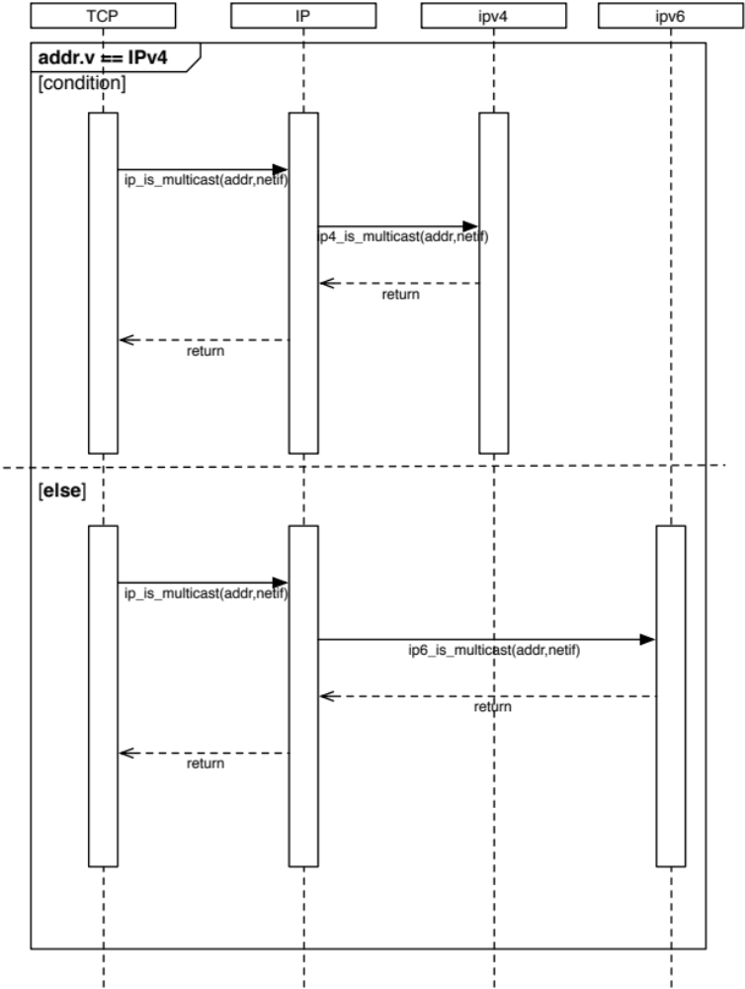
Figure 11: Wrapper for easy integration of IPv4 and IPv6 addresses inside higher level protocols. The corresponding IP implementation is called by some wrapping method.

void ip_addr_set(struct ip_addr *dest, struct ip_addr *src)
{
dest->version = src->version;
if (src->version == IPV4) {
ip4_addr_set((struct ip4_addr*) &dest->addr,
(struct ip4_addr*) &src->addr);
} else
{
ip6_addr_set((struct ip6_addr*) &dest->addr,
(struct ip6_addr*) &src->addr);
}
}

TCP Layer – No Copy Data Propagation

The TCP write and enqueue operations have been modified to support a no copy argument passing methodology. Instead of pointers to memory locations the TCP Layer has been adapted to support the use of pbuf structures as memory references. This allows the application to pass a pbuf to the TCP/TLS Layer and the TCP Layer will keep a reference to this pbuf to ensure the memory is not freed until the TCP Layer successfully sent the data.

The TCP Layer first fragments the data to send into segments, which are specified by a tcp_seg structure. This segment holds a reference to a memory location holding the TCP_HEADER chained with a reference to the data contained inside this segment.
This will be done for all parts of the data to be sent. An example is depicted in the figure below:

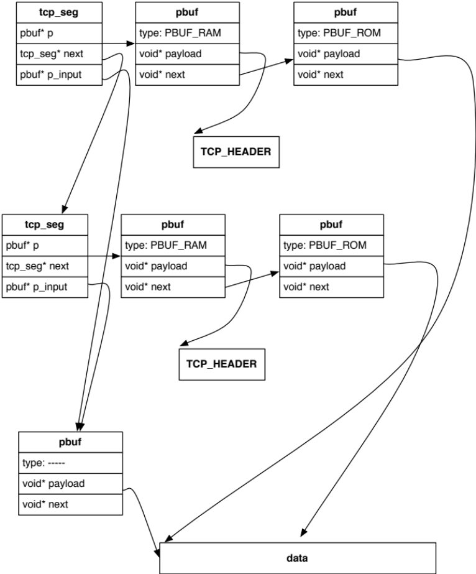
Figure 12: TCP packet segmentation by chains of tcp segments containing chains of pbufs for header and data representation.

Further Adaptations:

- TCP, UDP implementation needed to be adapted to use the appropriate checksum calculation function.
- Multiple parts of the input and output functions needed to be changed to do correct calculations based on the used IP packet version.
- The TCP PCB needed to be adapted to support both IPv4 and IPv6 addresses.
- The correct IP protocol output method needed to be called depending on the used IP address type.
- The IPv6 output method needed to be implemented (called ethndp_output())

- PBUF allocation may become inefficient. At the moment memory can be allocated for different layers that will automatically reserve memory for lower level layers. Since a TCP layer does not know if it is send using IPv4 or IPv6 the current implementation allocates the maximum possible memory usage. This wastes about 20 bytes per IPv4 packet. (TODO: analyze whether this is a problem or not since memory is allocated in aligned chunks anyway!)

Source Code Optimizations

Some optimizations to the source code have been made:

- Moved unneeded methods into separate files so that these methods may not be linked into the final binary (this will be done in an automatic strip process later on).
- The ethernet_input() method has been placed inside a distinct ethernet.c file. (Moved from etharp.c)

Protocol Details
In the following sections the design of the protocols added to the lwip stack is described.

IPv6

The lwip v.1.3.2 implementation only supported small parts of the IPv6 protocol. The IPv6 header was already supported but no extensions where supported at all. The following extensions have been added to the IP-Stack.

ICMPv6 / NDP

As the IPv6 protocol makes extensive use of ICMPv6 and/or especially NDP these protocols have been added to the IP-Stack in the first place.

Files:
List of all files belonging to the ICMPv6 / NDP implementation:

ICMPv6 Handler | core/ipv6/icmp6.c
NDP Handler | core/ipv6/ethndp.c  core/ipv6/icmp6.c

The NDP protocol is used by the IPv6 protocol for auto configuring [10] the ipv6 address of a network adapter. It is defined as a ICMPv6 extension and reception of NDP extended packets is done inside the icmp6.c file. Sending NDP packets is done inside the ethndp.c file which implements the ndp protocol for use with ethernet based network adapters. Thus sending a NDP packet using the ethndp_request() method will directly send the ethernet packet containing the NDP packet on top of a given network interface. This could be easily changed to support any kind of underlying protocol but has been implemented this way for memory and performance reasons.

The NDP protocol automatically initiates the auto configuration process whenever a network interface is set to an active state (calling the netif_up() method on that network interface). The assigned MAC address is then used to calculate a link local IPv6 address. This address is then used inside a DAD (Duplicate Address Detection) process. If no answer is received after three iterations the address is automatically assigned to the network interface. For further information see [10].

TLS

As a part of the ETSI Standard the TLS protocol has been added to the existing lwIP stack. The current implementation features a TLS 1.1 compatible implementation. No TLS extensions have been implemented yet. TLS renegotiation has been disabled for security reasons. The TLS implementation only supports server mode connections. The TLS stack can, thus, only be used in server mode. No client TLS connections may be initiated.

Files:
List of all files belonging to the tls implementation:

TLS State Machine | core/tls/tls.c
TLS API | include/lwip/tls/tls.h
TLS Types and Configurations | include/lwip/tls/tls_types.h  include/lwip/tls/tls_private_key.h  include/lwip/tls/tls_cipher_suites.h  core/tls/tls_cipher_suites.c
TLS AES | core/tls/tls_aes.c  include/lwip/tls/tls_aes.h
TLS RSA | core/tls/tls_rsa.c  include/lwip/tls/tls_rsa.h
Pseudo Random Function and Hashing Algorithms | core/tls/prf.c
DER Certificate Validation | core/tls/der_certificate.c  include/lwip/tls/der_certificate.h

An overview of the tls package is given in the figure below:

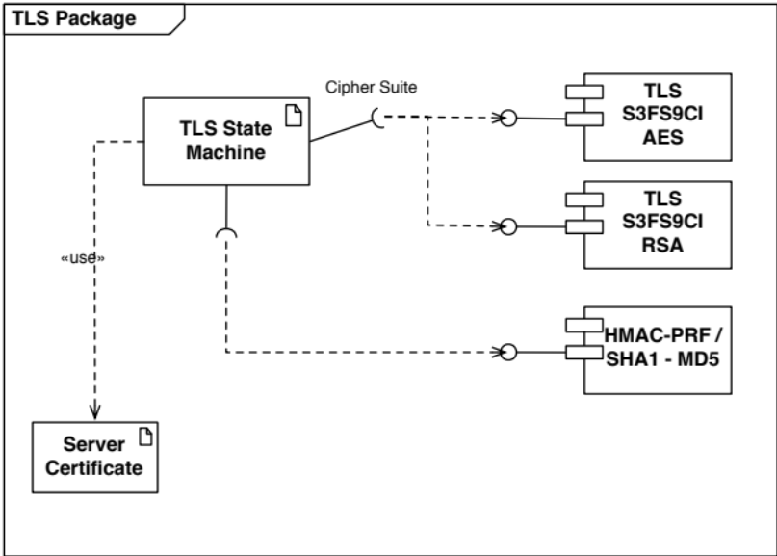

The general handshake flow of a client connecting to the TLS Server implementation is depicted in the picture below:

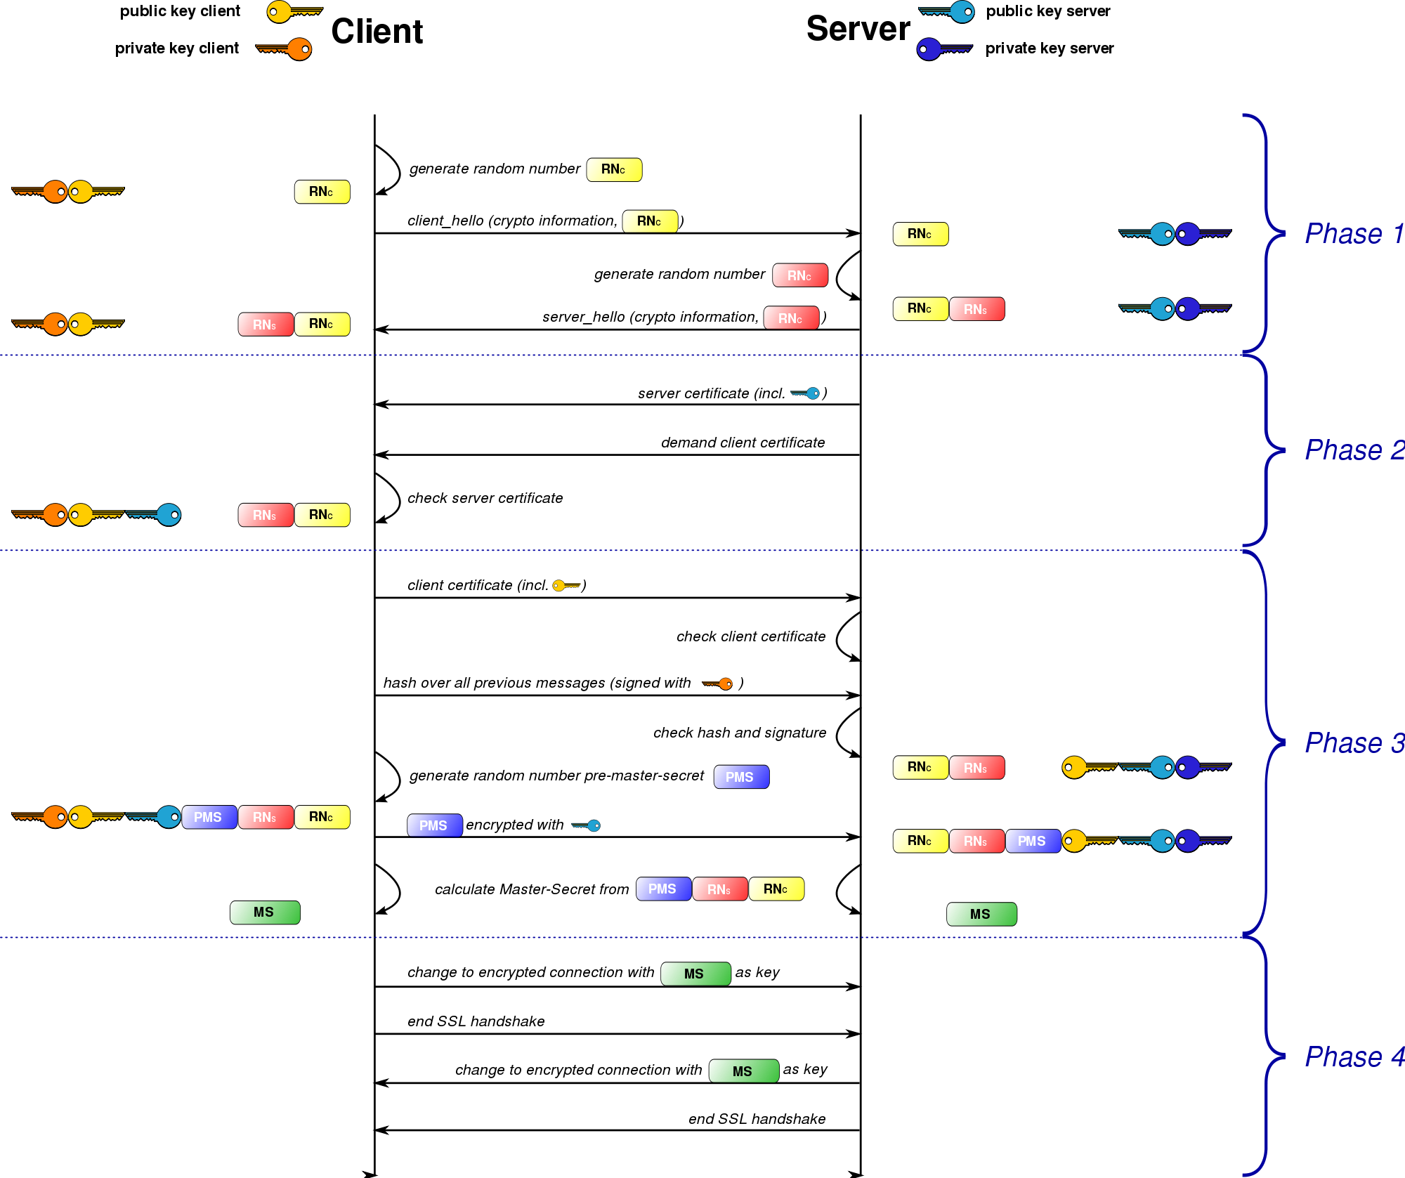

All steps depicted on server side are currently implemented, although some constraints hold with respect to the supported algorithms for some of the steps. An overview of the algorithms and functionalities implemented is given in the following sections.

Supported Protocols/Algorithms

The current TLS implementation supports the following Protocols and Algorithms:

Hash Functions: SHA1, MD5,
Key Exchange: RSA 1024
Symmetric Encryption: AES128

SHA1 and MD5 are currently used inside the running hash calculation and the Pseudo Random Function used for HMAC generation and validation (see the TLS Specification for more information on the PRF):

err_t PRF(u8_t* secret, u8 secret_len, u8_t* seed, u8 seed_len, u8_t* ret_buf, u8 ret_len)

The TLS implementation features an extendable interface which allows the addition of new authentication and encryption algorithms. This can easily be done by editing the cipher_suites array inside the tls_cipher_suites.c file. Each cipher suite entry contains the following information:

/*
* Cipher Suite description structure.
*
* This structure holds pointers to the implementation of the cipher suite algorithms.
*/
typedef struct {
CipherSuite id;
u8_t mac_hash_size; // Message Authentication Code Hash size
u8_t key_material_length; // The Encryption key Length
u8_t block_size; // The block length of the cipher if its a block cipher

err_t (* hmac_hash)(u8_t* key, u16_t key_len, u8_t* message, u16_t message_len, u8_t* ret, u8_t* add_msg, u16_t add_msg_len ); // HMAC_hash method

err_t (* encrypt)(u8_t* pu8InData, u8_t* pu8OutData, u16_t u16len, struct TLS_Connection* psTls_con); // method for data encryption

err_t (* decrypt)(u8_t* pu8InData, u8_t* pu8OutData, u16_t u16len, struct TLS_Connection* psTls_con); // method for data decryption

err_t (* key_decrypt)(void* indata, void* outdata, u16_t len, struct TLS_Connection* tls_con); // method for premaster key decryption

} Cipher_Suite;

Cipher-Suites can be used with various Data-Encryption algorithms as well as different HMAC hashing algorithms and authentication algorithms. RSA Authentication is fixed at the moment. The current implementation forces the use of a server certificate and key exchange using RSA. The HMAC Hash algorithm used for TLS 1.1 is HMAC_SHA1 by default. TLS 1.2 features a variable set of HMAC hash algorithms. For easy integration the hashing algorithm can thus be set here. A valid configuration may look as follows:
// cipher suites sorted by security level (lower id = higher security level)
Cipher_Suite cipher_suites[NUM_CIPHER_SUITES] = {
#if TLS_RSA_WITH_AES_128_CBC_SHA
{ { 0x00, 0x2F },
20, // mac hash size is 20 bytes
16, // the key for this aes mode is 128 bit long
16, // aes always has a block size of 16 bytes!
&HMAC_SHA1, // HMAC hash algorithm
&tls_aes_encrypt, // method pointer to the AES block encryption method
&tls_aes_decrypt, // method pointer to the AES block decryption method
&rsa_enc_premaster_decrypt // method pointer to the RSA decryption method
}
#endif
};

TLS Connection Control Structure

Every TLS Connection can be identified by its TLS_Connection structure holding all information on the connection. The structure is passed to the TLS state machine on packet reception as it is referenced by the user argument of the corresponding TCP session.

typedef struct tls_secret_random {
u8_t label_string[13];
struct Random client_random;
struct Random server_random;
} __attribute__((__packed__)) tls_secret_random;

typedef union tls_secret_key_array {
struct tls_secret_random master_random;
u8_t mac_key_array[MAX_MAC_KEY_ARRAY_LENGTH];
} tls_secret_key_array;

typedef struct SecurityParameters {
MD5_CTX *md5_ctx; // running md5 sum
SHA1Context *sha1_ctx; // running sha1 sum
u16_t cipher_suite_id;
CompressionMethod compression_algorithm;
u8_t reserved; // reserved for alignment
opaque master_secret[48];
tls_secret_key_array secret;
} __attribute__((__packed__)) SecurityParameters ;

struct TLS_Connection {
SecurityParameters security_parameters;
Connection_State state;
HandshakeType next_handshake_type;

// sequence number of the read record .. 64 bit is emulated
u32_t read_seq_num;

// sequence number of the write record .. 64 bit is emulated
u32_t write_seq_num;
s32_t write_bytes;

// Receive method for application data after decryption
err_t (* recv)(void *arg, struct tcp_pcb *tpcb, struct pbuf *p, err_t err);
// Sent method for the application
err_t (* sent)(void *arg, struct tcp_pcb *tpcb, u16_t len);

#ifdef TLS_SUPPORT_SESSIONS
u8_t session_id_len;
opaque session_id[32];
#endif
};

The state of the connection is stored inside the state member of the structure. If this is the “Handshake” state the next expected handshake message type is stored inside the next_handshake_type field. This essentially ensures the right state machine flows of a TLS server control block in handshake mode.

For the MAC generation of the encrypted data transfer a read and a write sequence number is used. Initially this is set to zero for every connection (This may be a security issue that has been discussed by the TLS forum.) The current implementation does not support sessions (due to the renegotiation security issue) but can already hold the session identifier for future support of the renegotiation extension for secure session support.

Each connection stores security related information inside the security_parameters structure.
The corresponding cipher suite is referenced here, the running hash values are built here and the secret keys are stored inside the secret and the master_secret field. The secret field is used for two different purposes. On the one hand the memory location is used to temporarily store the client and the server random numbers, which are used for the master key generation process. After the master secret is generated by the client and the server the memory location is used by the symmetric encryption algorithm. AES for example stores the Initialization Vectors (IV) as well as the Server- and Client–Write Keys. The minimal size of this byte array is max(sizeof(tls_secret_random),sizeof(symmetric_algorithm_storage)) in order to ensure that all data can be stored.

Changing the Server Certificate

The Server certificate is contained in the x509_server_cert_msg constant inside the include/lwip/tls/tls_private_key.h file. It is the binary BER encoded little endian (network byte order) representation of a certificate and needs to contain the certificate chain up to the root certificate. This may be only one certificate if it is self-signing. The private exponent and the private modulus also need to be specified inside the corresponding constants for use with the RSA crypto processor. Alignment to corresponding hardware integer size is mandatory.
An example 1024 bit RSA private key may be given as:

// Little endian word order (1024 bit word!)
const static u8_t private_exponent[] __attribute__ ((aligned(4) )) = {
0x1, 0x3f, 0x7c, 0xd6, 0xa8, 0xe0, 0x7, 0x21,
0xfc, 0x11, 0xa6, 0xe2, 0x40, 0x18, 0xe6, 0x2,
0x2e, 0xee, 0x68, 0x52, 0x2d, 0x6f, 0xf3, 0x61,
0x6, 0xc7, 0xfc, 0x61, 0xc7, 0xc1, 0x61, 0x5c,
0x7a, 0xc, 0xaf, 0x71, 0x53, 0x96, 0x25, 0xad,
0x98, 0xd, 0x71, 0xa0, 0x41, 0xeb, 0x4, 0xa,
0x67, 0x15, 0x95, 0x5c, 0x87, 0x54, 0x38, 0x35,
0x88, 0xc, 0x4e, 0x9a, 0xfb, 0x6e, 0x5d, 0x26,
0xf4, 0x65, 0x6, 0x95, 0xdf, 0xd0, 0x85, 0xa,
0xb, 0xa9, 0x97, 0xf6, 0x35, 0xa, 0x28, 0x17,
0x43, 0xff, 0x7e, 0xc9, 0x57, 0xf2, 0xa3, 0x65,
0x4f, 0x61, 0x11, 0x31, 0xba, 0x62, 0x7f, 0xf4,
0x1d, 0xda, 0xdc, 0xc4, 0x93, 0x13, 0x73, 0x22,
0x3b, 0xb0, 0xdd, 0xe8, 0x98, 0x92, 0x96, 0x25,
0x19, 0x85, 0x8d, 0x7, 0x56, 0xa6, 0x22, 0xb7,
0x8a, 0x3e, 0x6b, 0xe5, 0x82, 0x8b, 0x3a, 0x6};

// Little endian word order (1024 bit word!)
const static u8_t private_modulus[] __attribute__ ((aligned(4) )) = {
0x27, 0xc9, 0xe9, 0x9b, 0x51, 0xf1, 0xbe, 0xf8,
0x19, 0x7f, 0x90, 0xa3, 0xfb, 0x1f, 0x79, 0x8c,
0x5e, 0x53, 0x79, 0x20, 0xc9, 0xaa, 0xcc, 0x38,
0x3, 0x62, 0x74, 0x85, 0x55, 0x18, 0x33, 0xe5,
0xad, 0xde, 0x3d, 0x6b, 0xc3, 0x37, 0xf, 0xea,
0x8f, 0xbc, 0x1b, 0x2, 0xf9, 0x99, 0x30, 0xa9,
0x62, 0x6d, 0xb0, 0x84, 0x7, 0xaa, 0x2d, 0xf1,
0xb6, 0x52, 0xa3, 0xf5, 0xe9, 0x29, 0x9d, 0xd3,
0x9d, 0x27, 0xd9, 0x2a, 0x14, 0xbb, 0xc9, 0x16,
0x55, 0x7d, 0x1a, 0x48, 0x7f, 0x46, 0xa8, 0xe8,
0x2a, 0x48, 0xf2, 0x44, 0x37, 0x85, 0x92, 0xa3,
0x5b, 0xb4, 0xe, 0x16, 0x45, 0x98, 0x55, 0x55,
0x63, 0x0, 0xe2, 0x41, 0x4b, 0x72, 0xdd, 0x73,
0x6, 0x87, 0xe, 0xb4, 0xe8, 0xa6, 0xc2, 0x12,
0x56, 0xc1, 0x74, 0xf0, 0x5a, 0xc9, 0x6e, 0x41,
0xfb, 0x99, 0x69, 0x16, 0x7d, 0x66, 0x6a, 0xdc };

During the handshake the server will send its server certificate message, which is hardcoded as a constant to reduce volatile memory usage. Thus, whenever the server certificate is changed the constant must be adapted to contain the correct binary form of the certificate (This might be automated in the future). The highlighted bytes need to be adapted inside the following example:

// 1024 bit rsa key based self signed certificate
const static u8_t x509_server_cert_msg[] = {
// the tls message headers
0x16,
0x03, // VERSION major
0x01, // VERSION minor
0x02, // length
0x13, // length

// tls certificate handshake header
0x0b,
0x00,
0x02, // length
0x0f, // length

// length of the rest of the message = 521+3=0x20c
0x00,
0x02,
0x0c,

// certificate length = 521 = 0x209
0x00,
0x02,
0x09,

// following the der encoded certificate (521 bytes)
0x30, 0x82, 0x02, 0x05, 0x30,
0x82, 0x01, 0x6e, 0x02, 0x09,
0x00, 0xe1, 0x28, 0x05, 0xe2,
0x25, 0x48, 0x32, 0x92, 0x30,
0x0d, 0x06, 0x09, 0x2a, 0x86,
. . . .
0xb4, 0x3e, 0xa9, 0x9b, 0xaa,
0xa0, 0xa9, 0x29, 0x23, 0x7b,
0x96, 0xff,
0x97,
0xc8,
0xea,
0xe2,

#if TLS_FORCE_CLIENT_CERTIFICATE
// the tls message header
0x16,0x03,0x01,0x00, 0x08,

// tls certificate request handshake header
0x0d, 0x00, 0x00, 0x04 ,

// tls certificate requests frame
0x01, 0x01,
0x00, 0x00,
#endif

// the tls message header , server hello done
0x16, 0x03, 0x01, 0x00, 0x04,
0x0e, 0x00, 0x00, 0x00 };

In order to get DER encoded format of the certificate, examine a DER binary encoded certificate using openssl:

openssl x509 -text -in server_cert.der -inform DER
The certificate can then be copied into the msg structure above. The marked length fields need to be adapted if the der encoded certificate length is different to 521 bytes.
Typical Workflow:
Given the server public certificate (server.crt) one may extract the public key information from the certificate by using the following command in a linux shell (on a big endian machine, e.g. x86):

openssl x509 -text -in server.crt

The output may look as follows:

Certificate:
Data:
Version: 1 (0x0)
Serial Number:
e1:28:05:e2:25:48:32:92
Signature Algorithm: sha1WithRSAEncryption
Issuer: C=DE, ST=NRW, L=Paderborn, O=Safran Morpho
Validity
Not Before: Sep 15 12:24:30 2010 GMT
Not After : Sep 15 12:24:30 2011 GMT
Subject: C=DE, ST=NRW, L=Paderborn, O=Safran Morpho
Subject Public Key Info:
Public Key Algorithm: rsaEncryption
RSA Public Key: (1024 bit)
Modulus (1024 bit):
00:dc:6a:66:7d:16:69:99:fb:41:6e:c9:5a:f0:74:
c1:56:12:c2:a6:e8:b4:0e:87:06:73:dd:72:4b:41:
e2:00:63:55:55:98:45:16:0e:b4:5b:a3:92:85:37:
44:f2:48:2a:e8:a8:46:7f:48:1a:7d:55:16:c9:bb:
14:2a:d9:27:9d:d3:9d:29:e9:f5:a3:52:b6:f1:2d:
aa:07:84:b0:6d:62:a9:30:99:f9:02:1b:bc:8f:ea:
0f:37:c3:6b:3d:de:ad:e5:33:18:55:85:74:62:03:
38:cc:aa:c9:20:79:53:5e:8c:79:1f:fb:a3:90:7f:
19:f8:be:f1:51:9b:e9:c9:27
Exponent: 65537 (0x10001)
Signature Algorithm: sha1WithRSAEncryption
09:24:17:88:48:f0:60:89:ff:5d:81:0b:4b:1e:7e:73:bc:13:
31:5b:88:b0:72:8d:f1:5d:6e:0b:31:b6:b0:db:24:bf:8f:de:
28:94:59:c7:83:5e:88:41:96:85:68:40:8b:95:9a:34:64:81:
4d:49:83:63:28:73:47:c6:4c:b1:94:50:bd:0a:d8:cf:eb:0e:
0f:eb:96:22:e6:db:bf:dd:bc:d0:49:0e:c1:2e:a1:71:f8:dc:
d7:8c:a9:0d:fd:49:0a:94:b2:81:a7:7b:e7:fa:85:2d:29:fa:
0f:cf:4e:6f:b4:3e:a9:9b:aa:a0:a9:29:23:7b:96:ff:97:c8:
ea:e2
-----BEGIN CERTIFICATE-----
MIICBTCCAW4CCQDhKAXiJUgykjANBgkqhkiG9w0BAQUFADBHMQswCQYDVQQGEwJE
RTEMMAoGA1UECBMDTlJXMRIwEAYDVQQHEwlQYWRlcmJvcm4xFjAUBgNVBAoTDVNh
ZnJhbiBNb3JwaG8wHhcNMTAwOTE1MTIyNDMwWhcNMTEwOTE1MTIyNDMwWjBHMQsw
CQYDVQQGEwJERTEMMAoGA1UECBMDTlJXMRIwEAYDVQQHEwlQYWRlcmJvcm4xFjAU
BgNVBAoTDVNhZnJhbiBNb3JwaG8wgZ8wDQYJKoZIhvcNAQEBBQADgY0AMIGJAoGB
ANxqZn0WaZn7QW7JWvB0wVYSwqbotA6HBnPdcktB4gBjVVWYRRYOtFujkoU3RPJI
KuioRn9IGn1VFsm7FCrZJ53TnSnp9aNStvEtqgeEsG1iqTCZ+QIbvI/qDzfDaz3e
reUzGFWFdGIDOMyqySB5U16MeR/7o5B/Gfi+8VGb6cknAgMBAAEwDQYJKoZIhvcN
AQEFBQADgYEACSQXiEjwYIn/XYELSx5+c7wTMVuIsHKN8V1uCzG2sNskv4/eKJRZ
x4NeiEGWhWhAi5WaNGSBTUmDYyhzR8ZMsZRQvQrYz+sOD+uWIubbv9280EkOwS6h
cfjc14ypDf1JCpSygad75/qFLSn6D89Ob7Q+qZuqoKkpI3uW/5fI6uI=
-----END CERTIFICATE-----

The modulus can then be extracted and stored inside an array inside the tls_private_key.h file. Be sure to convert the byte order into the byte order used by the underlying hardware architecture. The whole modulus resembles only one word! The given 1024 bit modulus converted into little endian word order may thus be (the leading 0 must be omitted):

const static u8_t rsa_modulus[] __attribute__ ((aligned(4) )) = {
0x27, 0xc9, 0xe9, 0x9b, 0x51, 0xf1, 0xbe, 0xf8,
0x19, 0x7f, 0x90, 0xa3, 0xfb, 0x1f, 0x79, 0x8c,
0x5e, 0x53, 0x79, 0x20, 0xc9, 0xaa, 0xcc, 0x38,
0x3, 0x62, 0x74, 0x85, 0x55, 0x18, 0x33, 0xe5,
0xad, 0xde, 0x3d, 0x6b, 0xc3, 0x37, 0xf, 0xea,
0x8f, 0xbc, 0x1b, 0x2, 0xf9, 0x99, 0x30, 0xa9,
0x62, 0x6d, 0xb0, 0x84, 0x7, 0xaa, 0x2d, 0xf1,
0xb6, 0x52, 0xa3, 0xf5, 0xe9, 0x29, 0x9d, 0xd3,
0x9d, 0x27, 0xd9, 0x2a, 0x14, 0xbb, 0xc9, 0x16,
0x55, 0x7d, 0x1a, 0x48, 0x7f, 0x46, 0xa8, 0xe8,
0x2a, 0x48, 0xf2, 0x44, 0x37, 0x85, 0x92, 0xa3,
0x5b, 0xb4, 0xe, 0x16, 0x45, 0x98, 0x55, 0x55,
0x63, 0x0, 0xe2, 0x41, 0x4b, 0x72, 0xdd, 0x73,
0x6, 0x87, 0xe, 0xb4, 0xe8, 0xa6, 0xc2, 0x12,
0x56, 0xc1, 0x74, 0xf0, 0x5a, 0xc9, 0x6e, 0x41,
0xfb, 0x99, 0x69, 0x16, 0x7d, 0x66, 0x6a, 0xdc
};

The same holds for the public exponent.

Extracting the private exponent from the server.key file can be done by using the command:

openssl rsa -text -in server.key

The private exponent will be listed inside the output and can be copied into a private exponent array similarly to the public modulus extraction (be aware of the endianess).

TLS Certificate Validation
The TLS implementation may be configured to force the connecting client to authenticate itself by sending a certificate (chain). The certificates must be sent in ASN.1 DER binary encoding format (see ITU-T X.690). If this option is configured the handshake between server and client may only succeed if the client uses a certificate that can be validated through the public key of the server (which functions as the trusted certificate database here). This can be done by providing a single certificate which is directly signed by the servers public key or by a signing certificate chain which top level certificate can be validated by the servers public key. The internal DER certificate validation is done by the DER_isValidCertificate method on the TLS client certificate message:
err_t DER_isValidCertificate(DER_Certificate pDERCert, DER_Certificate pDERCert_next)
This method checks if a certificate pDERCert can be validated by the pDERCert_next certificate. Currently the Certificate Validation algorithm only supports the following signature algorithms:
SHA1WITHRSA, MD5WITHRSA.
Certificates signed using a different algorithm cannot be validated and will thus be rejected. Certificates MUST be version x509.1.

TLS API

The following tls api calls are provided by the tls api file tls.h:

err_t tls_new( struct tcp_pcb *pcb, err_t(* recv)(void *arg, struct tcp_pcb *tpcb, struct pbuf *p, err_t err))

Description:
Creates a new TLS Control block and binds the TCP PCB to this new control block. Also sets the function to be called for decoded data packets.

Parameters:

pcb: Pointer to the TCP Process Control Block used for this TLS connection.
recv: Method pointer to the function that shall be called whenever a TLS packet has been successfully decrpypted (user application method)

err_t tls_recv(void *arg, struct tcp_pcb *pcb, struct pbuf *p, err_t error)

Description:
Reception method for incoming TLS packets. Usually called by the TCP stack.

Parameters:

arg: Pointer to the corresponding TLS_Connection structure for this tls packet.
pcb: Pointer to the TCP Process Control Block used for this TLS connection.
p: Pbuf holding the data of the packet.
error: Error code of the lower protocol layer. (Default: 0)

err_t tls_write(struct tcp_pcb *pcb, struct pbuf* p_data, u16_t len, u8_t apiflags)

Description:
Writes a data packet to be send over the TLS stack. Takes a pointer to the data to be send to the client.

Parameters:

pcb: Pointer to the TCP Process Control Block used for this TLS connection.
p_data: Pointer to the PBUF holding the data to be sent.
len: Total data length.
apiflags: Flags. Currently ignored and passed to the TCP write method if this is not a TLS connection.

void tls_sent(struct tcp_pcb *pcb, err_t (* sent)(void *arg, struct tcp_pcb *tpcb, u16_t len))

Description:
Method to register a callback method whenever a TLS packet has been successfully received by the client. This allows to implement a “send on reception” mechanism by the application to save volatile memory.

Parameters:

pcb: Pointer to the TCP Process Control Block used for this TLS connection.
sent: Pointer to the method to be called whenever a TLS packet has been re ceived by the peer.

A TLS secured connection needs to use a dedicated TCP PCB. After a TCP PCB has been created and the TCP protocol accepted an incoming connection, the receive method needs to be set to the TLS receive method. Therefor a TLS control block needs to be created using the “tls_new” api call. The created structure will contain the user receive method that will be called whenever a correctly decodeable TLS packet has been received. The decoded packet will be forwarded to that method. Thus, the user application only sees the application traffic and does not see any TLS protocol specific behaviour. The following source code demonstrates the use of the TLS API for setting up a TLS secured HTTP server (HTTPS).

// This is the callback function that is called when a connection has been accepted.
static err_t https_accept(void *arg, struct tcp_pcb *pcb, err_t error) {

// Set up the function http_recv() to be called when data arrives.

tls_new(pcb,&http_recv); // for setting up a tls connection based server
return ERR_OK;
}

void main()
{
struct tcp_pcb *pcb;
pcb = tcp_new(); /* Create a new TCP PCB. */
tcp_bind(pcb, NULL, 443); /* Bind the PCB to TCP port 443 (https). */

pcb = tcp_listen(pcb); /* Change TCP state to LISTEN. */

/* Set up https_accept() function to be called when a new connection arrives. */
tcp_accept(pcb, &https_accept);
}

Important Memory Allocation Policy

Whenever data is send over an encrypted TLS connection it is very important to allocate enough memory for the data to be encrypted in place. This means that in front of the data to be sent there needs to be enough space for the TLS Header (TLS.1.1 Header Size is 5 bytes). The data itself will be encrypted in place, which will add some alignment bytes (depending, e.g., on the encryption algorithms block size). Every TLS message is also secured by a Message Authentication Code (MAC), which is placed behind the data. Thus whenever the application is allocating a buffer for data to be sent these overhead bytes need to be allocated as well (If the application would not care about this we would have to temporarily allocate a new buffer which doubles the memory requirements). The following code demonstrates a typical memory allocation process inside the application for TLS protected data.

struct pbuf *pdata = pdata = pbuf_alloc(PBUF_RAW, 231 + #tls_header_size + #alignment + #tls_mac_size , PBUF_RAM);

if (pdata != NULL) {
pbuf_header(pdata,-5);

The pdata pbuf pointer points to the valid location after this code. It manages a memory space of 231 bytes for the packet data. The additional allocated memory is used for the protocols. Using the following pre-processor macro may ease the allocation:

#define TLS_ALLOC(s) pbuf_alloc(PBUF_RAW, s + 5 + 4 + 16, PBUF_RAM)

for a 4 byte aligned, 16 byte MAC size TLS 1.1 connection. If you are unsure about the MAC size used by the connection use the biggest size offered to a client.

IP-Stack Interfaces

The implementation of lwIP uses specific functions and data structures to work correctly. These methods need to be provided and access points need to be implemented from the underlying hardware layer. The following table gives an overview of the methods and the functionality that need to be provided for the IP-Stack to compile.

File | Comment | Contents
cc.h | Type definitions and Standard-Out/ Debug methods definition | #define BYTE_ORDER  ...  typedef unsigned char u8_t;  …  #define LWIP_PLATFORM_ASSERT(x)
sys_arch.h | System architecture wrapper file. Maps methods for memory allocation and thread management. (Currently unused since no OS support implemented) | typedef unsigned int size_t;  void sys_init(void);  void abort(void);  void* malloc( size_t len );  …
perf.h | Performance specific method interface definitions. | void perf_print_times(struct tms *start, struct tms *end, char *key);  …
lwip_opts.h | Configuration of the lwip stack can be done here. | #define LWIP_ICMP 1  #define LWIP_TLS 1

The following picture gives a short overview, which components may interact with the environment (OS, low level driver). The corresponding interfaces are explained later on.

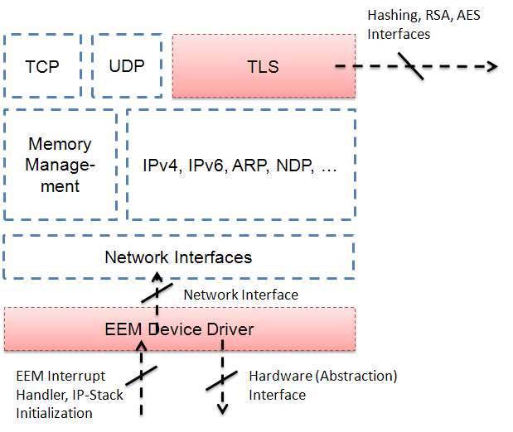
Most of the internal IP-Stack components are self-contained and do not interact directly with the environment. The IP-Stack contains an own memory management policy, which is highly optimized to the components memory requirements. The memory area, which is used for this memory manager, is statically allocated by a buffer at link time.

S3FS9CI EEM Device Driver Interface

The EEM Device Driver provides two methods, which are used for initialization and for interrupt handling respectively.

EEM Device Driver Initialization

The Initialization of the Device Driver is done by calling:

void vInitEEMHandler()
void vEEMUsbInitialized()

This will initialize the network interface inside the IP-Stack. The lower level input methods need to be called appropriately from the device driver as well as the device driver needs to be called by the lwip stack by some means. For this purpose the lwip stack introduced the network interface structure netif, which holds pointers to user defined implementations for low level input and output. The initialization of this network interface is done inside a user-defined method. The overall process can be seen inside figure 12. The network interface is added to the lwIP stack by calling the netif_add() method. This method will call the provided user-defined method (here ethernetif_init()) after some initialization steps. The user-defined method will then be responsible for setting up the low level function pointers and initializing the hardware.

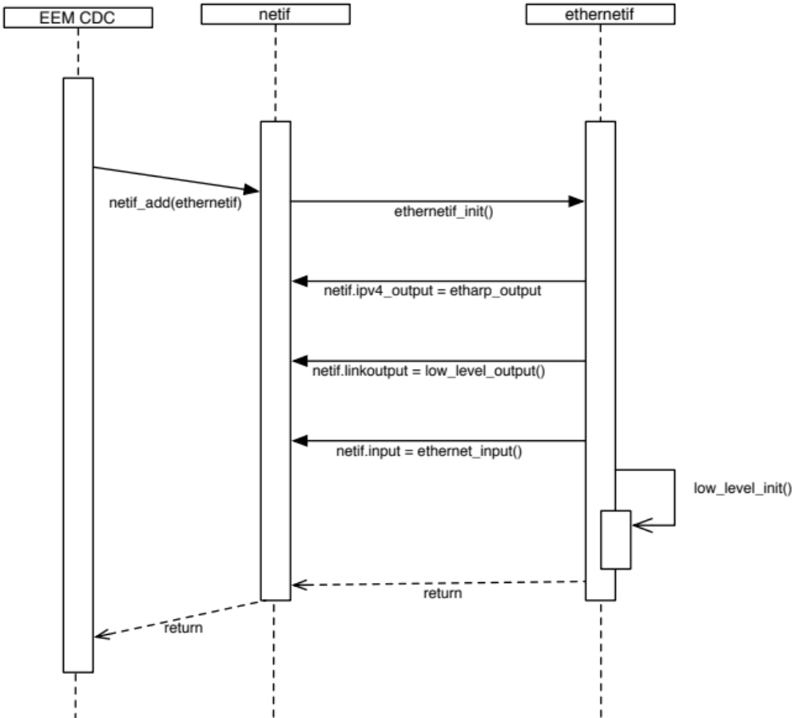
Figure 13: Initialization sequence for the EEM network interface.

The implementation of the ethernetif_init() method is given in figure 13. Each network interface needs to define methods for low level output, input and initialization. After the device driver has been initialized and the usb enumeration has been done the network interface may be set to active by calling the vEEMUsbInitialized method which will allow the communication with the IP-Stack over USB.

err_t ethernetif_init(struct netif *netif) {

#if LWIP_NETIF_HOSTNAME
/* Initialize interface hostname */
netif->hostname = "lwip";
#endif /* LWIP_NETIF_HOSTNAME */

/* Set the network interface name */
netif->name[0] = IFNAME0;
netif->name[1] = IFNAME1;
/* We directly use etharp_output() here to save a function call.
* You can instead declare your own function an call etharp_output()
* from it if you have to do some checks before sending (e.g. if link
* is available...) */
netif->ip4_output = etharp_output;
netif->input = ethernet_input;
netif->linkoutput = low_level_output;

netif->hwaddr_len = 6;

/* initialize the hardware */
low_level_init(netif);

return ERR_OK
;
}

Figure 14: EEM ethernet interface initialization method example.

Interrupt Handler
EEM USB Interrupts need to be forwarded to the interrupt handling method:

void vHandleEEMInterrupt(void)

See 3.2 EEM Handler Design for information on the behavior.

OS and Low-Level Interfaces
The S3FS9CI EEM-Device Driver implementation uses the following list of preprocessor macros to access the USB hardware:

/*
* Defines used to easily port this EEM Handler to different Endpoints
*
* Whenever the endpoint is changed these defines need to
* be adapted to point to the correct registers.
*/

// Interrupt Register Deinitions
#define EEM_INT_REG_EP_OUT INT_REG_EP4
#define EEM_INT_REG_EP_IN INT_REG_EP3

// Data Register Definitions
#define EEM_rUSBEP_OUT rUSBEP4
#define EEM_rUSBEP_OUT_WC rUSBEP4WC
#define EEM_rUSBEP_IN rUSBEP3
#define EEM_rUSBEP_IN_CSR rUSBEP3CSR
#define EEM_rUSBEP_OUT_CSR rUSBEP4CSR

// Defines for Operations on the Data and Interrupt Registers

// Defines for the OUT Endpoint
#define EEM_EP_OUT_CSR_OUT_PACKET_READY EP4_OUT_CSR_OUT_PACKET_READY
#define EEM_EP_OUT_CSR_SENT_STALL EP4_OUT_CSR_SENT_STALL
#define EEM_EP_OUT_CSR_FIFO_FULL EP4_OUT_CSR_FIFO_FULL
#define EEM_EP_OUT_CSR_SEND_STALL SET_EP4_OUT_CSR_SEND_STALL
#define EEM_CLR_EP_OUT_CSR_SENT_STALL CLR_EP4_OUT_CSR_SENT_STALL
#define EEM_CLR_EP_OUT_CSR_OUT_PKT_RDY CLR_EP4_OUT_CSR_OUT_PKT_RDY

// Defines for the IN Endpoint
#define EEM_EP_IN_CSR_IN_PACKET_READY EP3_CSR_IN_PACKET_READY
#define EEM_EP_IN_MAXP_SIZE EP3_IN_MAXP_SIZE
#define EEM_SET_EP_IN_CSR_IN_PACKET_READY SET_EP3_IN_CSR_IN_PACKET_READY
#define EEM_SET_EP_IN_CSR_FIFO_FLUSH SET_EP3_IN_CSR_FIFO_FLUSH

The current implementation uses the register definition and preprocessor macros defined inside the s3fs9ci.h header file. For different hardware architectures the macros need to be adapted or replaced by methods which fulfill the corresponding functionality.

Hashing Interface
The current implementation calculates the SHA1 and the MD5 checksum at various places using the following Context structures:

typedef struct SHA1Context {
unsigned Message_Digest[5]; /* Message Digest (output) */

unsigned Length_Low; /* Message length in bits */
unsigned Length_High; /* Message length in bits */

unsigned char Message_Block[64]; /* 512-bit message blocks */
int Message_Block_Index; /* Index into message block array */

int Computed; /* Is the digest computed? */
int Corrupted; /* Is the message digest corrupted? */
} SHA1Context;

/* Data structure for MD5 (Message Digest) computation */
typedef struct {
UINT4 i[2]; /* number of _bits_ handled mod 2^64 */
UINT4 buf[4]; /* scratch buffer */
unsigned char in[64]; /* input buffer */
unsigned char digest[16]; /* actual digest after MD5Final call */
} MD5_CTX;

No member of these structures is directly referenced to allow portability to different SHA1 and MD5 implementations. Only pointers to the context are used so the context structure may be replaced as well. The interfaces used on these structures are listed below:

void MD5Init (MD5_CTX *mdContext)

Parameters:

mdContext Pointer to the MD5 Context Structure

Description:

Initialize the MD5 Context Structure.

void MD5Update(MD5_CTX *mdContext, unsigned char *inBuf, unsigned int inLen)

Parameters:

mdContext Pointer to the MD5 Context Structure
inBuf Pointer to the Bytes to be hashed
inLen Amount of Bytes to be hashed

Description:

Adds the inLen amount of bytes located at inBuf to the MD5 hash buffer (Builds the running hash value if enough bytes are added to the buffer).

void MD5Final(MD5_CTX *mdContext)

Parameters:

mdContext Pointer to the MD5 Context Structure

Description:
Finalize the MD5 buffer. All remaining bytes in the hash buffer will be hashed (padded with some bytes depending on the algorithm) and the final hash value will the calculated.

void SHA1Reset(SHA1Context *shaContext)

Parameters:

shaContext Pointer to the SHA1 Context Structure

Description:

Initialize the SHA1 Context Structure

void SHA1Input(SHA1Context *shaContext, const unsigned char *inBuf, unsigned int inLen)

Parameters:

shaContext Pointer to the MD5 Context Structure
inBuf Pointer to the Bytes to be hashed
inLen Amount of Bytes to be hashed

Description:

Adds the inLen amount of bytes located at inBuf to the SHA1 hash buffer (Builds the running hash value if enough bytes are added to the buffer).

int SHA1Result(SHA1Context *shaContext)

Parameters:

shaContext Pointer to the SHA1 Context Structure

Description:

Finalize the SHA1 buffer. All remaining bytes in the hash buffer will be hashed and the final hash value will the calculated.

In order to access the result of the hash computation a macro has been introduces which needs to be adapted inside the ipstack_conf.h header file to return the pointer to the corresponding hash field or implement some wrapper method dealing appropriately:

/******************************************************************
** Return then hash value field containing the hash
**
** @arg md5context Pointer to the md5 context structure
** @return Pointer to the hash value
******************************************************************/
#define MD5_GETHASH(md5context) ((md5context)->digest)

/******************************************************************
** Return then hash value field containing the hash
**
** @arg sha1context Pointer to the sha1 context structure
** @return Pointer to the hash value
******************************************************************/
#define SHA1_GETHASH(sha1context) ((sha1context)->Message_Digest)

Crypto Interface

As the TLS component introduces a security layer for authenticated and encrypted communication several crypto methods are referenced. See the TLS chapter 4.2 for information on the TLS structures. In order to use a different crypto library the following methods need to be implemented:

err_T rsa_decrypt (void* indata, void* outdata, u16_t len, u8_t* key_exponent, size_t exponent_len, u8_t* key_modulus, size_t modulus_len)

Parameters:

indata Pointer to the bytes to be encrypted

outdata Pointer to the memory location for the encrypted rsa data to be stored. May be the same as indata.

len Length of the data in bytes. (128 == 1024 bit block rsa encryption)

key_exponent Pointer to the exponent of the public key.

exponent_len Length of the exponent in bytes.

key_modulus Pointer to the Modulus of the key.

modulus_len Length of the modulus in bytes.

Description:

Performs a RSA decryption operation on the indata with the given public key.

IP-Stack Timers

The process model of the Ip-Stack requires some functions to be periodically called in order to guarantee the correct operation of some protocols. The following list gives an overview which functions need some dedicated timer management:

Function Name | Interval | Description
ethar_tmr() | 5 seconds | This method is used by the address resolution protocols. This method periodically scans the AR-Cache for retransmission of AR requests (ARP or NDP). It also purges old entries.
tcp_tmr() | 250 ms | This method is used for retransmission of unacknowledged tcp segments inside the communication window. Also sends tcp keep alive messages if a connection has this flag set.

Currently the hardware timer directly calls these methods. Thus, running with highest priority. Inside a multithreaded realtime system these timer events need to be scheduled as any other activity.

Application Programming Interface

The lwIP implementation has been designed for use with the two basic I/O patterns: the asynchronous event based concept and the synchronous multi-threading pattern.

The IP UICC follows the event based pattern because this can be easily integrated into different operating systems including such offering single tasking support only.

According to the asynchronous concept control returns directly from those TCP functions which depend on the availability of internal and external resources. These functions are called “Requests” in this document.

A function which does not depend on external resources and therefore can be executed immediately (e.g. to process information provided on an event) are called “Accessor”.

An application making use of this implementation is structured like a subroutine which is called on well-defined events, like platform start-up or data received, and which returns control (to the O/S) once a specific task has been carried out to allow the O/S to finally process the asynchronous functions initiated earlier.

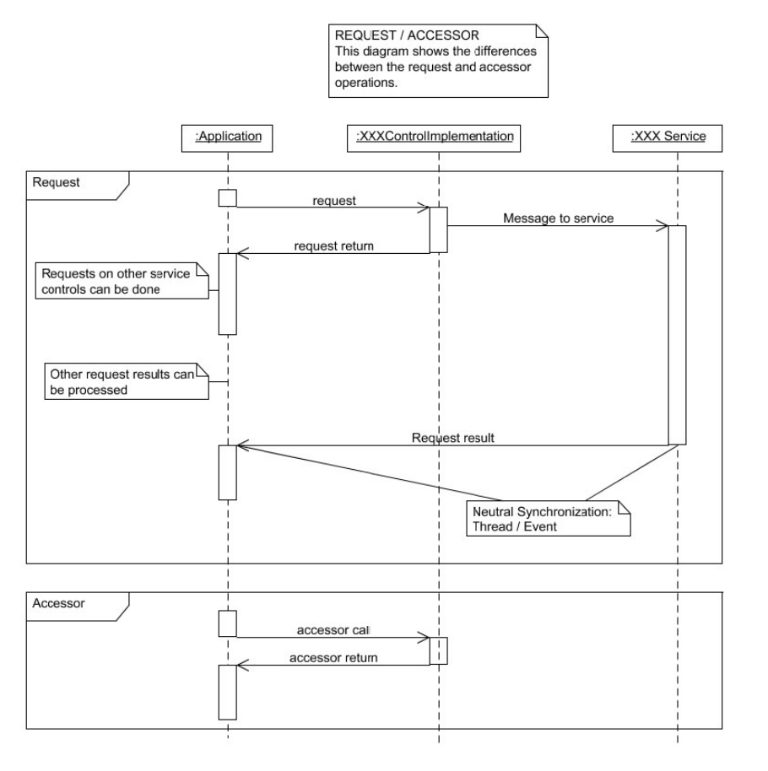
The following figure describes this process model.

Figure 15: Request and Accessor method call processing
Applications will make use of the following lwIP for a communication over TCP or UDP.

TCP Interface

Function | Type | Description
tcp_new | Accessor | Creates a new TCP connection (control block - PCB)
tcp_arg | Accessor | Sets the connection state related to a given TCP connection PCB to be used in the following communication
tcp_bind | Accessor | Binds a PCB to an IP address and port
tcp_listen | Requestor | Sets a connection into “listening” mode
tcp_listen_with_backlog | Requestor | As “tcp_listen” but with limited number of outstanding connections
tcp_accepted | Accessor | Accepts an incoming connection (after being informed of a connection request in “accept” callback.
tcp_accept | Accessor | Installs a callback function to invoked on an incoming connection request
tcp_connect | Requestor | Initiates a client TCP connection an installs a callback function to be invoked on when the connection is established
tcp_write | Requestor | Enqueus data to be sent over an open connection
tcp_sent | Accessor | Specifies the callback function that should be called when data has successfully been received (i.e., acknowledged) by the remote host
tcp_recv | Requestor | Installs a callback function to invoked when data has been received
tcp_recved | Accessor | Confirms that data has been received
tcp_poll | Accessor | Specifies a polling interval and a callback function to be invoked for polling
tcp_close | Accessor
tcp_abort | Requestor | Aborts the connection by sending a RST (reset) segment to the remote host
tcp_err | Accessor | Specifies the function that should be called when a fatal error has occurred on the connection.

UDP Interface

Function | Type | Description
udp_new | Accessor | Creates a new UDP connection (control block - PCB)
udp_remove | Accessor | Removes a connection (and de-allocates the PCB)
udp_bind | Accessor | Binds a PCB to an IP address and port
udp_connect | Accessor | Initializes a UDP client connection
udp_disconnect | Accessor | Removes the remote address and port from a PCB
udp_send | Requestor | Sends data over a UDP connection
udp_rec | Requestor | Installs a callback function to invoked when data has been received

Application Implementation Example

The following example from Adam Dunkels (see section 18.2 of [4]) shows a simplified implementation of a HTTP server as it will be used in the project to demonstrate an IP communication between a browser on a PC and the IP UICC.
The Web-Server does not accept fragmented requests as they may be send by clients. This needs to be added inside the application part and needs to store multiple HTTP packets to combine them if they are fragmented.

/*
* http_server.c
*
* Created on: 26.07.2010
* Author: danielb
*/

/* A simple HTTP/1.0 server directly interfacing the stack. Data is send in multiple packets after the previous packet has been received by the client to save memory. */

#include "lwip/tcp.h"
#include "tls/tls.h"
#include "lwip/pbuf.h"
#include "lwip/stats.h"

/* This is the data for the actual web page. */
static char
indexdata[] =
"HTTP/1.0 200 OK\r\nContent-Type: text/html\r\nConnection: close\r\n\r\n\
<html><head><title>Sagem Orga/s-lab - IP-Stack Demonstrator</title><style> td.h{background-color:#BEC8D1;text-indent:5px;font-family:Verdana;\
font-weight:bold;color:#404040;}table.s{font-size:11px;background-color:#fafafa;border:1px #6699CC solid;border-collapse:collapse;}\
td{text-indent:5px;text-align:left;border: 1px #888888 solid;}</style> </head><body><table class=\"s\"><tr>\
<td colspan=\"4\" class=\"h\">Smart Card Summary</td></tr><tr><td class=\"h\">Variable</td><td class=\"h\">Available</td>\
<td class=\"h\">Used</td><td class=\"h\">Max</td></tr>";

static char enddata[] = "<tr><td colspan=\"4\" class=\"h\">Smart Card Web Server running on port: 80 (HTTP/TCP/IP) and port 443 (HTTPS/TCP/IP/TLS)</td></tr> \
</table></body></html>";

/* This is the callback function that is called when a TCP segment has arrived in the connection. */

#if LWIP_TCP

char * memp_names[] = {
#define LWIP_MEMPOOL(name,num,size,desc) desc,
#include "lwip/memp_std.h"
};

//extern struct stats_ lwip_stats;

static int stage;

static err_t http_sent(void *arg, struct tcp_pcb *pcb, u16_t len) {
LOG(LOG_VERBOSE,("http_sent called! \n"));
if (stage == 1) {
LOG(LOG_VERBOSE,("stage1 \n"));
#define NUM_STATS (MEMP_MAX -3)

struct pbuf *pdata = pdata = pbuf_alloc(PBUF_RAW, NUM_STATS*73 + 61+ 5+20+16, PBUF_RAM);

if (pdata != NULL) {
pbuf_header(pdata,-5);
LOG(LOG_VERBOSE,("http_sent: sending data \n"));

//char* stats_str = pdata->payload;
char* ptr = pdata->payload;

for (int i= 3; i< MEMP_MAX; i++)
{
libsprintf( ptr,"<tr><td>%16s</td><td>%4d</td><td>%4d</td><td>%4d</td></tr>",memp_names[i],lwip_stats.memp[i].avail,lwip_stats.memp[i].used,lwip_stats.memp[i].max);
ptr += 73;
}

libsprintf( ptr,"<tr><td>HEAP</td><td>%4d</td><td>%4d</td><td>%4d</td></tr>",lwip_stats.mem.avail,lwip_stats.mem.used,lwip_stats.mem.max);

tls_write(pcb, pdata, NUM_STATS*73 + 61, 0);
pbuf_free(pdata);
stage = 2;
}

} else
if (stage == 2) {
LOG(LOG_VERBOSE,("stage2 \n"));
struct pbuf *pdata = pdata = pbuf_alloc(PBUF_RAW, sizeof(enddata), PBUF_ROM);
pdata->payload = enddata;

tls_write(pcb, pdata, sizeof(enddata), 0);
pbuf_free(pdata);
tcp_close(pcb);
stage = 0;
}

}

static err_t http_recv(void *arg, struct tcp_pcb *pcb, struct pbuf *p, err_t error) {
char *rq;
LOG(LOG_VERBOSE,("http receive called! \n"));
if (p != NULL)
{ // If we got a NULL pbuf in p, the remote end has closed the connection.
rq = p->payload; // The payload pointer in the pbuf contains the data in the TCP segment.

int get = 0;

// Check if the request was an HTTP "GET /".
if (rq[0] == 'G' && rq[1] == 'E' && rq[2] == 'T' && rq[3] == ' ' )
{
get = 1;
}

// free the incoming data anyway!
pbuf_free(p);

if (get == 1) {

LOG(LOG_VERBOSE,("http get called!\n"));
stage = 1;

struct pbuf *pdata = pbuf_alloc(PBUF_RAW, sizeof(indexdata), PBUF_ROM);
pdata->payload = indexdata;

tls_write(pcb, pdata, sizeof(indexdata), 0);
pbuf_free(pdata);

}

} else {
LOG(LOG_VERBOSE,("tcp connection closed! \n"));
// EOF if p == NULL

}

return ERR_OK;
}

// This is the callback function that is called when a connection has been accepted.
static err_t http_accept(void *arg, struct tcp_pcb *pcb, err_t error) {
// Set up the function http_recv() to be called when data arrives.
tcp_recv(pcb, &http_recv); // for normal unsecure connections
tcp_sent(pcb, &http_sent);
return ERR_OK;
}

// This is the callback function that is called when a connection has been accepted.
static err_t https_accept(void *arg, struct tcp_pcb *pcb, err_t error) {
// Set up the function http_recv() to be called when data arrives.

// TODO put into tls file and set with tls_new
tls_new(pcb,&http_recv); // for setting up a tls connection based server
tls_sent(pcb, &http_sent);
return ERR_OK;
}

// The initialization function.
void http_init(void) {
struct tcp_pcb *pcb;
pcb = tcp_new(); /* Create a new TCP PCB. */
//tcp_bind(pcb, NULL, 443); /* Bind the PCB to TCP port 443 (https). */
tcp_bind(pcb, NULL, 80); /* Bind the PCB to TCP port 80 (https). */
pcb = tcp_listen(pcb); /* Change TCP state to LISTEN. */

/* Set up http_accept() function to be called when a new connection arrives. */
tcp_accept(pcb, &http_accept);

// Setup tls secured server connection
pcb = tcp_new(); /* Create a new TCP PCB. */
tcp_bind(pcb, NULL, 443); /* Bind the PCB to TCP port 443 (https). */

pcb = tcp_listen(pcb); /* Change TCP state to LISTEN. */

/* Set up http_accept() function to be called when a new TLS connection arrives. */
tcp_accept(pcb, &https_accept);

LOG(LOG_INFO,("http_server initialized at port 80 and 443\n"));
}

Cross-Layering Approaches
This section describes the cross layering approaches implemented to enhance the runtime and memory performance of the IP-Stack. The approaches listed here have not been implemented yet. They only describe possible additions to the functionality of the protocol stack that may be done in the future.

Lower Layer Target Address Filter

The EEM Module may be able to filter packets that are not targeted to the smartcard by examining the IPv4/6 target address field as well as the Target Port for TCP connections. This can already be done before the whole packet will be copied into the RAM and thus can save memory. By examining the first bytes of the received usb packet (may be done while reading the bytes from the hardware register) the higher level protocols and addresses may be read on the fly. A simple memory compare may than decide whether the packet will be delivered to the higher level protocols.

References

I Bibliography

[1] | Sagem Orga, s-lab; Configurable IP-Stack for Smart Cards, project description, November 3, 2009
[2] | ETSI TS 102 600, Smart Cards; Characteristics of the USB Interface, Release 7
[3] | ETSI TS 102 483 Internet Protocol connectivity between UICC and terminal, Release 7
[4] | Universal Serial Bus, Device Class Specification for Communication Devices, "CDC Subclass specification for Ethernet Emulation Model" subclass, Revision 1.00, USB Implementers Forum, Device Working Group: Communication.  Available at http://www.usb.org/developers/devclass_docs
[5] | Adam Dunkels, Design and Implementation of the lwIP TCP/IP Stack, February 20, 2001
[6] | lwIP GNU Project, http://savannah.nongnu.org/projects/lwip
[7] | RFC 1122, Requirements for Internet Hosts - Communication Layers
[8] | RFC 4291, IP Version 6 Addressing Architecture
[9] | RFC 2460, Internet Protocol, Version 6 (IPv6) Specification
[10] | RFC 2461, Neighbor Discovery for IP Version 6 (IPv6)
[11] | RFC 2464, Transmission of IPv6 Packets over Ethernet Networks
[12] | RFC 4862, IPv6 Stateless Address Autoconfiguration
[13] | RFC 2508, Compressing IP/UDP/RTP Headers for Low-Speed Serial Links
[14] | RFC 4346 The Transport Layer Security (TLS) Protocol Version 1.1

II Summary of abbreviations

CDC Communication Device Class

EEM Ethernet Emulation Model

ICC Integrated Circuit Card

IP UICC Prototype of a UICC implementing the Internet Protocol Stack

UICC Universal ICC

IP Internet Protocol

lwIP Lightweight Internet Protocol

NAD Neighbourhood Advertisement

NSM Neighbourhood Solicitation Message

DAD Duplicate Address Detection

