Auditable Real Invariant-Bundle Computation and Manifold Extensions for Quasi-Periodic CR3BP Tori
Status: adviser_submission_decision_candidate. This bilingual package is ready for an adviser’s venue/submission decision; no target journal has been selected and no external submission is authorized.
- Author: Wuwenhao Wu (兀文昊)
- Adviser: Chen Zhang (张晨)
- Institution: University of Chinese Academy of Sciences
- Package date: 2026-07-21
- Registry SHA256: B38099E93BB85AD4B97035D667A4AD5E6A74C1805B612EDEABC7AF6497C23EE5
- Method table SHA256: 0B66A89B13926BAF90114741796EA1128AC39A6C62BB092B4A1018B97CDEB88B
- Manifold table SHA256: 248A1F8CB8F958640D526CFFC2859AC3AEDF697BEE5BDAF78EBED95AD898FB8E
- Figure manifest SHA256: FE7147FC8FF4702C1EF6A86454AC45F21CACFD667542DEFD9E17303FC1DE040C
- Source Git commit: 95a606ef75888fcef7f4d8cb2eedb120efc13b22

1. Introduction
Quasi-periodic orbit manifolds are frequently seeded from eigenvectors of a large discrete differential or from eigenvectors computed independently at each phase. Both shortcuts can obscure the actual object of interest: a real subbundle transported by a phase-shifted linear cocycle. A complex selected eigenvector may be silently projected to its real part, adjacent phases may jump by sign or subspace, and a direction that looks smooth at one spectral resolution may not converge as the phase grid is refined.
This study starts only after freezing the McCarthy 2018 reproduction baseline. The baseline contains 54 engineering outputs (13 V0 and 41 V2), but it is explicitly not a thesis-wide strict-equivalence claim. The research layer therefore treats reproduction artifacts as immutable benchmark sources and never promotes research status into the figure-validation table.
The paper evaluates three numerical routes: a deliberately retained pointwise eigendecomposition baseline, an ordered partial real-Schur subspace method, and a shifted QR/SVD cocycle iteration. The contribution is an auditable framework and systematic comparison across 15 cases and four families. It is not a claim of a new invariant-bundle theorem.

2. Problem formulation
Let an invariant curve be sampled at odd phases theta_i = 2*pi*i/N. A local state-transition matrix A(theta_i) maps a perturbation at theta_i to theta_i + rho. A real rank-k bundle is an orthonormal matrix field E(theta) in R^(6 x k) satisfying
A(\theta)E(\theta) \approx E(\theta+\rho)R(\theta),
where R(theta) is scalar for k=1 and a real 2 x 2 reduced map for k=2. The normalized local residual is
r(\theta_i)= \frac{\lVert A_i E_i-E_{i+\rho}(E_{i+\rho}^{T}A_iE_i)\rVert_F} {\max(\lVert A_iE_i\rVert_F,\epsilon_\mathrm{mach})}.
The audit records maximum and mean residual, adjacent-phase and cross-resolution principal angles, selected spectrum, relative imaginary part, reciprocal-pair error, local multiplier estimate, runtime, memory estimate, status, and failure reason. A rank-two real subspace is never relabelled as a rank-one direction.

3. Quasi-periodic orbit and cocycle model
For each registry case, the stored invariant-curve nodes are propagated for the frozen mapping time with the CR3BP variational equations. The terminal state is compared with Fourier interpolation of the source curve at theta+rho. Only after this map revalidation passes is the cocycle used by a method.
The collocation operator is
G_N=(P_{\theta+\rho\rightarrow\theta}\otimes I_6) \operatorname{diag}(A_0,\ldots,A_{N-1}),
where P is the odd-grid trigonometric interpolation matrix. This operator is useful for ordered spectral-block selection, while the reported scientific criterion remains the pointwise cocycle equation above.

4. Failure modes of pointwise eigenselection
The baseline eigendecomposes each local A_i, selects the stable or unstable candidate by multiplier magnitude, takes a real part, normalizes each node, and aligns adjacent signs. It therefore reproduces the conventional failure mode rather than hiding it. Across all 15 cases it obtains 0 accepted results; its high-resolution maximum residuals are 1.240e-01, 1.598e-01, and 1.434e-01 for Halo N45, Vertical N57, and Sun–Earth member 468.
The Route-H controls expose a second failure mode. The saved scan classified member 68 as a near-real positive control under the seed rotation. Direct revalidation shows that this legacy operator has a curve-map residual of 1.988e-03. The physically corrected rotation closes at 8.697e-13, but its selected block is rank two with relative imaginary part 0.342. Thus “near-real DG eigenvalue” and “validated physical one-dimensional bundle” are not interchangeable claims.

5. Proposed invariant-bundle method
The term proposed here refers to the evaluated numerical framework, not to a new mathematical theorem. The first improved route extracts a selected real partial-Schur block from G_N.
\begin{algorithm}[t]
\caption{Ordered partial real-Schur bundle tracking}
\begin{algorithmic}[1]
\Require Local matrices $A_i$, phases $\theta_i$, rotation $\rho$, branch
\Ensure Real bases $E_i$, rank $k\in\{1,2\}$, residuals $r_i$
\State Assemble $G_N=(P_{\theta+\rho\rightarrow\theta}\otimes I)\operatorname{diag}(A_i)$
\State Order hyperbolic roots by distance to the real axis
\If{the selected root is real within the frozen tolerance}
\State Set $k\gets1$ and form a normalized real vector
\Else
\State Set $k\gets2$ and realify the conjugate pair with real/imaginary columns
\EndIf
\State Orthonormalize the selected block and verify $\lVert G_NQ-Q(Q^TG_NQ)\rVert_F$
\State Reshape into nodewise bases, apply local QR, and align adjacent phases
\State Compute $R_i=E_{i+\rho}^TA_iE_i$ and $r_i$
\end{algorithmic}
\end{algorithm}
The second route is independent shifted QR/SVD graph iteration.
\begin{algorithm}[t]
\caption{Shifted QR/SVD cocycle iteration}
\begin{algorithmic}[1]
\Require $A_i$, $\theta_i$, $\rho$, rank $k$, cap $K=200$
\Ensure Real phase-aligned bases $E_i$ and convergence history
\State Initialize each $E_i$ from the leading local right-singular subspace
\For{$j=1,\ldots,K$}
\State Transport $F_i\gets A_iE_i$ and apply local QR
\State Align frames on the shifted grid $\theta_i+\rho$
\State Interpolate $F$ back to the base grid and apply local QR
\State Align to the previous iterate and along phase
\State Stop if the maximum subspace angle is at most $2\times10^{-6}$ degrees
\EndFor
\State Compute the cocycle residual; retain nonconvergence as a failed result
\end{algorithmic}
\end{algorithm}

6. Numerical implementation
All source integrations use DOP853 with rtol=1e-11, atol=1e-13, and fixed maximum steps (0.01 Earth–Moon, 0.005 Sun–Earth). Campaign caps are 15 cases, N57, 200 QR iterations, and 1800 seconds. Per-case cocycle checkpoints are keyed by state-artifact hash, state key, mapping time, rotation, mass ratio, and integration step. The research pass threshold is max residual <= 1e-6; 1e-6 < residual <= 1e-3 is a boundary unless another failure applies. These are research-only thresholds and do not modify reproduction gates.
The locked Windows SciPy runtime cannot execute scipy.linalg.schur and raises 0xc06d007f. The stored implementation therefore constructs and verifies a selected real partial Schur block from the ordered invariant eigenpair. This limitation is explicit and motivates later backend cross-validation.

7. Benchmark families
The registry contains five Earth–Moon quasi-halo cases, three Earth–Moon quasi-vertical cases, five Route-H cases when the physical and legacy member-68 operators are counted separately, and two Sun–Earth L1 cases. Halo includes N21/N33/N45 lifts, a smaller N15 member, and the old N9 low-resolution negative control. Vertical includes N33/N45/N57. Route H includes physical members 17, 32, 54, and 68 plus the legacy member-68 operator. Sun–Earth includes accepted active-geometry member 468 and a saved smaller-amplitude checkpoint. No branch is blindly extended during benchmarking.

8. Resolution and phase-continuity tests
The partial real-Schur method records 7 accepted, 4 boundary, and 4 failed cases. QR/SVD records 10 accepted and 5 failed cases. On Halo N45 their maximum residuals are 5.999e-11 and 4.403e-12; on Vertical N57 they are 6.373e-08 and 3.891e-09; on Sun–Earth 468 they are 6.543e-07 and 9.472e-09.
Cross-resolution principal angles become small for both improved methods, but that fact alone is insufficient. Full-sheet distances relative to the highest resolution remain approximately 0.0219 and 0.0150 for Halo N21/N33, and 0.0245 and 0.0195 for Vertical N33/N45. All exceed the retained 0.01 boundary.

9. Global manifold experiments
Stage F uses seven cases, three methods, three full-state perturbation norms (5e-8, 1e-7, 2e-7), two signs, and 41 time samples, for 126 stored rows. Within each case, methods share source states, phases, propagation duration, integrator, tolerances, coordinates, and stopping rule. The maximum Jacobi drift is 2.220e-15; the maximum initial linear-growth-ratio deviation is 1.127e-06.
At Halo N45, Vertical N57, and Sun–Earth 468, both improved methods pass the bundle and manifold checks. The pointwise baseline fails at every Stage-F case because its bundle residual already fails. At the three anchors its direction differs from QR by roughly 7–9 degrees, while partial real Schur is within approximately 4e-5 degrees. This difference becomes clearer when the displacement sheet is normalized by perturbation size: pointwise-to-QR distance is order 1e-2, whereas Schur-to-QR distance is 1e-7 or smaller at the anchors.

10. Computational cost
For the three accepted family anchors, partial real Schur required 0.106, 0.170, and 0.043 seconds; QR/SVD required 0.201, 0.267, and 0.080 seconds. Failed Route-H QR runs consume several seconds because they reach the 200-iteration cap. Runtime is therefore coupled to convergence status, and failed rows must be included in any accuracy–cost comparison.

11. Preregistered Stage-H extensions
The four empirical gaps named in the reviewed Chinese draft were executed under preregistered case, iteration, retry, and wall-time caps. Completion here means that accepted, boundary, and failed outcomes are all preserved with CSV, NPZ, Markdown, configuration, environment, and SHA256 evidence. It does not mean that every numerical row passed, and none of these research results promotes a reproduction authority table.
Stage | Preregistered scope | Observed result | Gate
H2 stable bundles | 3 cases × 3 methods | 9 rows; improved accepted=6; pointwise fail=3 | pass
H2 stable manifolds | 3 cases × 3 methods × 3 perturbations × 2 signs | 54 rows; improved accepted=36 | pass
H3 Route-H rank-two objects | 2 cases and 8 angular seeds | 90 phase diagnostics; 8 manifold rows; Schur accepted=4 | pass
H4 three-period propagation | 3 cases × 2 methods × 2 signs | 12 result rows: accepted=8 and physical boundary=4; 492 trajectory events | pass
H5 Sun–Earth expansion | 3 distinct local sources × 3 methods | 9 benchmark rows; improved boundary=6 and pointwise fail=3 | pass

11.1 Stable bundles and stable-manifold propagation
The Halo N45, Vertical N57, and Sun–Earth member-468 anchors were reevaluated on the stable branch and propagated backward. Both improved methods produced six accepted one-dimensional stable-bundle rows across the three cases, whereas all three pointwise rows retained order-1e-1 invariance residuals and failed. The subsequent 54-row stable-manifold campaign covered three perturbation norms and both signs: 36 improved-method rows were accepted, while 18 pointwise rows retained their upstream bundle failure. This closes the previously explicit stable-branch evidence gap only for the declared cases, one mapping period, and perturbation range.

11.2 Physical Route-H rank-two real objects
The corrected-rho operators for members 68 and 32 remain rank-two real conjugate blocks and are never relabelled as one-dimensional directions. Their maximum raw equation residual is 5.678e-14 and their maximum gauge-consistent subspace residual is 2.152e-12. Real-Schur realification generated four accepted rank-two manifold cells while retaining the frozen Stage-E normalized-frame residuals and one-dimensional failures. H3 therefore adds a valid rank-two representation and geometric object; it does not rewrite the historical rank-one gate.
QR/SVD was bounded to local-SVD, Schur-seed, and deterministic-random initializations with 500 iterations each. All six retries remained bounded failures, generated no accepted manifold, and were never collapsed to rank one. The supported claim is method-specific: the Schur construction yields the tested rank-two objects, whereas the tested QR/SVD variants do not converge to an accepted object.

11.3 Three-period propagation and physical-radius boundaries
H4 propagated each stable anchor for exactly three mapping periods. Local, global, and far-field thresholds record first crossings but never terminate integration. Eight of twelve method/sign rows were accepted and four were retained as physical boundaries; every case has at least one collision-free accepted row. Four close-approach first attempts triggered the single preregistered tighter retry. The maximum selected Jacobi drift is 7.918e-11. The positive Halo and negative Vertical signs enter the sampled lunar physical radius for both improved methods, so these rows remain boundaries rather than being deleted or described as numerical failures.

11.4 Three additional local Sun–Earth sources
H5 uses three different local source artifacts and arrays: active-event-step, sharpness-stage-4, and energy-frontier. None is a frozen Stage-C registry array. Recomputed source-map residuals are 8.264e-09, 9.583e-09, 1.885e-09 and pass their source-specific limits. The six improved Schur/QR benchmark rows have residuals near 4.3e-5 to 4.8e-5 and therefore remain boundaries under the frozen research threshold; all three pointwise rows fail. The associated one-period campaign stores 12 improved-method boundary rows and six diagnostic pointwise failures.
Here, “independent new source” is deliberately narrow: the sources are distinct local artifacts, state arrays, and metadata fingerprints. They are not an external solver, external institution, or independent experimental dataset. Every H5 row carries the preregistered source-authority boundary.

12. Discussion
Three conclusions are supported. First, low pointwise eigenpair residual does not imply low cocycle residual: the pointwise method solves the wrong local problem. Second, real subspace handling matters independently of numerical accuracy; complex pairs must remain rank two. Third, a small bundle residual does not guarantee converged global-sheet geometry. The N21/N33 and N33/N45 full-sheet failures demonstrate why source, bundle, and manifold gates must be reported separately.
The Route-H result is especially instructive. Correcting the curve rotation improves curve closure by about nine orders of magnitude relative to the legacy operator, yet removes the accepted one-dimensional Schur control. This is not a reason to restore the old rotation; it is evidence that operator semantics must be part of benchmark provenance.
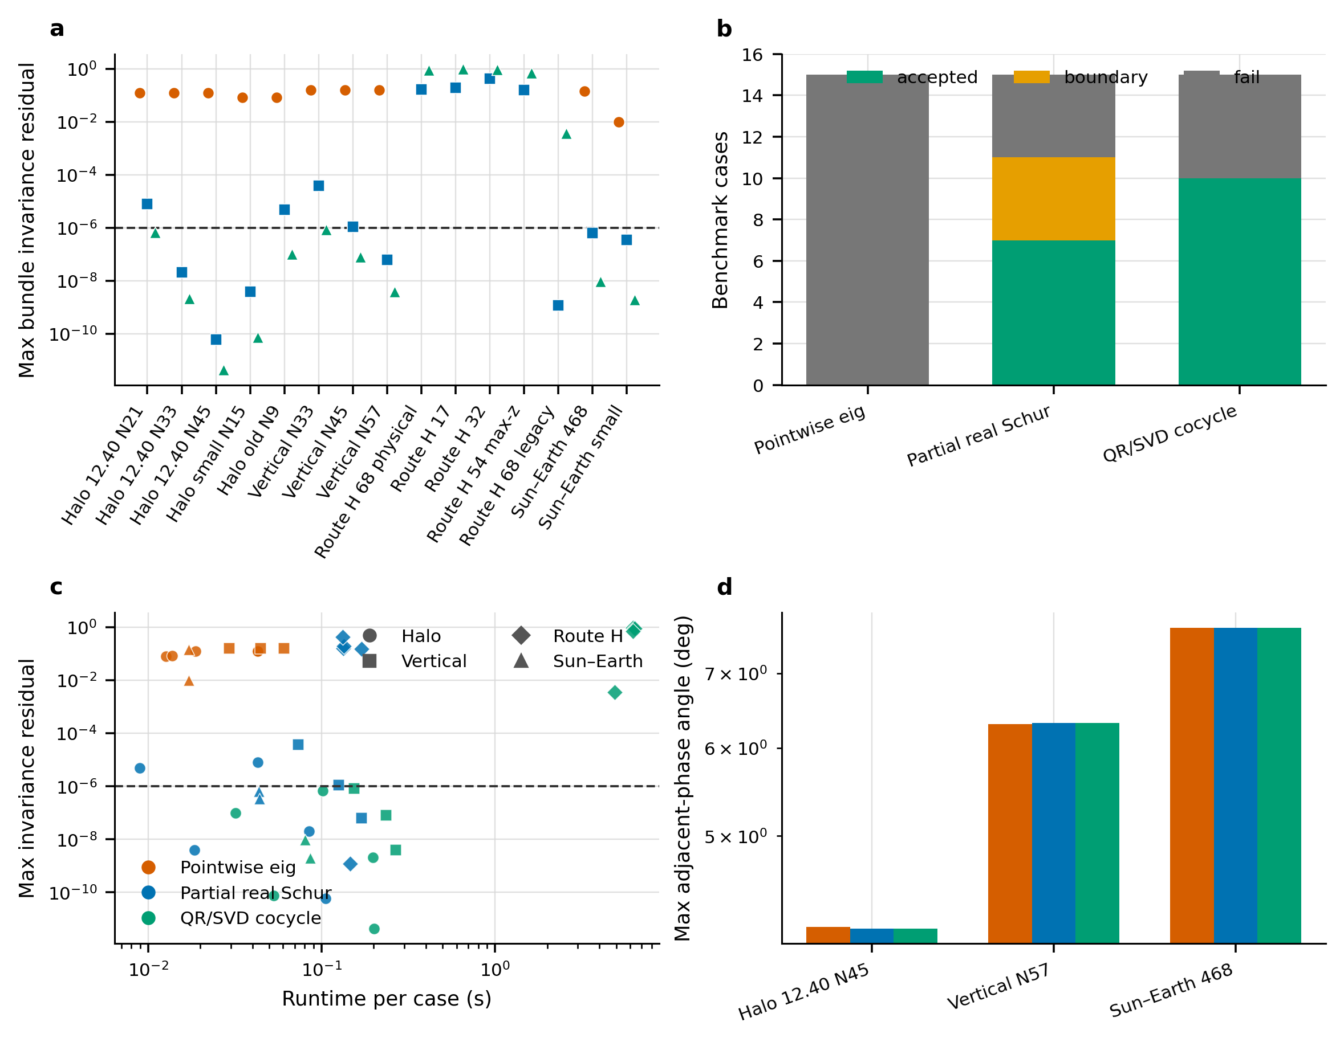
Method-level accepted, boundary, and failed outcomes
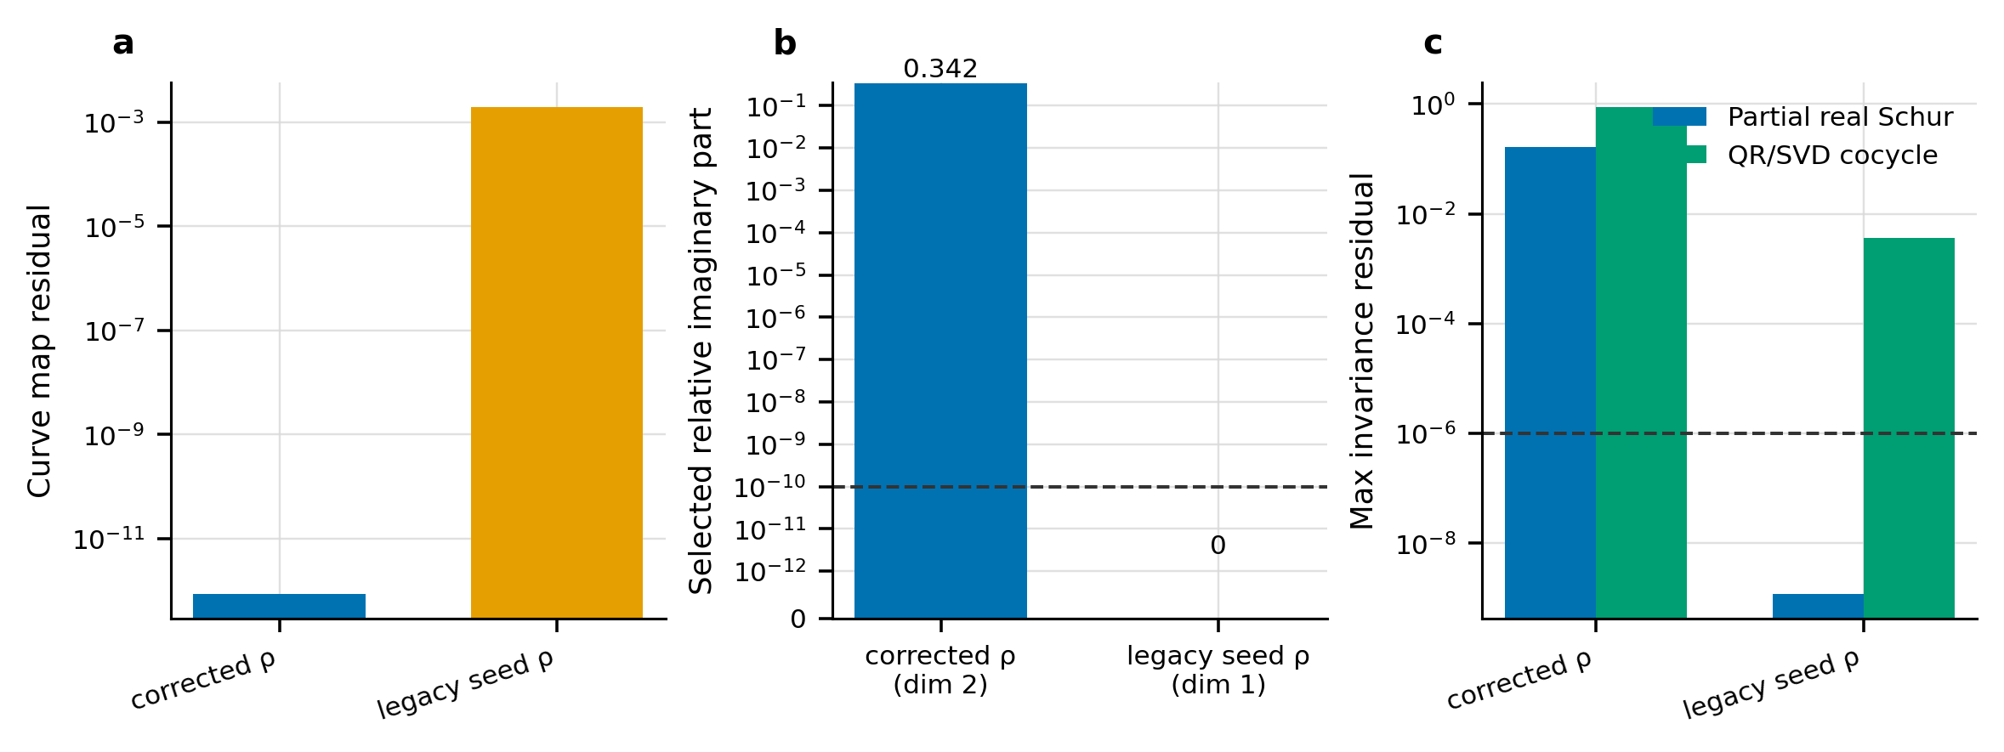
Route-H physical and legacy operator controls
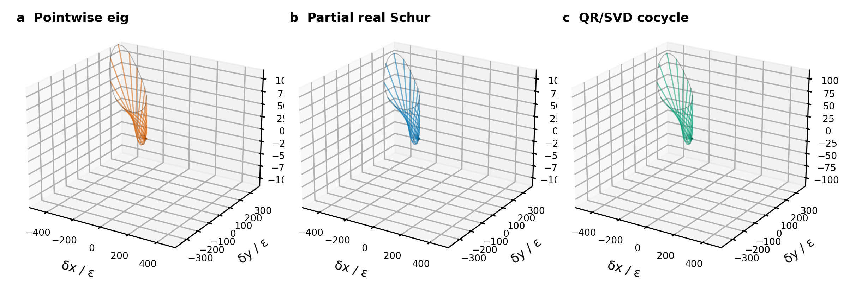
Representative manifold displacement sheets

13. Limitations
Stage H adds three stable-bundle campaigns, two rank-two Route-H manifold objects, three fixed three-period propagations, and three distinct local Sun–Earth source benchmarks. The supported scope is still bounded by the preregistered CR3BP cases, finite perturbations, a three-period horizon, and local source artifacts. There is no new convergence theorem, external solver replication, ephemeris-model validation, or target-journal assessment. The lower-resolution 0.01 manifold boundary and the frozen Chapter-4 0/4 projection holdout remain untouched.

14. Conclusion
The frozen evidence supports an auditable real invariant-bundle framework and systematic comparison. Across multiple Earth–Moon and Sun–Earth families, partial real-Schur and shifted QR/SVD methods repeatedly reduce cocycle residuals by many orders of magnitude relative to pointwise eigenselection and produce consistent high-resolution displacement sheets. The same workflow also exposes genuine negative results: Route-H physical corrected-rho cases do not yield an accepted one-dimensional bundle, and low-resolution sheets do not clear the retained convergence boundary. These failures and boundaries define the current scope of the contribution and prevent overclaiming. The completed Stage-H campaign upgrades the deliverable from an internal draft to an adviser submission-decision candidate, not to an externally authorized or venue-formatted submission.

15. Evidence map
- Registry and provenance: research/invariant_bundles/benchmarks/benchmark_registry.csv
- Method comparison: research/invariant_bundles/results/csv/method_comparison.csv
- Resolution comparison: research/invariant_bundles/results/csv/resolution_convergence.csv
- Manifold comparison: research/invariant_bundles/results/csv/manifold_convergence.csv
- Figures and hashes: research/invariant_bundles/figures/research_figure_manifest.csv
- Reproduction baseline: data/computed/reproduction_baseline_v1_summary.csv
- Detailed tables: tables.md
- Claim-by-claim traceability: claim_evidence_matrix.csv

