Overview
There is an out-of-bound write issue caused by integer overflow that can occur in function convert_8u32s_C1R()(openjpeg-2.1.2/src/bin/jp2/convert.c:368).
This issue can be caused by a malformed TIFF file.

Environments
lsb_release -a
No LSB modules are available.
Distributor ID: LinuxMint
Description: Linux Mint 18 Sarah
Release: 18
Codename: sarah

uname -a
Linux kirito-virtual-machine 4.4.0-21-generic #37-Ubuntu SMP Mon Apr 18 18:33:37 UTC 2016 x86_64 x86_64 x86_64 GNU/Linux

Compilers: gcc
gcc --version
gcc (Ubuntu 5.4.0-6ubuntu1~16.04.2) 5.4.0 20160609
Copyright (C) 2015 Free Software Foundation, Inc.
This is free software; see the source for copying conditions. There is NO
warranty; not even for MERCHANTABILITY or FITNESS FOR A PARTICULAR PURPOSE.

OpenJPEG-2.1.2

libtiff:
aptitude versions libtiff5-dev
Package libtiff5-dev:
i 4.0.6-1 xenial 500
Package libtiff5-dev:i386:
p 4.0.6-1 xenial 500

Exception
Use the PoC file with command “./opj_compress -i PoC -o /tmp/tmp.j2k”,where “opj_compress” is compiled by gcc with AddressSanitizer switch:
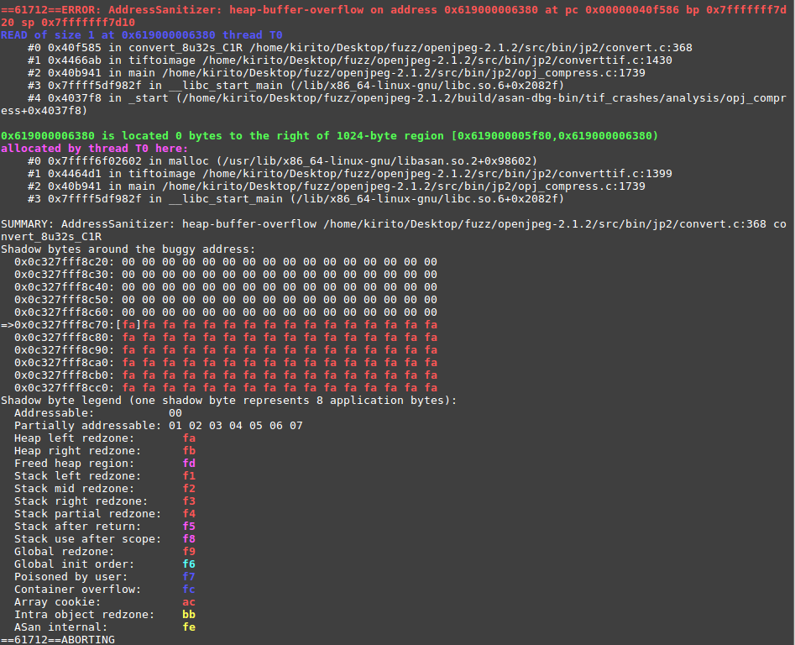

==61712==ERROR: AddressSanitizer: heap-buffer-overflow on address 0x619000006380 at pc 0x00000040f586 bp 0x7fffffff7d20 sp 0x7fffffff7d10
READ of size 1 at 0x619000006380 thread T0
#0 0x40f585 in convert_8u32s_C1R /home/kirito/Desktop/fuzz/openjpeg-2.1.2/src/bin/jp2/convert.c:368
#1 0x4466ab in tiftoimage /home/kirito/Desktop/fuzz/openjpeg-2.1.2/src/bin/jp2/converttif.c:1430
#2 0x40b941 in main /home/kirito/Desktop/fuzz/openjpeg-2.1.2/src/bin/jp2/opj_compress.c:1739
#3 0x7ffff5df982f in __libc_start_main (/lib/x86_64-linux-gnu/libc.so.6+0x2082f)
#4 0x4037f8 in _start (/home/kirito/Desktop/fuzz/openjpeg-2.1.2/build/asan-dbg-bin/tif_crashes/analysis/opj_compress+0x4037f8)

0x619000006380 is located 0 bytes to the right of 1024-byte region [0x619000005f80,0x619000006380)
allocated by thread T0 here:
#0 0x7ffff6f02602 in malloc (/usr/lib/x86_64-linux-gnu/libasan.so.2+0x98602)
#1 0x4464d1 in tiftoimage /home/kirito/Desktop/fuzz/openjpeg-2.1.2/src/bin/jp2/converttif.c:1399
#2 0x40b941 in main /home/kirito/Desktop/fuzz/openjpeg-2.1.2/src/bin/jp2/opj_compress.c:1739
#3 0x7ffff5df982f in __libc_start_main (/lib/x86_64-linux-gnu/libc.so.6+0x2082f)

SUMMARY: AddressSanitizer: heap-buffer-overflow /home/kirito/Desktop/fuzz/openjpeg-2.1.2/src/bin/jp2/convert.c:368 convert_8u32s_C1R
Shadow bytes around the buggy address:
0x0c327fff8c20: 00 00 00 00 00 00 00 00 00 00 00 00 00 00 00 00
0x0c327fff8c30: 00 00 00 00 00 00 00 00 00 00 00 00 00 00 00 00
0x0c327fff8c40: 00 00 00 00 00 00 00 00 00 00 00 00 00 00 00 00
0x0c327fff8c50: 00 00 00 00 00 00 00 00 00 00 00 00 00 00 00 00
0x0c327fff8c60: 00 00 00 00 00 00 00 00 00 00 00 00 00 00 00 00
=>0x0c327fff8c70:[fa]fa fa fa fa fa fa fa fa fa fa fa fa fa fa fa
0x0c327fff8c80: fa fa fa fa fa fa fa fa fa fa fa fa fa fa fa fa
0x0c327fff8c90: fa fa fa fa fa fa fa fa fa fa fa fa fa fa fa fa
0x0c327fff8ca0: fa fa fa fa fa fa fa fa fa fa fa fa fa fa fa fa
0x0c327fff8cb0: fa fa fa fa fa fa fa fa fa fa fa fa fa fa fa fa
0x0c327fff8cc0: fa fa fa fa fa fa fa fa fa fa fa fa fa fa fa fa
Shadow byte legend (one shadow byte represents 8 application bytes):
Addressable: 00
Partially addressable: 01 02 03 04 05 06 07
Heap left redzone: fa
Heap right redzone: fb
Freed heap region: fd
Stack left redzone: f1
Stack mid redzone: f2
Stack right redzone: f3
Stack partial redzone: f4
Stack after return: f5
Stack use after scope: f8
Global redzone: f9
Global init order: f6
Poisoned by user: f7
Container overflow: fc
Array cookie: ac
Intra object redzone: bb
ASan internal: fe
==61712==ABORTING

It is clearly that this is a heap-buffer-overflow vulnerability.

Analysis
I used gdb to debug this crash.This crash happens at function convert_8u32s_C1R()(openjpeg-2.1.2/src/bin/jp2/convert.c:368)
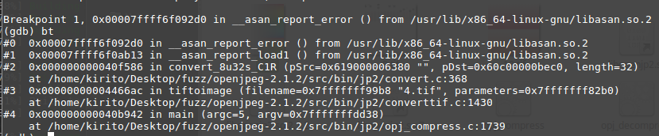
The source code is as follows:
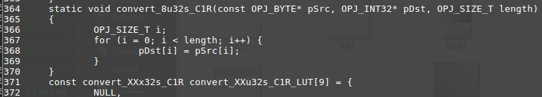

I can obtain the values with gdb:
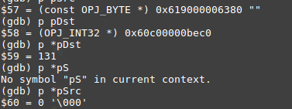
This crash happens when write to pDst with AddressSanitizer.
Then backtraced to the caller of function,
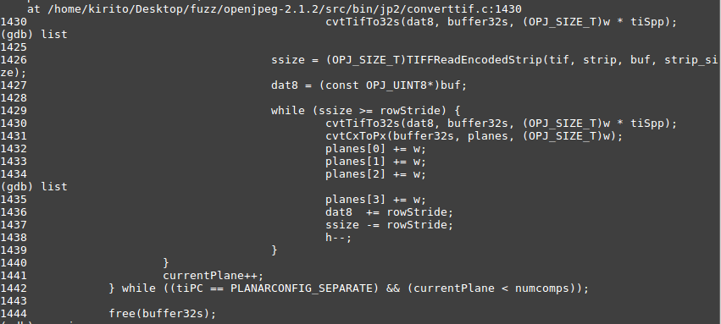
There are some varibles:
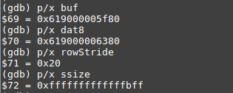
So, we can see something interesting. The pointer “dat8” changes 0x400 bytes until now, so we can calculate that the variable “ssize” at line:1426 is 0xffffffffffffffff, which is the biggest number in unsigned int64 but the -1 in signed int64. According to this content, we can infer this variable is unsigned int64.
But the condition expression is “ssize >= rowStride”,so the while loop will call the cvtTifTo32s() function over and over until some errors occur.

This vulnerable looks like a integer overflow, then I find some evidence from the source code.
openjpeg-2.1.2/src/bin/jp2/convertif.c:1426
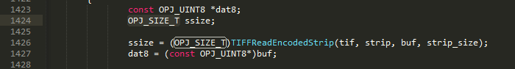
The type of ssize is “OPJ_SIZE_T”,
openjpeg-2.1.2/src/lib/openjp2/openjpeg.h:133
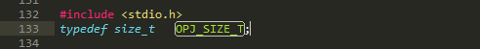
So, the type “size_t” is unsigned.

Then, I traced the result type of TIFFReadEncodedStrip() function:
openjpeg-2.1.2/thirdparty/libtiff/tiff_read.c:316
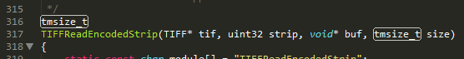
openjpeg-2.1.2/thirdparty/libtiff/tiffio.h:67
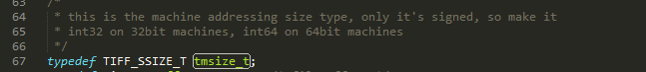
Openjpeg-2.1.2/thirdparty.libtiff/CMakeLists.txt:213
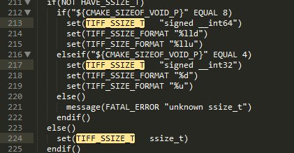
So it is clearly that this integer overflow occers at the openjpeg-2.1.2/src/bin/jp2/convertif.c:1426 .This code tranform the “tmsize_t(signed int)” to “OPL_SIZE_T(unsigned int)”,.

There are many line “return((tmsize_t)(-1));” in tif.read.c(), so if the input is crafted，then it can cause the heap-buffer-overflow.
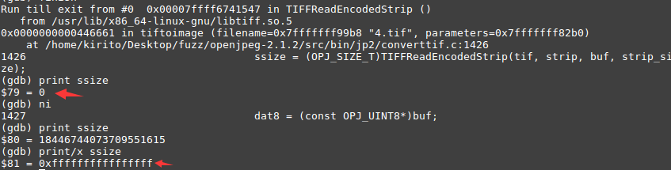

In this PoC, the second time of the loop in openjpeg-2.1.2/src/bin/jp2/convertif.c:1426 will trigger this vulnerability.

This loop call TIFFReadEncodedStrip() to get ssize. I debugged this function and found it return -1 at openjpeg-2.1.2/thirdparty/libtiff/tif_read.c:356, then caused the crash.
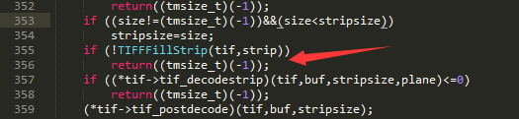
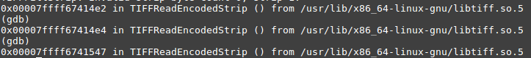
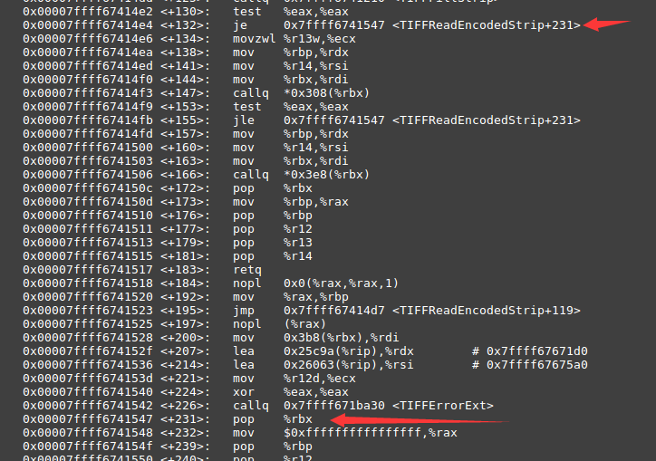

Then， I debugged TIFFFillStrip() and found it returned 0 at openjpeg-2.1.2/thirdparty/libtiff/tif_read.c:508, the condition expression !TIFFFillStrip() in TIFFReadEncodedStrip() is true, so it returns -1(0xffffffffffffffff in unsigned int64)



