Requirements:

Python 3.9.7, pcapy, impacket, zmq, ipwhois, pygame, netifaces, pyproj, pygeoip, kivy

Create new conda environment:

conda create --name myenv

Replace myenv with the environment name

Activate myenv:

conda activate myenv

Install python 3.9.7 within new environment:

conda install python=3.9.7

Install dependencies:

sudo pip install pcapy impacket zmq ipwhois pygame netifaces pyproj pygeoip kivy

Errors:

1. You don't have permission to capture on that device ((cannot open BPF device) /dev/bpf0: Permission denied):

Under

.vscode

{} launch.json

"configurations": [

{

"name": "Python: Current File",

"type": "python",

"request": "launch",

"program": "${file}",

"console": "integratedTerminal",

"cwd": "${workspaceFolder}/source",

"sudo": true

Add “cwd” and “sudo” line.

Use touch bar to run the file instead of the button in VS GUI

2. 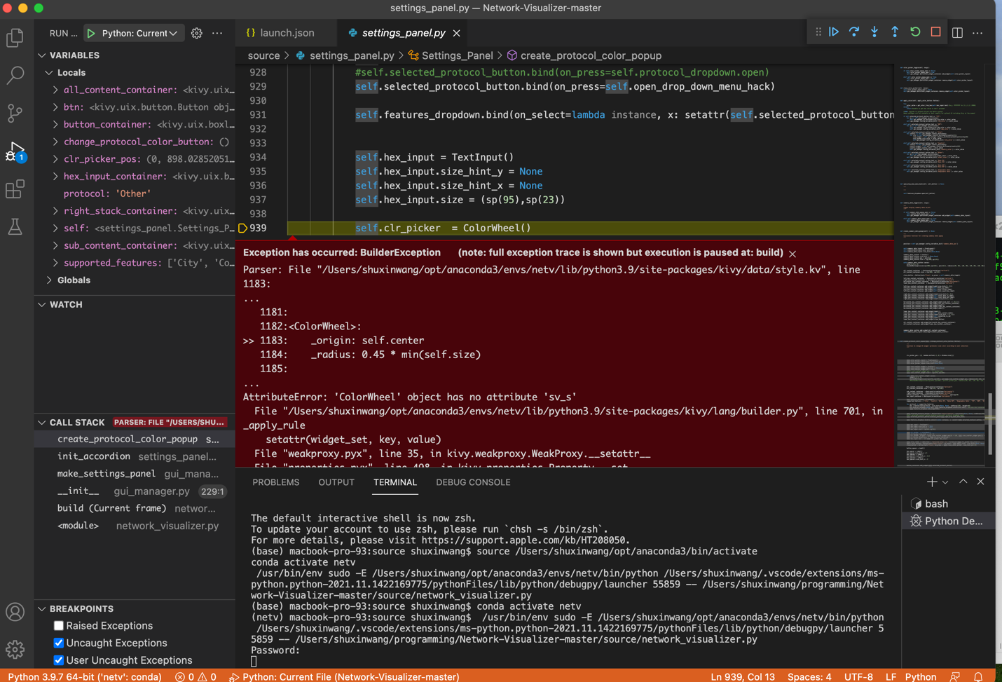

Comment out _origin, _radius within colorwheel in style.kv file.

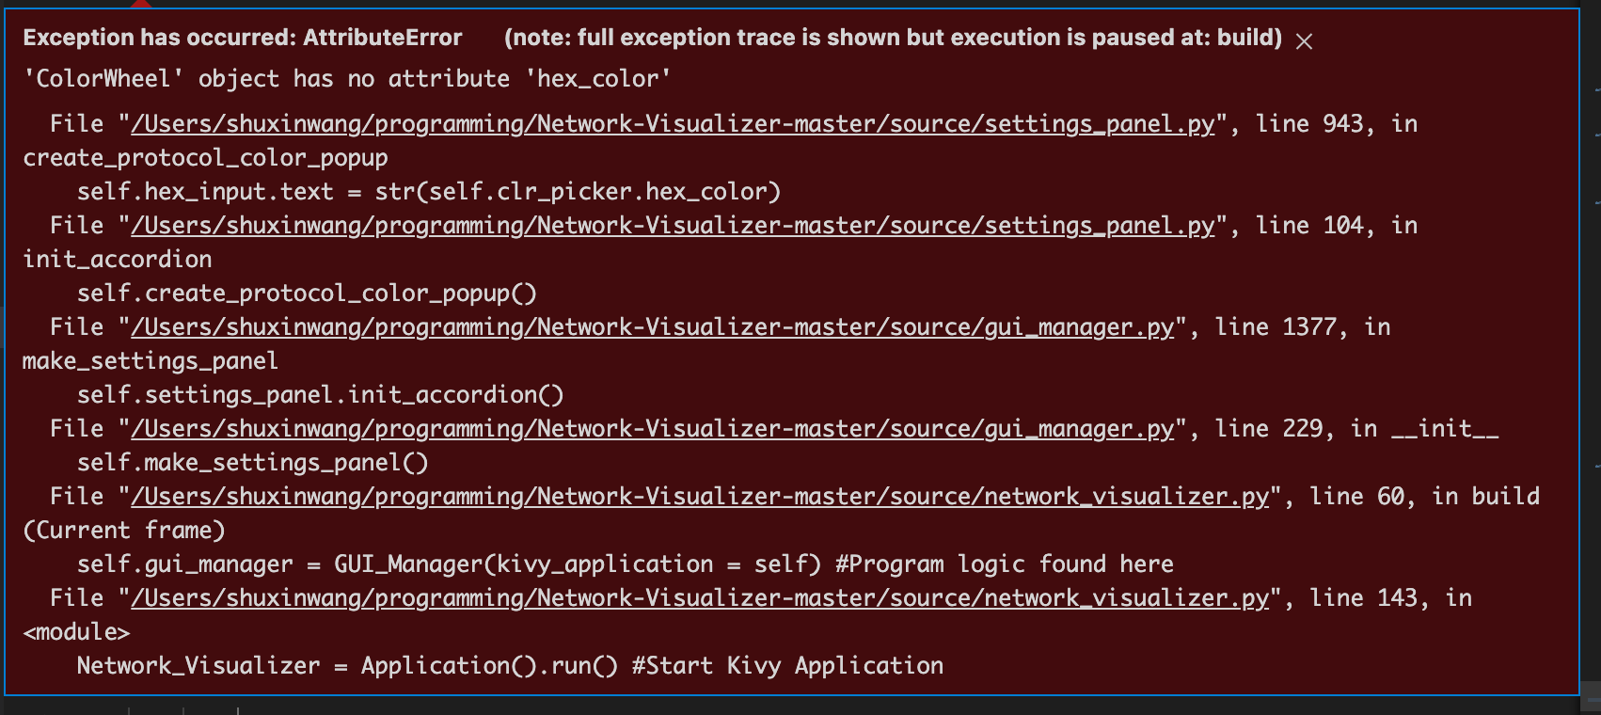

Replace colorpicker.py within kivy packages.

Find the directory for kivy package and replace colorpicker.py, should be something like this:

users/shuxinwang/opt/anaconda3/envs/netv/lib/python3.9/site-packages/kivy/uix

3. gui_manager.py line221:

get_mac() function only get the first interface IP address. Fix that.