**webapi接口接入文档**

**V1.0**

**科大讯飞股份有限公司**

**iFLYTEK CO., LTD.**

变更历史

|  |  |  |  |
| --- | --- | --- | --- |
| **版本** | **变更说明** | **作者** | **日期** |
| V0.1 | 创建文档 | jlchen4 | 2017.9 |

变更历史 1

1 简介 3

2 接入步骤 3

2.1 aiui开放平台创建webapi应用 3

2.2 得到APPID和ApiKey 3

2.3 添加ip白名单 4

2.4 配置相关技能 4

2.5 参考demo编写代码 4

2.6 Java示例详解 4

# 1 简介

本文档旨在帮助开发者快速接入webapi接口

# 2 接入步骤



## aiui开放平台创建webapi应用

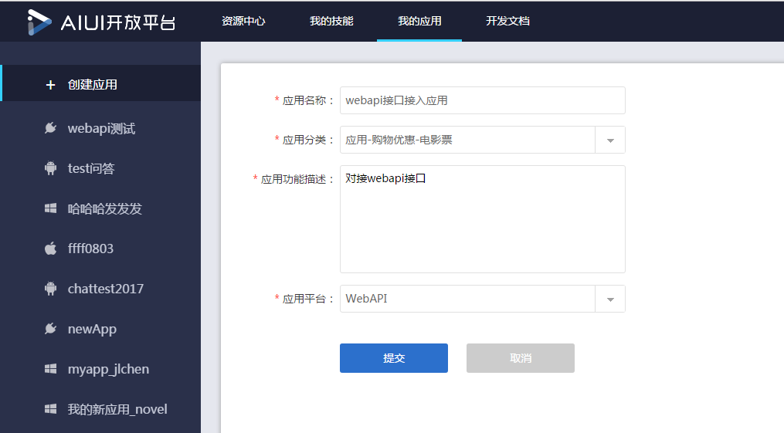

## 得到APPID和ApiKey

APPID和ApiKey如下图

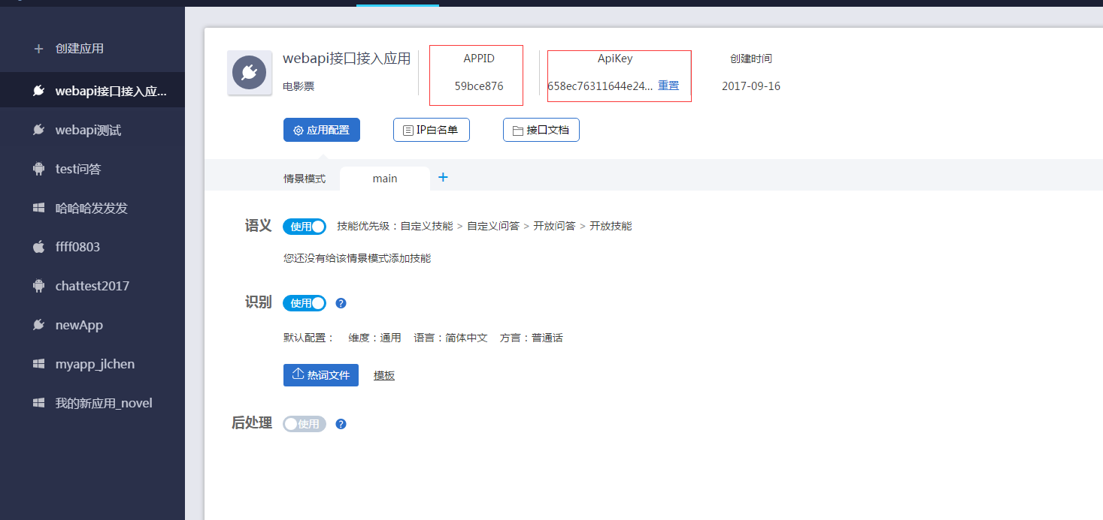

## 添加ip白名单

ip白名单为调用webapi接口服务器外网ip,请务必配置正确。

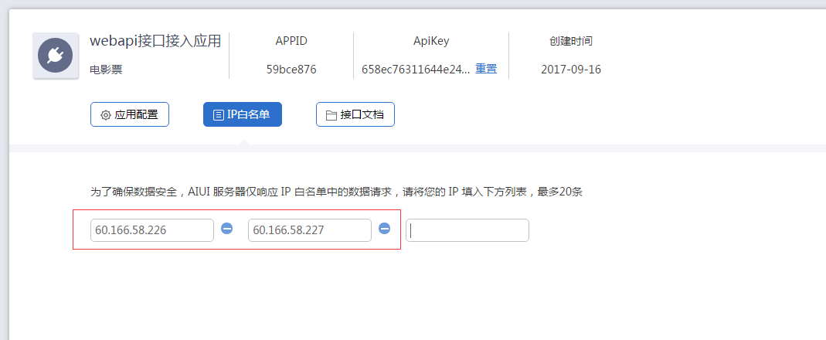

## 配置相关技能

调用文本语义、语音语义接口时，请根据需要配置相关技能。详细步骤可参考文档地址

<http://aiui.xfyun.cn/info/guide>

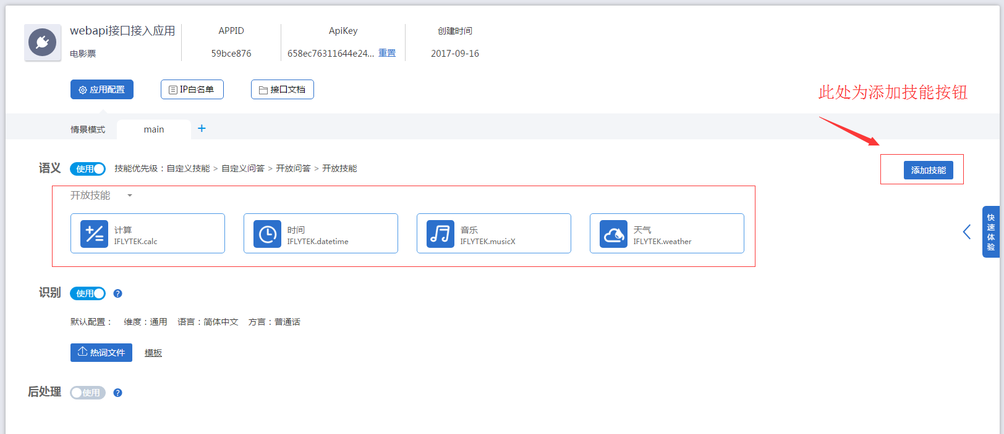

## 参考demo编写代码

webapi示例代码地址

<https://github.com/IflytekAIUI/DemoCode/>

## Java示例详解

package com.iflytek.voicecloud.jupiter.platform.common;

import java.io.BufferedReader;

import java.io.File;

import java.io.FileInputStream;

import java.io.IOException;

import java.io.InputStream;

import java.io.InputStreamReader;

import java.io.PrintWriter;

import java.io.UnsupportedEncodingException;

import java.net.HttpURLConnection;

import java.net.URL;

import java.security.MessageDigest;

import org.apache.commons.codec.binary.Base64;

import org.apache.commons.io.IOUtils;

import org.slf4j.Logger;

import org.slf4j.LoggerFactory;

public class Iat {

private static Logger logger = LoggerFactory.getLogger(Iat.class);

private final static String[] hexDigits = { "0", "1", "2", "3", "4", "5",

"6", "7", "8", "9", "a", "b", "c", "d", "e", "f" };

public static void main(String[] args) {

//讯飞开放平台注册申请应用的应用ID(APPID)

String xAppid = "xxxxxxxx";

System.out.println("X-Appid:" + xAppid);

long time = System.currentTimeMillis() / 1000;

//得到当前UTC时间戳

String curTime = String.valueOf(time);

System.out.println("X-CurTime:" + curTime);

//标准JSON格式参数

String xParam = "{\"auf\":\"16k\",\"aue\":\"raw\",\"scene\":\"main\"}";

String xParamBase64 = getBase64(xParam);

System.out.println("X-Param:" + xParamBase64);

//音频文件

File file = new File("F:/16k.pcm");

String fileData = null;

try {

InputStream is = new FileInputStream(file);

byte[] bytes = IOUtils.toByteArray(is);

//Base64编码

fileData = Base64.encodeBase64String(bytes);

} catch (Exception e) {

e.printStackTrace();

}

fileData = "data=" + fileData;

//ApiKey创建应用时自动生成

String apiKey = "xxxxxxxxxxxxxxxxxxxxxxxxxxxxxxxxx";

String token = apiKey + curTime + xParamBase64 + fileData;

//md5得到X-CheckSum

String xCheckSum = md5Encode(token);

System.out.println("X-CheckSum:" + xCheckSum);

String resBody = "";

PrintWriter out = null;

BufferedReader in = null;

try {

String url = "https://api.xfyun.cn/v1/aiui/v1/iat";

URL realUrl = new URL(url);

// 打开和URL之间的连接

HttpURLConnection conn = (HttpURLConnection) realUrl

.openConnection();

conn.setReadTimeout(2000);

conn.setConnectTimeout(1000);

conn.setRequestMethod("POST");

// 发送POST请求必须设置如下两行

conn.setDoOutput(true);

conn.setDoInput(true);

conn.setRequestProperty("X-Appid", xAppid);

conn.setRequestProperty("X-CurTime", curTime);

conn.setRequestProperty("X-Param", xParamBase64);

conn.setRequestProperty("X-CheckSum", xCheckSum);

conn.setRequestProperty("Connection", "keep-alive");

conn.setRequestProperty("Content-type",

"application/x-www-form-urlencoded; charset=utf-8");

// 获取URLConnection对象对应的输出流

out = new PrintWriter(conn.getOutputStream());

// 发送请求参数

out.print(fileData);

// flush输出流的缓冲

out.flush();

// 定义BufferedReader输入流来读取URL的响应

// 将返回的输入流转换成字符串

InputStream inputStream = conn.getInputStream();

InputStreamReader inputStreamReader = new InputStreamReader(

inputStream, "utf-8");

in = new BufferedReader(inputStreamReader);

String line;

while ((line = in.readLine()) != null) {

resBody += line;

}

System.out.println("result body :" + resBody);

} catch (Exception e) {

e.printStackTrace();

} finally {

try {

if (out != null) {

out.close();

}

if (in != null) {

in.close();

}

} catch (IOException ex) {

ex.printStackTrace();

}

}

}

/**

* Base64加密

* @author jlchen4

* @date 2017年9月16日 下午3:45:30

* @param str 加密字符串

* @return

*/

public static String getBase64(String str) {

if (str == null || "".equals(str)) {

return "";

}

try {

byte[] encodeBase64 = Base64.encodeBase64(str.getBytes("UTF-8"));

str = new String(encodeBase64);

} catch (UnsupportedEncodingException e) {

e.printStackTrace();

}

return str;

}

/**

* md5加密

* @author jlchen4

* @date 2017年9月16日 下午3:44:46

* @param source 加密字符串

* @return

*/

public static String md5Encode(String source) {

String result = null;

try {

result = source;

// 获得MD5摘要对象

MessageDigest messageDigest = MessageDigest.getInstance("MD5");

// 使用指定的字节数组更新摘要信息

messageDigest.update(result.getBytes("utf-8"));

// messageDigest.digest()获得16位长度

result = byteArrayToHexString(messageDigest.digest());

} catch (Exception e) {

logger.error("Md5 Exception!", e);

}

return result;

}

private static String byteArrayToHexString(byte[] bytes) {

StringBuilder stringBuilder = new StringBuilder();

for (byte tem : bytes) {

stringBuilder.append(byteToHexString(tem));

}

return stringBuilder.toString();

}

private static String byteToHexString(byte b) {

int n = b;

if (n < 0) {

n = 256 + n;

}

int d1 = n / 16;

int d2 = n % 16;

return hexDigits[d1] + hexDigits[d2];

}

}