Content Provider Integration eHUB – Required Information
This document lists the information that Axiell R&D needs from a new e-media content provider to integrate it with the eHUB and then test the implementation.

Requirements for development
Axiell R&D needs the following to be able to start the development.
- Contact person
Name of and contact information to contact person from e-media content provider.
- API documentation etc.
Any information available to make it possible to integrate the new e-media content provider. This information varies between e-media content providers. We would like
- API documentation,
- any other documentation of interest,
- the address to an administration interface where to manage settings and rules, if applicable (including login information),
- or other similar information.
- Parameter information
Detailed information about different parameters for the e-media content provider. The parameters differ between e-media content providers; below is an example for Overdrive.
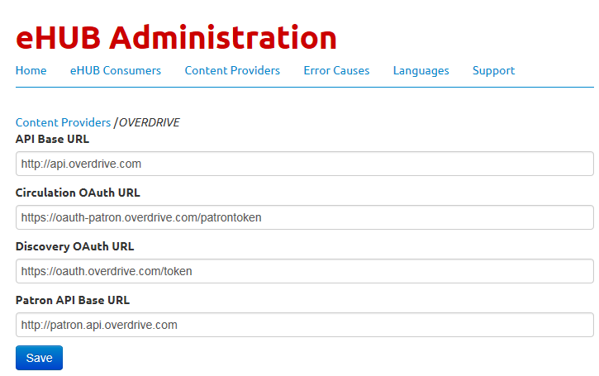
- Formats
A list of the supported formats for the e-media content provider.
Below is an example for Overdrive.
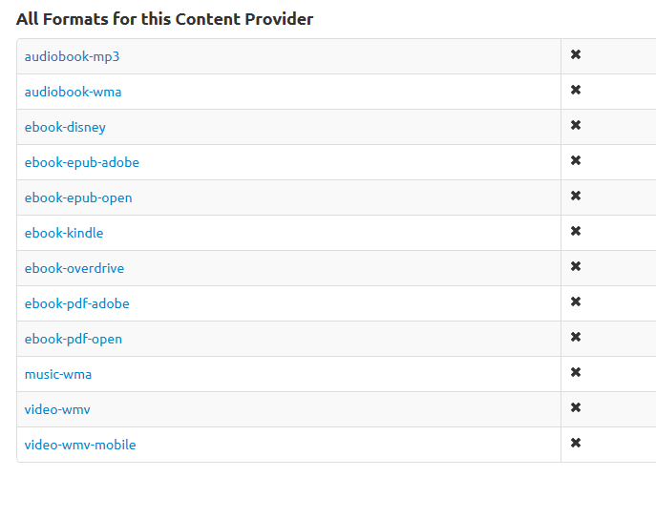

Requirements for testing
Axiell R&D needs the following to be able to test the implementation:
- Information about test environment
How can we access the e-media content provider environment for testing? This can be a test environment or the test can be done directly against a production environment. Is there any special procedure that we need to know of during testing, for example, removal of loans?
- Information about consumers
Detailed information about different parameters for the e-media content provider’s consumers. This information is needed to be able to connect Arena test environment to the e-media content provider’s consumers. Below is an example for Overdrive.
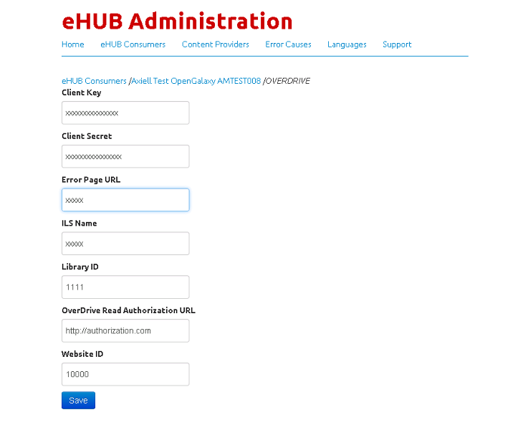

- Borrowers
- Borrowers that should be able to borrow e-media
A list of borrowers for the current Arena test environment that can borrow e-media. These borrowers should also be available in the backend system that is connected to the current Arena test environment. These borrowers should automatically be able to loan an e-media item. This means that it should not be any requirement to manually register borrowers at the content provider site when testing eHUB through Arena.
- Borrowers that should not be able to borrow e-media
We also need a list of borrowers that should not be able to download e-media.
- Index for the supported formats
Depends on the formats that the e-media content provider supports; an index file for the e-media that is available at the e-media content provider and in the backend.
If the e-media content provider supports both e-book and e-audio, we need available index existing at the e-media content provider and in the backend (that is connected to the current Arena test environment), both for e-book and for e-audio. For example, if the content provider is Overdrive, with supported formats e-audio and e-book then the e-audio and e-books that are available at Overdrive should also be available in the backend that is going to be use for testing. If Arena test environment is connected to OG backend Saker, then e-audio and e-books need to be available in Overdrive and Saker. For testing of the entire flow, Axiell Arena needs the list of the record ID:s for e-audio and e-books that are available in Overdrive and in Saker. In the following table you can see information that is good to have when testing.
Content Provider Name | Format | ContentProviderRecordId | Record Id | ISBN | Author | Title
Overdrive | e-Book | 9780312870676 | 1407402196 | 9781407402192 | Arnott, Jake. | Long firm
Overdrive | e-Audio | 9781449890698 | 140740220X | 9781407402208 | Bonavero, Yves. | Something in the sea

