# Cover Page

# 

# Table of Contents

# Introduction

### Objective

### Controls

**W**

**A**

**S**

**D**

**Q**

**E**

**X**

**C**

**F**

**SPACE**

**Tab**

# Game feature description

**The Missile Intercept**

**For normal sidewinder missiles, the method for target tracking is done with infrared sensor and proportional navigation where if two moving objects remain on a constant bearing and appear to be getting closer then they will collide.**

**The approach I wanted to take with my algorithm was to use radar instead of infrared. The radar system employed is the same as that used with aircraft and is described later on.**

**Researching a method for target interception was initially difficult as a lot of the information was heavily mathematical and thesis based and well beyond anything I wanted to implement at this stage.**

**I did in the end come across an excellently described method that allowed predicting an interception in 2D based on targets known velocity and a missile with a known top speed.**

***[ Source:*** [*http://jaran.de/goodbits/2011/07/17/calculating-an-intercept-course-to-a-target-with-constant-direction-and-velocity-in-a-2-dimensional-plane/#respond*](http://jaran.de/goodbits/2011/07/17/calculating-an-intercept-course-to-a-target-with-constant-direction-and-velocity-in-a-2-dimensional-plane/#respond) *]*

I

Target

Intercept Vector

Missile Base

Target velocity

Origin

We know the missiles top speed

**The theory works based on the fact that the Intercept vector is common for both the missile and the target.**

**I target = Target + (time * Target velocity)**

**I missile = Missile Base + (time * Missile velocity)**

**What we know**

* **Targets position can be discovered**
* **Targets velocity can be measured**
* **The missiles position is known**
* **The missiles velocity is known**

**What is not known is the time but can be discovered because**

**I target = I missile**

**Put maths here**

**The radar system**

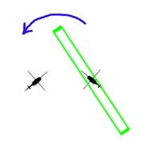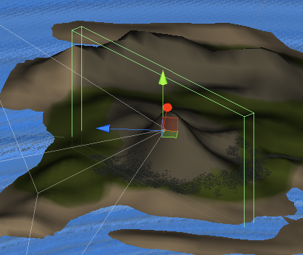

The player/owner craft sweeps the area with a bounding box.  This meant to represent a radar sweep of the area.

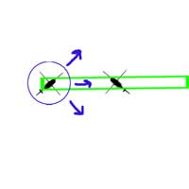

If the sweep collides with another craft, that craft spawns a bounding sphere that will continue to expand until it expires.  This is to represent the ping back.

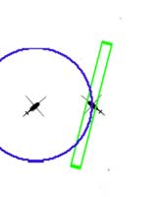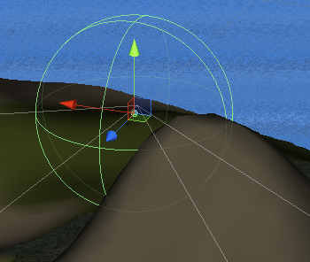

Once the owner/player craft receives the ping they begin to log the origin and signature of the received ping and from this the tracking process can begin.

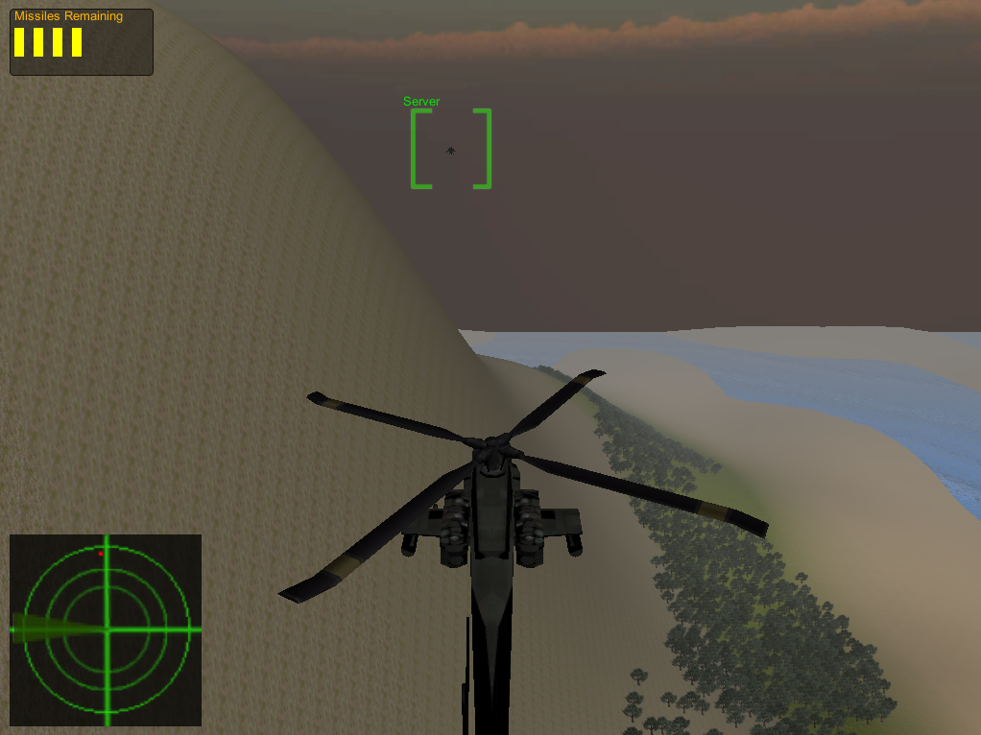

Figure Players Radar HUD System

**The Multiplayer**

Originally I had intended to use AI in the game to create enemy objectives. But having spent more time than intended getting the radar and missile algorithm in place I felt I wouldn’t have had sufficient time to put in place a decent AI system.

As an alternative I decided to try using Unity’s multiplayer features to create the enemy or objectives.

*Unity’s Master Server*

While Unity provided a full API for everything needed to use multiplayer. It was probably the hardest of all Unity’s features to research on the internet. But a came a across a good video that gave me enough to get off the ground using Unity’s free to use testing master server to register and discover games. The master server is a remote server run by unity for testing that acts as a database for storing game names, IP addresses and ports so that they can be easily discovered. Unity uses a server / client approach to multiplayer where a game will register themselves as a server and all other games will join that server as a client. From following the video tutorial I didn’t change much with how tutorial demonstrated how to register or obtained hosts as it worked - no need to change it. [ Source <http://cgcookie.com/unity/2011/12/20/introduction-to-networking-in-unity/> ]

The real work came about handling the many players and working out where certain logic takes place and doesn’t need to be propagated across the network taking up bandwidth and processing time. An example of this is where does the radar sweep take place? In reality it happens simultaneously for both player and target but in a network simulation it only needs to take place on the local machine of the player. Having it happen on two machines at the same time is wasteful and could lead to conflicts in information similar to what can happen when using threads.

*LAN game discovery*

While it was great to be able to access the master server for registering games I wasn’t satisfied with this being the only approach to register and discover games mainly because it relies on internet connectivity and firewall access.

With Unity’s networking API it is very easy to simply plug in an IP address and port number and create a connection. But the issue is how to discover what game is available and what is the IP and port number for the server hosting that game.

To do this I followed a simple tutorial on UDP multicast where it demonstrated two applications where one was a listener and the other was the sender and it would simply send a list of numbers and the listener would read and decode the messages. UDP was perfect in this case for my game as it is connectionless.

To make it work in the game I had to employ threading as I needed two processes to run simultaneously. I needed to set up a listener

# Works used in accomplishing this project

Algorithm for finding the thing,

Unity networking tutorial

UDP multicasting

Unity Detonator pack (avail and free to use from the unity asset store

the models = Blend swap CC Zero

# Originality Statement

add and sign

# Weekly project forms

Issues faced

**Unit testing**

One of the biggest issues faced surrounded the fact that unity classes than inherit from monobehaviour cannot be instantiated as the “new” keyword is not supported. This made testing difficult and in some cases impossible. A solution I proposed and tried was to abstract as much behaviours and states and put them in a concrete class which my base monobehaviour class could then instantiate. Having a concrete class meant that it would be possible to create unit tests. Unfortunately a lot of features used in my application made use of monobehaviour and put them out of the scope of being tested completely. Examples being the networking and Radar systems developed in the application.

**Version Control**

Unity has made the use version control difficult when it comes to their indie package making it very difficult to collaborating on assets. The issue surrounds the fact that all assets are stored as binaries so when it comes to version control it is impossible for the VC system to distinguish who made what changes and will only overwrite the previous change. With careful management it is possible to work together having specific rules on who can work on what.

Unity pro is required to force text so full version control is possible. However for the indie package they introduced meta files that are stored alongside each file allowing the version control system know that are changes.

For my project I chose to use GIT for version control and GitHub for my offsite storage server. I went for GIT over the others for no particular reason other than I was curious to try it out. What I liked about it over the others is how it creates snap shots rather than versioning individual files. Also I like the fact it is distributed meaning it possible to work locally and commit changes without the need for internet/network connectivity and changes could be later pushed to the server. What this also meant is that it is possible in the event of a failure be it the local machine or the server that it would be completely restore the repository based on which ever repository is still intact.

Something to note in creating a git repository for a Unity project is the ignore file (basically which files are not to be versioned). The following is a sample from my ignore file:

[Ll]ibrary/

[Tt]emp/

[Oo]bj/

Standard Assets/

The first three are the most important and should not be versioned as the files contained within can cause all sort of conflicts if working from different machines, this was an issue I encountered recently when trying to used DropBox for a different project and because these files were present and the files updated out of sync meaning that one of my assets completely disappeared even though it was working perfectly when I saved and closed the application.

Regardless these files will be regenerated on whatever machine the project will be opened on again when checked out.

**Integrated Development Environment**

(Source control, Mono (crashing) and Visual studio, testing, importing projects, RegisterHost FPS drop, Multicasting Vbox issue)

# Class Diagram

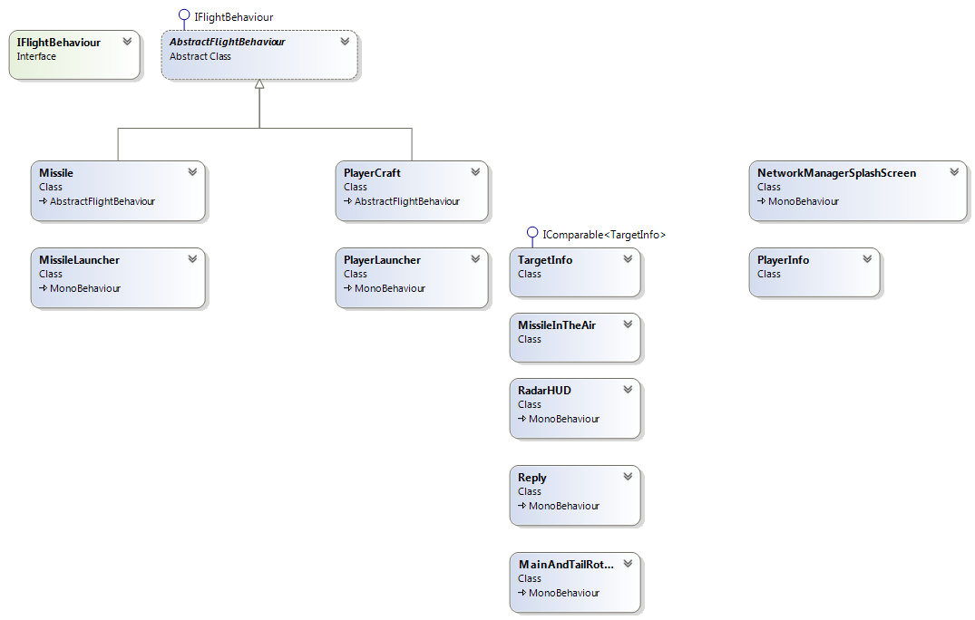

# The Code

# Screenies





