RFA 15: MOXSI Abundance Diagnostics in Active Regions
Will Barnes
Albert Shih
Jake Parker
2025-01-29

Summary
- number: 15
- type: RFA
- category: Instrument systems
- name: SNR Calculations

Request
Provide SNR calculations for full wavelength range for AR case. Demonstrate the abundance sensitivity.

Comment
The SNR looked quite low for the portion of the detector shown for the AR case. Please demonstrate you have adequate SNR for abundance calculations.

Selecting Line Pairs for Abundance Diagnostics
- Low-FIP elements: enhanced at coronal abundances
- High-FIP elements: little change from coronal to photospheric abundances
- Goal: Estimate abundances by measuring ratios of high- and low-FIP lines
- Requires:
  - Pairs of high- and low-FIP lines
  - With overlapping thermal sensitivity
  - That are sufficiently strong and
  - Have minimal blends
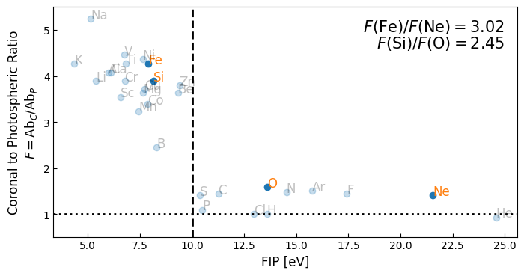
Coronal-to-photospheric abundance ratio or FIP ratio as function for first ionization potential (FIP) for all elements in CHIANTI.

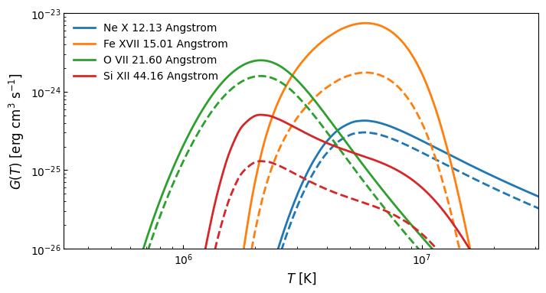
Contribution functions for the four selected diagnostic lines. These four lines represent pairs of high- and low-FIP elements with overlapping thermal sensitivity. The solid lines denote coronal abundances and the dashed lines denote photospheric abundances.
To illustrate the usefulness of these line pairs, we can look at the ratios between these contribution functions at the relevant temperatures.
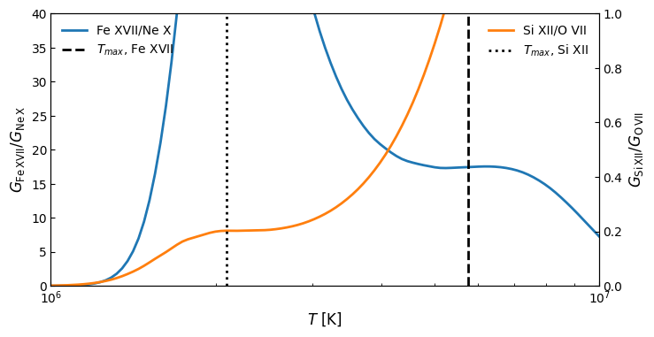
Contribution function ratios for the two line ratio diagnostics: Fe XVII 15.01 Å/Ne X 12.13 Å (‘hot’) and O VII 21.60 Å/Si XII 44.16 Å (‘cool’). The dashed and dotted lines denote the temperatures at which the pairs of contributions functions are at their maximum. Note that the ratios are most flat near these temperatures.

Estimating Line Intensities as Observed by MOXSI
We can compute the intensities first using an estimate of our active region DEM combined with our knowledge of the effective area and the contribution functions we’ve computed above.
Estimates of MOXSI throughput for relevant spectral lines
Ion | Wavelength [Å] | Coronal [ph] | Photospheric [ph]
Ne 10 | 12.1321 | 123.492 | 87.4259
Fe 17 | 15.0129 | 2042.7 | 478.855
O 7 | 21.601 | 1123.45 | 708.85
Si 12 | 44.16 | 561.971 | 144.449
We note that from these modeled intensity estimates we recovered the expected FIP ratios for both line pairs.
table[1][2] / table[0][2] / (table[1][3] / table[0][3])
array([3.01995172])
table[3][2] / table[2][2] / (table[3][3] / table[2][3])
array([2.45470892])

Estimating Intensity Ratios from MOXSI Forward Model
Next, we can compute the intensity ratios from our forward modeled spectra. We model the spectra of individual elements so as to better illustrate how particular ions are observed by MOXSI without the contamination of the continuum.
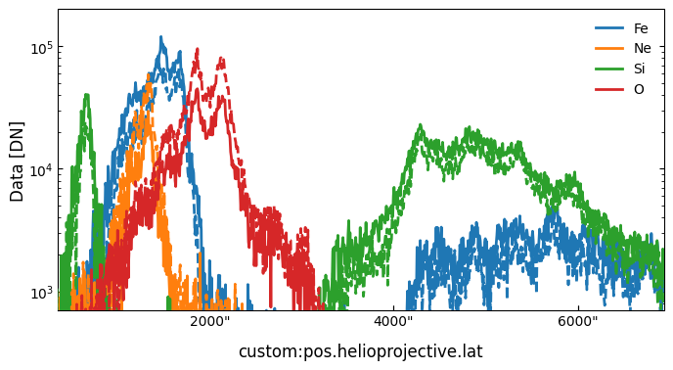
Modeled MOXSI spectra from an active region for the four elements of interest in the abundance ratio. The solid line shows the photospheric intensities and the solid line shows the coronal intensities.
The intensity ratio
$$\frac{F\left(\text{Fe}\right)}{F\left(\text{Ne}\right)}=\frac{I_{C}\left(\text{Fe XVII 15.01 Å}\right)}{I_{C}\left(\text{Ne X 12.13 Å}\right)}\frac{I_{P}\left(\text{Ne X 12.13 Å}\right)}{I_{P}\left(\text{Fe XVII 15.01 Å}\right)}$$
can then be computed from our forward-modeled spectra.
(intensity_coronal_fe17 / intensity_coronal_ne10) / (intensity_photospheric_fe17 / intensity_photospheric_ne10)
$4.4282927$
Similarly, the intensity ratio
$$\frac{F\left(\text{Si}\right)}{F(\text{O)}}=\frac{I_{C}\left(\text{Si XII 44.16 Å}\right)}{I_{C}\left(\text{O VII 21.601 Å}\right)}\frac{I_{P}\left(\text{O VII 21.601 Å}\right)}{I_{P}\left(\text{Si XII 44.16 Å}\right)}$$
can also be computed.
(intensity_coronal_si12 / intensity_coronal_o7) / (intensity_photospheric_si12 / intensity_photospheric_o7)
$2.6533907$
We find that ratios of our forward modeled MOXSI spectra at the locations of our diagostic lines for coronal and photospheric abundances are consistent with those theoretical ratios, particularly for the cool Si/O pair. This indicates that these lines, as measured by MOXSI, have significant diagnostic power to measure changes in abundance at both hot and cool temperatures.
We note that the Fe/Ne pair is higher than the expected theoretical result. This is likely due to the uncertainty in the line location due to the spatially-extended nature of the active region and the variable location of the hot emission within that spatial region.

Estimating SNR in Key Diagnostic Lines
Finally, to estimate SNR in each line we require for abundance diagnsotics, we extract the intensity of each line by fitting a Lorentzian plus background at each line location in our full forward-modeled MOXSI spectra. We then use the resulting intensity (above the background) combined with the uncertainty of the fit to estimate a signal-to-noise ratio (SNR) for each diagnostic line.
First, determine an approximate initial model by fitting the zeroth order “spectra”. Note that this effectively determines the spatial location and width of the active region as rebinned onto the dispersion axis.
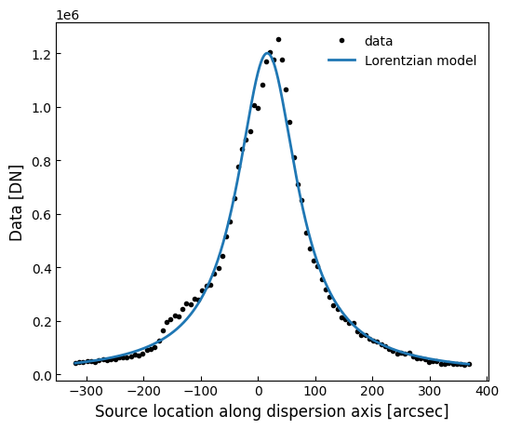
We note that this spectra is modeled in photon space using an integration time of 1 h, incorporating effects due to the PSF with an accompanying 30 arcsecond pointing jitter. The effect of charge spreading is not included for this particular model.
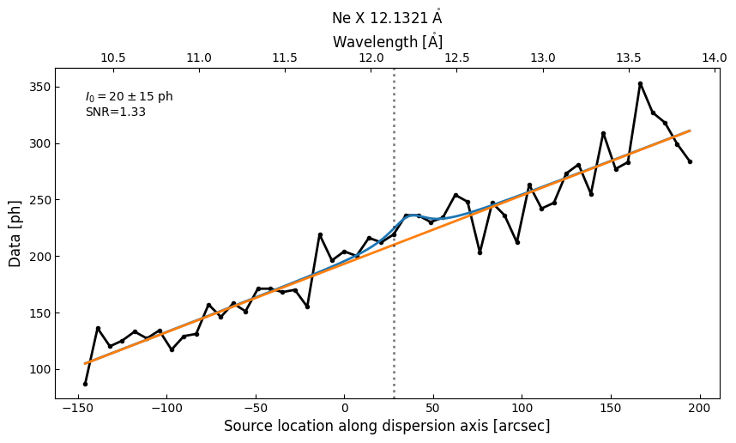
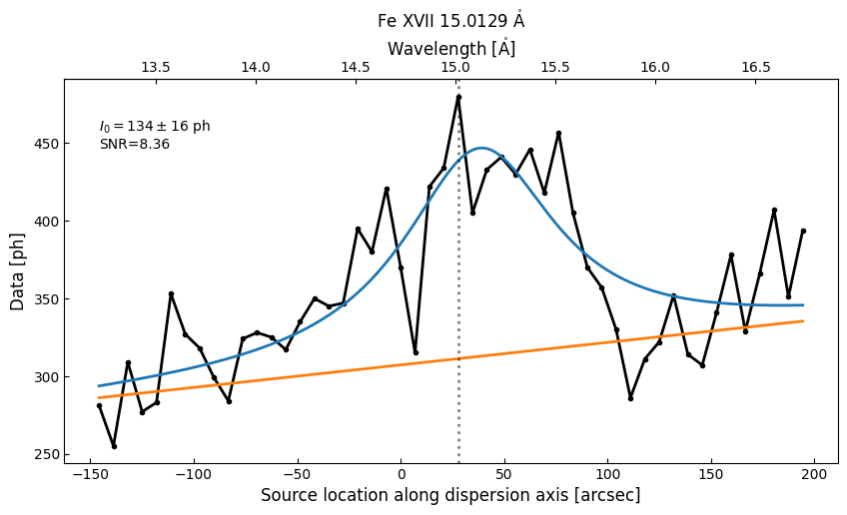
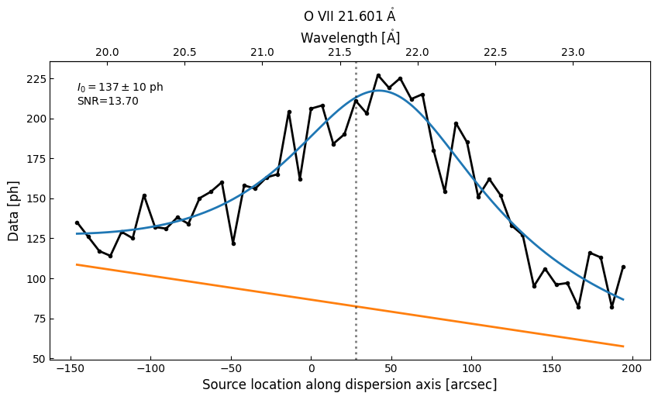
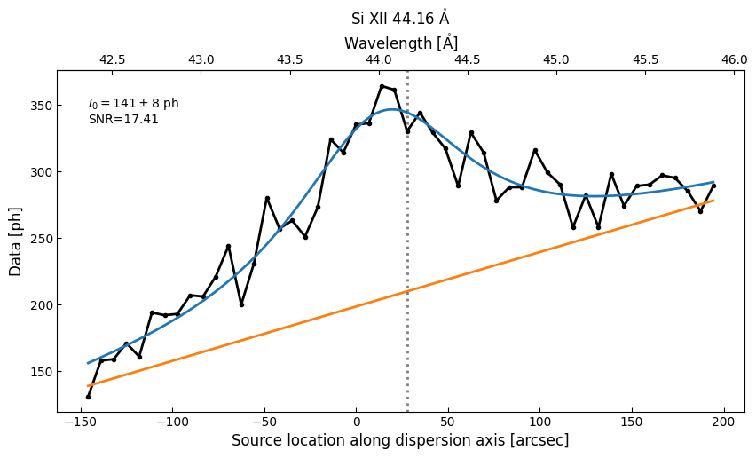
We note that in all diagnostic lines but Ne X 12.13 Å, we achieve adequate SNR as well as over 100 photons above the background with an integration time of 1.5 hours. We intend to mitigate the lack of signal in Ne X 12.13 Å by performing more sophisticated inversions as well as exploring the use of additional high-temperature, high-FIP lines that can be used in combination with Fe XVII 15.01 Å for abundance diagnostics.

