Evaluation and Optimization of YOLO Models for Small Object Detection on the VisDrone Dataset

1. Introduction
Object Detection is an important application of Computer Vision for surveillance, automation, aerial monitoring, and more. In this project, YOLO-based object detection models are used for evaluation against the VisDrone dataset, which is very hard because of its complex nature – high object density and high frequency of small object categories in the dataset. The goal of this project is to come up with a good baseline model, do some experimentation to find out ways of improvement and compare several YOLO model types trained consistently. For this reason, numerical output data from the models will be used extensively without too many visual plots and other material.

2. Dataset
Object Detection is an important application of Computer Vision for surveillance, automation, aerial monitoring, and more. In this project, YOLO-based object detection models are used for evaluation against the VisDrone dataset, which is very hard because of its complex nature – high object density and high frequency of small object categories in the dataset. The goal of this project is to come up with a good baseline model, do some experimentation to find out ways of improvement and compare several YOLO model types trained consistently. For this reason, numerical output data from the models will be used extensively without too many visual plots and other material.

3. Methodology
In this project, the training and testing of the models are performed by using the Ultralytics YOLO framework. All the experiments are run on a Google Colab notebook with a Tesla T4 GPU. The baseline model used here is YOLO11n, and the evaluation metrics used are mAP50-95, mAP50, Precision, and Recall. A controlled experiment methodology has been adopted to ensure that any change in the performance is due to particular changes like image resolution and data augmentation and not due to other reasons.

4. Baseline Model and Evaluation
A YOLO11n is used in the baseline model, which has been trained for 30 epochs, and the input images size used is 640. The best performance obtained was a mAP50-95 of 0.158, mAP50 of 0.282, Precision of 0.407, and Recall of 0.317. The model shows steady improvement in loss and validation performance during the training phase without much sign of overfitting. As far as the detection accuracy is concerned, large objects like cars have shown accurate detection, but smaller objects, especially bicycles, show low performance.
The model shows steady improvement in loss and validation performance during the training phase without much sign of overfitting.

4.1 Training Performance
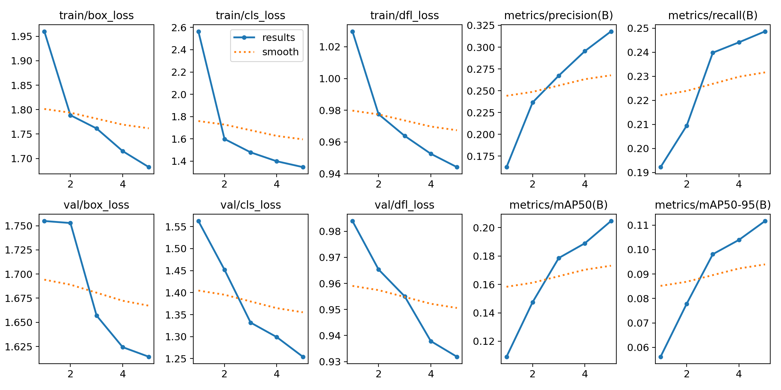
Figure 1: Training and validation loss curves along with performance metrics (Precision, Recall, mAP50, mAP50-95).
Figure 1 illustrates the training behavior for the basic YOLO11n model. Here, both training and validation losses decrease smoothly, signifying stable training. In parallel, precision, recall, and mAP values keep increasing epoch by epoch, which signifies efficient training and learning of the network.

4.2 Precision-Recall Analysis
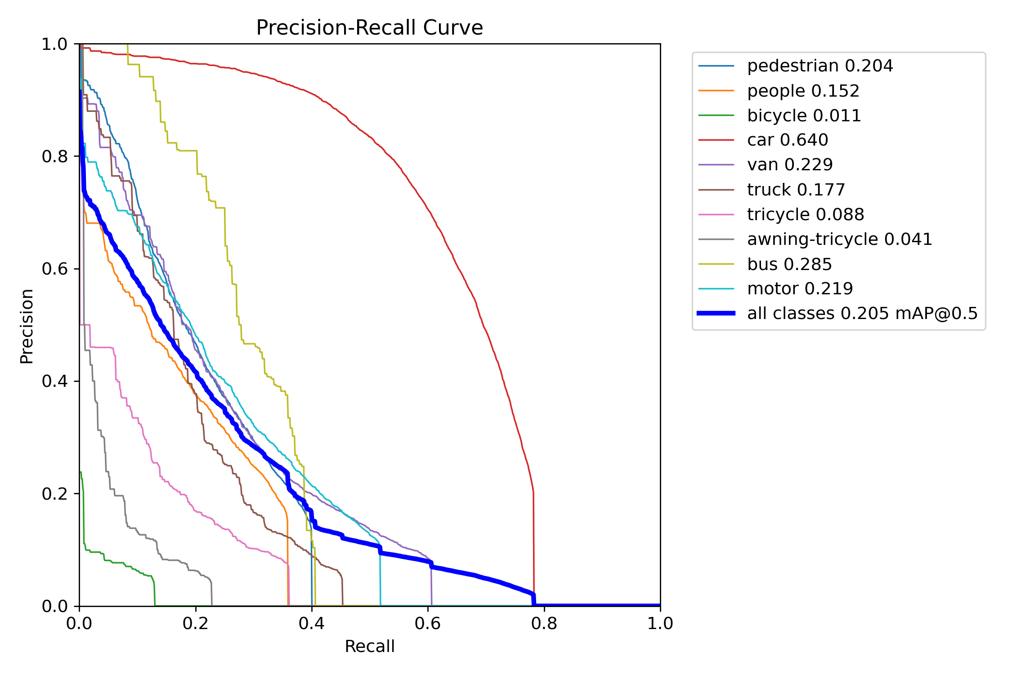
Figure 2. Precision-Recall Curve for All Classes
As can be seen from Figure 2, PR curves are plotted for all types of objects. Performance of the algorithm is good for large objects like cars with AP = 0.640, while the results are poor for small objects like bicycles with AP = 0.011.

4.3 Confusion Matrix Analysis
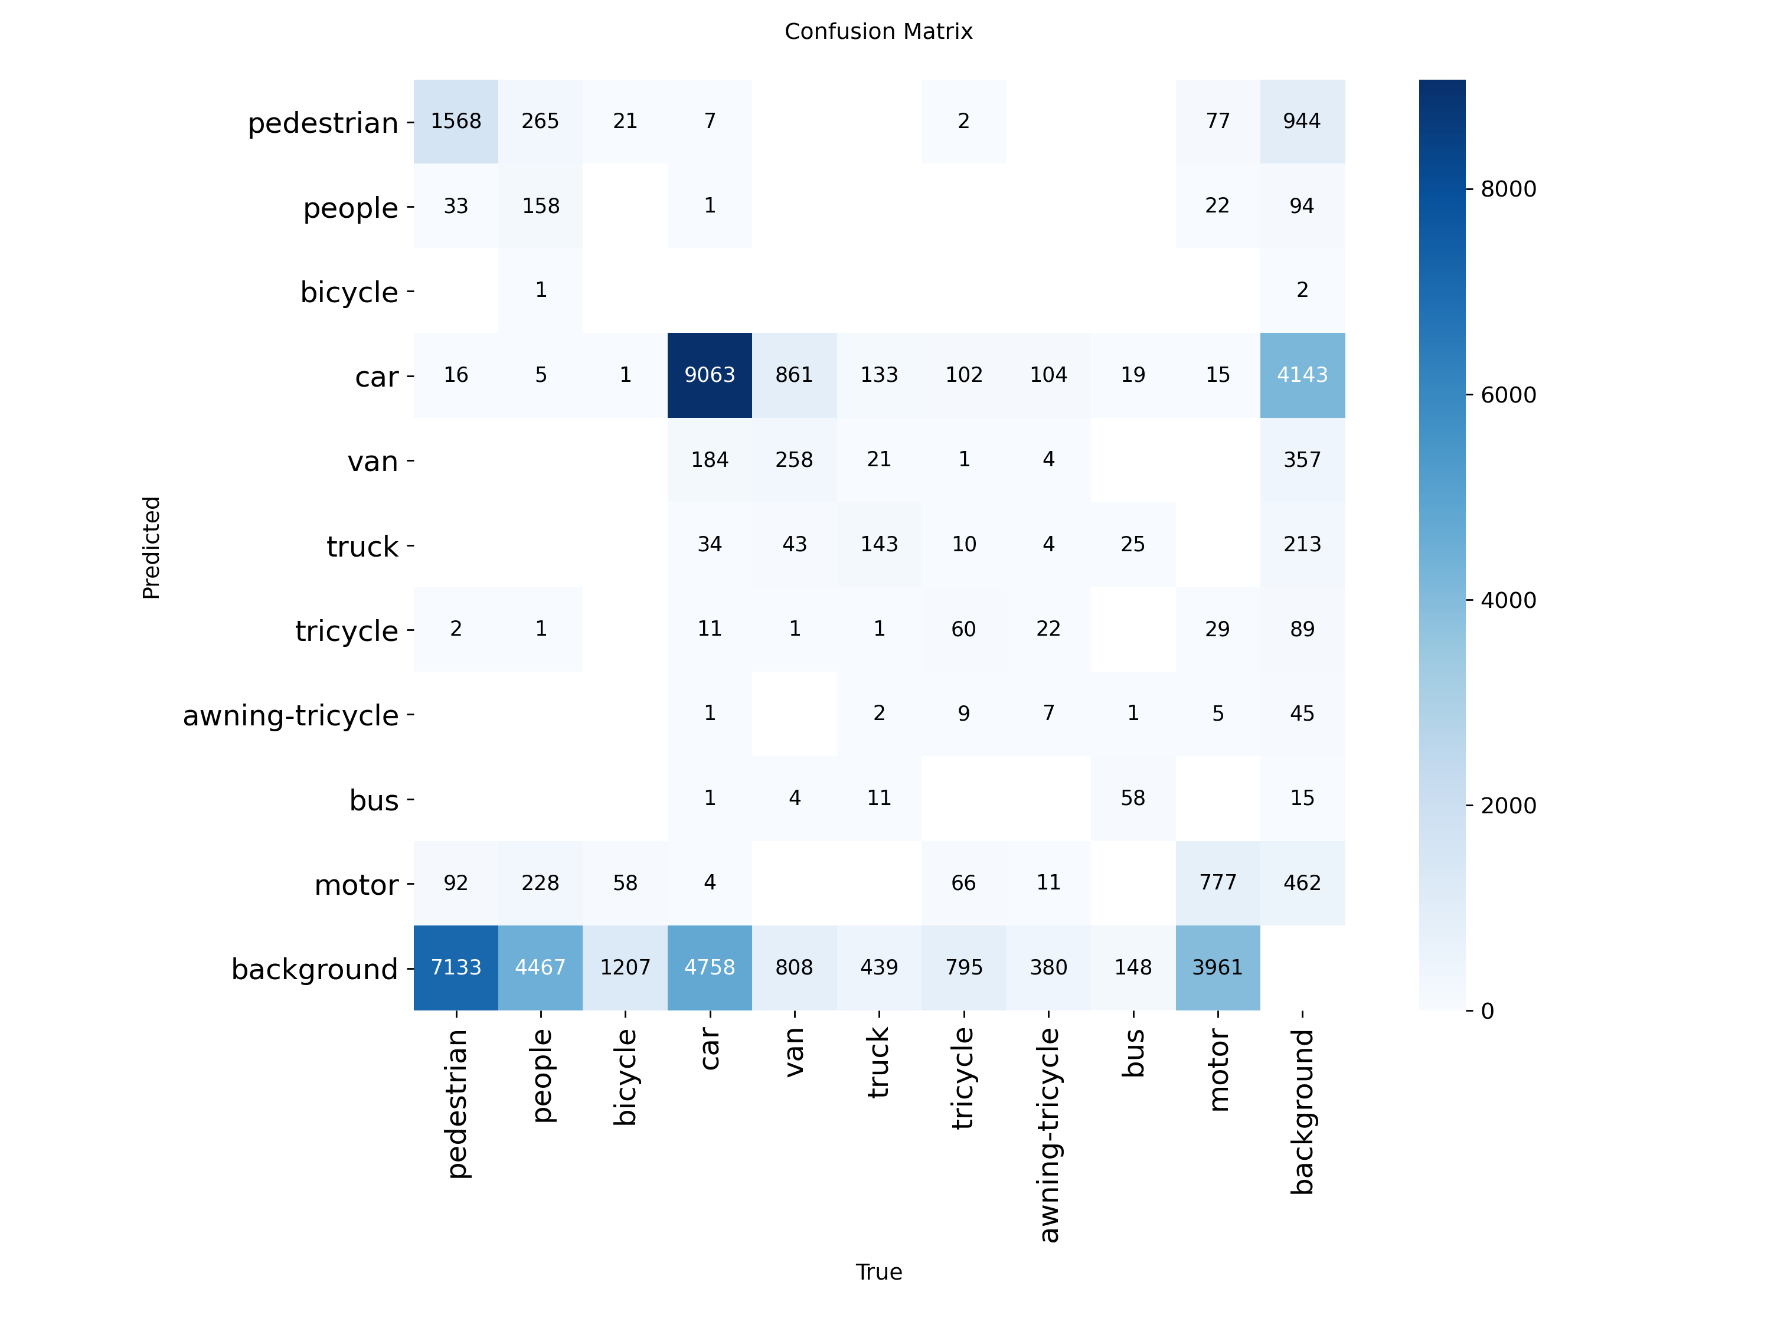
Figure 3. Confusion Matrix of Model Predictions
Figure 3 shows the confusion matrix for the results from the validation set. The numbers along the diagonal indicate instances where the classification was successful in correctly identifying a particular class, for example, vehicles. At the same time, however, misclassification is evident for some classes, especially those that look alike, like pedestrians and people or cars and trucks. Another point worth considering is the high percentage of false positives where the background is labeled as an object.
4.4 Detection Results
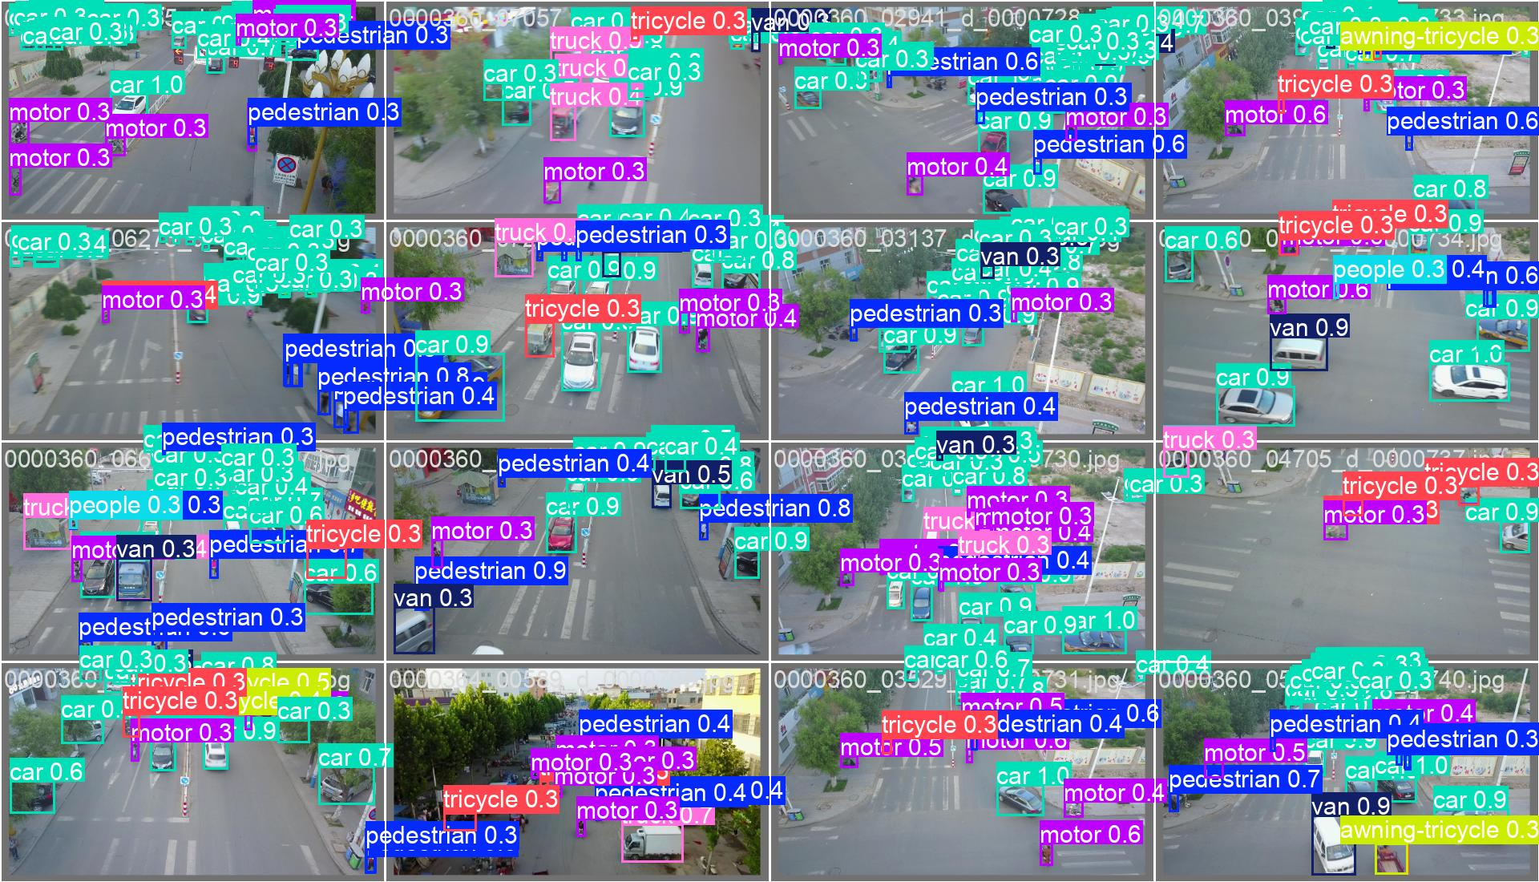
Figure 4. Sample Detection Results on Validation Images
Figure 4 shows some detection results on validation images. As can be seen from Figure 4, the model is capable of detecting many objects even in the presence of complex traffic scenes. But in doing so, it creates many boxes whose probability are comparatively low. There are overlaps in the detections made, implying the tendency of over-detection by the model.

5. Experiment 1: Image Resolution
For the first experiment, the input image resolution is increased to 960, which helps in detecting smaller objects. For training, the number of epochs increases to 12 due to the reduced batch size so as to accommodate in GPU. As a result, improvements can be observed since mAP50-95 rose up to 0.199, and mAP50 reached 0.338 values, which are also accompanied by improved Precision and Recall rates. Such an outcome is logical as high-resolution pictures allow preserving enough details about the objects in the image, making it easier to detect small objects. The experiment proves that image resolution is a crucial parameter in case of training with small objects datasets.

6. Experiment 2: Data Augmentation
In the second experiment, the goal is to train the model with data augmentation involving HSV transformations, rotation, etc. However, despite expectations, the results worsened, as mAP50-95 fell to 0.131, and mAP50 declined to 0.238 values; at the same time, the model's Precision and Recall scores were also lower than before. Thus, it can be concluded that the used augmentation strategy does not work well with the current dataset. It is most probable due to the fact that color and geometric transformations make it difficult to recognize important details of the objects.

7. Model Comparison
An experiment has been carried out using four versions of YOLO algorithms: YOLO11n, YOLOv8n, YOLOv5nu, and YOLOv10n. They have all been trained in equal conditions: there are 6 epochs and an image size of 640. YOLO11n gives the best result, having an mAP50-95 of 0.118. The second-best result was shown by YOLOv8n, while YOLOv10n and YOLOv5nu are much worse. Thus, simpler architecture might give better performance with limited training time.

8. Discussion
It can be seen from the results that the increase in resolution has the most influence on results. It is even more useful in the case of small objects' detection. Data augmentation is also dangerous as it can change visual details of images, leading to bad results. Model complexity cannot guarantee better performance, especially with limited conditions for training.

9. Conclusion
The experiment showed that the application of YOLO architecture on the VisDrone dataset is possible and can be successful, yet performance relies heavily on the choice of the training regime. Raising the image resolution was found to be the most efficient method for achieving this. Conversely, the use of data augmentation techniques could negatively impact performance. Of all the models considered, YOLO11n proved to be the optimal one in terms of the combination of accuracy and speed.

