CMPE 401 Project 2 – Time Series Modeling Report

1. Introduction
The present project aims at investigating the problem of time-series modeling by applying deep learning methods. Specifically, two distinct tasks are proposed to examine: one that involves classification with Transformer network architecture and another task for forecasting with LSTM architecture.

2. Datasets
FordA Dataset:
Time series classification task. A single instance consists of 500 time steps and belongs to one of two classes.
Jena Climate Dataset:
Time series prediction task. This is a dataset consisting of measurements made at different points in time. The objective is to make predictions of future temperatures.

3. Transformer Classification (Baseline)
Classification of data using Transformer was done using FordA data set.
Output:
Test Accuracy ≈ 0.5159
Conclusion:
It is clear that the above model could not perform any better than a guess (50%). This implies that the transformer model could not find any pattern at all in the data.
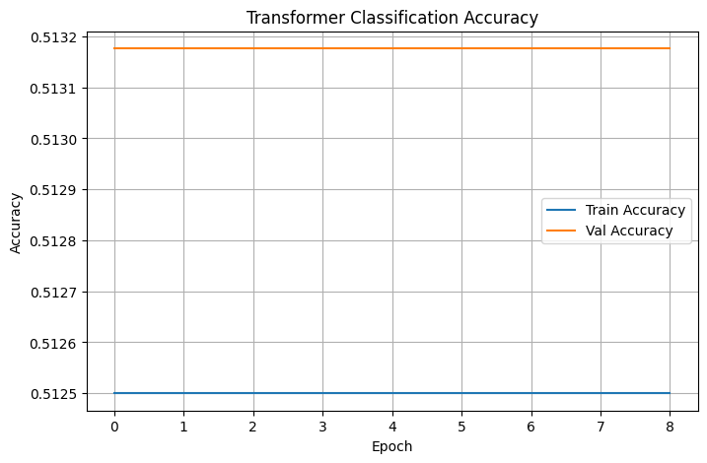
Figure 1 shows that both training and validation accuracy remain constant at around 0.51, indicating that the model fails to learn meaningful patterns.
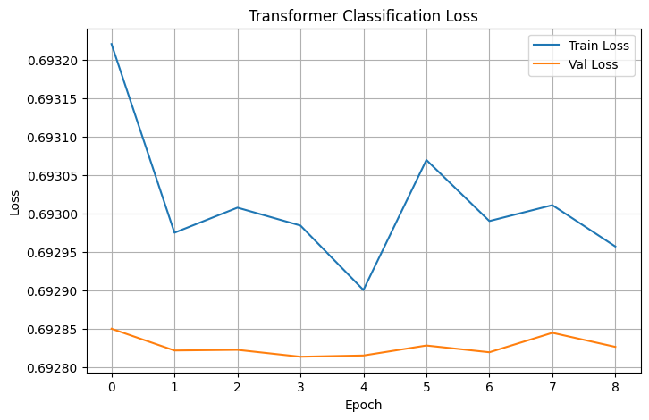
Figure 2 shows that the loss does not decrease significantly, confirming that the model is not improving during training.

4. LSTM Forecasting (Baseline)
LSTM was employed for predictions using the Jena Climate dataset. It consists of one LSTM layer with 32 neurons.
Results:
MAE test ≈ 0.2502
Observations:
It can be observed that there is a problem of overfitting, since the training error drops and validation errors rise.
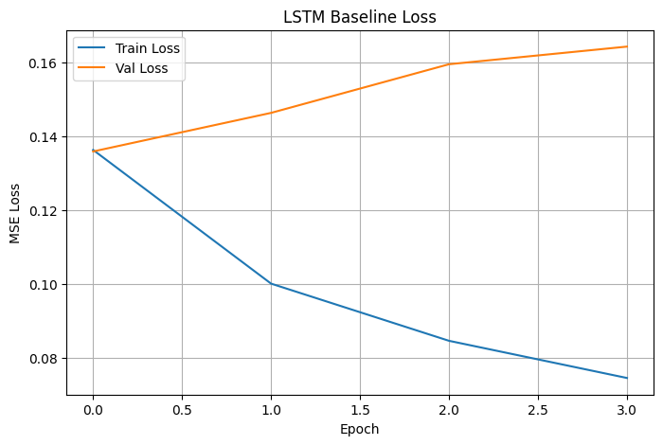
Figure 3 shows that training loss decreases while validation loss increases, indicating overfitting.
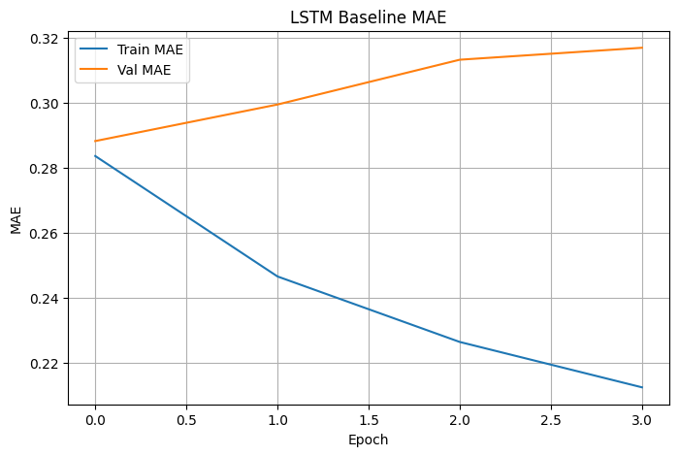
Figure 4 shows that training MAE decreases while validation MAE increases, further confirming that the model overfits the training data.

5. Model Improvements
Improvement #1: Expanded Hidden Layer (32→64)
Output: MAE ≈ 0.2648
Comment: This did not increase performance; it is probably overfitting.
Improvement #2: Added Stacked LSTM layers
Output: MAE ≈ 0.2589
Comment: An improvement from the previous attempt, but still not better than our starting point.
Improvement #3: Tuned Learning Rate & Batch Size
Output: MAE ≈ 0.2492
Comment: Best performance thus far. Tuning helped optimize.

6. Benchmark Comparison
LSTM Baseline: 0.2502
Improvement 1: 0.2648
Improvement 2: 0.2589
Improvement 3: 0.2492

7. Discussion
From the results, one can see that model complexity does not always result in improved performance. Instead, larger models overfitted the training data. However, optimizing model parameters resulted in better performance.

8. Conclusion
From the above project, it is clear that model tuning plays an important role in time series modeling. The simpler model can perform much better than the more complicated models by tuning its hyperparameters.

