**NAME: AISHWARYA DESHMUKH**

**ROLL NO.: D003**

**SAP ID.: 60009230154**

**Experiment 5:**

(Shell scripts)

**Aim:** To study and implement basic Shell scripting.

**Theory:**

**Shell Script**

Shell is a program which interprets user commands through CLI like Terminal. The Bourne shell, bash shell and the C shell are the most used shells in Unix. Unix commands may also be executed non-interactively in the form of a Shell program or a Shell Script. The script is a series of commands that will be run together.

It can combine lengthy and repetitive sequences of commands into a single and simple script, which can be stored and executed anytime. This reduces the effort required by the end user. Typical operations performed by shell scripts include file manipulation, program execution, and printing text.

**Creating and executing a shell script Steps** in creating a Shell Script:

1. **Create a file using** a **vi** editor (or any other editor).
2. Name the script file with **extension .sh**
3. **Start** the script with **#! /bin/sh**
4. Write some code.
5. Save the script file as filename.sh
6. Give the shell permission to execute it.
7. For **executing** the script type **bash filename.sh**

**An example shell script**

The following example shows a simple shell script that lists the contents of the current directory and also shows the path of the current directory.

#!/bin/sh ls

pwd

**Lab Assignments to complete in this session**

**Implementation Instruction:**

**Objectives:**

* + To understand shell variables and shell programming.
  + To develop shell scripts.

**Outcomes:** After study of this experiment, the student will be able to

* + Develop shell scripts for simple tasks.

**Prerequisite:** UNIX shell.

**Requirements:** Personal Computer, Ubuntu OS, Text Editor, LibreOffice.

1. Write Shell script to copy files from one folder to another

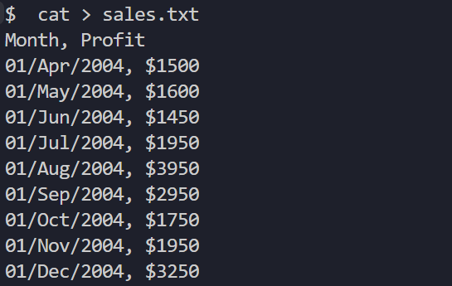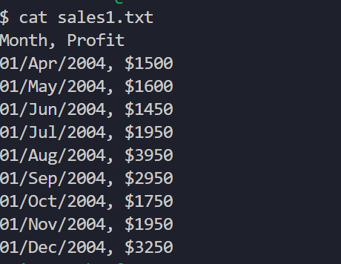

1. Write Shell script Count number of words, characters and lines.

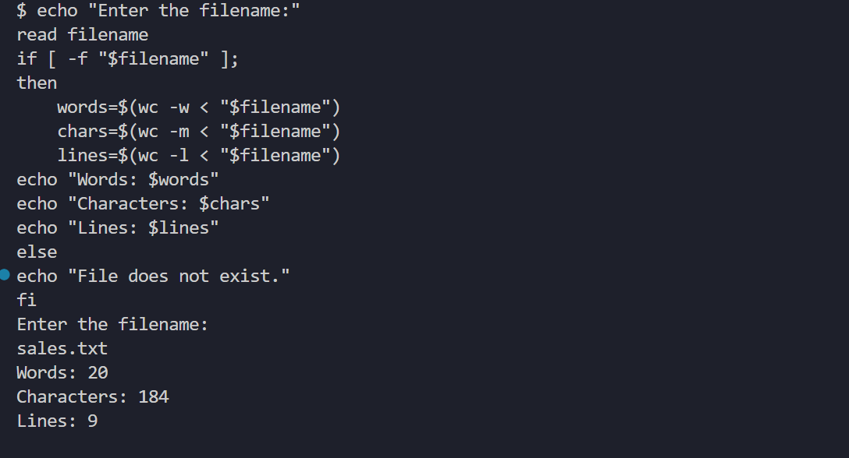

1. Write Shell script To describe files in different format.

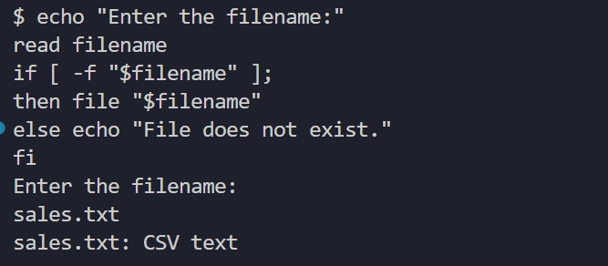

1. Write Shell script to find factorial of given number using bash script

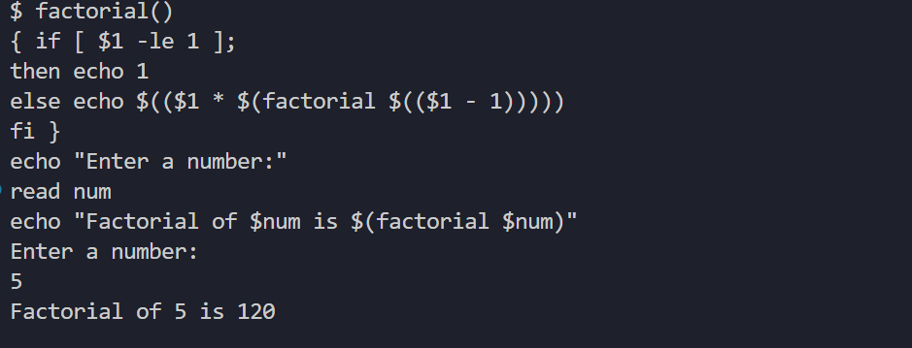

1. Display first 10 natural numbers using bash script

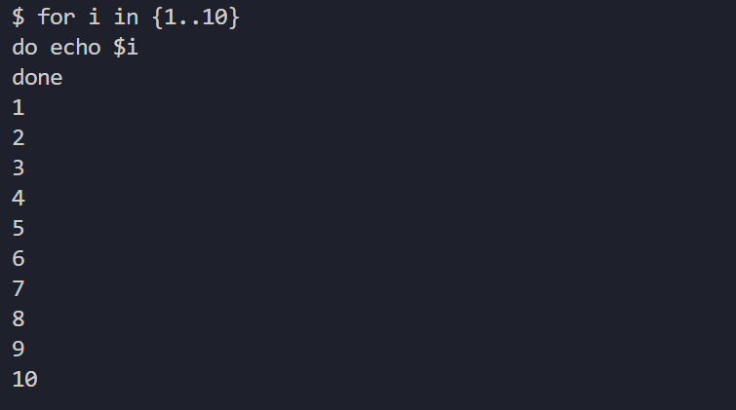

1. Display Fibonacci series using bash script

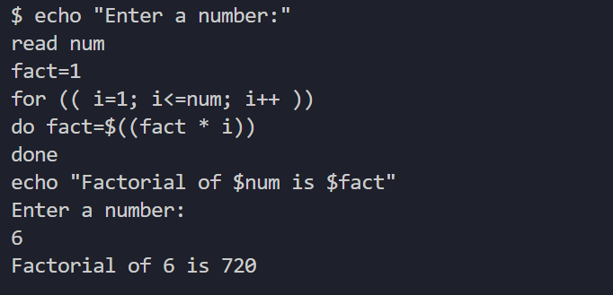

1. Find given number is prime or nor using bash script

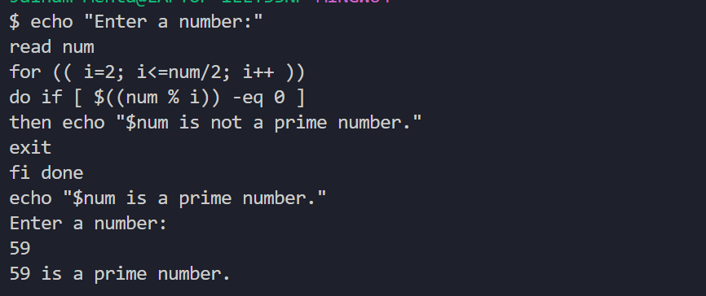

1. Write shell script to find biggest of three numbers

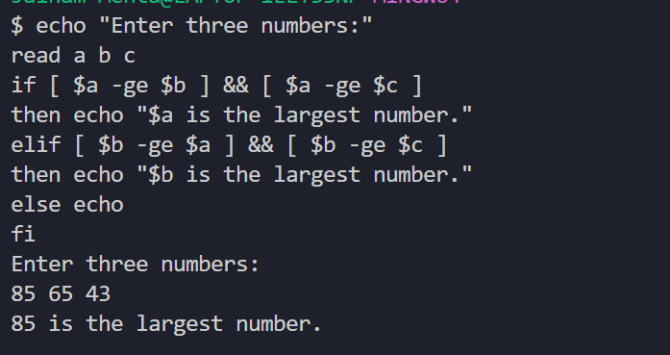

1. Write shell script to reverse a given number

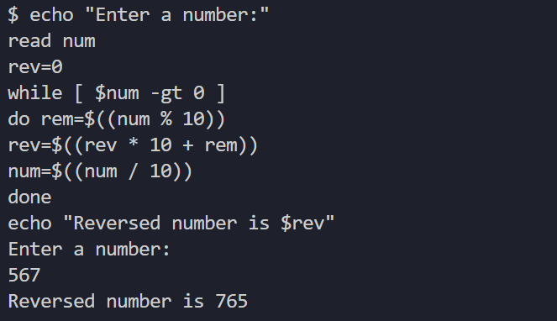

1. Write shell script to find Sum of individual digits (1234 => 1+2+3+4=10)

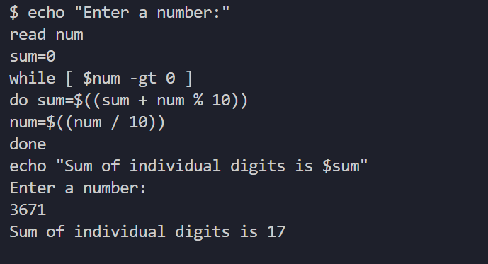

1. Write a shell script to display a list of users currently logged in.

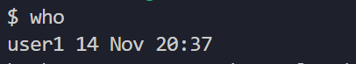

1. Write a shell script to perform arithmetic operations.

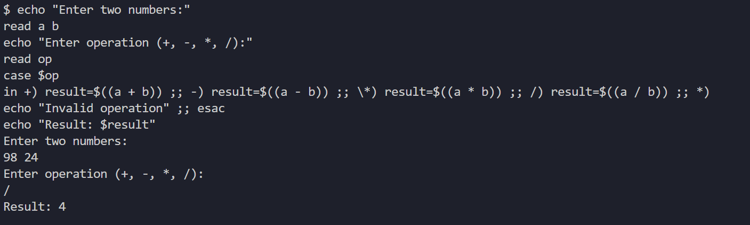

1. Write a shell script to copy contents of one file to another.

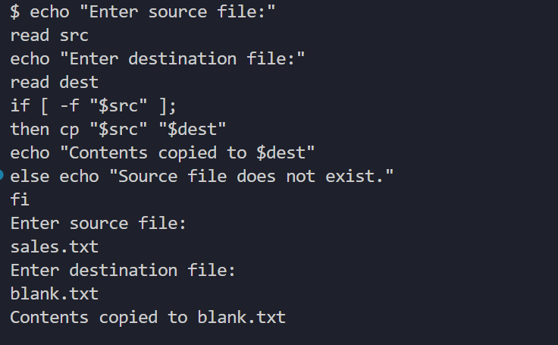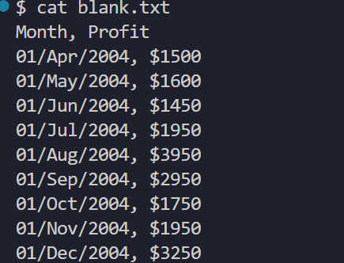

1. Write a shell program to generate multiplication table of a number upto a given range.

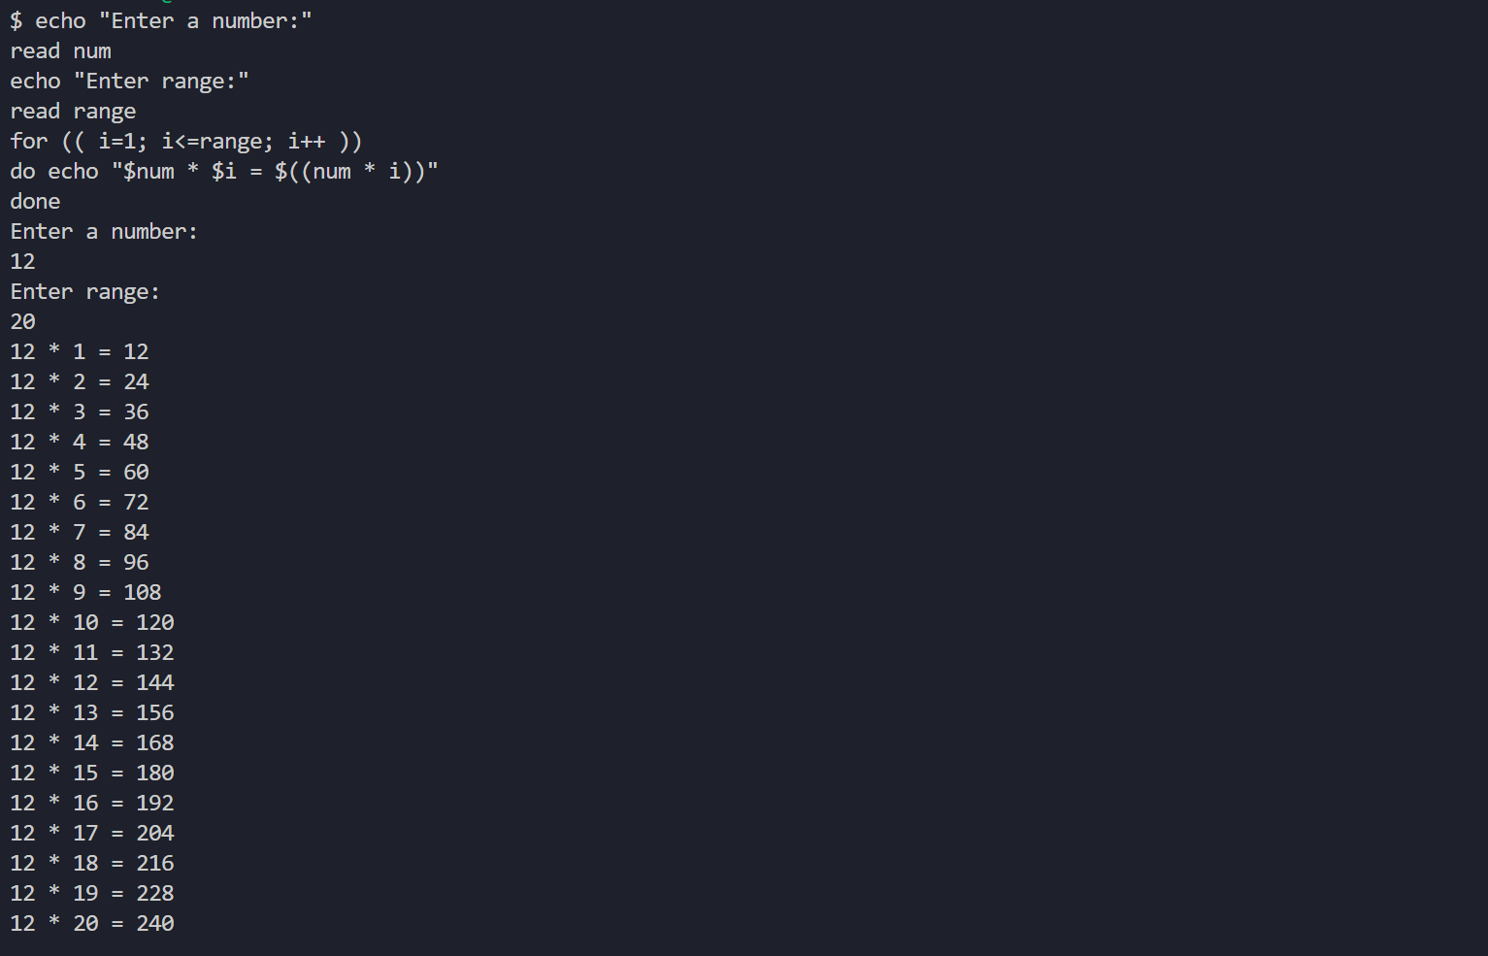

1. Write a shell program to count the number of files in a directory.

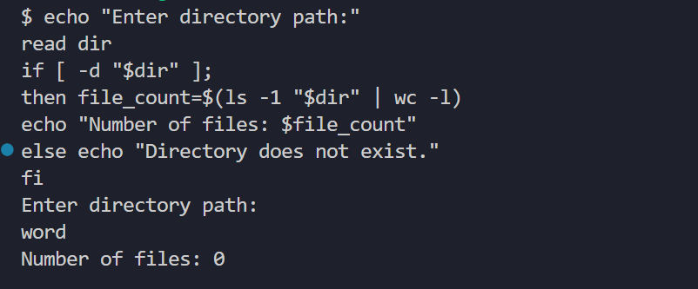

1. Shell Script to find the number of matched characters, words and lines in a file.

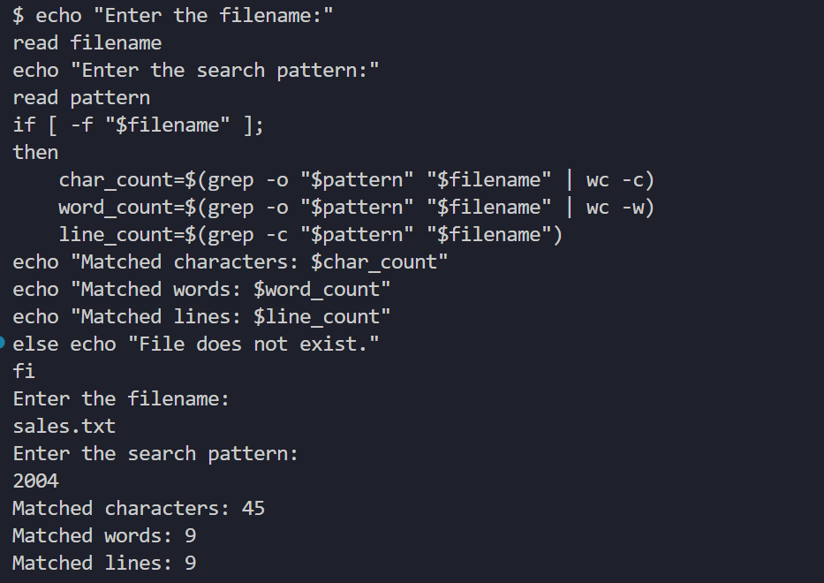

1. Write a script to find the number of characters, words and lines in a file.

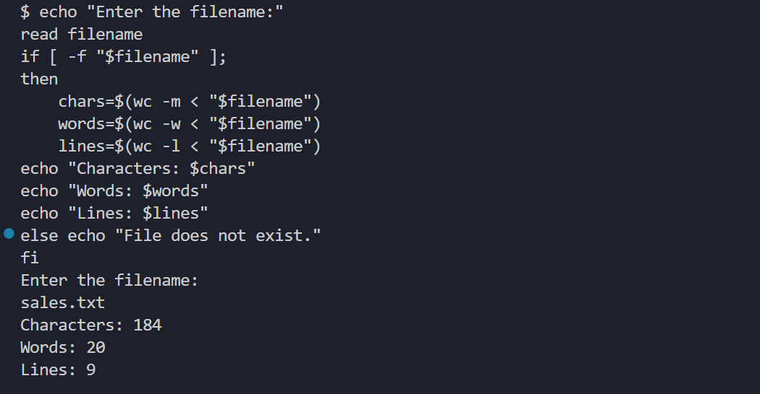

1. Write a script to display list of files starting with particular letter in the directory.

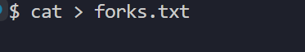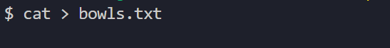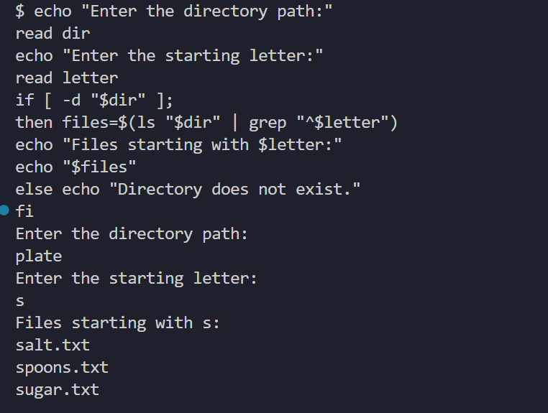

1. Write a script to develop a Fibonacci series.

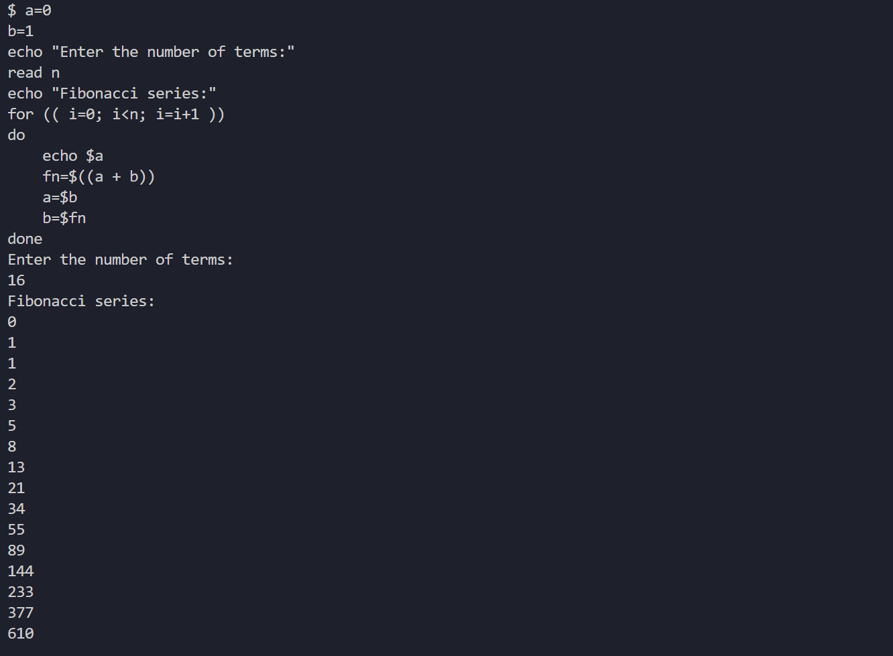

1. Write a shell script to replace the Nth occurrence of a pattern.

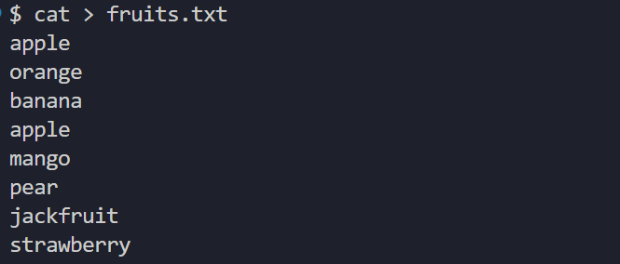 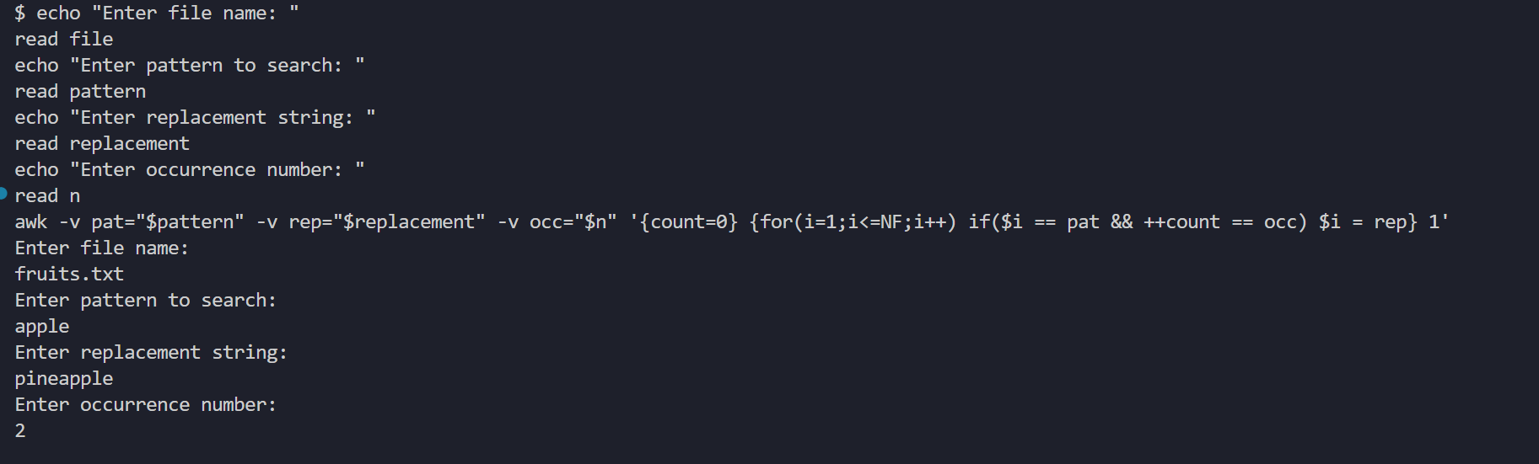 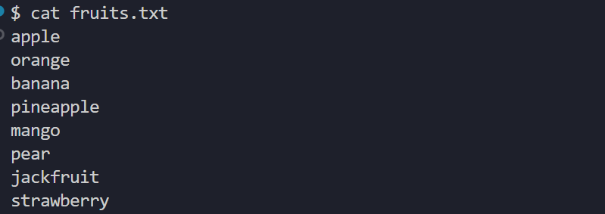

1. Write a shell script to convert temperature from Centigrade to Fahrenheit.

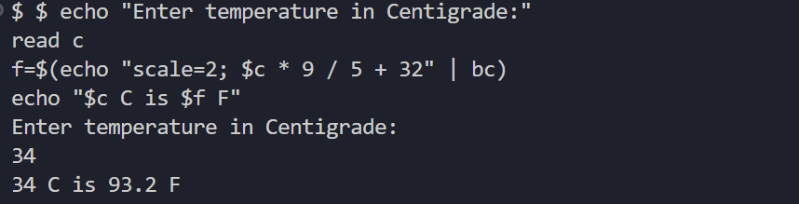

1. Write a shell script to compute the power of a given number.

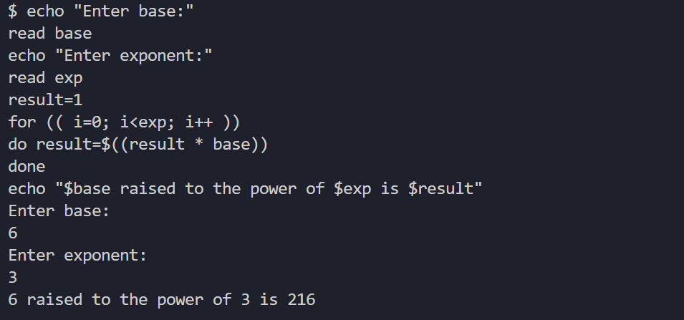

1. Write a shell script to check whether the entered number is prime or not.

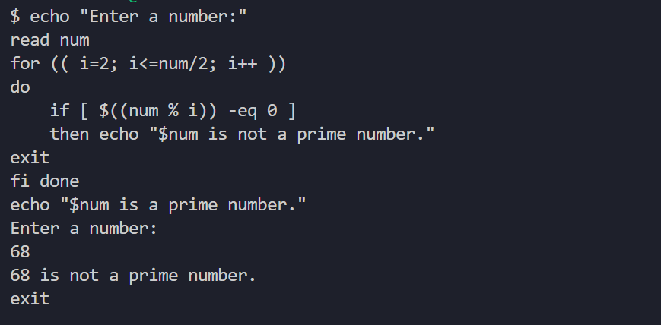

1. Write a shell script to check whether the year is leap year or not.

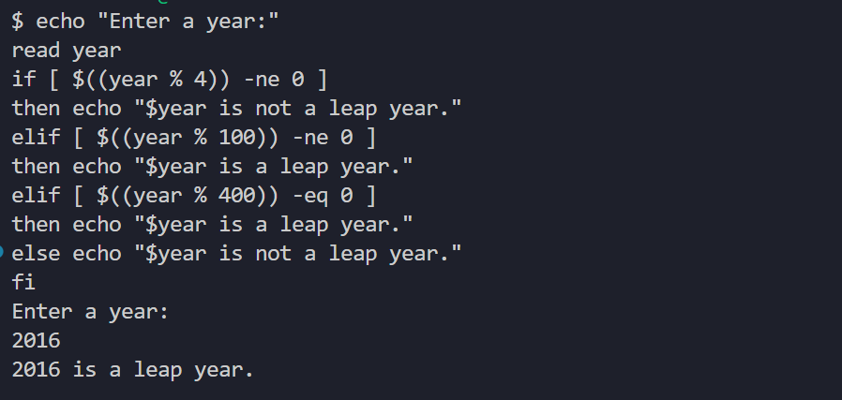

1. Write a shell script to check whether a number is even or odd.

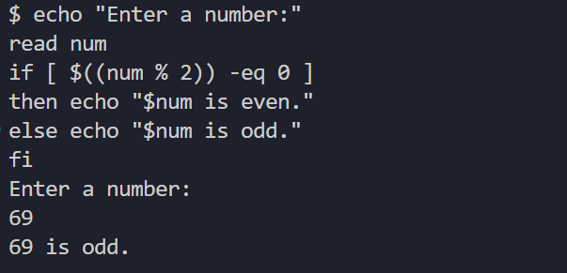

1. When to use shell scripts?

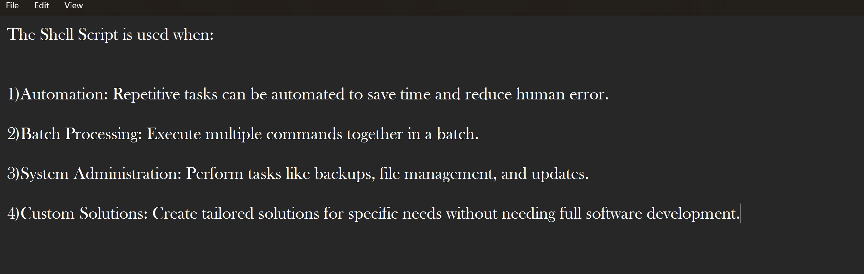

1. Where is the bash program located on your system?

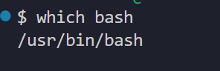

1. How to find the current shell which you are using in UNIX?

